Support Vector Regression: SVR fits a function that balances flatness with tolerance to errors using the ε-insensitive loss. Kernel functions (e.g., radial basis function) enable nonlinear regression in the sliding-window feature space, where each row encodes the latest lags of the series. Important hyperparameters include the kernel, cost (C), epsilon (ε), and kernel-specific parameters. SVR is robust to outliers and works well with properly scaled inputs.
Objective: Demonstrate time-series forecasting with SVM (Support Vector Regression) using sliding windows, normalization, model fitting, and evaluation with metrics and plots.
# Time Series Regression - SVM
# Installing the package (if needed)
#install.packages("tspredit")
# Loading the packages
library(daltoolbox)
library(tspredit)
# Series for study and sliding windows
data(tsd)
ts <- ts_data(tsd$y, 10)
ts_head(ts, 3)
## t9 t8 t7 t6 t5 t4 t3 t2 t1 t0
## [1,] 0.0000000 0.2474040 0.4794255 0.6816388 0.8414710 0.9489846 0.9974950 0.9839859 0.9092974 0.7780732
## [2,] 0.2474040 0.4794255 0.6816388 0.8414710 0.9489846 0.9974950 0.9839859 0.9092974 0.7780732 0.5984721
## [3,] 0.4794255 0.6816388 0.8414710 0.9489846 0.9974950 0.9839859 0.9092974 0.7780732 0.5984721 0.3816610
# Series visualization
library(ggplot2)
plot_ts(x=tsd$x, y=tsd$y) + theme(text = element_text(size=16))
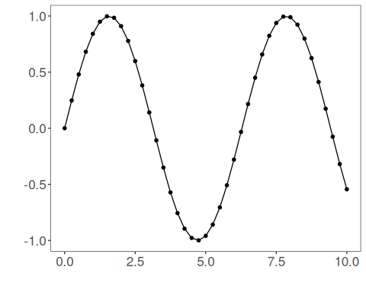
# Train-test split and projection (X, y)
samp <- ts_sample(ts, test_size = 5)
io_train <- ts_projection(samp$train)
io_test <- ts_projection(samp$test)
# Preprocessing (global min-max normalization)
preproc <- ts_norm_gminmax()
# Training the SVM model
model <- ts_svm(ts_norm_gminmax(), input_size=4)
model <- fit(model, x=io_train$input, y=io_train$output)
# Fit evaluation (train)
adjust <- predict(model, io_train$input)
adjust <- as.vector(adjust)
output <- as.vector(io_train$output)
ev_adjust <- evaluate(model, output, adjust)
ev_adjust$mse
## [1] 5.130098e-07
# Forecast on test set (5 steps ahead)
prediction <- predict(model, x=io_test$input[1,], steps_ahead=5)
prediction <- as.vector(prediction)
output <- as.vector(io_test$output)
ev_test <- evaluate(model, output, prediction)
ev_test
## $values
## [1] 0.41211849 0.17388949 -0.07515112 -0.31951919 -0.54402111
##
## $prediction
## [1] 0.41268934 0.17333448 -0.07563299 -0.31983409 -0.54481781
##
## $smape
## [1] 0.002684197
##
## $mse
## [1] 3.199991e-07
##
## $R2
## [1] 0.9999972
##
## $metrics
## mse smape R2
## 1 3.199991e-07 0.002684197 0.9999972
# Plot comparing actual vs fit (train) and forecast (test)
yvalues <- c(io_train$output, io_test$output)
plot_ts_pred(y=yvalues, yadj=adjust, ypre=prediction) + theme(text = element_text(size=16))
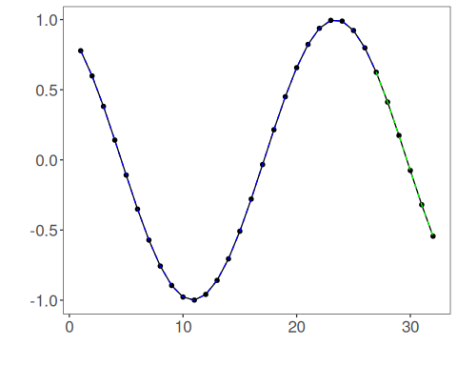
References - A. J. Smola and B. Schölkopf (2004). A tutorial on support vector regression. Statistics and Computing, 14(3), 199–222.

