Stock Closing-Price Forecasting with Non-Deterministic Auxiliaries
About the method - This workflow keeps close as the forecasting target and treats open, high, low, and volume as non-deterministic auxiliary variables. - Unlike the previous example, the auxiliary variables are not governed by a fixed law of formation. They need their own forecasting models.
Didactic goal: compare a direct ARIMA baseline on the closing price against a target-centered multivariate workflow whose auxiliary variables mix ts_mlp(), ts_elm(), ts_darima(), and ts_warma().
source(url("https://raw.githubusercontent.com/cefet-rj-dal/tspredit/main/examples/seed.R"))
# Stock closing-price forecasting with non-deterministic auxiliaries
# Installing the package (if needed)
# install.packages("tspredit")
library(daltoolbox)
library(tspredit)
We now switch to a different multivariate scenario. Instead of deterministic calendar auxiliaries, we use market variables from the packaged stocks collection. The target is the closing price, while the other fields behave as non-deterministic auxiliary series.
data(stocks)
if (!is.null(attr(stocks, "url"))) {
stocks <- loadfulldata(stocks)
}
ticker_name <- if ("VALE3" %in% names(stocks)) "VALE3" else names(stocks)[1]
ticker <- stocks[[ticker_name]]
ticker <- ticker[, c("open", "high", "low", "close", "volume")]
ticker <- stats::na.omit(ticker)
mv <- ts_data_mv(
ticker,
y = "close",
x = c("open", "high", "low", "volume")
)
ts_head(mv, 3)
## close open high low volume
## 1 3.500000 3.500000 3.542500 3.500000 585600
## 2 3.416666 3.466666 3.474166 3.416666 782400
## 3 3.416666 3.375000 3.416666 3.375000 1876800
The aligned object can now be split in time just like any other target-centered multivariate dataset.
samp <- ts_sample(mv, test_size = 5)
Before introducing the multivariate workflow, we build a direct univariate baseline on the closing price itself. This keeps the interpretation honest: we first ask how far a classical ARIMA can go before bringing in the auxiliary variables.
close_ts <- ts_data(ticker$close, 1)
close_samp <- ts_sample(close_ts, test_size = 5)
arima_baseline <- ts_arima()
arima_baseline <- fit(arima_baseline, x = close_samp$train)
pred_arima <- predict(arima_baseline, x = close_samp$test[1,], steps_ahead = 5)
pred_arima <- as.vector(pred_arima)
ev_arima <- evaluate(arima_baseline, as.vector(close_samp$test), pred_arima)
ev_arima$metrics
## mse smape R2
## 1 4.904158 0.02269408 -2.053065
This time, the auxiliary variables are not deterministic. We therefore assign real forecasting models to them. After a few trial configurations, a Random Forest worked better as the target learner for this particular stock holdout, while the auxiliaries remain intentionally heterogeneous:
- open uses ELM
- high uses DARIMA
- low uses MLP
- volume uses WARMA
model <- ts_regsw_mv(
model_y = ts_mv_spec(
ts_rf(ts_norm_gminmax(), input_size = 4),
variables = c("close", "open", "high", "low")
),
models_x = list(
open = ts_mv_spec(
ts_elm(ts_norm_gminmax(), input_size = 3, nhid = 3, actfun = "purelin"),
variables = c("open", "close", "high")
),
high = ts_mv_spec(
ts_darima(ts_norm_diff(), input_size = 3),
variables = c("high", "close", "open")
),
low = ts_mv_spec(
ts_mlp(ts_norm_gminmax(), input_size = 3, size = 2, decay = 0.1),
variables = c("low", "close", "open")
),
volume = ts_mv_spec(
ts_warma(input_size = 3, steps = 1),
variables = c("volume")
)
),
window_size = 5
)
This mixed specification also clarifies an important point of the current API: the univariate support models used inside ts_regsw_mv do not need to be all of the same family. Here:
- ts_rf() gives a more stable target learner for this stock example
- ts_elm() offers a lighter neural alternative for one auxiliary variable
- ts_darima() acts as a lightweight ARIMA-like learner in the sliding-window world, with differencing delegated to preprocessing
- ts_mlp() remains available as a nonlinear auxiliary learner
- ts_warma() acts as a local-normalization competitor in the same ts_regsw lineage
set_example_seed()
model <- fit(model, samp$train)
We first inspect the next closing-price forecast.
pred_1 <- predict(model, steps_ahead = 1)
pred_1
## [1] 88.5635
We then inspect the recursive multi-step path for the target.
pred_5 <- predict(model, steps_ahead = 5)
pred_5
## [1] 88.5635 87.4750 87.6003 87.4603 87.5465
And finally the full recursive system, including the auxiliary predictions.
pred_all <- predict(model, steps_ahead = 5, return_all = TRUE)
pred_all
## $y
## [1] 88.5635 87.4750 87.6003 87.4603 87.5465
##
## $x
## $x$open
## [1] 85.80139 88.61880 89.57019 87.88007 88.15521
##
## $x$high
## [1] 90.64456 90.82650 89.66789 89.05472 89.18879
##
## $x$low
## [1] 86.76855 86.95671 86.91732 87.05260 86.91490
##
## $x$volume
## [1] 34433500 35625440 34347888 32881186 34999543
##
##
## attr(,"class")
## [1] "ts_mv_prediction"
## attr(,"y_name")
## [1] "close"
## attr(,"x_names")
## [1] "open" "high" "low" "volume"
## attr(,"variables")
## [1] "close" "open" "high" "low" "volume"
## attr(,"steps_ahead")
## [1] 5
To keep the notebook readable, we plot the target and two representative auxiliaries.
plot_close <- plot_ts_pred_mv(samp$train, samp$test, pred_all, variable = "close")
plot_open <- plot_ts_pred_mv(samp$train, samp$test, pred_all, variable = "open")
plot_volume <- plot_ts_pred_mv(samp$train, samp$test, pred_all, variable = "volume")
Target trajectory:
plot_close
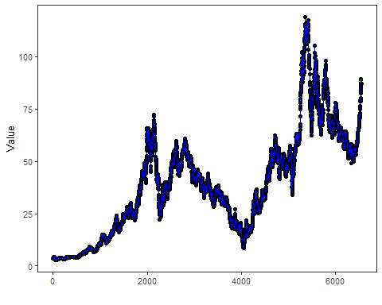
Auxiliary variable open:
plot_open
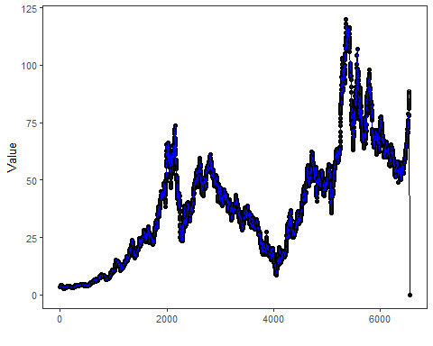
Auxiliary variable volume:
plot_volume
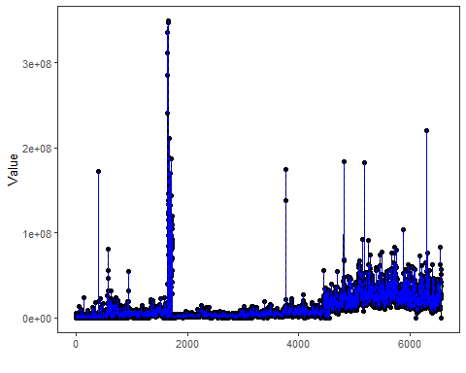
The held-out target values remain available for evaluation against the target forecast.
output <- tail(samp$test$close, 5)
ev_test <- evaluate(model, output, pred_5)
ev_test$metrics
## mse smape R2
## 1 1.19053 0.01033564 0.2588403
We can now compare the direct closing-price baseline against the multivariate workflow on the same five-step horizon.
rbind(
ARIMA_close = ev_arima$metrics,
MV_mixed = ev_test$metrics
)
## mse smape R2
## ARIMA_close 4.904158 0.02269408 -2.0530650
## MV_mixed 1.190530 0.01033564 0.2588403
What this example shows - stocks provides a natural target-centered multivariate scenario with non-deterministic auxiliary variables. - A direct ARIMA on the closing price remains an important baseline and should be checked before moving to a richer multivariate design. - Auxiliary variables do not need to share the same learner: some can use ts_elm(), others can use ts_mlp(), ts_darima(), or ts_warma(). - ts_darima() and ts_warma() are useful support models for the target-centered multivariate workflow because they already live in the ts_regsw lineage. - This is a different scenario from the previous deterministic-auxiliary example: here the auxiliary variables must themselves be forecast as evolving stochastic series.

