PyTorch MLP Regression
About the method - torch_ts_mlp() is a feedforward neural forecaster implemented through the daltoolboxdp PyTorch backend. - It keeps the same sliding-window protocol used by the other regressors, while replacing the classical nnet learner with a deeper configurable MLP.
Didactic goal: compare the standard ts_mlp() baseline with a PyTorch-based feedforward alternative before moving to convolutional and recurrent sequence models.
source(url("https://raw.githubusercontent.com/cefet-rj-dal/tspredit/main/examples/seed.R"))
# Time Series Regression - PyTorch MLP
# Installing packages (if needed)
# install.packages("tspredit")
We start by loading the packages used throughout this example.
# Loading the packages
library(daltoolbox)
library(daltoolboxdp)
library(tspredit)
We load the example series that will be used throughout the demonstration.
# Series for study and sliding windows
data(tsd)
ts <- ts_data(tsd$y, 10)
ts_head(ts, 3)
## t9 t8 t7 t6 t5 t4 t3
## [1,] 0.0000000 0.2474040 0.4794255 0.6816388 0.8414710 0.9489846 0.9974950
## [2,] 0.2474040 0.4794255 0.6816388 0.8414710 0.9489846 0.9974950 0.9839859
## [3,] 0.4794255 0.6816388 0.8414710 0.9489846 0.9974950 0.9839859 0.9092974
## t2 t1 t0
## [1,] 0.9839859 0.9092974 0.7780732
## [2,] 0.9092974 0.7780732 0.5984721
## [3,] 0.7780732 0.5984721 0.3816610
Before moving on, we visualize the series so the effect of the next transformation can be compared against the original signal.
# Series visualization
library(ggplot2)
plot_ts(x = tsd$x, y = tsd$y) + theme(text = element_text(size = 16))
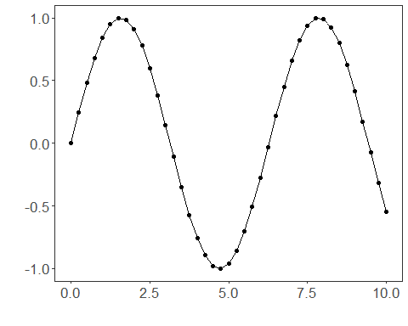
We now preserve the time order, split the data into train and test partitions, and project the windows into inputs and targets.
# Train-test split and projection (X, y)
samp <- ts_sample(ts, test_size = 5)
io_train <- ts_projection(samp$train)
io_test <- ts_projection(samp$test)
We now train the PyTorch MLP model on the prepared training data.
# Training the PyTorch MLP model
model <- torch_ts_mlp(
ts_norm_gminmax(),
input_size = 4,
hidden_sizes = c(16L, 8L),
epochs = 100L,
batch_size = 16L
)
set_example_seed()
model <- fit(model, x = io_train$input, y = io_train$output)
We first evaluate the in-sample fit so the model adjustment can be compared with the later forecast.
# Fit evaluation (train)
adjust <- predict(model, io_train$input)
adjust <- as.vector(adjust)
output <- as.vector(io_train$output)
ev_adjust <- evaluate(model, output, adjust)
ev_adjust$mse
## [1] 0.1782903
We now forecast the test set and compare the predicted values with the observed ones.
# Forecast on test set
prediction <- predict(model, x = io_test$input[1,], steps_ahead = 5)
prediction <- as.vector(prediction)
output <- as.vector(io_test$output)
ev_test <- evaluate(model, output, prediction)
ev_test
## $values
## [1] 0.41211849 0.17388949 -0.07515112 -0.31951919 -0.54402111
##
## $prediction
## [1] 0.7210775 0.6664229 0.6165880 0.5381956 0.5377110
##
## $smape
## [1] 1.54351
##
## $mse
## [1] 0.5444734
##
## $R2
## [1] -3.702645
##
## $metrics
## mse smape R2
## 1 0.5444734 1.54351 -3.702645
This final plot summarizes the result of the transformation so the effect can be interpreted visually.
# Plot results
yvalues <- c(io_train$output, io_test$output)
plot_ts_pred(y = yvalues, yadj = adjust, ypre = prediction, color_prediction = "orange") + theme(text = element_text(size = 16))
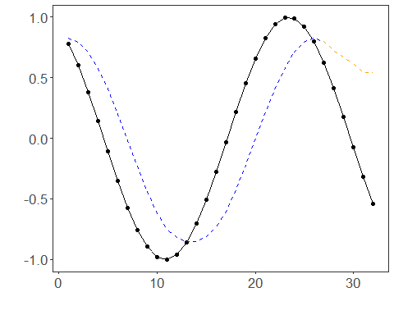
References - C. M. Bishop (1995). Neural Networks for Pattern Recognition. - A. Paszke et al. (2019). PyTorch: An Imperative Style, High-Performance Deep Learning Library.

