Stock Closing-Price Forecasting with Singular Multivariate Linear Regression
About the method - This example starts a second stock-model battery, now in the singular multivariate branch. - The target remains close, but the model is ts_lm_mv() over aligned observations with sw = 1.
Didactic goal: inspect how the singular multivariate branch behaves on the same stock scenario used in the sliding-window battery.
source(url("https://raw.githubusercontent.com/cefet-rj-dal/tspredit/main/examples/seed.R"))
# Stock closing-price forecasting with singular multivariate linear regression
# Installing packages (if needed)
# install.packages("tspredit")
library(daltoolbox)
library(tspredit)
We keep the same stock scenario used in the sliding-window battery, including the same two-year recorte and the same target-centered definition of the variables.
data(stocks)
if (!is.null(attr(stocks, "url"))) {
stocks <- loadfulldata(stocks)
}
ticker_name <- if ("VALE3" %in% names(stocks)) "VALE3" else names(stocks)[1]
ticker <- stocks[[ticker_name]]
ticker <- ticker[, c("date", "open", "high", "low", "close", "volume")]
ticker <- stats::na.omit(ticker)
ticker <- subset(ticker, open > 0 & high > 0 & low > 0 & volume > 0)
cutoff_date <- max(ticker$date) - 365 * 2
ticker <- ticker[ticker$date > cutoff_date, ]
mv <- ts_data_mv(
ticker[, c("open", "high", "low", "close", "volume")],
y = "close",
x = c("open", "high", "low", "volume")
)
samp <- ts_sample(mv, test_size = 5)
output <- tail(samp$test$close, 5)
In the singular linear-regression case, the future auxiliary values are taken directly from the aligned test rows. This makes the structural relation between close and the auxiliary variables explicit.
model <- ts_lm_mv(formula = close ~ open + high + low + volume)
model <- fit(model, samp$train)
pred_1 <- predict(model, x = samp$test, steps_ahead = 1)
pred_1
## [1] 88.34744
## attr(,"y_name")
## [1] "close"
## attr(,"x_names")
## [1] "open" "high" "low" "volume"
## attr(,"variables")
## [1] "close" "open" "high" "low" "volume"
## attr(,"steps_ahead")
## [1] 1
## attr(,"prediction_x")
## attr(,"prediction_x")$open
## [1] 86.42
##
## attr(,"prediction_x")$high
## [1] 89
##
## attr(,"prediction_x")$low
## [1] 86.42
##
## attr(,"prediction_x")$volume
## [1] 37709700
##
## attr(,"system")
## close open high low volume
## 1 88.34744 86.42 89 86.42 37709700
## attr(,"class")
## [1] "ts_mv_prediction" "numeric"
pred_5 <- predict(model, x = samp$test, steps_ahead = 5)
pred_5
## [1] 88.34744 88.54710 87.22328 86.23007 85.64975
## attr(,"y_name")
## [1] "close"
## attr(,"x_names")
## [1] "open" "high" "low" "volume"
## attr(,"variables")
## [1] "close" "open" "high" "low" "volume"
## attr(,"steps_ahead")
## [1] 5
## attr(,"prediction_x")
## attr(,"prediction_x")$open
## [1] 86.42 88.51 87.99 86.41 86.65
##
## attr(,"prediction_x")$high
## [1] 89.00 89.59 88.93 87.56 87.68
##
## attr(,"prediction_x")$low
## [1] 86.42 87.55 86.24 85.20 84.63
##
## attr(,"prediction_x")$volume
## [1] 37709700 51744400 57049000 28889600 26531100
##
## attr(,"system")
## close open high low volume
## 1 88.34744 86.42 89.00 86.42 37709700
## 2 88.54710 88.51 89.59 87.55 51744400
## 3 87.22328 87.99 88.93 86.24 57049000
## 4 86.23007 86.41 87.56 85.20 28889600
## 5 85.64975 86.65 87.68 84.63 26531100
## attr(,"class")
## [1] "ts_mv_prediction" "numeric"
attr(pred_5, "system")
## close open high low volume
## 1 88.34744 86.42 89.00 86.42 37709700
## 2 88.54710 88.51 89.59 87.55 51744400
## 3 87.22328 87.99 88.93 86.24 57049000
## 4 86.23007 86.41 87.56 85.20 28889600
## 5 85.64975 86.65 87.68 84.63 26531100
ev_test <- evaluate(model, output, pred_5)
ev_test$metrics
## mse smape R2
## 1 0.9813773 0.01045094 0.5353897
plot_ts_pred_mv(samp$train, samp$test, pred_5, variable = "close")
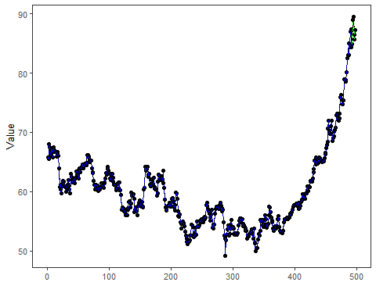
What this example shows - ts_lm_mv() can be applied to the same stock scenario as the sliding-window battery, but in the aligned singular branch. - The linear-regression formulation makes the relation between close and the auxiliaries explicit through a formula. - In this singular case, the future auxiliary values are supplied directly from the held-out aligned observations.

