Stock Closing-Price Forecasting with Singular ARIMAX
About the method - This example keeps the same stock scenario, but now the target close is forecast with ts_arimax(). - The auxiliary paths are generated by their own univariate support models inside the singular multivariate branch.
Didactic goal: inspect how the raw-series ARIMA branch extends to the aligned stock scenario without moving into sliding windows.
source(url("https://raw.githubusercontent.com/cefet-rj-dal/tspredit/main/examples/seed.R"))
# Stock closing-price forecasting with singular ARIMAX
# Installing packages (if needed)
# install.packages("tspredit")
library(daltoolbox)
library(tspredit)
data(stocks)
if (!is.null(attr(stocks, "url"))) {
stocks <- loadfulldata(stocks)
}
ticker_name <- if ("VALE3" %in% names(stocks)) "VALE3" else names(stocks)[1]
ticker <- stocks[[ticker_name]]
ticker <- ticker[, c("date", "open", "high", "low", "close", "volume")]
ticker <- stats::na.omit(ticker)
ticker <- subset(ticker, open > 0 & high > 0 & low > 0 & volume > 0)
cutoff_date <- max(ticker$date) - 365
ticker <- ticker[ticker$date > cutoff_date, ]
mv <- ts_data_mv(
ticker[, c("open", "high", "low", "close", "volume")],
y = "close",
x = c("open", "high", "low", "volume")
)
samp <- ts_sample(mv, test_size = 5)
output <- tail(samp$test$close, 5)
The target is learned with ARIMAX, while the singular branch projects the future auxiliary values through univariate ARIMA support models.
model <- ts_arimax(
models_x = list(
open = ts_arima(),
high = ts_arima(),
low = ts_arima(),
volume = ts_arima()
)
)
model <- fit(model, samp$train)
pred_1 <- predict(model, steps_ahead = 1)
pred_1
## [1] 85.12973
## attr(,"y_name")
## [1] "close"
## attr(,"x_names")
## [1] "open" "high" "low" "volume"
## attr(,"variables")
## [1] "close" "open" "high" "low" "volume"
## attr(,"steps_ahead")
## [1] 1
## attr(,"prediction_x")
## attr(,"prediction_x")$open
## [1] 84.71471
##
## attr(,"prediction_x")$high
## [1] 85.91756
##
## attr(,"prediction_x")$low
## [1] 84.13761
##
## attr(,"prediction_x")$volume
## [1] 33823708
##
## attr(,"system")
## close open high low volume
## 1 85.12973 84.71471 85.91756 84.13761 33823708
## attr(,"class")
## [1] "ts_mv_prediction" "numeric"
pred_5 <- predict(model, steps_ahead = 5)
pred_5
## [1] 85.12973 85.74534 85.66564 86.38978 86.27683
## attr(,"y_name")
## [1] "close"
## attr(,"x_names")
## [1] "open" "high" "low" "volume"
## attr(,"variables")
## [1] "close" "open" "high" "low" "volume"
## attr(,"steps_ahead")
## [1] 5
## attr(,"prediction_x")
## attr(,"prediction_x")$open
## [1] 84.71471 85.00943 85.30414 85.59886 85.89357
##
## attr(,"prediction_x")$high
## [1] 85.91756 86.21238 86.50720 86.80203 87.09685
##
## attr(,"prediction_x")$low
## [1] 84.13761 84.77751 84.66497 85.42839 85.27659
##
## attr(,"prediction_x")$volume
## [1] 33823708 34808034 35140363 34063940 35529814
##
## attr(,"system")
## close open high low volume
## 1 85.12973 84.71471 85.91756 84.13761 33823708
## 2 85.74534 85.00943 86.21238 84.77751 34808034
## 3 85.66564 85.30414 86.50720 84.66497 35140363
## 4 86.38978 85.59886 86.80203 85.42839 34063940
## 5 86.27683 85.89357 87.09685 85.27659 35529814
## attr(,"class")
## [1] "ts_mv_prediction" "numeric"
attr(pred_5, "system")
## close open high low volume
## 1 85.12973 84.71471 85.91756 84.13761 33823708
## 2 85.74534 85.00943 86.21238 84.77751 34808034
## 3 85.66564 85.30414 86.50720 84.66497 35140363
## 4 86.38978 85.59886 86.80203 85.42839 34063940
## 5 86.27683 85.89357 87.09685 85.27659 35529814
ev_test <- evaluate(model, output, pred_5)
ev_test$metrics
## mse smape R2
## 1 6.147663 0.02325208 -1.910469
plot_ts_pred_mv(samp$train, samp$test, pred_5, variable = "close")
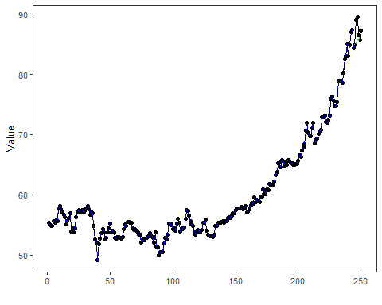
What this example shows - ts_arimax() extends the singular ARIMA branch to the same stock scenario used in the sliding-window battery. - The target remains close, but the forecast horizon also requires projected auxiliary trajectories. - Those auxiliary paths can be supplied by their own univariate ARIMA models in the singular branch.

