Conv1D Regression
About the method - A 1D convolutional network applies learnable filters across the lag window to detect local temporal motifs. - It is useful when short repeated patterns matter more than long global recurrence alone.
Didactic goal: understand how convolution changes the representation learned from sliding windows.
source(url("https://raw.githubusercontent.com/cefet-rj-dal/tspredit/main/examples/seed.R"))
# Time Series Regression - 1D CNN (Conv1D)
# Installing packages (if needed)
#install.packages("tspredit")
We start by loading the packages used throughout this example.
# Loading the packages
library(daltoolbox)
library(daltoolboxdp)
library(tspredit)
We load the example series that will be used throughout the demonstration.
# Series for study and sliding windows
data(tsd)
ts <- ts_data(tsd$y, 10)
ts_head(ts, 3)
## t9 t8 t7 t6 t5 t4 t3 t2 t1 t0
## [1,] 0.0000000 0.2474040 0.4794255 0.6816388 0.8414710 0.9489846 0.9974950 0.9839859 0.9092974 0.7780732
## [2,] 0.2474040 0.4794255 0.6816388 0.8414710 0.9489846 0.9974950 0.9839859 0.9092974 0.7780732 0.5984721
## [3,] 0.4794255 0.6816388 0.8414710 0.9489846 0.9974950 0.9839859 0.9092974 0.7780732 0.5984721 0.3816610
Before moving on, we visualize the series so the effect of the next transformation can be compared against the original signal.
# Series visualization
library(ggplot2)
plot_ts(x=tsd$x, y=tsd$y) + theme(text = element_text(size=16))
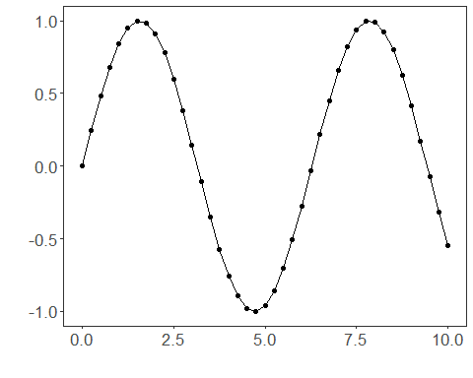
We now preserve the time order, split the data into train and test partitions, and project the windows into inputs and targets.
# Train-test split and projection (X, y)
samp <- ts_sample(ts, test_size = 5)
io_train <- ts_projection(samp$train)
io_test <- ts_projection(samp$test)
This step training the 1d cnn.
# Training the 1D CNN
model <- ts_conv1d(ts_norm_gminmax(), input_size=4, epochs=100)
set_example_seed()
model <- fit(model, x=io_train$input, y=io_train$output)
We first evaluate the in-sample fit so the model adjustment can be compared with the later forecast.
# Fit evaluation (train)
adjust <- predict(model, io_train$input)
adjust <- as.vector(adjust)
output <- as.vector(io_train$output)
ev_adjust <- evaluate(model, output, adjust)
ev_adjust$mse
## [1] 0.0001007105
We now forecast the test set and compare the predicted values with the observed ones.
# Forecast on test set
prediction <- predict(model, x=io_test$input[1,], steps_ahead=5)
prediction <- as.vector(prediction)
output <- as.vector(io_test$output)
ev_test <- evaluate(model, output, prediction)
ev_test
## $values
## [1] 0.41211849 0.17388949 -0.07515112 -0.31951919 -0.54402111
##
## $prediction
## [1] 0.4347691 0.2108168 -0.0255444 -0.2686127 -0.4891945
##
## $smape
## [1] 0.301998
##
## $mse
## [1] 0.001986985
##
## $R2
## [1] 0.9828383
##
## $metrics
## mse smape R2
## 1 0.001986985 0.301998 0.9828383
This final plot summarizes the result of the transformation so the effect can be interpreted visually.
# Plot results
yvalues <- c(io_train$output, io_test$output)
plot_ts_pred(y=yvalues, yadj=adjust, ypre=prediction, color_prediction="orange") + theme(text = element_text(size=16))
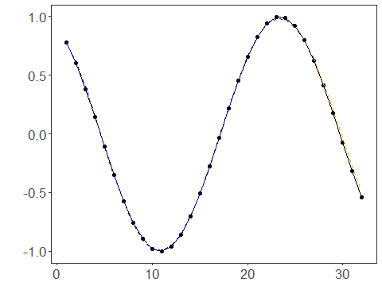
References - Y. LeCun, L. Bottou, Y. Bengio, and P. Haffner (1998). Gradient-based learning applied to document recognition. Proceedings of the IEEE, 86(11), 2278–2324.

