Model Tuning
About the technique - Tuning searches over hyperparameters such as input size and learner-specific settings. - In forecasting, this matters because the best model often depends as much on representation choices as on the learner family itself.
Didactic goal: show how hyperparameter search can be added without changing the rest of the tspredit workflow.
source(url("https://raw.githubusercontent.com/cefet-rj-dal/tspredit/main/examples/seed.R"))
# Installing the package (if needed)
#install.packages("tspredit")
We start by loading the packages used throughout this example.
# Loading the packages
library(daltoolbox)
library(tspredit)
We load the example series that will be used throughout the demonstration.
# Cosine series for study
i <- seq(0, 25, 0.25)
x <- cos(i)
Before moving on, we visualize the series so the effect of the next transformation can be compared against the original signal.
# Plot the series
plot_ts(x=i, y=x) + theme(text = element_text(size=16))
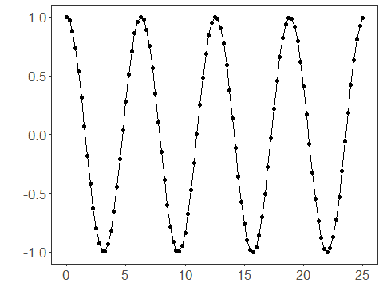
The next step organizes the series into sliding windows, which is the tabular representation used by the later transformations and models.
# Sliding windows
# Create a matrix of windows (t9..t0) from the series for training.
sw_size <- 10
ts <- ts_data(x, sw_size)
ts_head(ts, 3)
## t9 t8 t7 t6 t5 t4 t3 t2 t1 t0
## [1,] 1.0000000 0.9689124 0.8775826 0.7316889 0.5403023 0.3153224 0.0707372 -0.1782461 -0.4161468 -0.6281736
## [2,] 0.9689124 0.8775826 0.7316889 0.5403023 0.3153224 0.0707372 -0.1782461 -0.4161468 -0.6281736 -0.8011436
## [3,] 0.8775826 0.7316889 0.5403023 0.3153224 0.0707372 -0.1782461 -0.4161468 -0.6281736 -0.8011436 -0.9243024
This chunk sampling (train and test) split the data into train and test.
# Sampling (train and test)
# Split the data into train and test.
test_size <- 1
samp <- ts_sample(ts, test_size)
ts_head(samp$train, 3)
## t9 t8 t7 t6 t5 t4 t3 t2 t1 t0
## [1,] 1.0000000 0.9689124 0.8775826 0.7316889 0.5403023 0.3153224 0.0707372 -0.1782461 -0.4161468 -0.6281736
## [2,] 0.9689124 0.8775826 0.7316889 0.5403023 0.3153224 0.0707372 -0.1782461 -0.4161468 -0.6281736 -0.8011436
## [3,] 0.8775826 0.7316889 0.5403023 0.3153224 0.0707372 -0.1782461 -0.4161468 -0.6281736 -0.8011436 -0.9243024
ts_head(samp$test)
## t9 t8 t7 t6 t5 t4 t3 t2 t1 t0
## [1,] -0.7256268 -0.532833 -0.3069103 -0.06190529 0.1869486 0.424179 0.635036 0.8064095 0.9276444 0.9912028
This chunk hyperparameter tuning ts_tune optimizes base model hyperparameters. in this example, we use elm with ranges for nhid and activation function.
# Hyperparameter tuning
# ts_tune optimizes base model hyperparameters.
# In this example, we use ELM with ranges for nhid and activation function.
tune <- ts_tune(
input_size = c(3:5),
base_model = ts_elm(ts_norm_gminmax()),
ranges = list(
nhid = 1:10,
actfun = c("sig", "radbas", "relu", "purelin")
)
)
This chunk train projection and fit the best model.
# Train projection and fit the best model
io_train <- ts_projection(samp$train)
# Generic fit of the chosen model
set_example_seed()
model <- fit(tune, x=io_train$input, y=io_train$output)
We first evaluate the in-sample fit so the model adjustment can be compared with the later forecast.
# Fit evaluation (train)
adjust <- predict(model, io_train$input)
ev_adjust <- evaluate(model, io_train$output, adjust)
print(head(ev_adjust$metrics))
## mse smape R2
## 1 3.447795e-29 1.583855e-14 1
We now forecast the test set and compare the predicted values with the observed ones.
# Forecast on test set
steps_ahead <- 1
io_test <- ts_projection(samp$test)
prediction <- predict(model, x=io_test$input, steps_ahead=steps_ahead)
prediction <- as.vector(prediction)
output <- as.vector(io_test$output)
if (steps_ahead > 1)
output <- output[1:steps_ahead]
print(sprintf("%.2f, %.2f", output, prediction))
## [1] "0.99, 0.99"
This chunk evaluates the custom component on the held-out test segment.
# Test evaluation
ev_test <- evaluate(model, output, prediction)
print(head(ev_test$metrics))
## mse smape R2
## 1 6.933348e-29 8.400574e-15 NA
print(sprintf("smape: %.2f", 100*ev_test$metrics$smape))
## [1] "smape: 0.00"
This final plot summarizes the result of the transformation so the effect can be interpreted visually.
# Plot results
yvalues <- c(io_train$output, io_test$output)
plot_ts_pred(y=yvalues, yadj=adjust, ypre=prediction, color_prediction=if (steps_ahead == 1) "green" else "orange") + theme(text = element_text(size=16))
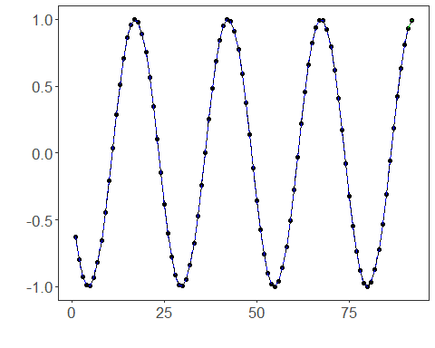
This chunk options of hyperparameter ranges by model ranges for elm.
# Options of hyperparameter ranges by model
# Ranges for ELM
ranges_elm <- list(
nhid = 1:10,
actfun = c("sig", "radbas", "relu", "purelin")
)
# Ranges for MLP
ranges_mlp <- list(
size = 1:8,
decay = c(0, 1e-4, 1e-3, 1e-2, 1e-1),
maxit = c(500, 1000, 2000)
)
# Ranges for RF
ranges_rf <- list(
nodesize = c(1, 3, 5),
ntree = c(50, 100, 200),
mtry = 1:3
)
# Ranges for SVM
ranges_svm <- list(
kernel = c("radial", "linear", "polynomial", "sigmoid"),
epsilon = c(0, 0.01, 0.05, 0.1, 0.2),
cost = c(1, 5, 10, 20, 50)
)
# Ranges for LSTM
ranges_lstm <- list(hidden_size = c(4L, 8L, 16L), epochs = c(50L, 100L, 200L))
# Ranges for CNN
ranges_cnn <- list(conv_channels = c(16L, 32L, 64L), epochs = c(50L, 100L, 200L))
These ranges are meant as practical starting points rather than exhaustive searches:
- for ELM, hidden sizes up to about 10 are already enough to show the effect of model capacity in this small example;
- for MLP, a coarse decay grid is usually more useful than sweeping every value between 0 and 1;
- for RF, very small forests tend to be unstable in recursive forecasting, so ntree should usually start at 50 or more;
- for SVM, the kernel name must be "polynomial" instead of "poly", and it is safer to search a compact cost/epsilon grid first;
- for LSTM and CNN, short epoch grids are more realistic for tutorials than huge values like 10000.
The random-forest mtry range is capped at 1:3 here because this example tunes input_size over 3:5, and mtry must never exceed the number of lagged attributes used by the model.
References - J. Bergstra and Y. Bengio (2012). Random search for hyper-parameter optimization. Journal of Machine Learning Research, 13, 281–305.

