DARIMA Regression
About the method - ts_darima() is a delegated-differencing ARIMA-like regressor in the ts_regsw lineage. - Instead of embedding the integration order inside the model, it delegates that role to the preprocessing pipeline.
Didactic goal: show how an ARIMA-inspired learner can live naturally in the sliding-window workflow of tspredit.
source(url("https://raw.githubusercontent.com/cefet-rj-dal/tspredit/main/examples/seed.R"))
# Time Series Regression - DARIMA
# Installing the package (if needed)
#install.packages("tspredit")
We start by loading the packages used throughout this example.
# Loading the packages
library(daltoolbox)
library(tspredit)
We load the same didactic series used by the other prediction examples and materialize lagged windows.
# Series for study (generates sliding windows t9..t0)
data(tsd)
ts <- ts_data(tsd$y, 10)
ts_head(ts, 3)
## t9 t8 t7 t6 t5 t4 t3 t2 t1 t0
## [1,] 0.0000000 0.2474040 0.4794255 0.6816388 0.8414710 0.9489846 0.9974950 0.9839859 0.9092974 0.7780732
## [2,] 0.2474040 0.4794255 0.6816388 0.8414710 0.9489846 0.9974950 0.9839859 0.9092974 0.7780732 0.5984721
## [3,] 0.4794255 0.6816388 0.8414710 0.9489846 0.9974950 0.9839859 0.9092974 0.7780732 0.5984721 0.3816610
Before moving on, we visualize the original series so the effect of delegated differencing can be interpreted later in the pipeline.
# Original series visualization
library(ggplot2)
plot_ts(x = tsd$x, y = tsd$y) + theme(text = element_text(size = 16))
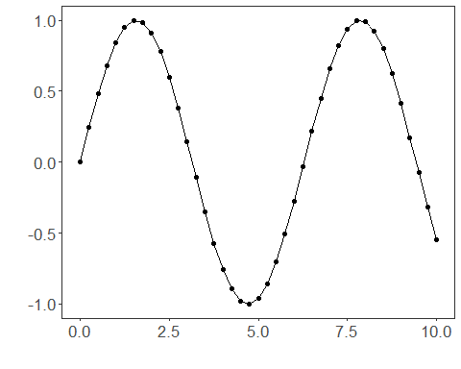
We now preserve the time order, split the data into train and test partitions, and project the windows into inputs and targets.
# Train-test split and projection (X, y)
samp <- ts_sample(ts, test_size = 5)
io_train <- ts_projection(samp$train)
io_test <- ts_projection(samp$test)
In this model, the integration logic is delegated to preprocessing. We therefore use ts_norm_diff() to express the differencing step explicitly in the pipeline.
# Delegated differencing through preprocessing
preproc <- ts_norm_diff()
We now train the DARIMA model on the prepared training data.
# Training the DARIMA model
model <- ts_darima(ts_norm_diff(), input_size = 4)
set_example_seed()
model <- fit(model, x = io_train$input, y = io_train$output)
We first evaluate the in-sample fit so the adjustment can be compared with the later recursive forecast.
# Fit evaluation (train)
adjust <- predict(model, io_train$input)
adjust <- as.vector(adjust)
output <- as.vector(io_train$output)
ev_adjust <- evaluate(model, output, adjust)
ev_adjust$mse
## [1] 6.636612e-32
We now generate a five-step forecast on the test segment and compare it with the observed values.
# Forecast on test set (5 steps ahead)
prediction <- predict(model, x = io_test$input[1,], steps_ahead = 5)
prediction <- as.vector(prediction)
output <- as.vector(io_test$output)
ev_test <- evaluate(model, output, prediction)
ev_test
## $values
## [1] 0.41211849 0.17388949 -0.07515112 -0.31951919 -0.54402111
##
## $prediction
## [1] 0.41211849 0.17388949 -0.07515112 -0.31951919 -0.54402111
##
## $smape
## [1] 1.578894e-15
##
## $mse
## [1] 1.556151e-31
##
## $R2
## [1] 1
##
## $metrics
## mse smape R2
## 1 1.556151e-31 1.578894e-15 1
The final plot compares the observed series, the training adjustment, and the forecasted test horizon.
# Plot comparing actual vs fit (train) and forecast (test)
yvalues <- c(io_train$output, io_test$output)
plot_ts_pred(y = yvalues, yadj = adjust, ypre = prediction, color_prediction = "orange") + theme(text = element_text(size = 16))
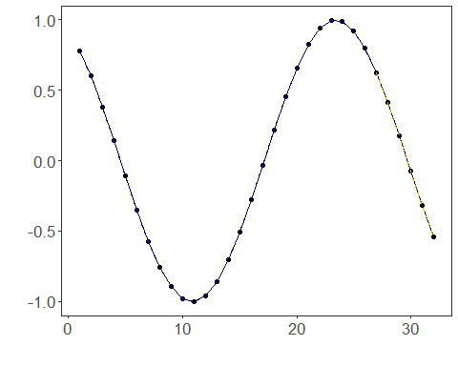
What this example highlights - ts_darima() lives in the same sliding-window world as the machine-learning regressors. - The differencing logic is explicit in the pipeline through ts_norm_diff(). - This makes the model a natural univariate support block for target-centered multivariate forecasting.
References - G. E. P. Box, G. M. Jenkins, G. C. Reinsel, and G. M. Ljung (2015). Time Series Analysis: Forecasting and Control. Wiley. - R. J. Hyndman and G. Athanasopoulos (2021). Forecasting: Principles and Practice. Third Edition. OTexts. https://otexts.com/fpp3/

