Objective: Project a ts_data object into input components (X) and output (y), separating attribute columns and the target for modeling.
#install.packages("tspredit")
# Loading the package
library(tspredit)
# Series for study
data(tsd)
# Series visualization
library(ggplot2)
plot_ts(x=tsd$x, y=tsd$y) + theme(text = element_text(size=16))
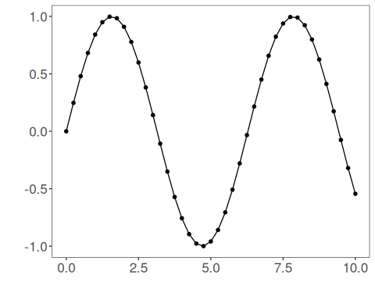
# Sliding windows
sw_size <- 5
ts <- ts_data(tsd$y, sw_size)
ts_head(ts, 3)
## t4 t3 t2 t1 t0
## [1,] 0.0000000 0.2474040 0.4794255 0.6816388 0.8414710
## [2,] 0.2474040 0.4794255 0.6816388 0.8414710 0.9489846
## [3,] 0.4794255 0.6816388 0.8414710 0.9489846 0.9974950
# Projection (X, y)
io <- ts_projection(ts)
# Input data (X)
ts_head(io$input)
## t4 t3 t2 t1
## [1,] 0.0000000 0.2474040 0.4794255 0.6816388
## [2,] 0.2474040 0.4794255 0.6816388 0.8414710
## [3,] 0.4794255 0.6816388 0.8414710 0.9489846
## [4,] 0.6816388 0.8414710 0.9489846 0.9974950
## [5,] 0.8414710 0.9489846 0.9974950 0.9839859
## [6,] 0.9489846 0.9974950 0.9839859 0.9092974
# Output data (y)
ts_head(io$output)
## t0
## [1,] 0.8414710
## [2,] 0.9489846
## [3,] 0.9974950
## [4,] 0.9839859
## [5,] 0.9092974
## [6,] 0.7780732

