LOWESS filter: LOWESS (LOESS) performs locally weighted polynomial regression around each target point, down‑weighting distant observations with a kernel and iteratively reducing the effect of outliers with robust weights. The span controls the degree of smoothing.
Objective: Apply the LOWESS filter (local smoothing) to reduce noise and spikes while preserving the series trend.
# Filter - LOWESS
# Installing the package (if needed)
#install.packages("tspredit")
# Loading the packages
library(daltoolbox)
library(tspredit)
# Series for study with artificial noise and spikes
data(tsd)
y <- tsd$y
noise <- rnorm(length(y), 0, sd(y)/10)
spike <- rnorm(1, 0, sd(y))
tsd$y <- tsd$y + noise
tsd$y[10] <- tsd$y[10] + spike
tsd$y[20] <- tsd$y[20] + spike
tsd$y[30] <- tsd$y[30] + spike
# Noisy series visualization
library(ggplot2)
plot_ts(x=tsd$x, y=tsd$y) + theme(text = element_text(size=16))
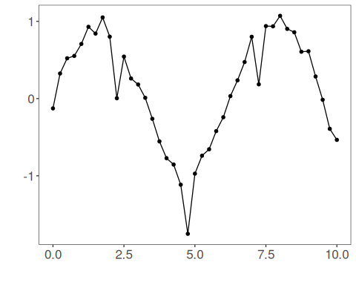
# Applying the LOWESS filter
filter <- ts_fil_lowess(f = 0.2)
filter <- fit(filter, tsd$y)
y <- transform(filter, tsd$y)
plot_ts_pred(y=tsd$y, yadj=y) + theme(text = element_text(size=16))
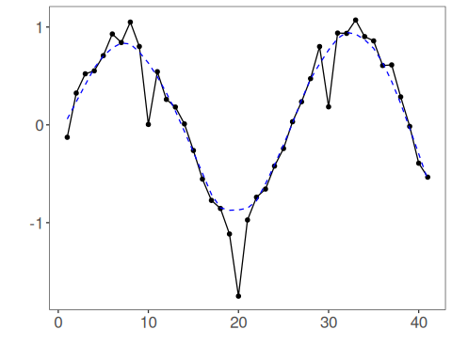
References - W. S. Cleveland (1979). Robust locally weighted regression and smoothing scatterplots. Journal of the American Statistical Association, 74(368), 829–836.

