Global Min-max: Compute the global minimum and maximum on the training data and rescale each value as (x − min) / (max − min). Apply the same parameters to validation/test to avoid leakage. This preserves relative ordering and maps all features to a common range.
Objective: Apply global min-max normalization (0 to 1) over the training series, transform the data, and visualize the effect of scaling.
# Global Min-Max Normalization
# Installing the package (if needed)
#install.packages("tspredit")
# Loading the packages
library(daltoolbox)
library(tspredit)
# Series for study
data(tsd)
# Series visualization
library(ggplot2)
plot_ts(x=tsd$x, y=tsd$y) + theme(text = element_text(size=16))
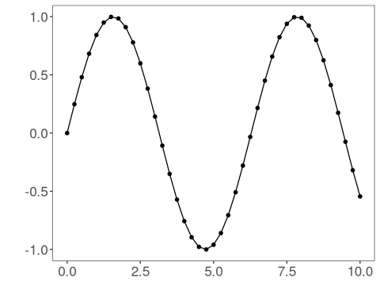
# Sliding windows
sw_size <- 10
ts <- ts_data(tsd$y, sw_size)
ts_head(ts, 3)
## t9 t8 t7 t6 t5 t4 t3 t2 t1 t0
## [1,] 0.0000000 0.2474040 0.4794255 0.6816388 0.8414710 0.9489846 0.9974950 0.9839859 0.9092974 0.7780732
## [2,] 0.2474040 0.4794255 0.6816388 0.8414710 0.9489846 0.9974950 0.9839859 0.9092974 0.7780732 0.5984721
## [3,] 0.4794255 0.6816388 0.8414710 0.9489846 0.9974950 0.9839859 0.9092974 0.7780732 0.5984721 0.3816610
summary(ts[,10])
## t0
## Min. :-0.99929
## 1st Qu.:-0.55091
## Median : 0.05397
## Mean : 0.02988
## 3rd Qu.: 0.63279
## Max. : 0.99460
# Target (t0) visualization after windowing
library(ggplot2)
plot_ts(y=ts[,10]) + theme(text = element_text(size=16))
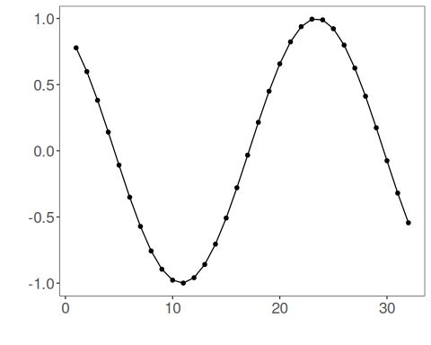
# Normalization (fit and transform)
preproc <- ts_norm_gminmax()
preproc <- fit(preproc, ts)
tst <- transform(preproc, ts)
ts_head(tst, 3)
## t9 t8 t7 t6 t5 t4 t3 t2 t1 t0
## [1,] 0.5004502 0.6243512 0.7405486 0.8418178 0.9218625 0.9757058 1.0000000 0.9932346 0.9558303 0.8901126
## [2,] 0.6243512 0.7405486 0.8418178 0.9218625 0.9757058 1.0000000 0.9932346 0.9558303 0.8901126 0.8001676
## [3,] 0.7405486 0.8418178 0.9218625 0.9757058 1.0000000 0.9932346 0.9558303 0.8901126 0.8001676 0.6915877
summary(tst[,10])
## t0
## Min. :0.0000
## 1st Qu.:0.2246
## Median :0.5275
## Mean :0.5154
## 3rd Qu.:0.8174
## Max. :0.9985
plot_ts(y=ts[,10]) + theme(text = element_text(size=16))
References - C. M. Bishop (2006). Pattern Recognition and Machine Learning. Springer.

