No normalization: No transformation is applied; the data flows unchanged. Use to isolate the effect of normalization by comparison with scaled alternatives.
Objective: Show the pipeline with no normalization (without changing the data), useful as a baseline and to demonstrate the preprocessing interface.
# No normalization
# Installing the package (if needed)
#install.packages("tspredit")
# Loading the packages
library(daltoolbox)
library(tspredit)
# Series for study
data(tsd)
library(ggplot2)
plot_ts(x=tsd$x, y=tsd$y) + theme(text = element_text(size=16))
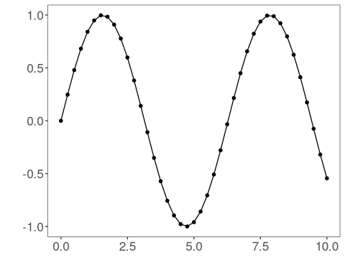
# Sliding windows
sw_size <- 10
ts <- ts_data(tsd$y, sw_size)
ts_head(ts, 3)
## t9 t8 t7 t6 t5 t4 t3 t2 t1 t0
## [1,] 0.0000000 0.2474040 0.4794255 0.6816388 0.8414710 0.9489846 0.9974950 0.9839859 0.9092974 0.7780732
## [2,] 0.2474040 0.4794255 0.6816388 0.8414710 0.9489846 0.9974950 0.9839859 0.9092974 0.7780732 0.5984721
## [3,] 0.4794255 0.6816388 0.8414710 0.9489846 0.9974950 0.9839859 0.9092974 0.7780732 0.5984721 0.3816610
summary(ts[,10])
## t0
## Min. :-0.99929
## 1st Qu.:-0.55091
## Median : 0.05397
## Mean : 0.02988
## 3rd Qu.: 0.63279
## Max. : 0.99460
library(ggplot2)
plot_ts(y=ts[,10]) + theme(text = element_text(size=16))
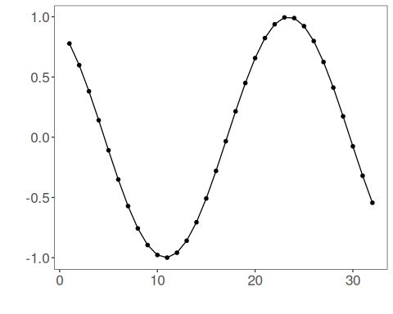
# Normalization
preproc <- ts_norm_none()
preproc <- fit(preproc, ts)
tst <- transform(preproc, ts)
ts_head(tst, 3)
## t9 t8 t7 t6 t5 t4 t3 t2 t1 t0
## [1,] 0.0000000 0.2474040 0.4794255 0.6816388 0.8414710 0.9489846 0.9974950 0.9839859 0.9092974 0.7780732
## [2,] 0.2474040 0.4794255 0.6816388 0.8414710 0.9489846 0.9974950 0.9839859 0.9092974 0.7780732 0.5984721
## [3,] 0.4794255 0.6816388 0.8414710 0.9489846 0.9974950 0.9839859 0.9092974 0.7780732 0.5984721 0.3816610
summary(tst[,10])
## t0
## Min. :-0.99929
## 1st Qu.:-0.55091
## Median : 0.05397
## Mean : 0.02988
## 3rd Qu.: 0.63279
## Max. : 0.99460
plot_ts(y=ts[,10]) + theme(text = element_text(size=16))
References - C. M. Bishop (2006). Pattern Recognition and Machine Learning. Springer.

