Jitter Augmentation
About the technique - Jitter augmentation adds small random perturbations to each window. - It is useful when the predictor should become less sensitive to minor measurement noise while preserving the overall local pattern.
Didactic goal: see how a simple stochastic perturbation can enlarge the training set without changing the forecasting workflow.
source(url("https://raw.githubusercontent.com/cefet-rj-dal/tspredit/main/examples/seed.R"))
# Time series augmentation - jitter
# Installing the package (if needed)
#install.packages("tspredit")
We start by loading the packages used throughout this example.
# Loading the packages
library(daltoolbox)
library(tspredit)
We load the example series that will be used throughout the demonstration.
# Series for study
data(tsd)
library(ggplot2)
plot_ts(x=tsd$x, y=tsd$y) + theme(text = element_text(size=16))

The next step organizes the series into sliding windows, which is the tabular representation used by the later transformations and models.
# Sliding windows
sw_size <- 10
xw <- ts_data(tsd$y, sw_size)
Now we augmentation (jitter).
# Augmentation (jitter)
augment <- ts_aug_jitter()
set_example_seed()
augment <- fit(augment, xw)
xa <- transform(augment, xw)
idx <- attr(xa, "idx")
ts_head(xa)
## t9 t8 t7 t6 t5 t4 t3 t2 t1 t0
## [1,] 0.0000000 0.2474040 0.4794255 0.6816388 0.8414710 0.9489846 0.9974950 0.9839859 0.9092974 0.7780732
## [2,] 0.2474040 0.4794255 0.6816388 0.8414710 0.9489846 0.9974950 0.9839859 0.9092974 0.7780732 0.5984721
## [3,] 0.4794255 0.6816388 0.8414710 0.9489846 0.9974950 0.9839859 0.9092974 0.7780732 0.5984721 0.3816610
## [4,] 0.6816388 0.8414710 0.9489846 0.9974950 0.9839859 0.9092974 0.7780732 0.5984721 0.3816610 0.1411200
## [5,] 0.8414710 0.9489846 0.9974950 0.9839859 0.9092974 0.7780732 0.5984721 0.3816610 0.1411200 -0.1081951
## [6,] 0.9489846 0.9974950 0.9839859 0.9092974 0.7780732 0.5984721 0.3816610 0.1411200 -0.1081951 -0.3507832
This plot overlays the original and augmented windows so you can see how the transformation changes the local shape.
# Plot a few representative windows on the lag axis
aug_rows <- (nrow(xw) + 1):min(nrow(xa), nrow(xw) + 6)
comparison <- do.call(
rbind,
lapply(aug_rows, function(row_id) {
source_row <- idx[row_id]
rbind(
data.frame(lag = seq_len(sw_size), value = as.numeric(xw[source_row, 1:sw_size]), series = "original", sample = paste("window", source_row)),
data.frame(lag = seq_len(sw_size), value = as.numeric(xa[row_id, 1:sw_size]), series = "augmented", sample = paste("window", source_row))
)
})
)
ggplot(comparison, aes(x = lag, y = value, color = series, group = series)) +
geom_line(linewidth = 0.7) +
geom_point(size = 1.2) +
facet_wrap(~ sample, ncol = 3) +
theme_minimal(base_size = 14)
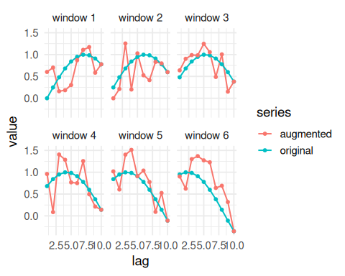
References - T. T. Um et al. (2017). Data augmentation of wearable sensor data for Parkinson’s disease monitoring using convolutional neural networks. ACM ICMI. - H. I. Fawaz, G. Forestier, J. Weber, L. Idoumghar, and P.-A. Muller (2019). Deep learning for time series classification: A review. Data Mining and Knowledge Discovery, 33, 917–963.

