Recency-Aware Augmentation
About the technique - Awareness augmentation gives more importance to windows that reflect the most recent regime of the series. - This is useful when old patterns may be less relevant than recent dynamics.
Didactic goal: see how augmentation can encode temporal preference instead of only geometric variation.
source(url("https://raw.githubusercontent.com/cefet-rj-dal/tspredit/main/examples/seed.R"))
# Installing the package (if needed)
#install.packages("tspredit")
We start by loading the packages used throughout this example.
# Loading the packages
library(daltoolbox)
library(tspredit)
This chunk cosine series with noise for study.
# Cosine series with noise for study
i <- seq(0, 2*pi+8*pi/50, pi/50)
x <- cos(i)
set_example_seed()
noise <- rnorm(length(x), 0, sd(x)/10)
x <- x + noise
x[30] <- rnorm(1, 0, sd(x))
x[60] <- rnorm(1, 0, sd(x))
x[90] <- rnorm(1, 0, sd(x))
options(repr.plot.width=6, repr.plot.height=5)
par(mfrow = c(1, 1))
plot(i, x)
lines(i, x)
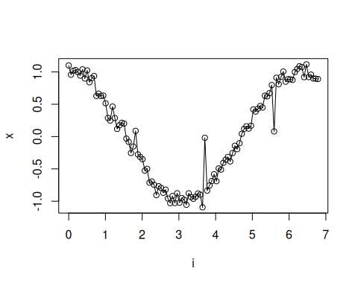
The next step organizes the series into sliding windows, which is the tabular representation used by the later transformations and models.
# Sliding windows
sw_size <- 10
xw <- ts_data(x, sw_size)
i <- 1:nrow(xw)
y <- xw[,sw_size]
plot(i, y)
lines(i, y)
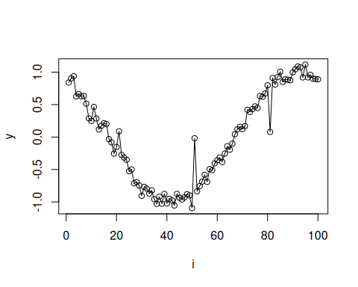
Now we augmentation (awareness).
# Augmentation (awareness)
filter <- ts_aug_awareness(0.25)
xa <- transform(filter, xw)
idx <- attr(xa, "idx")
This plot overlays the original and augmented windows so you can see how the transformation changes the local shape.
# Plot a few representative windows on the lag axis
library(ggplot2)
aug_rows <- (nrow(xw) + 1):min(nrow(xa), nrow(xw) + 6)
comparison <- do.call(
rbind,
lapply(aug_rows, function(row_id) {
source_row <- idx[row_id]
rbind(
data.frame(lag = seq_len(sw_size), value = as.numeric(xw[source_row, 1:sw_size]), series = "original", sample = paste("window", source_row)),
data.frame(lag = seq_len(sw_size), value = as.numeric(xa[row_id, 1:sw_size]), series = "augmented", sample = paste("window", source_row))
)
})
)
ggplot(comparison, aes(x = lag, y = value, color = series, group = series)) +
geom_line(linewidth = 0.7) +
geom_point(size = 1.2) +
facet_wrap(~ sample, ncol = 3) +
theme_minimal(base_size = 14)
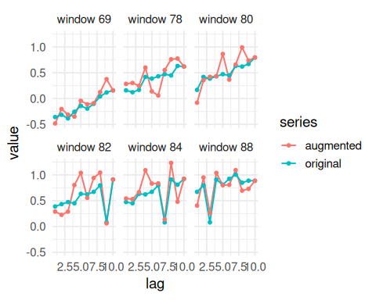
References - H. I. Fawaz, G. Forestier, J. Weber, L. Idoumghar, and P.-A. Muller (2019). Deep learning for time series classification: A review. Data Mining and Knowledge Discovery, 33, 917–963.

