Objective
This notebook introduces ipeadata.d, the daily macroeconomic dataset from Ipea.

Method at a glance
The notebook inspects the wide table layout used to package multiple univariate daily series in one object.

What you will do
- load ipeadata.d
- inspect dimensions and column names
- preview the first rows
- plot the first available series
source(url("https://raw.githubusercontent.com/cefet-rj-dal/tspredit/main/examples/seed.R"))
library(tspredit)
expand_dataset <- function(x) {
url <- attr(x, "url")
if (is.null(url) || !nzchar(url)) x else loadfulldata(x)
}
data(ipeadata.d)
ipeadata.d <- expand_dataset(ipeadata.d)
ipeadata.d <- tail(ipeadata.d, 365)
cat("Dataset: ipeadata.d\n")
## Dataset: ipeadata.d
cat("Rows:", nrow(ipeadata.d), "\n")
## Rows: 365
cat("Columns:", ncol(ipeadata.d), "\n")
## Columns: 13
head(names(ipeadata.d))
## [1] "GM366_IBVSP366" "GM366_ERC366" "GM366_EREURO366" "GM366_ERPV366" "GM366_ERV366" "GM366_TJOVER366"
head(ipeadata.d[, 1:4])
## GM366_IBVSP366 GM366_ERC366 GM366_EREURO366 GM366_ERPV366
## 7820 NA 3.5865 NA 2.67
## 7821 NA 3.6575 NA 2.66
## 7822 NA 3.6743 NA 2.63
## 7823 NA 3.6915 NA 2.59
## 7824 NA 3.6379 NA 2.68
## 7825 NA 3.5278 NA 2.70
ts.plot(ipeadata.d[[1]], ylab = "Value", xlab = "Day", main = names(ipeadata.d)[1])
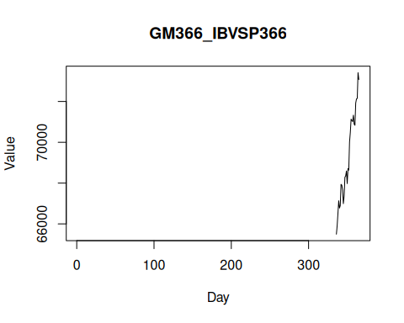

References
- Ipea. Ipeadata portal.

