Winsor Filter
About the method - Winsorization limits extreme values by capping them at less extreme thresholds. - It does not smooth the whole series; instead, it reduces the leverage of outliers before later modeling steps.
Didactic goal: understand an outlier-focused filter that protects the pipeline from spikes without redesigning the whole signal.
source(url("https://raw.githubusercontent.com/cefet-rj-dal/tspredit/main/examples/seed.R"))
# Filter - Winsorization
# Installing the package (if needed)
#install.packages("tspredit")
We start by loading the packages used throughout this example.
# Loading the packages
library(daltoolbox)
library(tspredit)
We load the example series that will be used throughout the demonstration.
# Series for study with artificial noise and spikes
data(tsd)
y <- tsd$y
noise <- rnorm(length(y), 0, sd(y)/10)
spike <- rnorm(1, 0, sd(y))
tsd$y <- tsd$y + noise
tsd$y[10] <- tsd$y[10] + spike
tsd$y[20] <- tsd$y[20] + spike
tsd$y[30] <- tsd$y[30] + spike
We plot the data here so the effect of the next transformation can be compared visually.
library(ggplot2)
# Noisy series visualization
plot_ts(x = tsd$x, y = tsd$y) + theme(text = element_text(size=16))
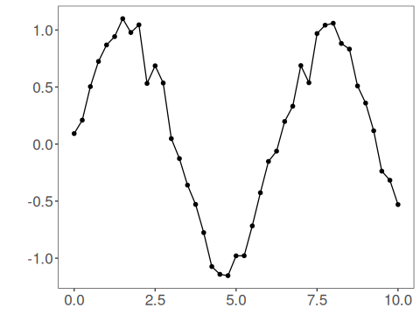
Now we applying the winsor filter.
# Applying the Winsor filter
filter <- ts_fil_winsor()
set_example_seed()
filter <- fit(filter, tsd$y)
y <- transform(filter, tsd$y)
plot_ts_pred(y=tsd$y, yadj=y) + theme(text = element_text(size=16))
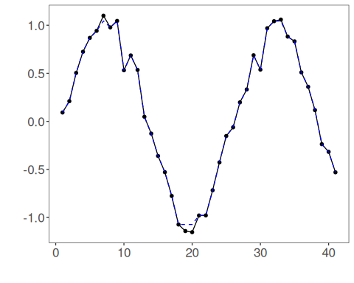
References - R. R. Wilcox (2012). Introduction to Robust Estimation and Hypothesis Testing. Academic Press.

