Target-Centered Multivariate Forecasting with Deterministic Auxiliaries
About the method - This workflow keeps y as the forecasting target and treats x1, ..., xn as auxiliary series that also receive their own predictive pipelines. - The multivariate wrapper reuses the univariate learners already available in tspredit, while coordinating how the synchronized lagged windows are built for each variable.
Didactic goal: provide a first overview of how multivariate forecasting works in tspredit 2.0 when the auxiliary variables follow deterministic laws of formation.
source(url("https://raw.githubusercontent.com/cefet-rj-dal/tspredit/main/examples/seed.R"))
# Target-centered multivariate forecasting with deterministic auxiliaries
# Installing the package (if needed)
# install.packages("tspredit")
We begin by loading the packages used in the example.
library(daltoolbox)
library(tspredit)
We now build an aligned multivariate dataset from benchmark data already available in tspredit. We use:
- the daily maximum load extracted from EUNITE.Loads as the target y
- the weekday code from EUNITE.Reg as x1
- a weekend indicator derived from EUNITE.Reg as x2
data(EUNITE.Loads)
data(EUNITE.Reg)
if (!is.null(attr(EUNITE.Loads, "url"))) {
EUNITE.Loads <- loadfulldata(EUNITE.Loads)
}
if (!is.null(attr(EUNITE.Reg, "url"))) {
EUNITE.Reg <- loadfulldata(EUNITE.Reg)
}
load_cols <- setdiff(names(EUNITE.Loads), "split")
y <- apply(EUNITE.Loads[, load_cols, drop = FALSE], 1, max)
x1 <- as.numeric(EUNITE.Reg$Weekday)
x2 <- as.numeric(EUNITE.Reg$Weekday %in% c(1, 7))
mv <- ts_data_mv(
data.frame(
y = y,
x1 = x1,
x2 = x2
),
y = "y"
)
ts_head(mv, 3)
## y x1 x2
## 1 797 4 0
## 2 777 5 0
## 3 797 6 0
The multivariate object preserves the temporal alignment across all variables and can be split in time just like the univariate workflow.
samp <- ts_sample(mv, test_size = 5)
We now define one specification for the target and one specification for each auxiliary variable. In this example, the auxiliary variables are deterministic calendar signals, so it is more coherent to forecast them with rule-based univariate predictors instead of generic learners.
model <- ts_regsw_mv(
model_y = ts_mv_spec(
ts_mlp(ts_norm_an(), input_size = 4, size = 4, decay = 0),
variables = c("y", "x1", "x2"),
transforms = list(y = ts_fil_ma(3))
),
models_x = list(
x1 = ts_mv_spec(ts_deterministic("periodic", period = 7)),
x2 = ts_mv_spec(ts_deterministic("periodic", period = 7))
),
window_size = 7
)
We fit the composed multivariate forecasting system on the training portion of the aligned series.
set_example_seed()
model <- fit(model, samp$train)
The first forecast mode is one-step ahead. It returns the next value of the target series.
pred_1 <- predict(model, steps_ahead = 1)
pred_1
## [1] 800.956
## attr(,"y_name")
## [1] "y"
## attr(,"x_names")
## [1] "x1" "x2"
## attr(,"variables")
## [1] "y" "x1" "x2"
## attr(,"steps_ahead")
## [1] 1
## attr(,"prediction_x")
## attr(,"prediction_x")$x1
## [1] 4
##
## attr(,"prediction_x")$x2
## [1] 0
##
## attr(,"system")
## y x1 x2
## 1 800.956 4 0
## attr(,"class")
## [1] "ts_mv_prediction" "numeric"
The second forecast mode is recursive multi-step prediction. By default, it returns the future path of y.
pred_5 <- predict(model, steps_ahead = 5)
pred_5
## [1] 800.9560 793.2817 786.2419 760.1793 713.9310
## attr(,"y_name")
## [1] "y"
## attr(,"x_names")
## [1] "x1" "x2"
## attr(,"variables")
## [1] "y" "x1" "x2"
## attr(,"steps_ahead")
## [1] 5
## attr(,"prediction_x")
## attr(,"prediction_x")$x1
## [1] 4 5 6 7 1
##
## attr(,"prediction_x")$x2
## [1] 0 0 0 1 1
##
## attr(,"system")
## y x1 x2
## 1 800.9560 4 0
## 2 793.2817 5 0
## 3 786.2419 6 0
## 4 760.1793 7 1
## 5 713.9310 1 1
## attr(,"class")
## [1] "ts_mv_prediction" "numeric"
If we want to inspect the whole recursive system, we can ask for the target and the auxiliary forecasts together through the prediction attributes.
pred_all <- predict(model, steps_ahead = 5)
pred_all
## [1] 800.9560 793.2817 786.2419 760.1793 713.9310
## attr(,"y_name")
## [1] "y"
## attr(,"x_names")
## [1] "x1" "x2"
## attr(,"variables")
## [1] "y" "x1" "x2"
## attr(,"steps_ahead")
## [1] 5
## attr(,"prediction_x")
## attr(,"prediction_x")$x1
## [1] 4 5 6 7 1
##
## attr(,"prediction_x")$x2
## [1] 0 0 0 1 1
##
## attr(,"system")
## y x1 x2
## 1 800.9560 4 0
## 2 793.2817 5 0
## 3 786.2419 6 0
## 4 760.1793 7 1
## 5 713.9310 1 1
## attr(,"class")
## [1] "ts_mv_prediction" "numeric"
attr(pred_all, "system")
## y x1 x2
## 1 800.9560 4 0
## 2 793.2817 5 0
## 3 786.2419 6 0
## 4 760.1793 7 1
## 5 713.9310 1 1
The multivariate plotting helper reuses the same visual language already used throughout the univariate examples, but now it returns one plot per variable.
plots <- plot_ts_pred_mv(samp$train, samp$test, pred_all)
Target trajectory:
plots$y
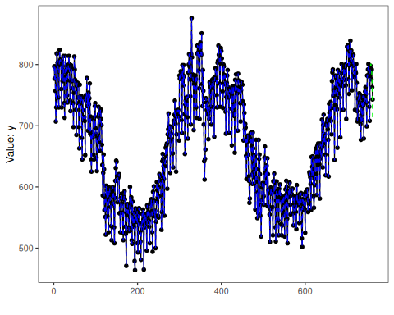
Auxiliary variable x1:
plots$x1
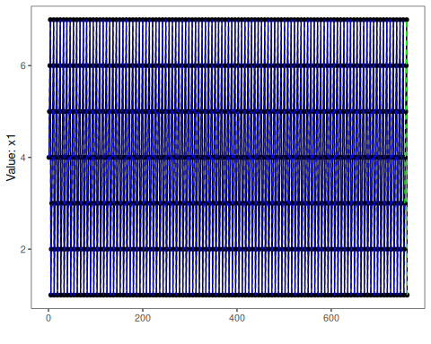
Auxiliary variable x2:
plots$x2
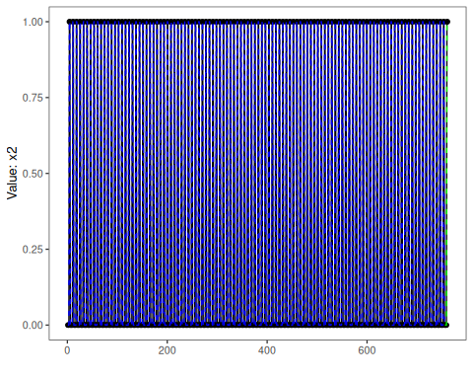
The held-out target values remain available for evaluation against the target forecast.
output <- tail(samp$test$y, 5)
ev_test <- evaluate(model, output, pred_5)
ev_test$metrics
## mse smape R2
## 1 256.7801 0.01708759 0.2420893
What this example shows - ts_data_mv() preserves synchronized multivariate observations before any lag expansion happens. - ts_mv_spec() lets each variable keep its own object-oriented pipeline. - ts_regsw_mv() coordinates one target model and one auxiliary model per covariate while reusing the learners already available in the univariate package. - Rule-based univariate predictors from the ts_deterministic() family are often more appropriate than generic learners for deterministic auxiliary variables. - This is the deterministic-auxiliary scenario; the next example in the sequence treats non-deterministic auxiliary variables as endogenous series with their own forecasting models.
References - Hyndman, R. J., & Athanasopoulos, G. Forecasting: Principles and Practice. - Salles, R., Pacitti, E., Bezerra, E., Marques, C., Pacheco, C., Oliveira, C., Porto, F., Ogasawara, E. (2023). TSPredIT: Integrated Tuning of Data Preprocessing and Time Series Prediction Models.

