PyTorch MLP Regression
About the method - torch_ts_mlp() is a feedforward neural forecaster implemented through the daltoolboxdp PyTorch backend. - It keeps the same sliding-window protocol used by the other regressors, while replacing the classical nnet learner with a deeper configurable MLP.
Didactic goal: compare the standard ts_mlp() baseline with a PyTorch-based feedforward alternative before moving to convolutional and recurrent sequence models.
source(url("https://raw.githubusercontent.com/cefet-rj-dal/tspredit/main/examples/seed.R"))
# Time Series Regression - PyTorch MLP
# Installing packages (if needed)
# install.packages("tspredit")
We start by loading the packages used throughout this example.
# Loading the packages
library(daltoolbox)
library(daltoolboxdp)
library(tspredit)
We load the example series that will be used throughout the demonstration.
# Series for study and sliding windows
data(tsd)
ts <- ts_data(tsd$y, 10)
ts_head(ts, 3)
## t9 t8 t7 t6 t5 t4 t3 t2 t1 t0
## [1,] 0.0000000 0.2474040 0.4794255 0.6816388 0.8414710 0.9489846 0.9974950 0.9839859 0.9092974 0.7780732
## [2,] 0.2474040 0.4794255 0.6816388 0.8414710 0.9489846 0.9974950 0.9839859 0.9092974 0.7780732 0.5984721
## [3,] 0.4794255 0.6816388 0.8414710 0.9489846 0.9974950 0.9839859 0.9092974 0.7780732 0.5984721 0.3816610
Before moving on, we visualize the series so the effect of the next transformation can be compared against the original signal.
# Series visualization
library(ggplot2)
plot_ts(x = tsd$x, y = tsd$y) + theme(text = element_text(size = 16))

We now preserve the time order, split the data into train and test partitions, and project the windows into inputs and targets.
# Train-test split and projection (X, y)
samp <- ts_sample(ts, test_size = 5)
io_train <- ts_projection(samp$train)
io_test <- ts_projection(samp$test)
We now train the PyTorch MLP model on the prepared training data.
# Training the PyTorch MLP model
model <- torch_ts_mlp(
ts_norm_gminmax(),
input_size = 4,
hidden_sizes = c(32L, 16L),
epochs = 200L,
batch_size = 8L
)
set_example_seed()
model <- fit(model, x = io_train$input, y = io_train$output)
We first evaluate the in-sample fit so the model adjustment can be compared with the later forecast.
# Fit evaluation (train)
adjust <- predict(model, io_train$input)
adjust <- as.vector(adjust)
output <- as.vector(io_train$output)
ev_adjust <- evaluate(model, output, adjust)
ev_adjust$mse
## [1] 1.727476e-05
We now forecast the test set and compare the predicted values with the observed ones.
# Forecast on test set
prediction <- predict(model, x = io_test$input[1,], steps_ahead = 5)
prediction <- as.vector(prediction)
output <- as.vector(io_test$output)
ev_test <- evaluate(model, output, prediction)
ev_test
## $values
## [1] 0.41211849 0.17388949 -0.07515112 -0.31951919 -0.54402111
##
## $prediction
## [1] 0.41312639 0.17741979 -0.06702211 -0.30823441 -0.53065376
##
## $smape
## [1] 0.03954484
##
## $mse
## [1] 7.711843e-05
##
## $R2
## [1] 0.9993339
##
## $metrics
## mse smape R2
## 1 7.711843e-05 0.03954484 0.9993339
This final plot summarizes the result of the transformation so the effect can be interpreted visually.
# Plot results
yvalues <- c(io_train$output, io_test$output)
plot_ts_pred(y = yvalues, yadj = adjust, ypre = prediction, color_prediction = "orange") + theme(text = element_text(size = 16))
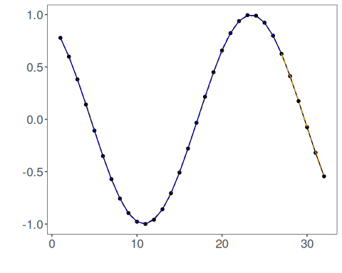
References - C. M. Bishop (1995). Neural Networks for Pattern Recognition. - A. Paszke et al. (2019). PyTorch: An Imperative Style, High-Performance Deep Learning Library.

