Target-Centered Multivariate Forecasting
About the method - This workflow keeps y as the forecasting target and treats x1, ..., xn as auxiliary series that also receive their own predictive pipelines. - The multivariate wrapper reuses the univariate learners already available in tspredit, while coordinating how the synchronized lagged windows are built for each variable.
Didactic goal: provide a first overview of how multivariate forecasting works in tspredit 2.0 using an existing benchmark from the package.
source(url("https://raw.githubusercontent.com/cefet-rj-dal/tspredit/main/examples/seed.R"))
# Target-centered multivariate forecasting
# Installing the package (if needed)
# install.packages("tspredit")
We begin by loading the packages used in the example.
library(daltoolbox)
## Warning: pacote 'daltoolbox' foi compilado no R versão 4.5.1
##
## Anexando pacote: 'daltoolbox'
## O seguinte objeto é mascarado por 'package:base':
##
## transform
library(tspredit)
## Registered S3 method overwritten by 'quantmod':
## method from
## as.zoo.data.frame zoo
We now build an aligned multivariate dataset from benchmark data already available in tspredit. We use:
- the daily maximum load extracted from EUNITE.Loads as the target y
- the holiday indicator from EUNITE.Reg as x1
- the weekday code from EUNITE.Reg as x2
data(EUNITE.Loads)
data(EUNITE.Reg)
if (!is.null(attr(EUNITE.Loads, "url"))) {
EUNITE.Loads <- loadfulldata(EUNITE.Loads)
}
if (!is.null(attr(EUNITE.Reg, "url"))) {
EUNITE.Reg <- loadfulldata(EUNITE.Reg)
}
load_cols <- setdiff(names(EUNITE.Loads), "split")
y <- apply(EUNITE.Loads[, load_cols, drop = FALSE], 1, max)
x1 <- as.numeric(EUNITE.Reg$Holiday)
x2 <- as.numeric(EUNITE.Reg$Weekday)
mv <- ts_data_mv(
data.frame(
y = y,
x1 = x1,
x2 = x2
),
y = "y"
)
ts_head(mv, 3)
## y x1 x2
## 1 797 1 4
## 2 777 0 5
## 3 797 0 6
The multivariate object preserves the temporal alignment across all variables and can be split in time just like the univariate workflow.
samp <- ts_sample(mv, test_size = 5)
We now define one specification for the target and one specification for each auxiliary variable. Each specification can use a different learner, different lag usage, and different raw-series transformations.
model <- ts_regsw_mv(
model_y = ts_mv_spec(
ts_mlp(ts_norm_an(), input_size = 4, size = 4, decay = 0),
variables = c("y", "x1", "x2"),
transforms = list(y = ts_fil_ma(3))
),
models_x = list(
x1 = ts_mv_spec(ts_arima()),
x2 = ts_mv_spec(
ts_rf(ts_norm_gminmax(), input_size = 4, ntree = 20),
variables = c("x2", "y"),
transforms = list(y = ts_fil_ma(3))
)
),
window_size = 7
)
We fit the composed multivariate forecasting system on the training portion of the aligned series.
set_example_seed()
model <- fit(model, samp$train)
The first forecast mode is one-step ahead. It returns the next value of the target series.
pred_1 <- predict(model, steps_ahead = 1)
pred_1
## [1] 799.6176
The second forecast mode is recursive multi-step prediction. By default, it returns the future path of y.
pred_5 <- predict(model, steps_ahead = 5)
pred_5
## [1] 799.6176 789.9847 783.9372 754.9339 712.4487
If we want to inspect the whole recursive system, we can ask for the target and the auxiliary forecasts together.
pred_all <- predict(model, steps_ahead = 5, return_all = TRUE)
pred_all
## $y
## [1] 799.6176 789.9847 783.9372 754.9339 712.4487
##
## $x
## $x$x1
## [1] 0.03349291 0.03591705 0.04017507 0.04198686 0.04182131
##
## $x$x2
## [1] 4 5 6 7 1
##
##
## attr(,"class")
## [1] "ts_mv_prediction"
## attr(,"y_name")
## [1] "y"
## attr(,"x_names")
## [1] "x1" "x2"
## attr(,"variables")
## [1] "y" "x1" "x2"
## attr(,"steps_ahead")
## [1] 5
The multivariate plotting helper reuses the same visual language already used throughout the univariate examples, but now it returns one plot per variable.
plots <- plot_ts_pred_mv(samp$train, samp$test, pred_all)
Target trajectory:
plots$y
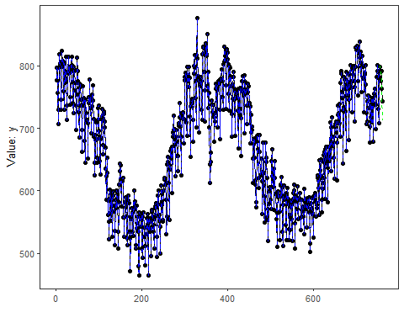
Auxiliary variable x1:
plots$x1
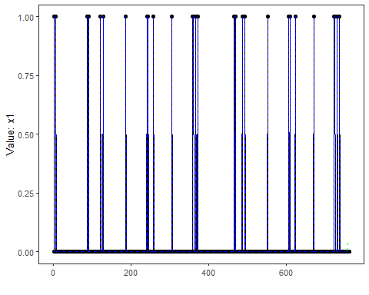
Auxiliary variable x2:
plots$x2
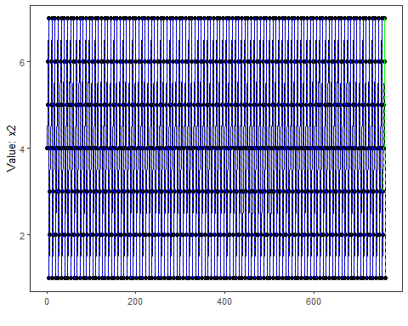
The held-out target values remain available for evaluation against the target forecast.
output <- tail(samp$test$y, 5)
ev_test <- evaluate(model, output, pred_5)
ev_test$metrics
## mse smape R2
## 1 266.6579 0.01830764 0.2129343
What this example shows - ts_data_mv() preserves synchronized multivariate observations before any lag expansion happens. - ts_mv_spec() lets each variable keep its own object-oriented pipeline. - ts_regsw_mv() coordinates one target model and one auxiliary model per covariate while reusing the learners already available in the univariate package.
References - Hyndman, R. J., & Athanasopoulos, G. Forecasting: Principles and Practice. - Salles, R., Pacitti, E., Bezerra, E., Marques, C., Pacheco, C., Oliveira, C., Porto, F., Ogasawara, E. (2023). TSPredIT: Integrated Tuning of Data Preprocessing and Time Series Prediction Models.

