Stock Closing-Price Forecasting with MLP as Target Learner
About the method - This example keeps the same stock-closing-price scenario, but now the target close is forecast with ts_mlp().
Didactic goal: inspect how a multilayer perceptron behaves as the target learner inside the target-centered multivariate workflow.
source(url("https://raw.githubusercontent.com/cefet-rj-dal/tspredit/main/examples/seed.R"))
# Stock closing-price forecasting with MLP as target learner
# Installing packages (if needed)
# install.packages("tspredit")
library(daltoolbox)
library(tspredit)
data(stocks)
if (!is.null(attr(stocks, "url"))) {
stocks <- loadfulldata(stocks)
}
ticker_name <- if ("VALE3" %in% names(stocks)) "VALE3" else names(stocks)[1]
ticker <- stocks[[ticker_name]]
ticker <- ticker[, c("date", "open", "high", "low", "close", "volume")]
ticker <- stats::na.omit(ticker)
ticker <- subset(ticker, open > 0 & high > 0 & low > 0 & volume > 0)
cutoff_date <- max(ticker$date) - 365 * 2
ticker <- ticker[ticker$date > cutoff_date, ]
mv <- ts_data_mv(
ticker[, c("open", "high", "low", "close", "volume")],
y = "close",
x = c("open", "high", "low", "volume")
)
samp <- ts_sample(mv, test_size = 5)
output <- tail(samp$test$close, 5)
model <- ts_regsw_mv(
model_y = ts_mv_spec(
ts_mlp(ts_norm_gminmax(), input_size = 4, size = 4, decay = 0),
variables = c("close", "open", "high", "low")
),
models_x = list(
open = ts_mv_spec(
ts_mlp(ts_norm_gminmax(), input_size = 3, size = 4, decay = 0),
variables = c("open", "close", "high")
),
high = ts_mv_spec(
ts_mlp(ts_norm_gminmax(), input_size = 3, size = 4, decay = 0),
variables = c("high", "close", "open")
),
low = ts_mv_spec(
ts_mlp(ts_norm_gminmax(), input_size = 3, size = 4, decay = 0),
variables = c("low", "close", "open")
),
volume = ts_mv_spec(
ts_mlp(ts_norm_gminmax(), input_size = 3, size = 4, decay = 0),
variables = c("volume", "close", "open")
)
),
window_size = 5
)
set_example_seed()
model <- fit(model, samp$train)
pred_1 <- predict(model, steps_ahead = 1)
pred_1
## [1] 72.69532
## attr(,"y_name")
## [1] "close"
## attr(,"x_names")
## [1] "open" "high" "low" "volume"
## attr(,"variables")
## [1] "close" "open" "high" "low" "volume"
## attr(,"steps_ahead")
## [1] 1
## attr(,"prediction_x")
## attr(,"prediction_x")$open
## [1] 85.05918
##
## attr(,"prediction_x")$high
## [1] 85.29949
##
## attr(,"prediction_x")$low
## [1] 81.44817
##
## attr(,"prediction_x")$volume
## [1] 21877063
##
## attr(,"system")
## close open high low volume
## 1 72.69532 85.05918 85.29949 81.44817 21877063
## attr(,"class")
## [1] "ts_mv_prediction" "numeric"
pred_5 <- predict(model, steps_ahead = 5)
pred_5
## [1] 72.69532 32.90832 70.70014 188.45650 51.03202
## attr(,"y_name")
## [1] "close"
## attr(,"x_names")
## [1] "open" "high" "low" "volume"
## attr(,"variables")
## [1] "close" "open" "high" "low" "volume"
## attr(,"steps_ahead")
## [1] 5
## attr(,"prediction_x")
## attr(,"prediction_x")$open
## [1] 85.05918 38.60900 -73.25965 73.60015 51.60219
##
## attr(,"prediction_x")$high
## [1] 85.2994888 72.5576631 50.9842936 -142.8079115 -0.8722029
##
## attr(,"prediction_x")$low
## [1] 81.44817 73.67211 -91.78459 200.51619 -26.27833
##
## attr(,"prediction_x")$volume
## [1] 21877063 25529676 29695572 25579320 28693895
##
## attr(,"system")
## close open high low volume
## 1 72.69532 85.05918 85.2994888 81.44817 21877063
## 2 32.90832 38.60900 72.5576631 73.67211 25529676
## 3 70.70014 -73.25965 50.9842936 -91.78459 29695572
## 4 188.45650 73.60015 -142.8079115 200.51619 25579320
## 5 51.03202 51.60219 -0.8722029 -26.27833 28693895
## attr(,"class")
## [1] "ts_mv_prediction" "numeric"
attr(pred_5, "system")
## close open high low volume
## 1 72.69532 85.05918 85.2994888 81.44817 21877063
## 2 32.90832 38.60900 72.5576631 73.67211 25529676
## 3 70.70014 -73.25965 50.9842936 -91.78459 29695572
## 4 188.45650 73.60015 -142.8079115 200.51619 25579320
## 5 51.03202 51.60219 -0.8722029 -26.27833 28693895
ev_test <- evaluate(model, output, pred_5)
ev_test$metrics
## mse smape R2
## 1 3119.531 0.5201632 -1475.87
plot_ts_pred_mv(samp$train, samp$test, pred_5, variable = "close")
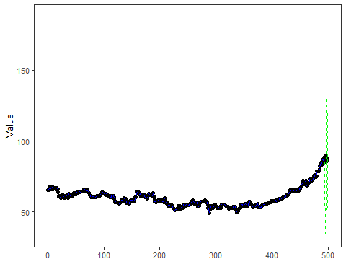
What this example shows - ts_mlp() can be reused directly as the target learner inside ts_regsw_mv(). - The same learner family can be reused for the target and for all endogenous auxiliaries when the goal is a cleaner didactic comparison.

