Stock Closing-Price Forecasting with Singular Vector Autoregression
About the method - This example closes the singular stock battery with ts_var(). - The whole aligned system is modeled jointly, but close remains the distinguished target returned by predict().
Didactic goal: inspect how a systemic singular model behaves on the same stock scenario used in the sliding-window battery.
source(url("https://raw.githubusercontent.com/cefet-rj-dal/tspredit/main/examples/seed.R"))
# Stock closing-price forecasting with singular vector autoregression
# Installing packages (if needed)
# install.packages("tspredit")
library(daltoolbox)
library(tspredit)
data(stocks)
if (!is.null(attr(stocks, "url"))) {
stocks <- loadfulldata(stocks)
}
ticker_name <- if ("VALE3" %in% names(stocks)) "VALE3" else names(stocks)[1]
ticker <- stocks[[ticker_name]]
ticker <- ticker[, c("date", "open", "high", "low", "close", "volume")]
ticker <- stats::na.omit(ticker)
ticker <- subset(ticker, open > 0 & high > 0 & low > 0 & volume > 0)
cutoff_date <- max(ticker$date) - 365 * 2
ticker <- ticker[ticker$date > cutoff_date, ]
mv <- ts_data_mv(
ticker[, c("open", "high", "low", "close", "volume")],
y = "close",
x = c("open", "high", "low", "volume")
)
samp <- ts_sample(mv, test_size = 5)
output <- tail(samp$test$close, 5)
The vector autoregression works directly on the aligned multivariate system and returns the target path together with the synchronized system forecast.
model <- ts_var(p_max = 3)
model <- fit(model, samp$train)
pred_1 <- predict(model, steps_ahead = 1)
pred_1
## [1] 84.15722
## attr(,"y_name")
## [1] "close"
## attr(,"x_names")
## [1] "open" "high" "low" "volume"
## attr(,"variables")
## [1] "close" "open" "high" "low" "volume"
## attr(,"steps_ahead")
## [1] 1
## attr(,"prediction_x")
## attr(,"prediction_x")$open
## [1] 84.40253
##
## attr(,"prediction_x")$high
## [1] 85.6386
##
## attr(,"prediction_x")$low
## [1] 83.31439
##
## attr(,"prediction_x")$volume
## [1] 22295395
##
## attr(,"system")
## close open high low volume
## 1 84.15722 84.40253 85.6386 83.31439 22295395
## attr(,"class")
## [1] "ts_mv_prediction" "numeric"
pred_5 <- predict(model, steps_ahead = 5)
pred_5
## [1] 84.15722 83.65722 83.55771 83.47442 83.44886
## attr(,"y_name")
## [1] "close"
## attr(,"x_names")
## [1] "open" "high" "low" "volume"
## attr(,"variables")
## [1] "close" "open" "high" "low" "volume"
## attr(,"steps_ahead")
## [1] 5
## attr(,"prediction_x")
## attr(,"prediction_x")$open
## [1] 84.40253 83.69493 83.41592 83.30848 83.25165
##
## attr(,"prediction_x")$high
## [1] 85.63860 85.07280 84.63328 84.55237 84.47928
##
## attr(,"prediction_x")$low
## [1] 83.31439 82.69821 82.58174 82.51848 82.48727
##
## attr(,"prediction_x")$volume
## [1] 22295395 24436690 26197759 27296923 27577709
##
## attr(,"system")
## close open high low volume
## 1 84.15722 84.40253 85.63860 83.31439 22295395
## 2 83.65722 83.69493 85.07280 82.69821 24436690
## 3 83.55771 83.41592 84.63328 82.58174 26197759
## 4 83.47442 83.30848 84.55237 82.51848 27296923
## 5 83.44886 83.25165 84.47928 82.48727 27577709
## attr(,"class")
## [1] "ts_mv_prediction" "numeric"
attr(pred_5, "system")
## close open high low volume
## 1 84.15722 84.40253 85.63860 83.31439 22295395
## 2 83.65722 83.69493 85.07280 82.69821 24436690
## 3 83.55771 83.41592 84.63328 82.58174 26197759
## 4 83.47442 83.30848 84.55237 82.51848 27296923
## 5 83.44886 83.25165 84.47928 82.48727 27577709
ev_test <- evaluate(model, output, pred_5)
ev_test$metrics
## mse smape R2
## 1 16.9202 0.04545384 -7.010475
plot_ts_pred_mv(samp$train, samp$test, pred_5, variable = "close")
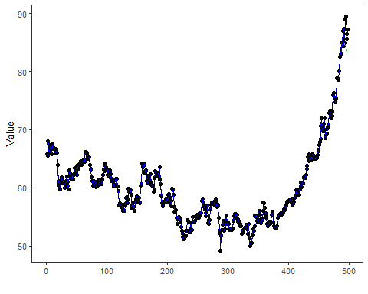
What this example shows - ts_var() models the aligned stock system jointly in the singular multivariate branch. - Even in this systemic setting, the package keeps close as the semantic target returned by predict(). - The full system forecast remains available through the multivariate prediction attributes.

