AwareSmooth: Combines recency‑aware sampling with window smoothing so recent segments are emphasized and noise is reduced. This yields augmented windows that better reflect current regimes while remaining plausible.

Objective: Augment data with temporal awareness and progressive smoothing, reducing noise and prioritizing recent samples.

# Installing the package (if needed)  
#install.packages("tspredit")

# Loading the packages  
library(daltoolbox)  
library(tspredit)

# Cosine series with noise for study  
  
i <- seq(0, 2*pi+8*pi/50, pi/50)  
x <- cos(i)  
noise <- rnorm(length(x), 0, sd(x)/10)  
  
x <- x + noise  
x[30] <- rnorm(1, 0, sd(x))  
  
x[60] <- rnorm(1, 0, sd(x))  
  
x[90] <- rnorm(1, 0, sd(x))  
  
  
options(repr.plot.width=6, repr.plot.height=5)   
par(mfrow = c(1, 1))  
plot(i, x)  
lines(i, x)

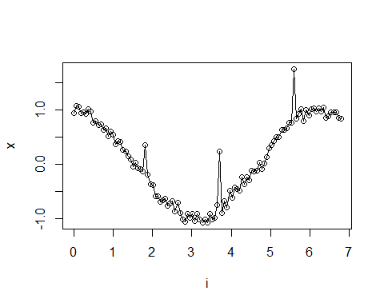

# Sliding windows  
  
sw_size <- 10  
xw <- ts_data(x, sw_size)  
i <- 1:nrow(xw)  
y <- xw[,sw_size]  
  
plot(i, y)  
lines(i, y)

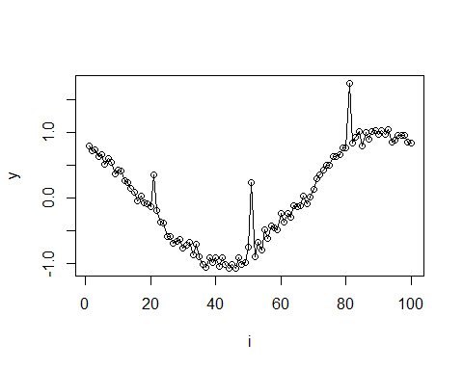

# Augmentation (awareness + smoothing)  
  
filter <- tspredit::ts_aug_awaresmooth(0.25)  
xa <- transform(filter, xw)  
idx <- attr(xa, "idx")

# Plot (original vs augmented windows)  
  
plot(x = i, y = y, main = "cosine")  
lines(x = i, y = y, col="black")  
for (j in 1:nrow(xa)) {  
 lines(x = (idx[j]-sw_size+1):idx[j], y = xa[j,1:sw_size], col="green")  
}

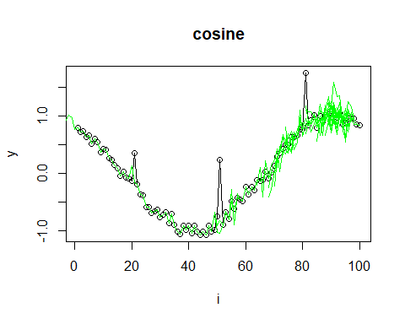

References - H. I. Fawaz, G. Forestier, J. Weber, L. Idoumghar, and P.-A. Muller (2019). Deep learning for time series classification: A review. Data Mining and Knowledge Discovery, 33, 917–963.