Objective: Demonstrate flip augmentation (mirror windows around the mean), generating symmetric variations of local patterns.

# Time series augmentation - flip  
  
# Installing the package (if needed)  
#install.packages("tspredit")

# Loading the packages  
library(daltoolbox)  
library(tspredit)

# Series for study  
  
data(tsd)  
library(ggplot2)  
plot_ts(x=tsd$x, y=tsd$y) + theme(text = element_text(size=16))

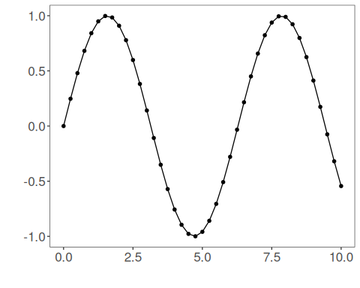

# Sliding windows  
  
sw_size <- 10  
xw <- ts_data(tsd$y, sw_size)

# Augmentation (flip)  
  
augment <- ts_aug_flip()  
augment <- fit(augment, xw)  
xa <- transform(augment, xw)  
idx <- attr(xa, "idx")  
ts_head(xa)

## t9 t8 t7 t6 t5 t4 t3 t2 t1 t0  
## [1,] 0.0000000 0.2474040 0.4794255 0.6816388 0.8414710 0.9489846 0.9974950 0.9839859 0.9092974 0.7780732  
## [2,] 0.2474040 0.4794255 0.6816388 0.8414710 0.9489846 0.9974950 0.9839859 0.9092974 0.7780732 0.5984721  
## [3,] 0.4794255 0.6816388 0.8414710 0.9489846 0.9974950 0.9839859 0.9092974 0.7780732 0.5984721 0.3816610  
## [4,] 0.6816388 0.8414710 0.9489846 0.9974950 0.9839859 0.9092974 0.7780732 0.5984721 0.3816610 0.1411200  
## [5,] 0.8414710 0.9489846 0.9974950 0.9839859 0.9092974 0.7780732 0.5984721 0.3816610 0.1411200 -0.1081951  
## [6,] 0.9489846 0.9974950 0.9839859 0.9092974 0.7780732 0.5984721 0.3816610 0.1411200 -0.1081951 -0.3507832

# Plot (original vs augmented windows)  
  
i <- 1:nrow(xw)  
y <- xw[,sw_size]  
plot(x = i, y = y, main = "cosine")  
lines(x = i, y = y, col="black")  
for (j in 1:nrow(xa)) {  
 lines(x = (idx[j]-sw_size+1):idx[j], y = xa[j,1:sw_size], col="green")  
}

