Wormhole: Randomly replaces a subset of lag positions with values drawn from earlier indices in the series, preserving marginal statistics while altering local context. This simulates alternative but plausible histories and improves robustness to temporal perturbations.

Objective: Augment data by replacing some lags with older values (wormhole), creating plausible alternative trajectories.

# Time series augmentation - wormhole  
  
# Installing the package (if needed)  
#install.packages("tspredit")

# Loading the packages  
library(daltoolbox)  
library(tspredit)

# Series for study  
  
data(tsd)  
library(ggplot2)  
plot_ts(x=tsd$x, y=tsd$y) + theme(text = element_text(size=16))

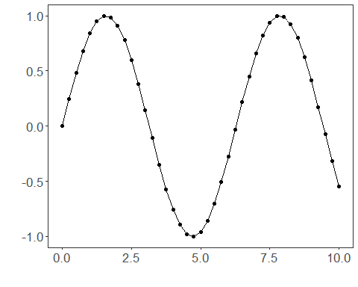

# Sliding windows  
  
sw_size <- 10  
xw <- ts_data(tsd$y, sw_size)

# Augmentation (wormhole)  
  
augment <- ts_aug_wormhole()  
augment <- fit(augment, xw)  
xa <- transform(augment, xw)  
idx <- attr(xa, "idx")  
ts_head(xa)

## t9 t8 t7 t6 t5 t4 t3 t2 t1  
## [1,] 0.0000000 0.2474040 0.4794255 0.6816388 0.8414710 0.9489846 0.9974950 0.9839859 0.9092974  
## [2,] 0.2474040 0.4794255 0.6816388 0.8414710 0.9489846 0.9974950 0.9839859 0.9092974 0.7780732  
## [3,] 0.4794255 0.6816388 0.8414710 0.9489846 0.9974950 0.9839859 0.9092974 0.7780732 0.5984721  
## [4,] 0.6816388 0.8414710 0.9489846 0.9974950 0.9839859 0.9092974 0.7780732 0.5984721 0.3816610  
## [5,] 0.8414710 0.9489846 0.9974950 0.9839859 0.9092974 0.7780732 0.5984721 0.3816610 0.1411200  
## [6,] 0.9489846 0.9974950 0.9839859 0.9092974 0.7780732 0.5984721 0.3816610 0.1411200 -0.1081951  
## t0  
## [1,] 0.7780732  
## [2,] 0.5984721  
## [3,] 0.3816610  
## [4,] 0.1411200  
## [5,] -0.1081951  
## [6,] -0.3507832

# Plot (original vs augmented windows)  
  
i <- 1:nrow(xw)  
y <- xw[,sw_size]  
plot(x = i, y = y, main = "cosine")  
lines(x = i, y = y, col="black")  
for (j in 1:nrow(xa)) {  
 lines(x = (idx[j]-sw_size+1):idx[j], y = xa[j,1:sw_size], col="green")  
}

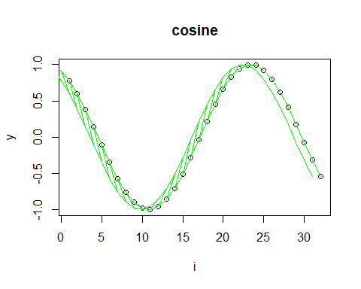

References - H. I. Fawaz, G. Forestier, J. Weber, L. Idoumghar, and P.-A. Muller (2019). Deep learning for time series classification: A review. Data Mining and Knowledge Discovery, 33, 917–963.