Objective: Build a ts_data object from a vector or data.frame and understand its sliding-window structure (columns t{k}).

#install.packages("tspredit")  
  
# Loading the package  
library(tspredit)

# Load data and split axis/value  
data(tsd)  
x <- tsd$x  
y <- tsd$y

library(ggplot2)  
# Visualize the original series  
plot_ts(x = x, y = y) + theme(text = element_text(size=16))

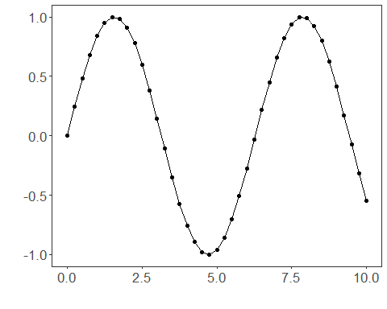

# ts_data without window (only t0)  
data <- ts_data(y)  
ts_head(data)

## t0  
## [1,] 0.0000000  
## [2,] 0.2474040  
## [3,] 0.4794255  
## [4,] 0.6816388  
## [5,] 0.8414710  
## [6,] 0.9489846

plot_ts(y=data[,1]) + theme(text = element_text(size=16))

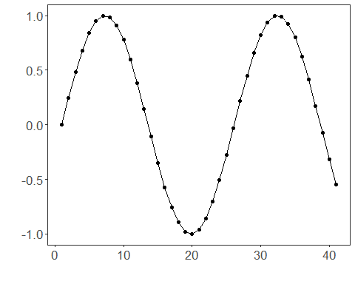

# ts_data with window size 10 (t9..t0)  
data10 <- ts_data(y, 10)  
ts_head(data10)

## t9 t8 t7 t6 t5 t4 t3  
## [1,] 0.0000000 0.2474040 0.4794255 0.6816388 0.8414710 0.9489846 0.9974950  
## [2,] 0.2474040 0.4794255 0.6816388 0.8414710 0.9489846 0.9974950 0.9839859  
## [3,] 0.4794255 0.6816388 0.8414710 0.9489846 0.9974950 0.9839859 0.9092974  
## [4,] 0.6816388 0.8414710 0.9489846 0.9974950 0.9839859 0.9092974 0.7780732  
## [5,] 0.8414710 0.9489846 0.9974950 0.9839859 0.9092974 0.7780732 0.5984721  
## [6,] 0.9489846 0.9974950 0.9839859 0.9092974 0.7780732 0.5984721 0.3816610  
## t2 t1 t0  
## [1,] 0.9839859 0.9092974 0.7780732  
## [2,] 0.9092974 0.7780732 0.5984721  
## [3,] 0.7780732 0.5984721 0.3816610  
## [4,] 0.5984721 0.3816610 0.1411200  
## [5,] 0.3816610 0.1411200 -0.1081951  
## [6,] 0.1411200 -0.1081951 -0.3507832

# Select a row  
r1 <- data10[12,]  
r1

## t9 t8 t7 t6 t5 t4  
## [1,] 0.381661 0.14112 -0.1081951 -0.3507832 -0.5715613 -0.7568025  
## t3 t2 t1 t0  
## [1,] -0.8949894 -0.9775301 -0.9992928 -0.9589243  
## attr(,"class")  
## [1] "ts_data" "matrix" "array"   
## attr(,"sw")  
## [1] 10

# Select a range of rows  
r2 <- data10[12:13,]  
r2

## t9 t8 t7 t6 t5 t4  
## [1,] 0.381661 0.1411200 -0.1081951 -0.3507832 -0.5715613 -0.7568025  
## [2,] 0.141120 -0.1081951 -0.3507832 -0.5715613 -0.7568025 -0.8949894  
## t3 t2 t1 t0  
## [1,] -0.8949894 -0.9775301 -0.9992928 -0.9589243  
## [2,] -0.9775301 -0.9992928 -0.9589243 -0.8589345  
## attr(,"class")  
## [1] "ts_data" "matrix" "array"   
## attr(,"sw")  
## [1] 10

# Select a column  
c1 <- data10[,1]  
ts_head(c1)

## t9  
## [1,] 0.0000000  
## [2,] 0.2474040  
## [3,] 0.4794255  
## [4,] 0.6816388  
## [5,] 0.8414710  
## [6,] 0.9489846

# Select a range of columns  
c2 <- data10[,1:2]  
ts_head(c2)

## t9 t8  
## [1,] 0.0000000 0.2474040  
## [2,] 0.2474040 0.4794255  
## [3,] 0.4794255 0.6816388  
## [4,] 0.6816388 0.8414710  
## [5,] 0.8414710 0.9489846  
## [6,] 0.9489846 0.9974950

# Select a range of rows and columns  
rc1 <- data10[12:13,1:2]  
rc1

## t9 t8  
## [1,] 0.381661 0.1411200  
## [2,] 0.141120 -0.1081951  
## attr(,"class")  
## [1] "ts_data" "matrix" "array"   
## attr(,"sw")  
## [1] 2

# Select one row and a range of columns  
rc2 <- data10[12,1:2]  
rc2

## t9 t8  
## [1,] 0.381661 0.14112  
## attr(,"class")  
## [1] "ts_data" "matrix" "array"   
## attr(,"sw")  
## [1] 2

# Select a range of rows and one column  
rc3 <- data10[12:13,1]  
rc3

## t9  
## [1,] 0.381661  
## [2,] 0.141120  
## attr(,"class")  
## [1] "ts_data" "matrix" "array"   
## attr(,"sw")  
## [1] 1

# Select a single observation  
rc4 <- data10[12,1]  
rc4

## t9  
## [1,] 0.381661  
## attr(,"class")  
## [1] "ts_data" "matrix" "array"   
## attr(,"sw")  
## [1] 1