Objective: Split a ts_data into training and test sets while preserving time order, defining the test size, and visualizing the parts.

#install.packages("tspredit")  
  
# Loading the package  
library(tspredit)

# Series for study  
  
data(tsd)

library(ggplot2)  
plot_ts(x = tsd$x, y = tsd$y) + theme(text = element_text(size=16))

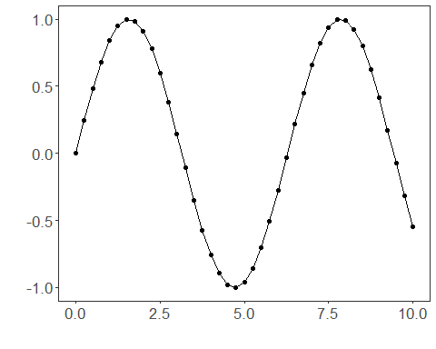

# Sliding windows  
  
sw_size <- 10  
ts <- ts_data(tsd$y, sw_size)  
ts_head(ts, 3)

## t9 t8 t7 t6 t5 t4 t3  
## [1,] 0.0000000 0.2474040 0.4794255 0.6816388 0.8414710 0.9489846 0.9974950  
## [2,] 0.2474040 0.4794255 0.6816388 0.8414710 0.9489846 0.9974950 0.9839859  
## [3,] 0.4794255 0.6816388 0.8414710 0.9489846 0.9974950 0.9839859 0.9092974  
## t2 t1 t0  
## [1,] 0.9839859 0.9092974 0.7780732  
## [2,] 0.9092974 0.7780732 0.5984721  
## [3,] 0.7780732 0.5984721 0.3816610

# Sampling (train and test)  
  
test_size <- 3  
samp <- ts_sample(ts, test_size)

# First five rows of the train set  
ts_head(samp$train, 5)

## t9 t8 t7 t6 t5 t4 t3  
## [1,] 0.0000000 0.2474040 0.4794255 0.6816388 0.8414710 0.9489846 0.9974950  
## [2,] 0.2474040 0.4794255 0.6816388 0.8414710 0.9489846 0.9974950 0.9839859  
## [3,] 0.4794255 0.6816388 0.8414710 0.9489846 0.9974950 0.9839859 0.9092974  
## [4,] 0.6816388 0.8414710 0.9489846 0.9974950 0.9839859 0.9092974 0.7780732  
## [5,] 0.8414710 0.9489846 0.9974950 0.9839859 0.9092974 0.7780732 0.5984721  
## t2 t1 t0  
## [1,] 0.9839859 0.9092974 0.7780732  
## [2,] 0.9092974 0.7780732 0.5984721  
## [3,] 0.7780732 0.5984721 0.3816610  
## [4,] 0.5984721 0.3816610 0.1411200  
## [5,] 0.3816610 0.1411200 -0.1081951

# Last five rows of the train set  
ts_head(samp$train[-c(1:(nrow(samp$train)-5)),])

## t9 t8 t7 t6 t5 t4  
## [1,] -0.27941550 -0.03317922 0.2151200 0.4500441 0.6569866 0.8230809  
## [2,] -0.03317922 0.21511999 0.4500441 0.6569866 0.8230809 0.9380000  
## [3,] 0.21511999 0.45004407 0.6569866 0.8230809 0.9380000 0.9945988  
## [4,] 0.45004407 0.65698660 0.8230809 0.9380000 0.9945988 0.9893582  
## [5,] 0.65698660 0.82308088 0.9380000 0.9945988 0.9893582 0.9226042  
## t3 t2 t1 t0  
## [1,] 0.9380000 0.9945988 0.9893582 0.9226042  
## [2,] 0.9945988 0.9893582 0.9226042 0.7984871  
## [3,] 0.9893582 0.9226042 0.7984871 0.6247240  
## [4,] 0.9226042 0.7984871 0.6247240 0.4121185  
## [5,] 0.7984871 0.6247240 0.4121185 0.1738895

# Test data  
ts_head(samp$test)

## t9 t8 t7 t6 t5 t4 t3  
## [1,] 0.8230809 0.9380000 0.9945988 0.9893582 0.9226042 0.7984871 0.6247240  
## [2,] 0.9380000 0.9945988 0.9893582 0.9226042 0.7984871 0.6247240 0.4121185  
## [3,] 0.9945988 0.9893582 0.9226042 0.7984871 0.6247240 0.4121185 0.1738895  
## t2 t1 t0  
## [1,] 0.41211849 0.17388949 -0.07515112  
## [2,] 0.17388949 -0.07515112 -0.31951919  
## [3,] -0.07515112 -0.31951919 -0.54402111