EMD filter: EMD iteratively extracts IMFs by sifting: local extrema define upper and lower envelopes whose mean is subtracted from the signal until the residual becomes an IMF; the process repeats on the remainder. Denoising is obtained by summing low‑frequency IMFs and the residual while attenuating high‑frequency IMFs.

Considerations - EMD is adaptive and data-driven (no fixed basis), suitable for nonlinear and nonstationary signals. - End effects can occur; visual checks are recommended near boundaries.

Objective: Empirical Mode Decomposition (EMD) decomposes a signal into a finite set of intrinsic mode functions (IMFs) derived directly from the data. By reconstructing the series from selected IMFs, you can suppress high-frequency noise and preserve meaningful structure.

# Filter - EMD  
  
# Install tspredit if needed  
#install.packages("tspredit")

# Load packages  
library(daltoolbox)  
library(tspredit)

# Prepare a noisy series example  
data(tsd)  
y <- tsd$y  
noise <- rnorm(length(y), 0, sd(y)/10)  
spike <- rnorm(1, 0, sd(y))  
tsd$y <- tsd$y + noise  
tsd$y[10] <- tsd$y[10] + spike  
tsd$y[20] <- tsd$y[20] + spike  
tsd$y[30] <- tsd$y[30] + spike

library(ggplot2)  
# Visualize the noisy input  
plot_ts(x=tsd$x, y=tsd$y) + theme(text = element_text(size=16))

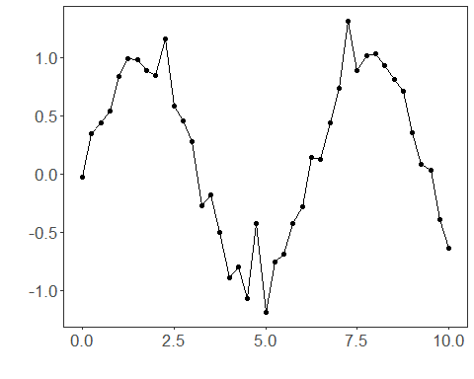

# Apply EMD-based filtering (IMF reconstruction)  
  
filter <- ts_fil_emd() # decompose into IMFs  
filter <- fit(filter, tsd$y) # compute decomposition  
y <- transform(filter, tsd$y) # reconstruct a denoised version  
  
# Compare original vs reconstructed  
plot_ts_pred(y=tsd$y, yadj=y) + theme(text = element_text(size=16))

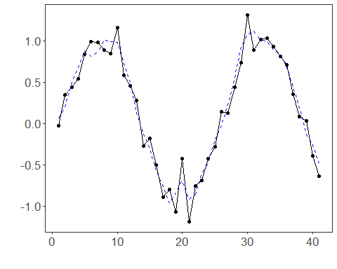

References - N. E. Huang et al. (1998). The empirical mode decomposition and the Hilbert spectrum for nonlinear and non-stationary time series analysis. Proceedings of the Royal Society A, 454(1971), 903–995.