Overview

The Moving Average (MA) filter smooths short-term fluctuations by replacing each point with the average of its neighbors. It is a simple and fast baseline to reduce random noise and highlight the underlying trend.

When to use - As a first pass to denoise a mildly noisy series - When you want an inexpensive baseline smoother before more complex models

Key parameter - window: the number of points averaged (here controlled by the first argument of ts_fil_ma). Larger values yield smoother curves but can lag and oversmooth peaks.

# Filter - Moving Average  
  
# Install tspredit if needed  
#install.packages("tspredit")

# Load packages  
library(daltoolbox)  
library(tspredit)

# Prepare a noisy series example  
# - start from built-in sample data  
# - add low-amplitude Gaussian noise  
# - inject a few spikes to stress-test robustness  
  
data(tsd)  
y <- tsd$y  
noise <- rnorm(length(y), 0, sd(y)/10)  
spike <- rnorm(1, 0, sd(y))  
tsd$y <- tsd$y + noise  
tsd$y[10] <- tsd$y[10] + spike  
tsd$y[20] <- tsd$y[20] + spike  
tsd$y[30] <- tsd$y[30] + spike

library(ggplot2)  
# Visualize the noisy series  
plot_ts(x=tsd$x, y=tsd$y) + theme(text = element_text(size=16))

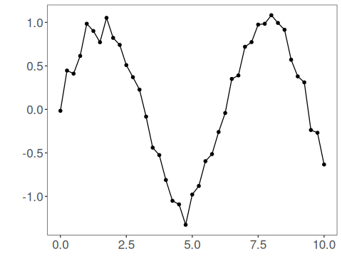

# Apply the Moving Average filter  
  
filter <- ts_fil_ma(3) # window size = 3 (use larger to smooth more)  
filter <- fit(filter, tsd$y) # calibrate (no learning; keeps interface consistent)  
y <- transform(filter, tsd$y) # get smoothed series  
  
# Compare original vs smoothed  
plot_ts_pred(y=tsd$y, yadj=y) + theme(text = element_text(size=16))

## Warning: Removed 2 rows containing missing values or values outside the scale range (`geom_line()`).

