Overview

Seasonal adjustment aims to remove periodic seasonal components from a series, making the underlying trend and cycle easier to analyze. After adjustment, remaining variation should reflect non-seasonal dynamics.

Notes - Ensure the frequency/periodicity in your data is appropriate for seasonal estimation. - Seasonal adjustment methods can differ in how they model trend and irregular components.

# Filter - seasonal adjustment  
  
# Install tspredit if needed  
#install.packages("tspredit")

# Load packages  
library(daltoolbox)  
library(tspredit)

# Prepare a series (with added noise/spikes for illustration)  
data(tsd)  
y <- tsd$y  
noise <- rnorm(length(y), 0, sd(y)/10)  
spike <- rnorm(1, 0, sd(y))  
tsd$y <- tsd$y + noise  
tsd$y[10] <- tsd$y[10] + spike  
tsd$y[20] <- tsd$y[20] + spike  
tsd$y[30] <- tsd$y[30] + spike

library(ggplot2)  
# Visualize original (noisy) series  
plot_ts(x=tsd$x, y=tsd$y) + theme(text = element_text(size=16))

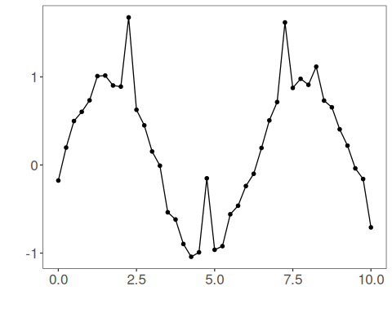

# Apply seasonal adjustment  
  
filter <- ts_fil_seas_adj() # adjust for seasonal effects  
filter <- fit(filter, tsd$y)  
y <- transform(filter, tsd$y)  
  
# Compare original vs seasonally adjusted  
plot_ts_pred(y=tsd$y, yadj=y) + theme(text = element_text(size=16))

