Overview

This generic smoothing filter reduces short-term variation to reveal the underlying signal. It can be used as a quick denoising step when you do not need a specific smoothing family (e.g., MA, LOWESS, spline).

Tip - Start with the default settings; if the result under/over-smooths, consider a more tailored filter (e.g., spline with spar, LOWESS with f).

# Filter - Smooth  
  
# Install tspredit if needed  
#install.packages("tspredit")

# Load packages  
library(daltoolbox)  
library(tspredit)

# Create a noisy example series  
data(tsd)  
y <- tsd$y  
noise <- rnorm(length(y), 0, sd(y)/10)  
spike <- rnorm(1, 0, sd(y))  
tsd$y <- tsd$y + noise  
tsd$y[10] <- tsd$y[10] + spike  
tsd$y[20] <- tsd$y[20] + spike  
tsd$y[30] <- tsd$y[30] + spike

library(ggplot2)  
# Visualize noisy input  
plot_ts(x=tsd$x, y=tsd$y) + theme(text = element_text(size=16))

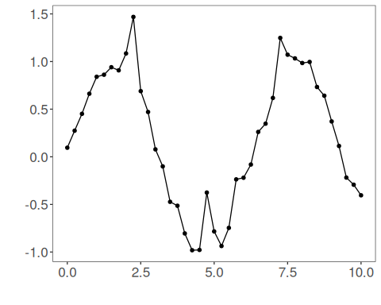

# Apply generic smoothing  
  
filter <- ts_fil_smooth() # defaults provide light smoothing  
filter <- fit(filter, tsd$y)  
y <- transform(filter, tsd$y)  
  
# Compare original vs smoothed  
plot_ts_pred(y=tsd$y, yadj=y) + theme(text = element_text(size=16))

