Objective: Apply cubic smoothing splines to reduce noise by controlling roughness via the spar parameter.

# Filter - Spline  
  
# Installing the package (if needed)  
#install.packages("tspredit")

# Loading the packages  
library(daltoolbox)  
library(tspredit)

# Series for study with artificial noise and spikes  
  
data(tsd)  
y <- tsd$y  
noise <- rnorm(length(y), 0, sd(y)/10)  
spike <- rnorm(1, 0, sd(y))  
tsd$y <- tsd$y + noise  
tsd$y[10] <- tsd$y[10] + spike  
tsd$y[20] <- tsd$y[20] + spike  
tsd$y[30] <- tsd$y[30] + spike

library(ggplot2)  
# Noisy series visualization  
plot_ts(x=tsd$x, y=tsd$y) + theme(text = element_text(size=16))

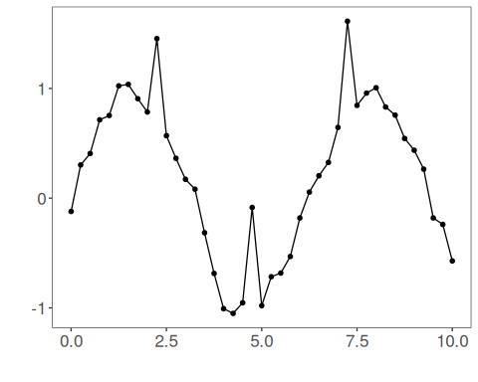

# Applying the Spline filter  
  
filter <- ts_fil_spline(spar = 0.5)  
filter <- fit(filter, tsd$y)  
y <- transform(filter, tsd$y)  
plot_ts_pred(y=tsd$y, yadj=y) + theme(text = element_text(size=16))

