Objective: Apply adaptive normalization (moving average/EMA) to handle distribution shifts over time and observe the effect on the target.

# Exponential Adaptive Normalization  
  
# Installing the package (if needed)  
#install.packages("tspredit")

# Loading the packages  
library(daltoolbox)  
library(tspredit)

# Series for study  
  
data(tsd)

# Series visualization  
library(ggplot2)  
plot_ts(x=tsd$x, y=tsd$y) + theme(text = element_text(size=16))

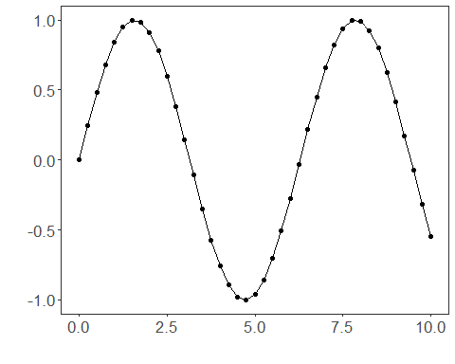

# Sliding windows  
  
sw_size <- 10  
ts <- ts_data(tsd$y, sw_size)  
ts_head(ts, 3)

## t9 t8 t7 t6 t5 t4 t3  
## [1,] 0.0000000 0.2474040 0.4794255 0.6816388 0.8414710 0.9489846 0.9974950  
## [2,] 0.2474040 0.4794255 0.6816388 0.8414710 0.9489846 0.9974950 0.9839859  
## [3,] 0.4794255 0.6816388 0.8414710 0.9489846 0.9974950 0.9839859 0.9092974  
## t2 t1 t0  
## [1,] 0.9839859 0.9092974 0.7780732  
## [2,] 0.9092974 0.7780732 0.5984721  
## [3,] 0.7780732 0.5984721 0.3816610

summary(ts[,10])

## t0   
## Min. :-0.99929   
## 1st Qu.:-0.55091   
## Median : 0.05397   
## Mean : 0.02988   
## 3rd Qu.: 0.63279   
## Max. : 0.99460

# Target (t0) visualization after windowing  
library(ggplot2)  
plot_ts(y=ts[,10]) + theme(text = element_text(size=16))

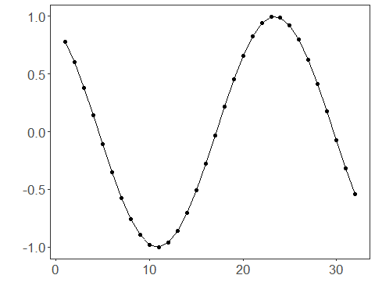

# Normalization  
  
preproc <- ts_norm_an()  
preproc <- fit(preproc, ts)  
tst <- transform(preproc, ts)  
ts_head(tst, 3)

## t9 t8 t7 t6 t5 t4 t3  
## [1,] 0.1770086 0.2931936 0.4021548 0.4971174 0.5721773 0.6226675 0.6454487  
## [2,] 0.2650884 0.3740495 0.4690122 0.5440720 0.5945622 0.6173435 0.6109994  
## [3,] 0.3677446 0.4627073 0.5377671 0.5882573 0.6110386 0.6046945 0.5696195  
## t2 t1 t0  
## [1,] 0.6391047 0.6040297 0.5424046  
## [2,] 0.5759245 0.5142994 0.4299558  
## [3,] 0.5079945 0.4236508 0.3218327

summary(tst[,10])

## t0   
## Min. :0.04995   
## 1st Qu.:0.15185   
## Median :0.41183   
## Mean :0.44854   
## 3rd Qu.:0.73197   
## Max. :0.94995

plot_ts(y=ts[1,]) + theme(text = element_text(size=16))

