Exponential Adaptive Normalization: EAN computes exponentially weighted means and (optionally) variances within each window using a decay factor. Each window is then centered and scaled by these adaptive statistics, enabling fast adaptation to local changes while smoothing out transient noise.

Key parameter - nw: the effective window span for the exponential averages; smaller values adapt faster to recent changes.

Objectives: EAN rescales each sliding window using exponentially weighted statistics so that the model focuses on shape rather than absolute level. This is helpful when the series level drifts over time (non-stationary mean/variance).

# Exponential Adaptive Normalization  
  
# Install tspredit if needed  
#install.packages("tspredit")

# Load packages  
library(daltoolbox)  
library(tspredit)

# Load a sample series  
  
data(tsd)

library(ggplot2)  
# Visualize original series  
plot_ts(x=tsd$x, y=tsd$y) + theme(text = element_text(size=16))

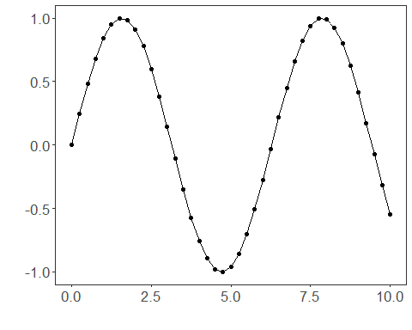

# Build sliding windows for supervised learning  
  
sw_size <- 10  
ts <- ts_data(tsd$y, sw_size)  
ts_head(ts, 3)

## t9 t8 t7 t6 t5 t4 t3 t2 t1  
## [1,] 0.0000000 0.2474040 0.4794255 0.6816388 0.8414710 0.9489846 0.9974950 0.9839859 0.9092974  
## [2,] 0.2474040 0.4794255 0.6816388 0.8414710 0.9489846 0.9974950 0.9839859 0.9092974 0.7780732  
## [3,] 0.4794255 0.6816388 0.8414710 0.9489846 0.9974950 0.9839859 0.9092974 0.7780732 0.5984721  
## t0  
## [1,] 0.7780732  
## [2,] 0.5984721  
## [3,] 0.3816610

summary(ts[,10])

## t0   
## Min. :-0.99929   
## 1st Qu.:-0.55091   
## Median : 0.05397   
## Mean : 0.02988   
## 3rd Qu.: 0.63279   
## Max. : 0.99460

library(ggplot2)  
# Visualize the target column (t0) after windowing  
plot_ts(y=ts[,10]) + theme(text = element_text(size=16))

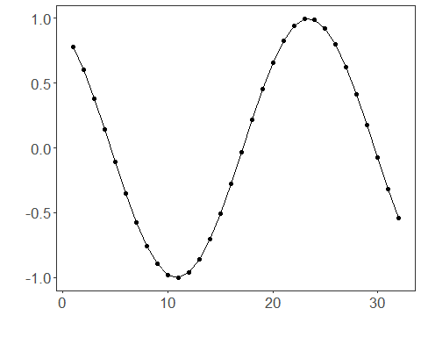

# Apply Exponential Adaptive Normalization  
  
preproc <- ts_norm_ean(nw = 3) # faster adaptation with smaller nw  
preproc <- fit(preproc, ts)  
tst <- transform(preproc, ts)  
ts_head(tst, 3)

## t9 t8 t7 t6 t5 t4 t3 t2 t1  
## [1,] 0.2323665 0.3104452 0.3836695 0.4474864 0.4979282 0.5318587 0.5471682 0.5429048 0.5193337  
## [2,] 0.3580339 0.4312581 0.4950750 0.5455169 0.5794473 0.5947568 0.5904935 0.5669224 0.5255090  
## [3,] 0.4924682 0.5562851 0.6067269 0.6406574 0.6559669 0.6517035 0.6281324 0.5867191 0.5300384  
## t0  
## [1,] 0.4779203  
## [2,] 0.4688283  
## [3,] 0.4616144

summary(tst[,10])

## t0   
## Min. :0.4545   
## 1st Qu.:0.4608   
## Median :0.4804   
## Mean :0.4911   
## 3rd Qu.:0.5226   
## Max. :0.5437

# Inspect one normalized window (shape emphasized)  
plot_ts(y=ts[1,]) + theme(text = element_text(size=16))

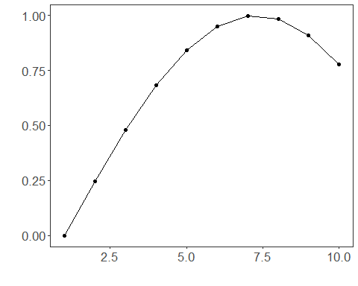

References - Ogasawara, E., Martinez, L. C., De Oliveira, D., Zimbrão, G., Pappa, G. L., Mattoso, M. (2010). Adaptive Normalization: A novel data normalization approach for non-stationary time series. Proceedings of the International Joint Conference on Neural Networks (IJCNN). <doi:10.1109/IJCNN.2010.5596746>