Global Min-max: Compute the global minimum and maximum on the training data and rescale each value as (x − min) / (max − min). Apply the same parameters to validation/test to avoid leakage. This preserves relative ordering and maps all features to a common range.

Objective: Apply global min-max normalization (0 to 1) over the training series, transform the data, and visualize the effect of scaling.

# Global Min-Max Normalization  
  
# Installing the package (if needed)  
#install.packages("tspredit")

# Loading the packages  
library(daltoolbox)  
library(tspredit)

# Series for study  
  
data(tsd)

# Series visualization  
library(ggplot2)  
plot_ts(x=tsd$x, y=tsd$y) + theme(text = element_text(size=16))

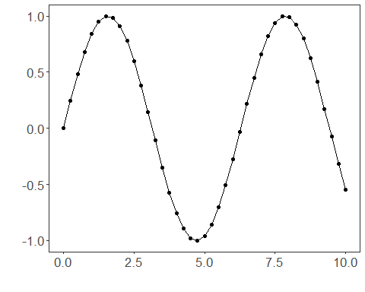

# Sliding windows  
  
sw_size <- 10  
ts <- ts_data(tsd$y, sw_size)  
ts_head(ts, 3)

## t9 t8 t7 t6 t5 t4 t3 t2 t1  
## [1,] 0.0000000 0.2474040 0.4794255 0.6816388 0.8414710 0.9489846 0.9974950 0.9839859 0.9092974  
## [2,] 0.2474040 0.4794255 0.6816388 0.8414710 0.9489846 0.9974950 0.9839859 0.9092974 0.7780732  
## [3,] 0.4794255 0.6816388 0.8414710 0.9489846 0.9974950 0.9839859 0.9092974 0.7780732 0.5984721  
## t0  
## [1,] 0.7780732  
## [2,] 0.5984721  
## [3,] 0.3816610

summary(ts[,10])

## t0   
## Min. :-0.99929   
## 1st Qu.:-0.55091   
## Median : 0.05397   
## Mean : 0.02988   
## 3rd Qu.: 0.63279   
## Max. : 0.99460

# Target (t0) visualization after windowing  
library(ggplot2)  
plot_ts(y=ts[,10]) + theme(text = element_text(size=16))

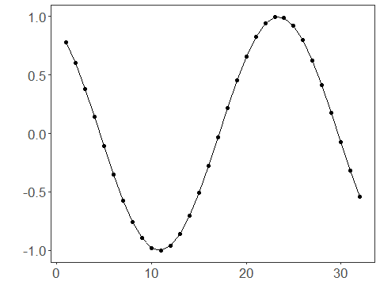

# Normalization (fit and transform)  
  
preproc <- ts_norm_gminmax()  
preproc <- fit(preproc, ts)  
tst <- transform(preproc, ts)  
ts_head(tst, 3)

## t9 t8 t7 t6 t5 t4 t3 t2 t1  
## [1,] 0.5004502 0.6243512 0.7405486 0.8418178 0.9218625 0.9757058 1.0000000 0.9932346 0.9558303  
## [2,] 0.6243512 0.7405486 0.8418178 0.9218625 0.9757058 1.0000000 0.9932346 0.9558303 0.8901126  
## [3,] 0.7405486 0.8418178 0.9218625 0.9757058 1.0000000 0.9932346 0.9558303 0.8901126 0.8001676  
## t0  
## [1,] 0.8901126  
## [2,] 0.8001676  
## [3,] 0.6915877

summary(tst[,10])

## t0   
## Min. :0.0000   
## 1st Qu.:0.2246   
## Median :0.5275   
## Mean :0.5154   
## 3rd Qu.:0.8174   
## Max. :0.9985

plot_ts(y=ts[,10]) + theme(text = element_text(size=16))



References - C. M. Bishop (2006). Pattern Recognition and Machine Learning. Springer.