Sliding window min-max normalization: For each sliding window (row), compute its local min and max and rescale that window to [0,1]. This emphasizes local shape and pattern while removing level and amplitude differences across windows.

Objective: Apply per-window min-max normalization (each row scaled by its own minima and maxima) and visualize the effect of scaling.

# Window-based Normalization (Min-Max)  
  
# Installing the package (if needed)  
#install.packages("tspredit")

# Loading the packages  
library(daltoolbox)  
library(tspredit)

# Series for study  
  
data(tsd)

# Series visualization  
library(ggplot2)  
plot_ts(x=tsd$x, y=tsd$y) + theme(text = element_text(size=16))

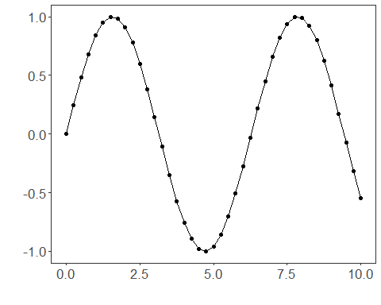

# Sliding windows  
  
sw_size <- 10  
ts <- ts_data(tsd$y, sw_size)  
ts_head(ts, 3)

## t9 t8 t7 t6 t5 t4 t3 t2 t1  
## [1,] 0.0000000 0.2474040 0.4794255 0.6816388 0.8414710 0.9489846 0.9974950 0.9839859 0.9092974  
## [2,] 0.2474040 0.4794255 0.6816388 0.8414710 0.9489846 0.9974950 0.9839859 0.9092974 0.7780732  
## [3,] 0.4794255 0.6816388 0.8414710 0.9489846 0.9974950 0.9839859 0.9092974 0.7780732 0.5984721  
## t0  
## [1,] 0.7780732  
## [2,] 0.5984721  
## [3,] 0.3816610

summary(ts[,10])

## t0   
## Min. :-0.99929   
## 1st Qu.:-0.55091   
## Median : 0.05397   
## Mean : 0.02988   
## 3rd Qu.: 0.63279   
## Max. : 0.99460

# Target (t0) visualization after windowing  
library(ggplot2)  
plot_ts(y=ts[,10]) + theme(text = element_text(size=16))

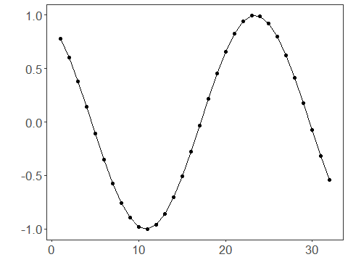

# Normalization (fit and transform)  
  
preproc <- ts_norm_swminmax()  
preproc <- fit(preproc, ts)  
tst <- transform(preproc, ts)  
ts_head(tst, 3)

## t9 t8 t7 t6 t5 t4 t3 t2 t1  
## [1,] 0.0000000 0.2480253 0.4806295 0.6833506 0.8435842 0.9513678 1.0000000 0.9864570 0.9115809  
## [2,] 0.0000000 0.3093246 0.5789095 0.7919932 0.9353274 1.0000000 0.9819901 0.8824175 0.7074731  
## [3,] 0.1587515 0.4871082 0.7466460 0.9212282 1.0000000 0.9780638 0.8567835 0.6436998 0.3520610  
## t0  
## [1,] 0.7800272  
## [2,] 0.4680341  
## [3,] 0.0000000

summary(tst[,10])

## t0   
## Min. :0.0000   
## 1st Qu.:0.0000   
## Median :0.2264   
## Mean :0.4301   
## 3rd Qu.:0.9974   
## Max. :1.0000

plot_ts(y=ts[1,]) + theme(text = element_text(size=16))

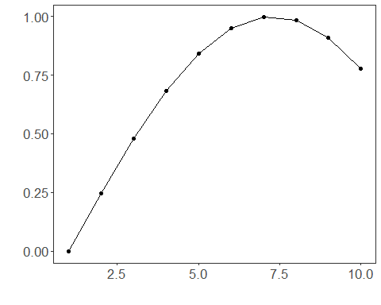

References - C. M. Bishop (2006). Pattern Recognition and Machine Learning. Springer.