Objective: Fit and evaluate an ARIMA (AutoRegressive Integrated Moving Average) model for time-series forecasting, performing a train-test split, automatic order selection, and evaluation with metrics and visualization.

#install.packages("tspredit")  
  
# Loading the package  
library(tspredit)

# Series for study (no sliding window)  
  
data(tsd)  
ts <- ts_data(tsd$y, 0)  
ts_head(ts, 3)

## t0  
## [1,] 0.0000000  
## [2,] 0.2474040  
## [3,] 0.4794255

# Series visualization  
library(ggplot2)  
plot_ts(x=tsd$x, y=tsd$y) + theme(text = element_text(size=16))

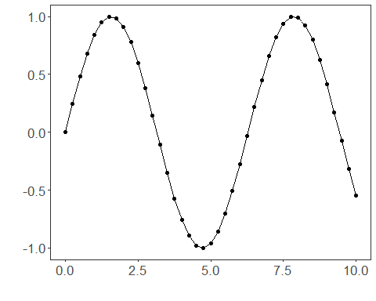

# Train-test split and projection (X, y)  
  
samp <- ts_sample(ts, test_size = 5)  
io_train <- ts_projection(samp$train)  
io_test <- ts_projection(samp$test)

# Training the ARIMA model (orders selected automatically)  
  
model <- ts_arima()  
model <- fit(model, x=io_train$input, y=io_train$output)

# Fit evaluation (train)  
  
adjust <- predict(model, io_train$input)  
adjust <- as.vector(adjust)  
output <- as.vector(io_train$output)  
ev_adjust <- evaluate(model, output, adjust)  
ev_adjust$mse

## [1] 0.02857686

# Forecast on test set (5 steps ahead)  
  
prediction <- predict(model, x=io_test$input[1,], steps_ahead=5)  
prediction <- as.vector(prediction)  
output <- as.vector(io_test$output)  
ev_test <- evaluate(model, output, prediction)  
ev_test

## $values  
## [1] 0.41211849 0.17388949 -0.07515112 -0.31951919 -0.54402111  
##   
## $prediction  
## [1] 0.6011374 0.5784414 0.5566023 0.5355877 0.5153665  
##   
## $smape  
## [1] 1.489711  
##   
## $mse  
## [1] 0.4904025  
##   
## $R2  
## [1] -3.235632  
##   
## $metrics  
## mse smape R2  
## 1 0.4904025 1.489711 -3.235632

# Plot comparing actual vs fit (train) and forecast (test)  
  
yvalues <- c(io_train$output, io_test$output)  
plot_ts_pred(y=yvalues, yadj=adjust, ypre=prediction) + theme(text = element_text(size=16))

