k-NN regression: k-NN regression predicts the next value by averaging (or weighting) the targets of the k most similar historical windows according to a distance measure (e.g., Euclidean). In the sliding-window setup, each row encodes the most recent lags of the series; neighbors with similar local patterns contribute to the forecast. The method is nonparametric and relies on appropriate scaling and a sensible choice of k.

Objective: Use KNN (K-Nearest Neighbors) to forecast time series from sliding windows, with normalization, model fitting, and evaluation.

# Time Series Regression - KNN  
  
# Installing the package (if needed)  
#install.packages("tspredit")

# Loading the packages  
library(daltoolbox)  
library(tspredit)

# Series for study and sliding windows  
  
data(tsd)  
ts <- ts_data(tsd$y, 10)  
ts_head(ts, 3)

## t9 t8 t7 t6 t5 t4 t3 t2 t1  
## [1,] 0.0000000 0.2474040 0.4794255 0.6816388 0.8414710 0.9489846 0.9974950 0.9839859 0.9092974  
## [2,] 0.2474040 0.4794255 0.6816388 0.8414710 0.9489846 0.9974950 0.9839859 0.9092974 0.7780732  
## [3,] 0.4794255 0.6816388 0.8414710 0.9489846 0.9974950 0.9839859 0.9092974 0.7780732 0.5984721  
## t0  
## [1,] 0.7780732  
## [2,] 0.5984721  
## [3,] 0.3816610

# Series visualization  
library(ggplot2)  
plot_ts(x=tsd$x, y=tsd$y) + theme(text = element_text(size=16))

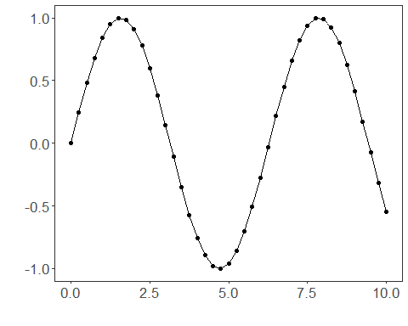

# Train-test split and projection (X, y)  
  
samp <- ts_sample(ts, test_size = 5)  
io_train <- ts_projection(samp$train)  
io_test <- ts_projection(samp$test)

# Preprocessing (global min-max normalization)  
  
preproc <- ts_norm_gminmax()

# Training the KNN model  
  
model <- ts_knn(ts_norm_gminmax(), input_size=4, k=3)  
model <- fit(model, x=io_train$input, y=io_train$output)

# Fit evaluation (train)  
  
adjust <- predict(model, io_train$input)  
adjust <- as.vector(adjust)  
output <- as.vector(io_train$output)  
ev_adjust <- evaluate(model, output, adjust)  
ev_adjust$mse

## [1] 0.00169231

# Forecast on test set (5 steps ahead)  
  
prediction <- predict(model, x=io_test$input[1,], steps_ahead=5)  
prediction <- as.vector(prediction)  
output <- as.vector(io_test$output)  
ev_test <- evaluate(model, output, prediction)  
ev_test

## $values  
## [1] 0.41211849 0.17388949 -0.07515112 -0.31951919 -0.54402111  
##   
## $prediction  
## [1] 0.5349524 0.3737510 0.1381953 -0.1059528 -0.3435132  
##   
## $smape  
## [1] 0.8890066  
##   
## $mse  
## [1] 0.0372727  
##   
## $R2  
## [1] 0.6780737  
##   
## $metrics  
## mse smape R2  
## 1 0.0372727 0.8890066 0.6780737

# Plot comparing actual vs fit (train) and forecast (test)  
  
yvalues <- c(io_train$output, io_test$output)  
plot_ts_pred(y=yvalues, yadj=adjust, ypre=prediction) + theme(text = element_text(size=16))

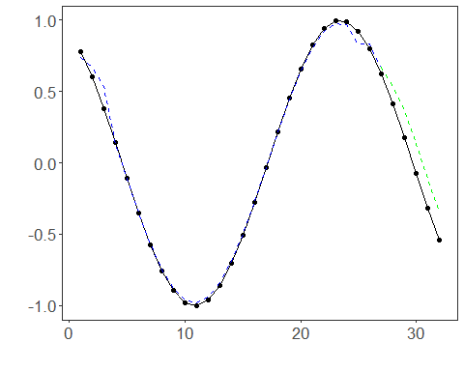

References - T. Cover and P. Hart (1967). Nearest neighbor pattern classification. IEEE Transactions on Information Theory, 13(1), 21–27.