MLP: An MLP is a feedforward neural network that maps the lagged inputs (sliding-window features) to the next-step target via one or more hidden layers with nonlinear activations. With sufficient hidden units, MLPs approximate complex nonlinear dynamics. Important hyperparameters include the hidden size (size), regularization (decay), and the input window length.

Objective: Demonstrate how to train, validate, and evaluate an MLP (Multilayer Perceptron) model for time-series forecasting with sliding windows, including data preparation, normalization, model fitting, and evaluation with metrics and plots.

# Time Series Regression - MLP  
  
# Installing the package (if needed)  
#install.packages("tspredit")

# Loading the packages  
library(daltoolbox)  
library(tspredit)

# Series for study (generates sliding windows t9..t0)  
  
data(tsd)  
ts <- ts_data(tsd$y, 10)  
ts_head(ts, 3)

## t9 t8 t7 t6 t5 t4 t3 t2 t1  
## [1,] 0.0000000 0.2474040 0.4794255 0.6816388 0.8414710 0.9489846 0.9974950 0.9839859 0.9092974  
## [2,] 0.2474040 0.4794255 0.6816388 0.8414710 0.9489846 0.9974950 0.9839859 0.9092974 0.7780732  
## [3,] 0.4794255 0.6816388 0.8414710 0.9489846 0.9974950 0.9839859 0.9092974 0.7780732 0.5984721  
## t0  
## [1,] 0.7780732  
## [2,] 0.5984721  
## [3,] 0.3816610

# Original series visualization  
library(ggplot2)  
plot_ts(x=tsd$x, y=tsd$y) + theme(text = element_text(size=16))

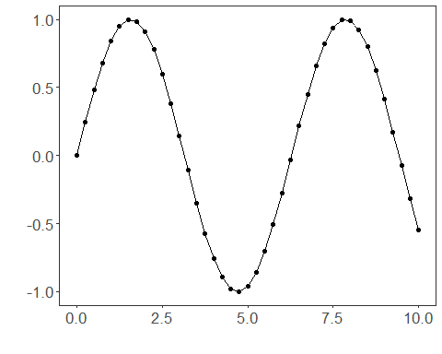

# Train-test split and projection (X, y)  
  
samp <- ts_sample(ts, test_size = 5)  
io_train <- ts_projection(samp$train)  
io_test <- ts_projection(samp$test)

# Preprocessing (global min-max normalization)  
  
preproc <- ts_norm_gminmax()

# Training the MLP model  
  
model <- ts_mlp(ts_norm_gminmax(), input_size=4, size=4, decay=0)  
model <- fit(model, x=io_train$input, y=io_train$output)

# Fit evaluation (train)  
  
adjust <- predict(model, io_train$input)  
adjust <- as.vector(adjust)  
output <- as.vector(io_train$output)  
ev_adjust <- evaluate(model, output, adjust)  
ev_adjust$mse

## [1] 1.452179e-05

# Forecast on test set (5 steps ahead)  
  
prediction <- predict(model, x=io_test$input[1,], steps_ahead=5)  
prediction <- as.vector(prediction)  
output <- as.vector(io_test$output)  
ev_test <- evaluate(model, output, prediction)  
ev_test

## $values  
## [1] 0.41211849 0.17388949 -0.07515112 -0.31951919 -0.54402111  
##   
## $prediction  
## [1] 0.41432866 0.17857629 -0.06878185 -0.31271542 -0.53941686  
##   
## $smape  
## [1] 0.03009372  
##   
## $mse  
## [1] 2.698181e-05  
##   
## $R2  
## [1] 0.999767  
##   
## $metrics  
## mse smape R2  
## 1 2.698181e-05 0.03009372 0.999767

# Plot comparing actual vs fit (train) and forecast (test)  
  
yvalues <- c(io_train$output, io_test$output)  
plot_ts_pred(y=yvalues, yadj=adjust, ypre=prediction) + theme(text = element_text(size=16))

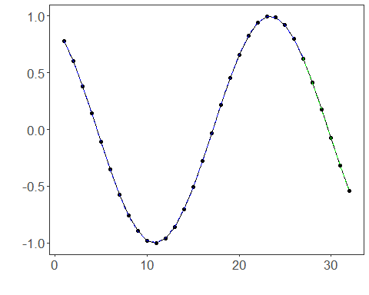

References - D. E. Rumelhart, G. E. Hinton, and R. J. Williams (1986). Learning representations by back-propagating errors. Nature, 323, 533–536.