Objective: Train and evaluate a 1D CNN (Conv1D) for time-series forecasting with sliding windows, including normalization, fitting, and evaluation.

# Time Series Regression - 1D CNN (Conv1D)  
  
# Installing packages (if needed)  
  
#install.packages("tspredit")

# Loading the packages  
library(daltoolbox)  
library(daltoolboxdp)  
library(tspredit)

# Series for study and sliding windows  
  
data(tsd)  
ts <- ts_data(tsd$y, 10)  
ts_head(ts, 3)

## t9 t8 t7 t6 t5 t4 t3 t2 t1 t0  
## [1,] 0.0000000 0.2474040 0.4794255 0.6816388 0.8414710 0.9489846 0.9974950 0.9839859 0.9092974 0.7780732  
## [2,] 0.2474040 0.4794255 0.6816388 0.8414710 0.9489846 0.9974950 0.9839859 0.9092974 0.7780732 0.5984721  
## [3,] 0.4794255 0.6816388 0.8414710 0.9489846 0.9974950 0.9839859 0.9092974 0.7780732 0.5984721 0.3816610

# Series visualization  
library(ggplot2)  
plot_ts(x=tsd$x, y=tsd$y) + theme(text = element_text(size=16))

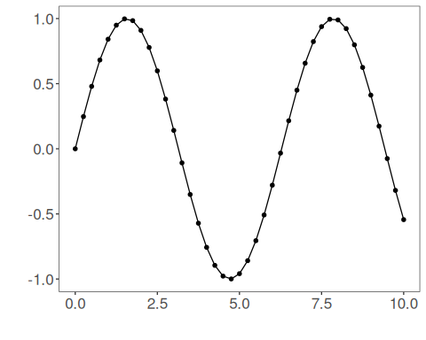

# Train-test split and projection (X, y)  
  
samp <- ts_sample(ts, test_size = 5)  
io_train <- ts_projection(samp$train)  
io_test <- ts_projection(samp$test)

# Training the 1D CNN  
  
model <- ts_conv1d(ts_norm_gminmax(), input_size=4, epochs=10000)  
model <- fit(model, x=io_train$input, y=io_train$output)

# Fit evaluation (train)  
  
adjust <- predict(model, io_train$input)  
adjust <- as.vector(adjust)  
output <- as.vector(io_train$output)  
ev_adjust <- evaluate(model, output, adjust)  
ev_adjust$mse

## [1] 1.713873e-06

# Forecast on test set  
  
prediction <- predict(model, x=io_test$input[1,], steps_ahead=5)  
prediction <- as.vector(prediction)  
output <- as.vector(io_test$output)  
ev_test <- evaluate(model, output, prediction)  
ev_test

## $values  
## [1] 0.41211849 0.17388949 -0.07515112 -0.31951919 -0.54402111  
##   
## $prediction  
## [1] 0.41193573 0.17425368 -0.07591131 -0.32145937 -0.54547821  
##   
## $smape  
## [1] 0.0042658  
##   
## $mse  
## [1] 1.326269e-06  
##   
## $R2  
## [1] 0.9999885  
##   
## $metrics  
## mse smape R2  
## 1 1.326269e-06 0.0042658 0.9999885

# Plot results  
  
yvalues <- c(io_train$output, io_test$output)  
plot_ts_pred(y=yvalues, yadj=adjust, ypre=prediction) + theme(text = element_text(size=16))

