Objective: Difference the series (first differences) and apply min-max normalization, observing level reduction and the effect on scale.

# Normalization by Differences (Diff)  
  
# Installing the package (if needed)  
#install.packages("tspredit")

# Loading the packages  
library(daltoolbox)  
library(tspredit)

# Series for study  
  
data(tsd)

# Series visualization  
library(ggplot2)  
plot_ts(x=tsd$x, y=tsd$y) + theme(text = element_text(size=16))

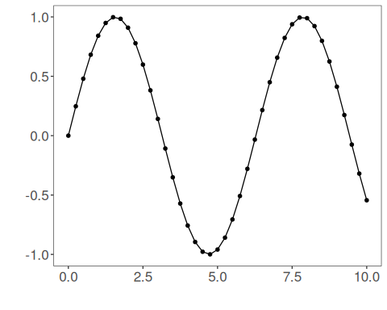

# Sliding windows  
  
sw_size <- 10  
ts <- ts_data(tsd$y, sw_size)  
ts_head(ts, 3)

## t9 t8 t7 t6 t5 t4 t3 t2 t1 t0  
## [1,] 0.0000000 0.2474040 0.4794255 0.6816388 0.8414710 0.9489846 0.9974950 0.9839859 0.9092974 0.7780732  
## [2,] 0.2474040 0.4794255 0.6816388 0.8414710 0.9489846 0.9974950 0.9839859 0.9092974 0.7780732 0.5984721  
## [3,] 0.4794255 0.6816388 0.8414710 0.9489846 0.9974950 0.9839859 0.9092974 0.7780732 0.5984721 0.3816610

summary(ts[,10])

## t0   
## Min. :-0.99929   
## 1st Qu.:-0.55091   
## Median : 0.05397   
## Mean : 0.02988   
## 3rd Qu.: 0.63279   
## Max. : 0.99460

# Target (t0) visualization after windowing  
library(ggplot2)  
plot_ts(y=ts[,10]) + theme(text = element_text(size=16))

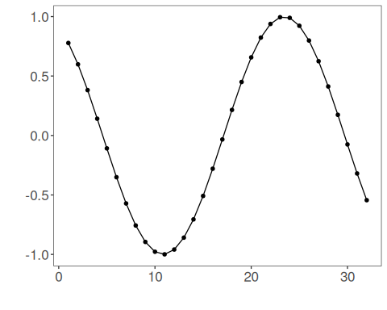

# Normalization (fit and transform)  
  
preproc <- ts_norm_diff()  
preproc <- fit(preproc, ts)  
tst <- transform(preproc, ts)  
ts_head(tst, 3)

## t8 t7 t6 t5 t4 t3 t2 t1 t0  
## [1,] 0.9982009 0.9672887 0.9073861 0.8222178 0.7170790 0.5985067 0.4738732 0.3509276 0.23731412  
## [2,] 0.9672887 0.9073861 0.8222178 0.7170790 0.5985067 0.4738732 0.3509276 0.2373141 0.14009662  
## [3,] 0.9073861 0.8222178 0.7170790 0.5985067 0.4738732 0.3509276 0.2373141 0.1400966 0.06531964

summary(tst[,9])

## t0   
## Min. :0.00000   
## 1st Qu.:0.06333   
## Median :0.29337   
## Mean :0.40975   
## 3rd Qu.:0.75129   
## Max. :1.00000

plot_ts(y=ts[,9]) + theme(text = element_text(size=16))

