Overview

Exponential Adaptive Normalization (EAN) rescales each sliding window using exponentially weighted statistics so that the model focuses on shape rather than absolute level. This is helpful when the series level drifts over time (non-stationary mean/variance).

Key parameter - nw: the effective window span for the exponential averages; smaller values adapt faster to recent changes.

# Exponential Adaptive Normalization  
  
# Install tspredit if needed  
#install.packages("tspredit")

# Load packages  
library(daltoolbox)  
library(tspredit)

# Load a sample series  
  
data(tsd)

library(ggplot2)  
# Visualize original series  
plot_ts(x=tsd$x, y=tsd$y) + theme(text = element_text(size=16))

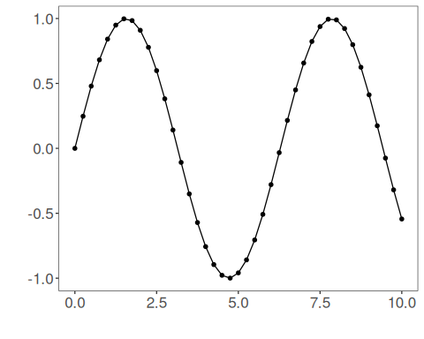

# Build sliding windows for supervised learning  
  
sw_size <- 10  
ts <- ts_data(tsd$y, sw_size)  
ts_head(ts, 3)

## t9 t8 t7 t6 t5 t4 t3 t2 t1 t0  
## [1,] 0.0000000 0.2474040 0.4794255 0.6816388 0.8414710 0.9489846 0.9974950 0.9839859 0.9092974 0.7780732  
## [2,] 0.2474040 0.4794255 0.6816388 0.8414710 0.9489846 0.9974950 0.9839859 0.9092974 0.7780732 0.5984721  
## [3,] 0.4794255 0.6816388 0.8414710 0.9489846 0.9974950 0.9839859 0.9092974 0.7780732 0.5984721 0.3816610

summary(ts[,10])

## t0   
## Min. :-0.99929   
## 1st Qu.:-0.55091   
## Median : 0.05397   
## Mean : 0.02988   
## 3rd Qu.: 0.63279   
## Max. : 0.99460

library(ggplot2)  
# Visualize the target column (t0) after windowing  
plot_ts(y=ts[,10]) + theme(text = element_text(size=16))

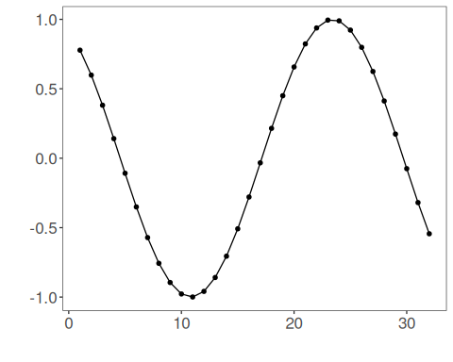

# Apply Exponential Adaptive Normalization  
  
preproc <- ts_norm_ean(nw = 3) # faster adaptation with smaller nw  
preproc <- fit(preproc, ts)  
tst <- transform(preproc, ts)  
ts_head(tst, 3)

## t9 t8 t7 t6 t5 t4 t3 t2 t1 t0  
## [1,] 0.2323665 0.3104452 0.3836695 0.4474864 0.4979282 0.5318587 0.5471682 0.5429048 0.5193337 0.4779203  
## [2,] 0.3580339 0.4312581 0.4950750 0.5455169 0.5794473 0.5947568 0.5904935 0.5669224 0.5255090 0.4688283  
## [3,] 0.4924682 0.5562851 0.6067269 0.6406574 0.6559669 0.6517035 0.6281324 0.5867191 0.5300384 0.4616144

summary(tst[,10])

## t0   
## Min. :0.4545   
## 1st Qu.:0.4608   
## Median :0.4804   
## Mean :0.4911   
## 3rd Qu.:0.5226   
## Max. :0.5437

# Inspect one normalized window (shape emphasized)  
plot_ts(y=ts[1,]) + theme(text = element_text(size=16))

