Objective: Project a ts_data object into input components (X) and output (y), separating attribute columns and the target for modeling.

#install.packages("tspredit")  
  
# Loading the package  
library(tspredit)

# Series for study  
  
data(tsd)

# Series visualization  
library(ggplot2)  
plot_ts(x=tsd$x, y=tsd$y) + theme(text = element_text(size=16))

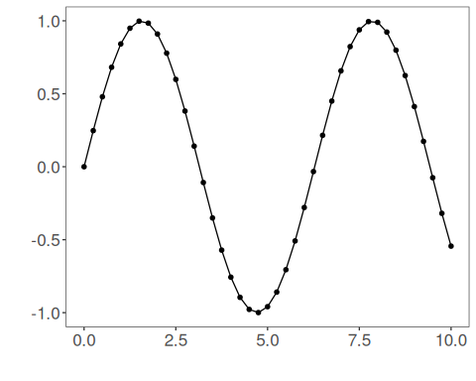

# Sliding windows  
  
sw_size <- 5  
ts <- ts_data(tsd$y, sw_size)  
ts_head(ts, 3)

## t4 t3 t2 t1 t0  
## [1,] 0.0000000 0.2474040 0.4794255 0.6816388 0.8414710  
## [2,] 0.2474040 0.4794255 0.6816388 0.8414710 0.9489846  
## [3,] 0.4794255 0.6816388 0.8414710 0.9489846 0.9974950

# Projection (X, y)  
  
io <- ts_projection(ts)

# Input data (X)  
ts_head(io$input)

## t4 t3 t2 t1  
## [1,] 0.0000000 0.2474040 0.4794255 0.6816388  
## [2,] 0.2474040 0.4794255 0.6816388 0.8414710  
## [3,] 0.4794255 0.6816388 0.8414710 0.9489846  
## [4,] 0.6816388 0.8414710 0.9489846 0.9974950  
## [5,] 0.8414710 0.9489846 0.9974950 0.9839859  
## [6,] 0.9489846 0.9974950 0.9839859 0.9092974

# Output data (y)  
ts_head(io$output)

## t0  
## [1,] 0.8414710  
## [2,] 0.9489846  
## [3,] 0.9974950  
## [4,] 0.9839859  
## [5,] 0.9092974  
## [6,] 0.7780732