PLA Outer Rim
Tire body V1.1
Radius of curvature of sketch1: 250mm
Arc angle between 2 center points: 5degrees (arc length: 22.51475mm)
Tire body V1.2
Radius of curvature of sketch1: 252mm
Arc angle between 2 center points: 5.3deg (arc length: 23.99mm)
Never printed v1.2, was a fix to an issue that didn’t exist.

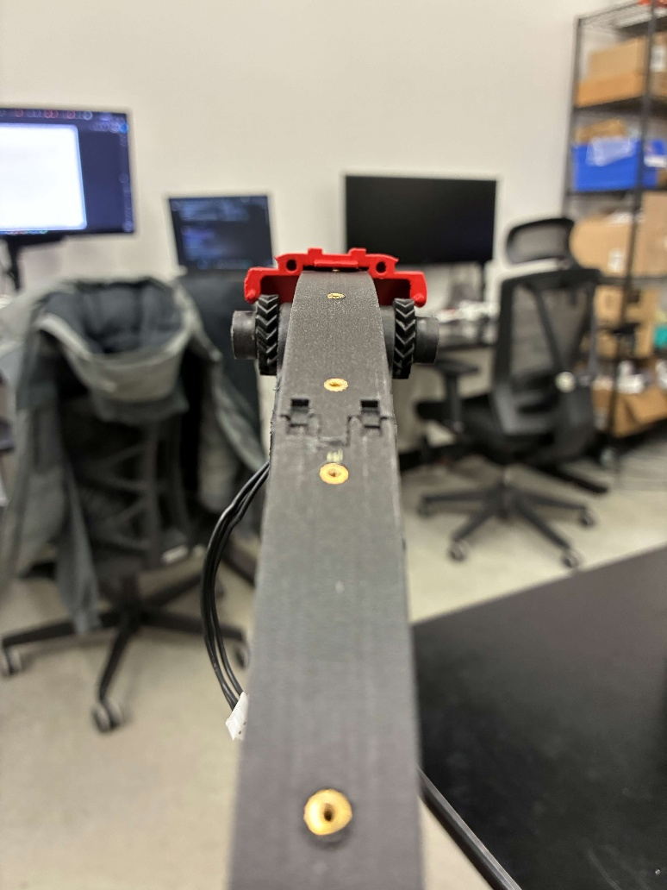
Interference on right side
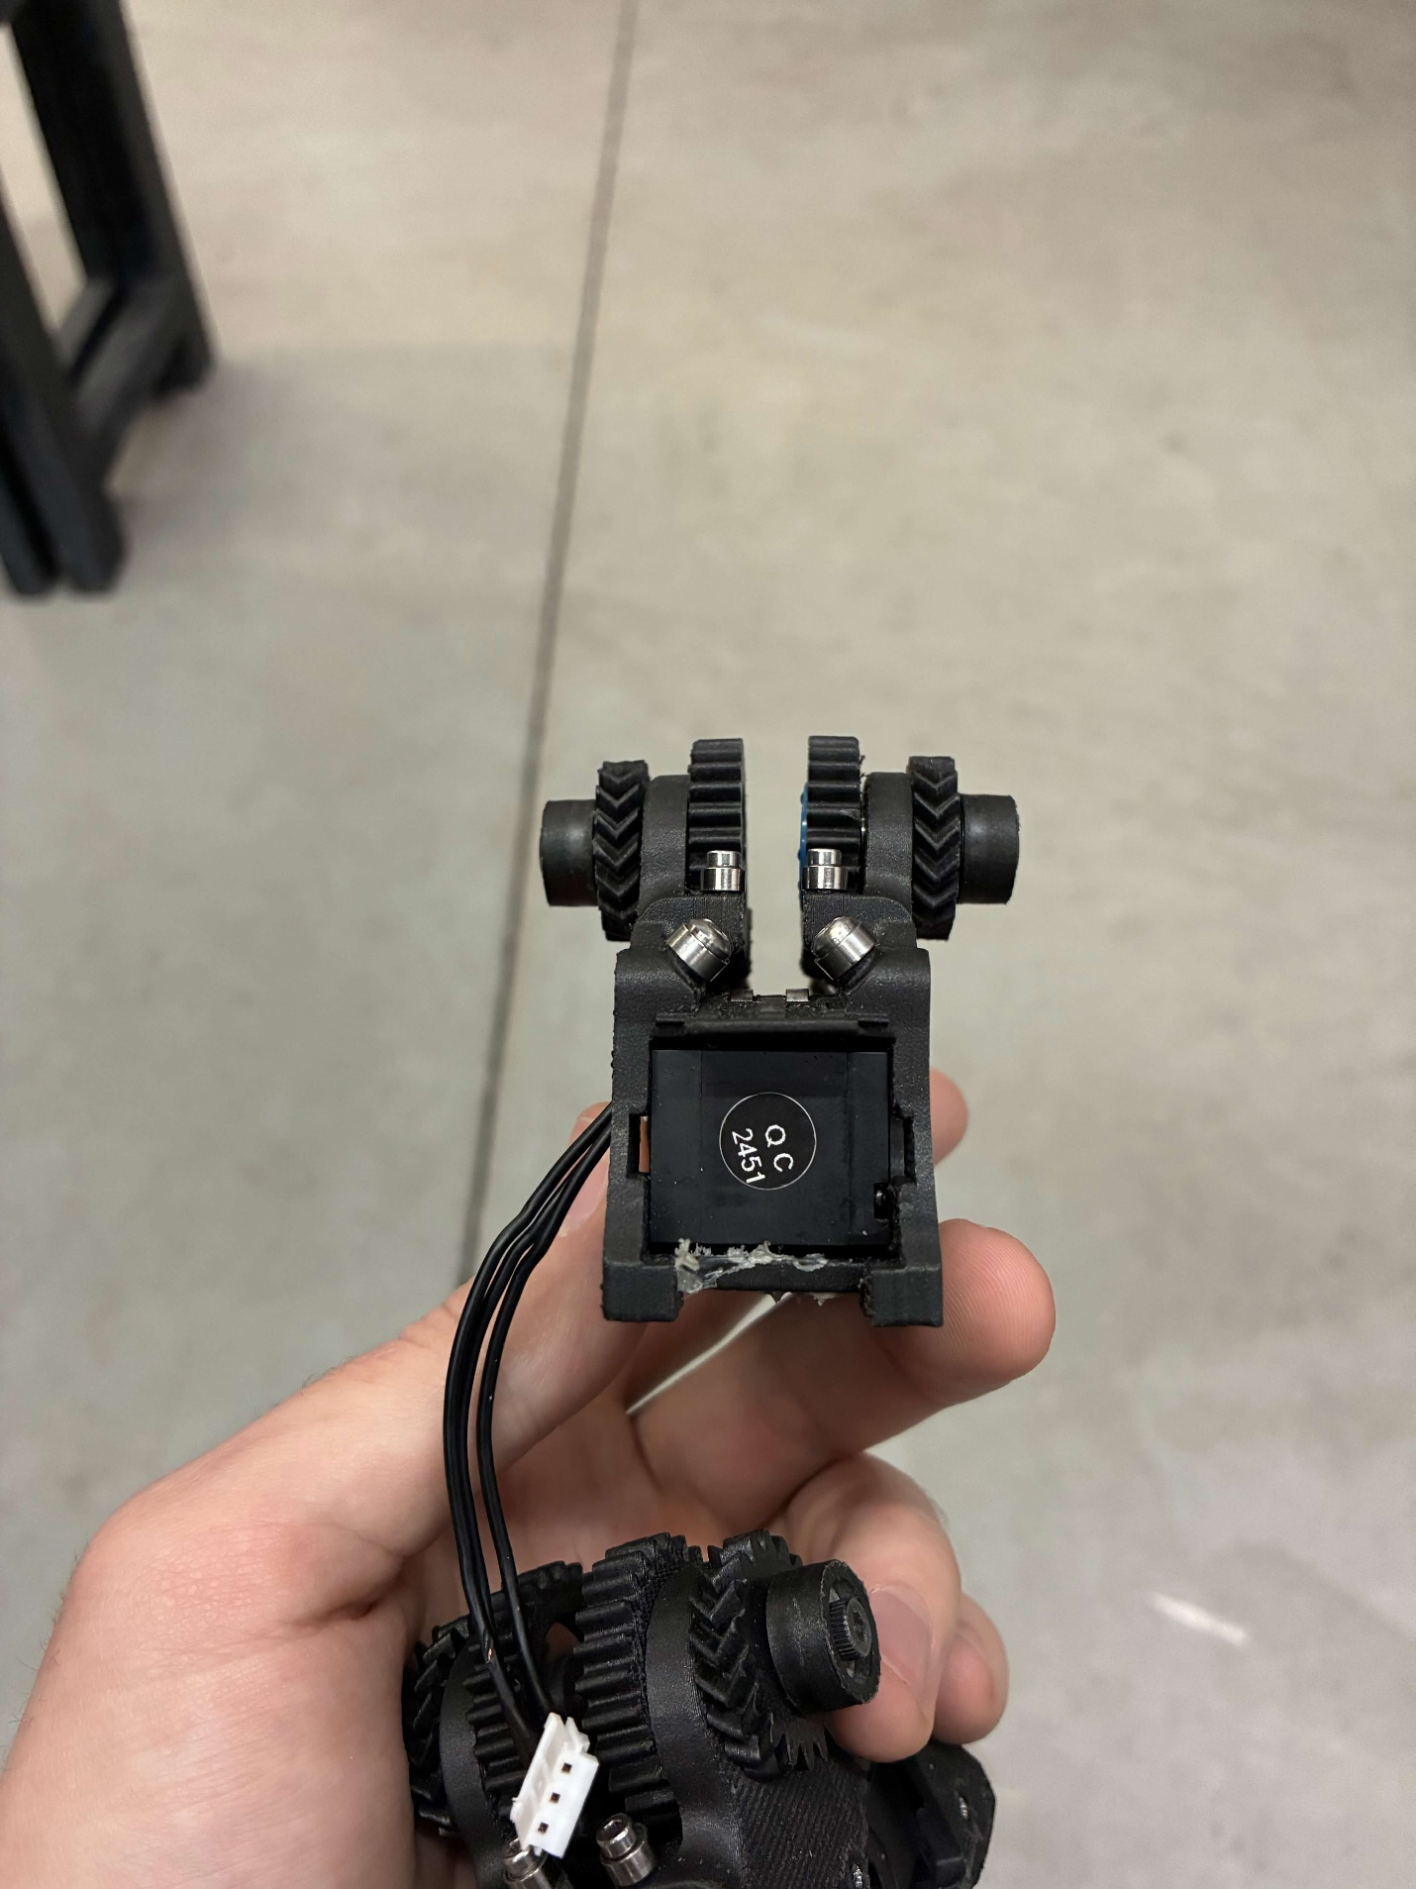
Bent
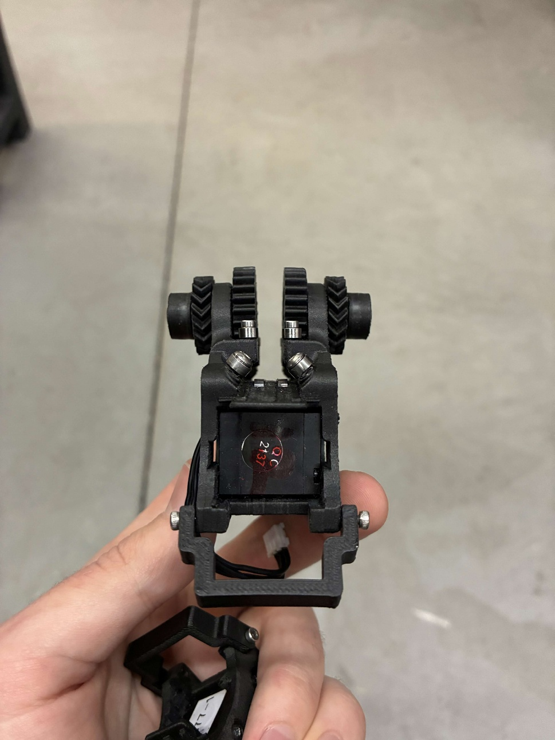
Normal
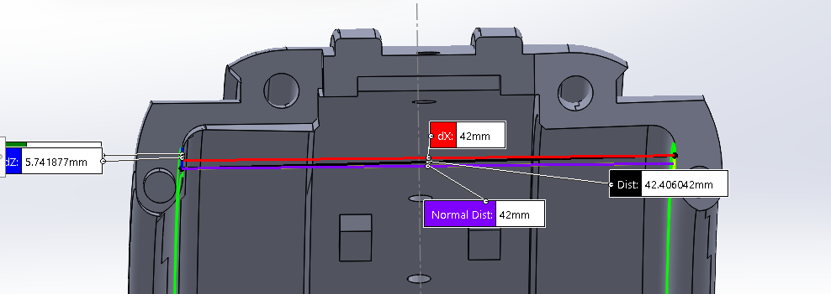
V1.1 shows 42mm, V1.1 piece measures ~41.7mm, old piece measures ~42mm. Moderate variability due to support remnants and low print quality where supports used to be connected.
V1.3
I increased this distance to 44mm by reducing the thickness of the flange by 1mm on each side. To do this, I also had to reduce the peg diameter from 2.2mm to 1.8mm, and the hole diameter from 2.7mm to 2.2mm.

TPU Tire:
Full TPU tire print is nasty, supports are very hard to remove. Raise3D E2 printer can maybe multi extrude for PLA supports. Downloaded ideaMaker to try and print on the E2 using files and templates from Kenta.
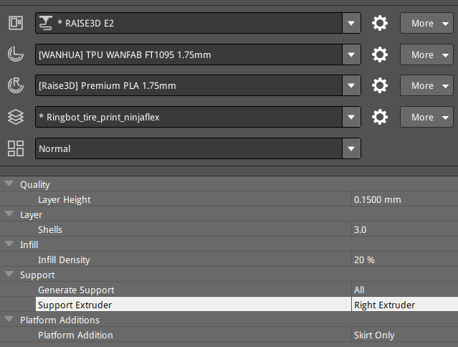
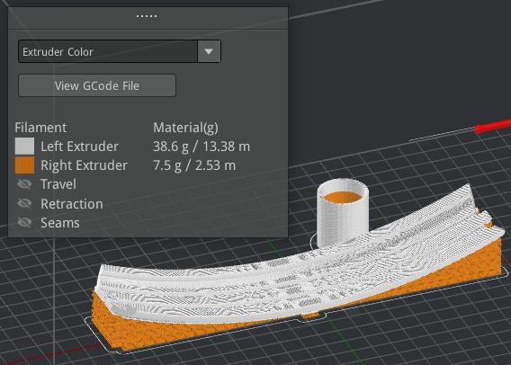
55C bed temp failed, trying 60. 60 worked, but issue was not bed temp, it was z-calibration of right extruder. TPU printed with PLA support, but there was one layer of TPU between the main body and supports.
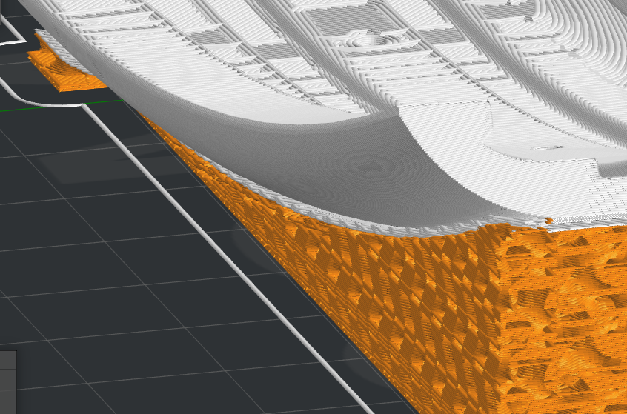
For some reason, slicer is adding in an extra layer of TPU, as shown in white, between the main body and the PLA supports.
- Dense support material from TPU to PLA
- Vertical offset layers = 0
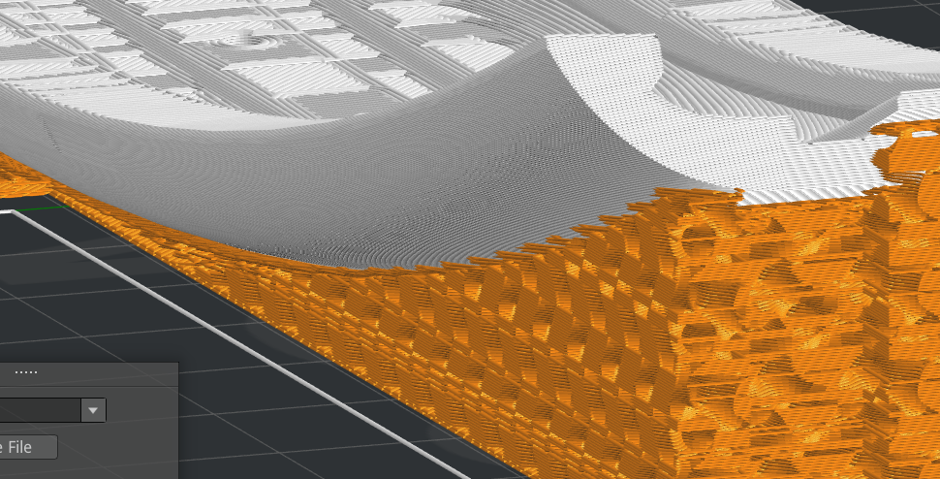
This change made it a bit easier to separate the supports, but it still took a decent amount of time to remove them. Either way, the new part looks nicer.
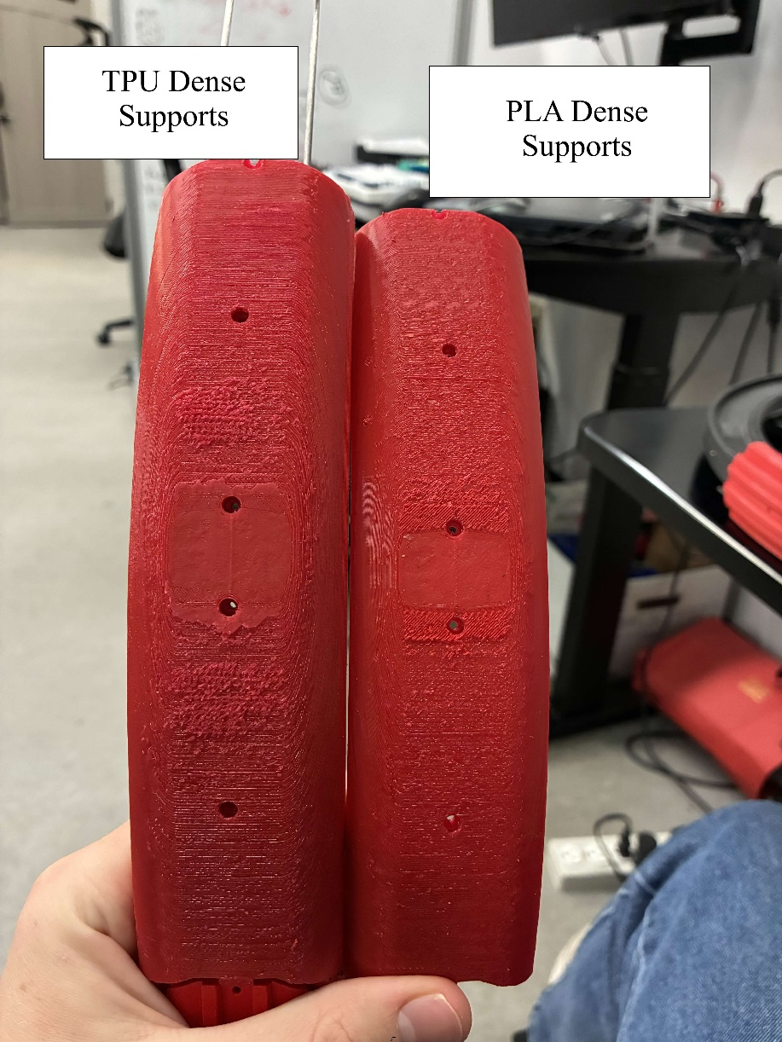
Vertical top offset layers 0 -> 1
Dense support infill 80% -> 70%
This led to easier removal, but removal time was still about 45 min – 1 hour.

Support Infill Type: Gyroid -> Lines
PLA Temperature: 225C -> 200C
Dense Support Fill: 70% -> 55%
Bits of PLA stuck in TPU
Dense Support Fill: back up to 80%
Support Infill Type: back to Gyroid
Enable Cooling Fans
This worked! PLA and TPU separated quite well. 15-20 mins per part of support removal. Printing the remaining tires with these settings.
Printing 2 pieces at once kept failing, so final 2 pieces will be printed one at a time.
Single piece failure.
Applied more glue, single piece success

Drive Module
Needed to assemble one drive module:
- 2 servos
- 2 motor shaft flange
  - Taken from motors in boxes
- 24 M1.5 screws: 4 per flange, 8 per motor for mounting
  - In little baggies in Robotis box
  - Use shorter screws for the flange, otherwise they stick out and interfere with servo
- 4 M2.5 screws: 2 for motor shaft, 2 for small gears shaft
  - M2x10 for motor shaft
  - M2x22 for small gears, couldn’t find, using M2x20
- 1 left 51 tooth Herringbone
  - Printed
- 1 right 51 tooth Herringbone
  - Printed
- 1 left 14 tooth Herringbone
  - printing
- 1 right 14 tooth Herringbone
  - printing
- 2 wheel spur gear
  - printing
- 2 rings
  - Created in CAD, added chamfer to assist with bearing placement
- 2 thrust ball bearing 16mm OD 8mm ID
  - McMaster bags in Ringbot box
- 2 washers for the thrust bearings
  - Same bags as thrust bearings
- 2 radial bearing 10mm OD 3mm ID
  - Found in McMaster bags in ringbot cardboard box
- 2 radial bearing 12mm OD 8mm ID
Weird 2 ended bent Phillips head tool works for M2 and M2.5

Ring housing for 10mm bearing
Couldn’t find in assembly, redesigned in CAD. 10mm ID, 13mm OD, 6mm height, slight chamfer for bearing insertion

Spur Gear:
Bearing and washer nominal diameter is 16mm, current housing hole is 16.35mm, CAD dimension is 16.4mm. Changing from 16.4mm to 16mm. Printed, bearing fits, but the gear is too thick. Changing thickness from 6.4mm to 5.8mm. This worked and meshed well when mounted to the rack, at first, but then the mount became very tight. I think this is because of the thrust bearings. I’m increasing the recess hole depth by 0.3mm. This worked. Shaft hole is a bit too small for M3 screw to bite, had to use drill. Increasing from 2.6mm to 2.8mm for future use, but not going to reprint.

Drive Module Body:
Sanded support side where 14 tooth Herringbone and 25mm spur contact the body.

Large Herringbone Gear (51 teeth)
I noticed that the screws I used to attach the flange to the gear were sticking out the other end of the flange and rubbing on the servo when spinning, so I replaced them with shorter screws. This removed the screw-servo interference, but now the gear itself is rubbing on the body of the drive module. Dist from servo to gear surface is 3.9mm (calipers), while thickness of drive module body is 3.75mm (calipers). Extruding mount face of gear an extra 0.3mm. Gear and body no longer rubbing, large gear and small gear meshing remains good. Printing 2 more for second drive module.

Electronics Assembly Checklist
- Mechanical drive module
- BNO IMU
  - Press fit into indent between large gears
- Raspberry Pi
  - Screws in on top of IMU, SD facing towards battery
- U2D2 controller
  - Press fit into body cover
- Body cover
  - Screws into main body, big hole opposite battery side
- XM430 W210 motor
  - Bottom cover removed, rest of motors screws into body cover
- 2/1 voltage regulator standoffs
  - Screw into side of motor
- 2/1 reg19a voltage regulators
  - One module needs 2, other module needs 1
  - Screw into standoffs
- Screws
  - 2 M2.5x5mm for RPi
  - 2 M2.5x5mm for each voltage regulator standoff
  - 2 M2.5x12mm for cover
Body Cover
Divot added to account for plastic cover in leg base motor
Resoldering

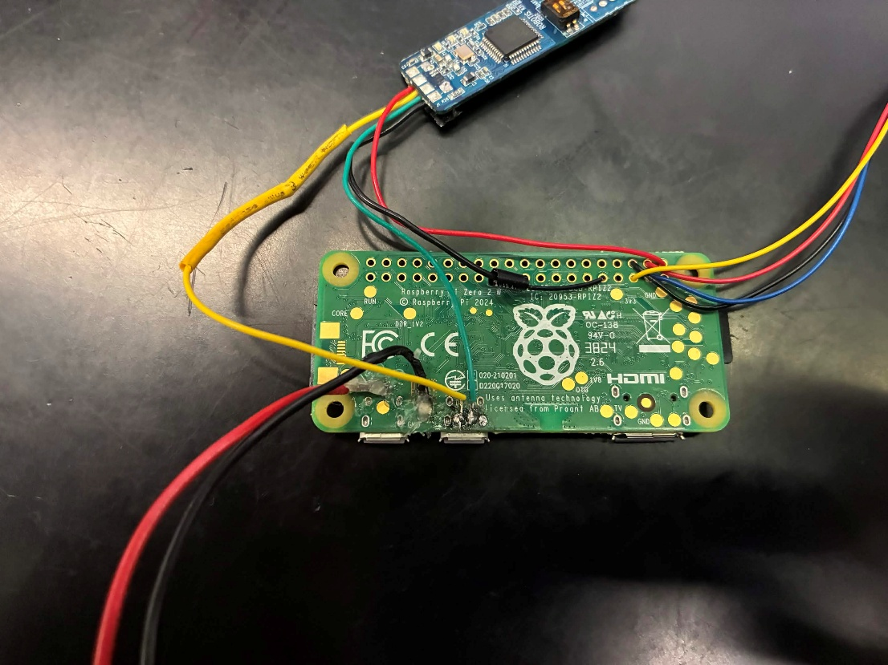
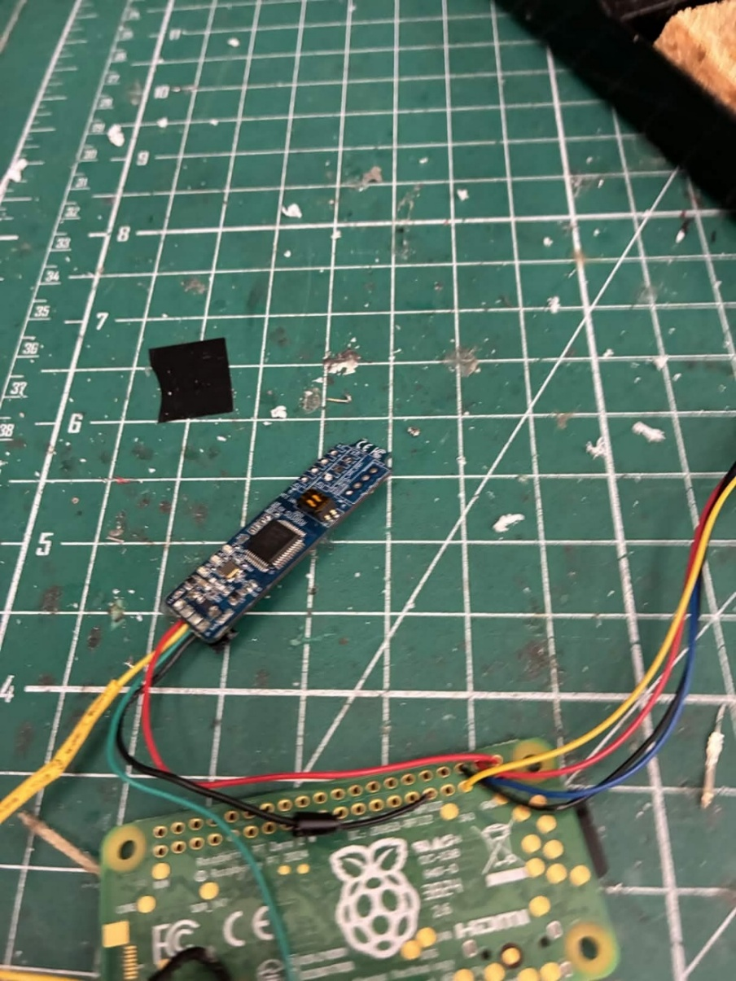

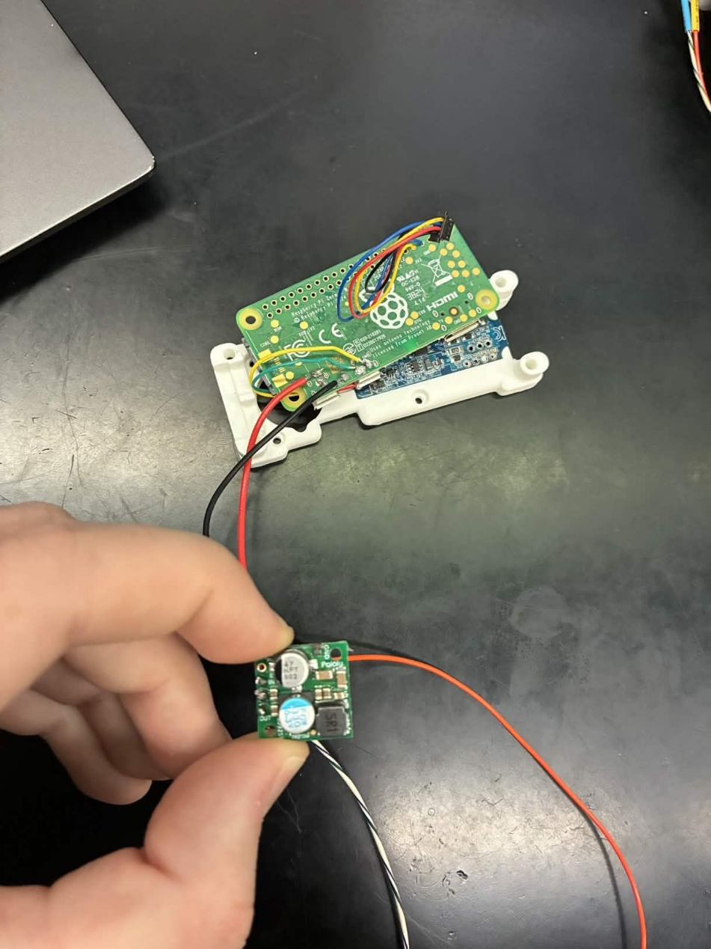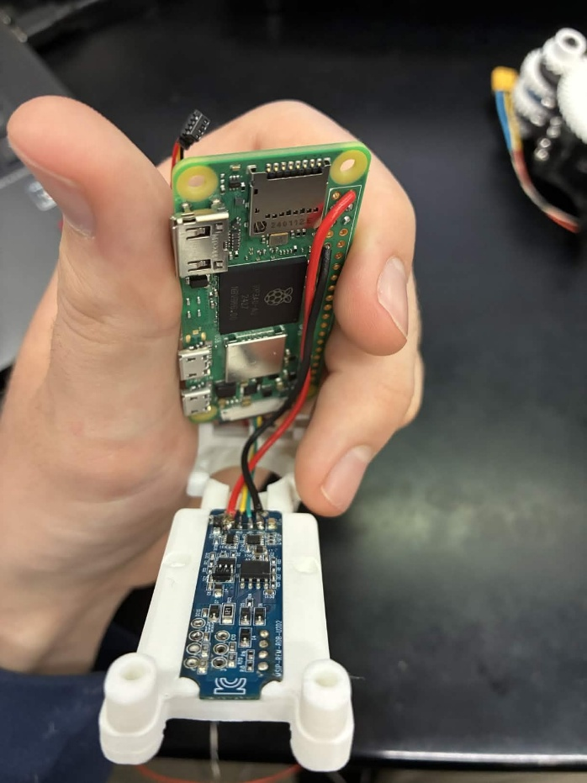
After initial resoldering followed by many changes, tweaks, and fixes, this is the Raspberry Pi with it’s connection to the voltage regulator, the U2D2 motor controller, and the IMU (not pictured, contects the 4 pin Stemma QT connector).
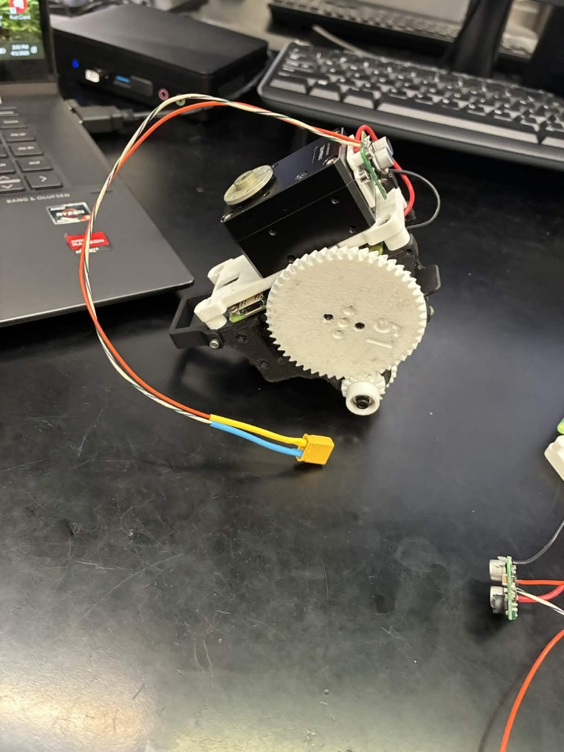
Partially complete drive module assembly. Still missing the headers that communicate across the telephone wire.
Next I began working on the inter-module connectors, specifically the telephone wire. After being taught how to crimp wires, I went through much trial and error crimping the 6 telephone wires and attaching them to male connectors. I then soldered the male connectors to their respective wires on the drive module and glued them into the drive module, as shown below.
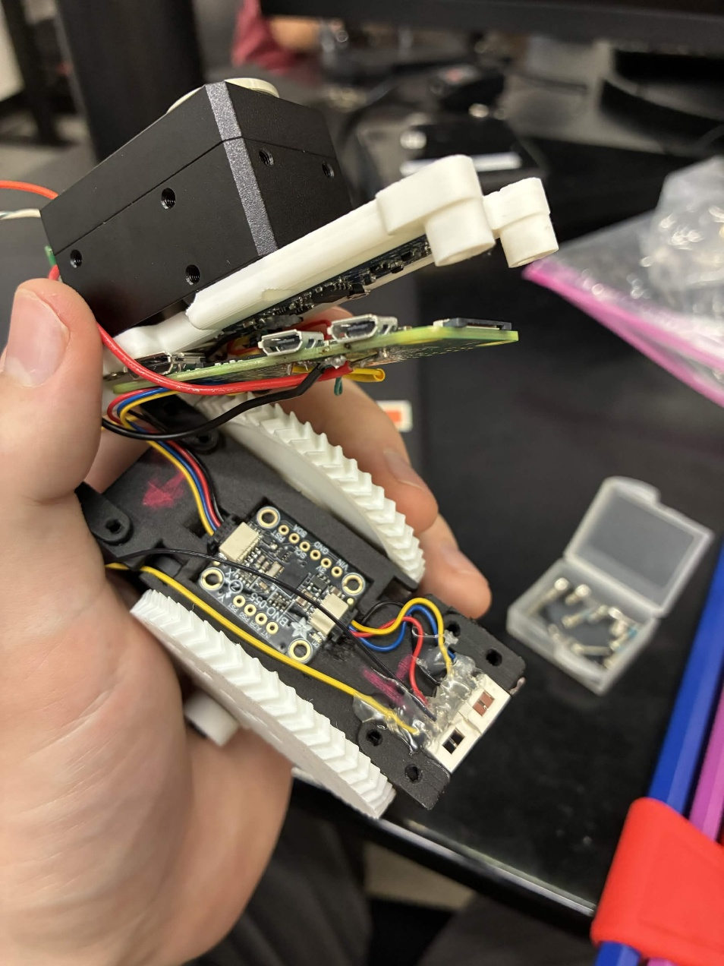
After gluing the connectors, I ran into an issue when screwing the Raspberry Pi and the cover onto the drive module. The glue was a bit too thick which prevented the cover from fitting properly. I carefully removed the glue, trying hard not to break any of the solder connections on the female connectors. I then reglued the connectors, this time pressing into the hot glue with the broad side of wire cutters to minimize the profile of the glue.
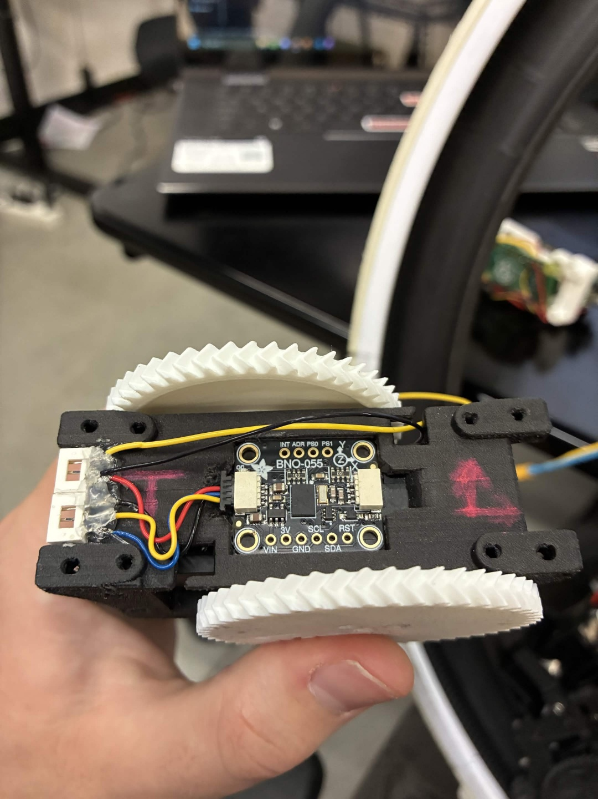
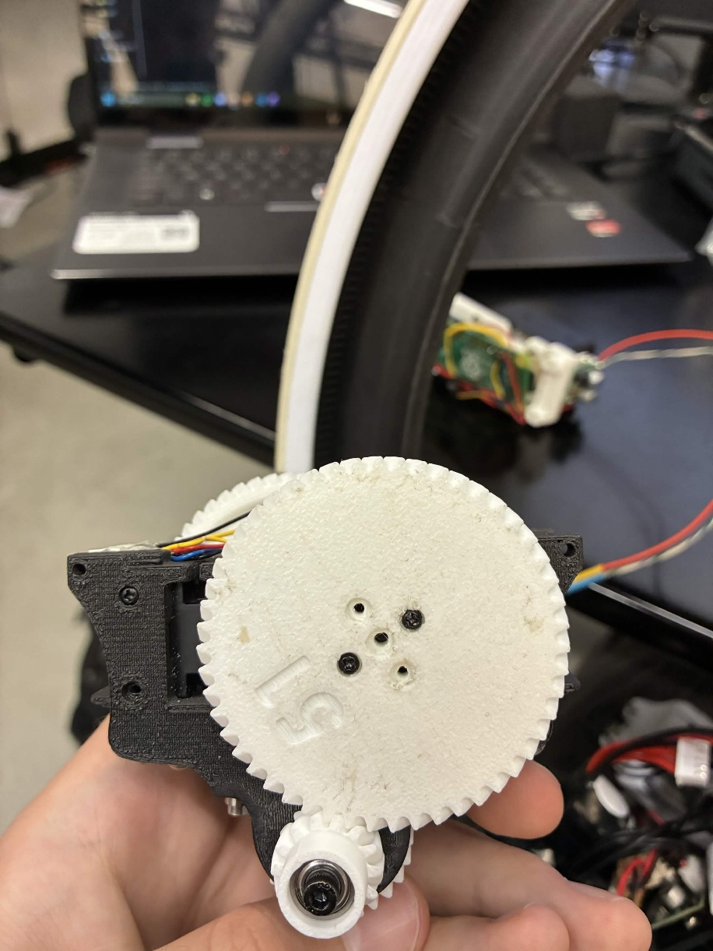
After regluing, the Raspberry Pi and the cover fit.
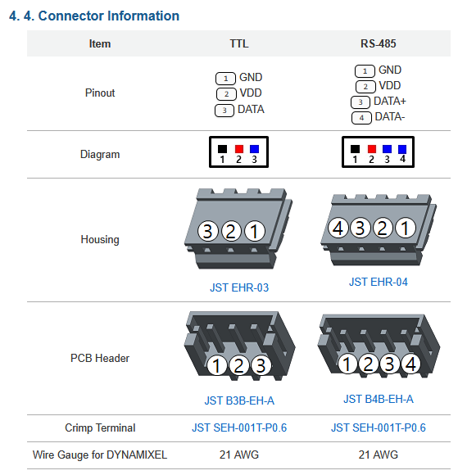
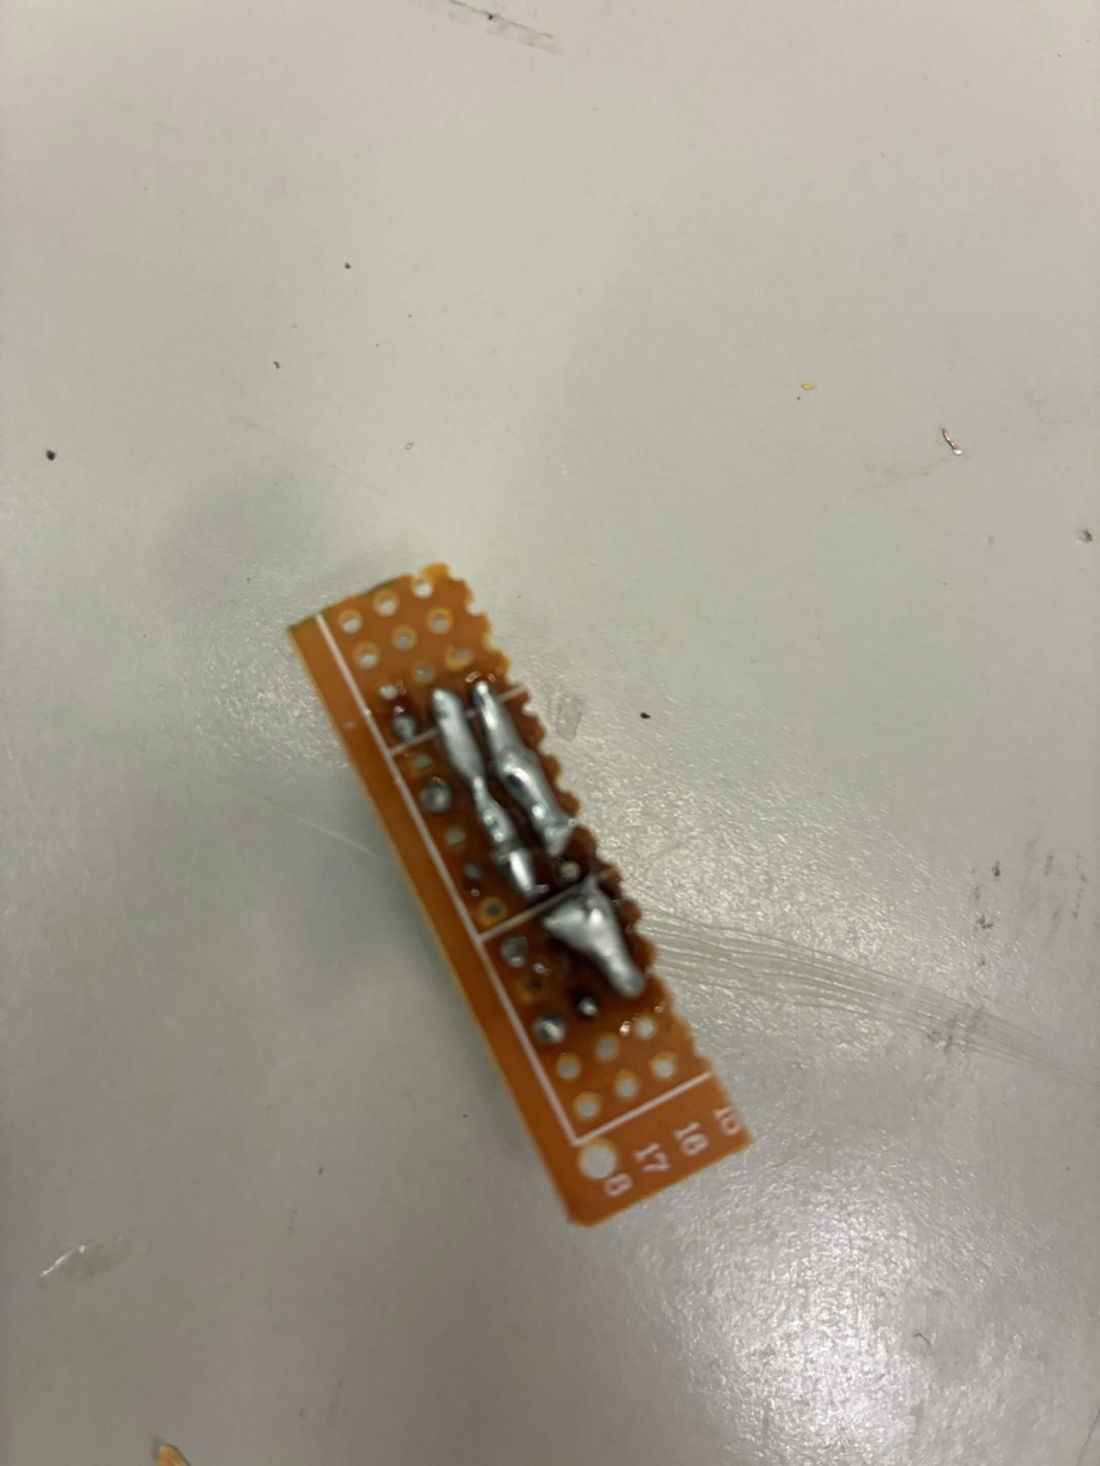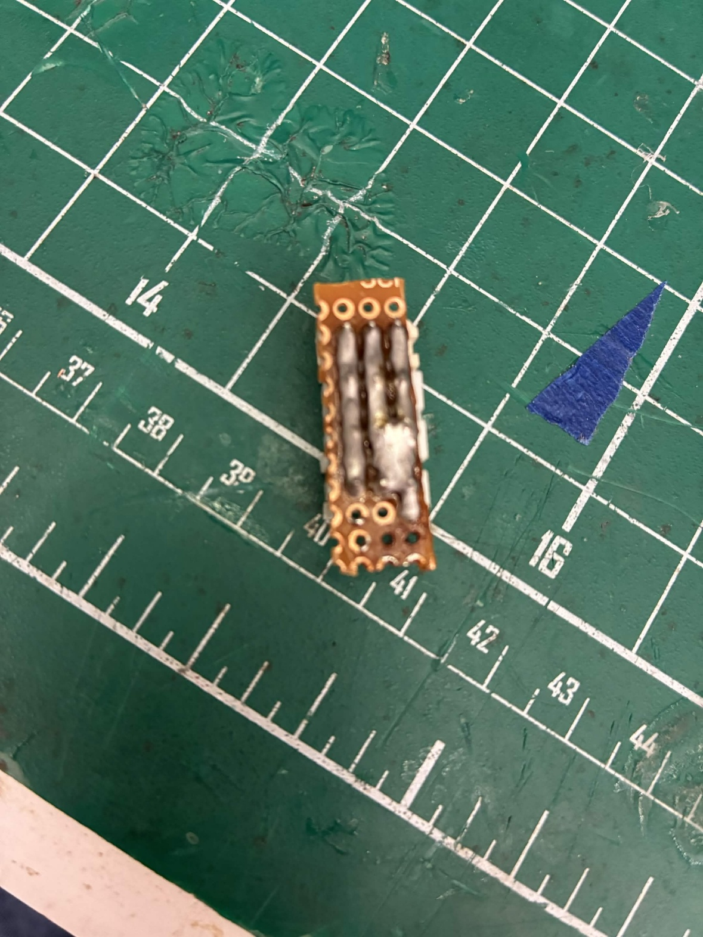
Next I began working on the perfboard that connects all of the motors to the batteries, each other, and the U2D2. At first I followed the previous designs, using lines of solder on the bottom of the perfboard to connect all power, ground, and data ports of the connectors to each other. This was a very volatile system, as one little mistake would cause these solder lines to fuse as seen above, and this was very difficult to undo. I then decided to use a piece of stripped solid core wire to connect the connectors to each other, simply soldering the connectors to the wire instead of using lines of solder. This worked quite well and I think should be used in future iterations.
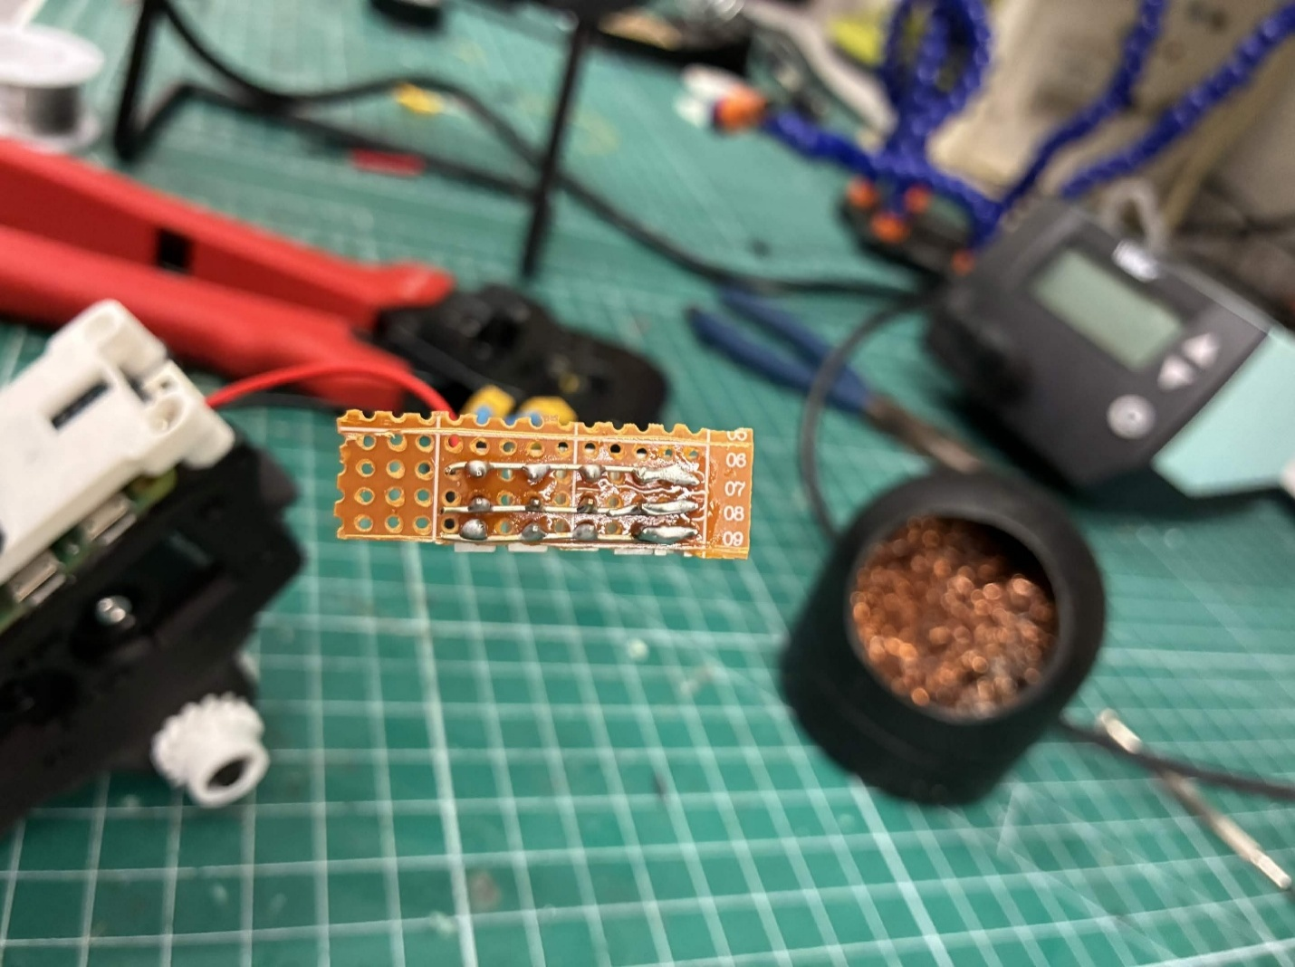
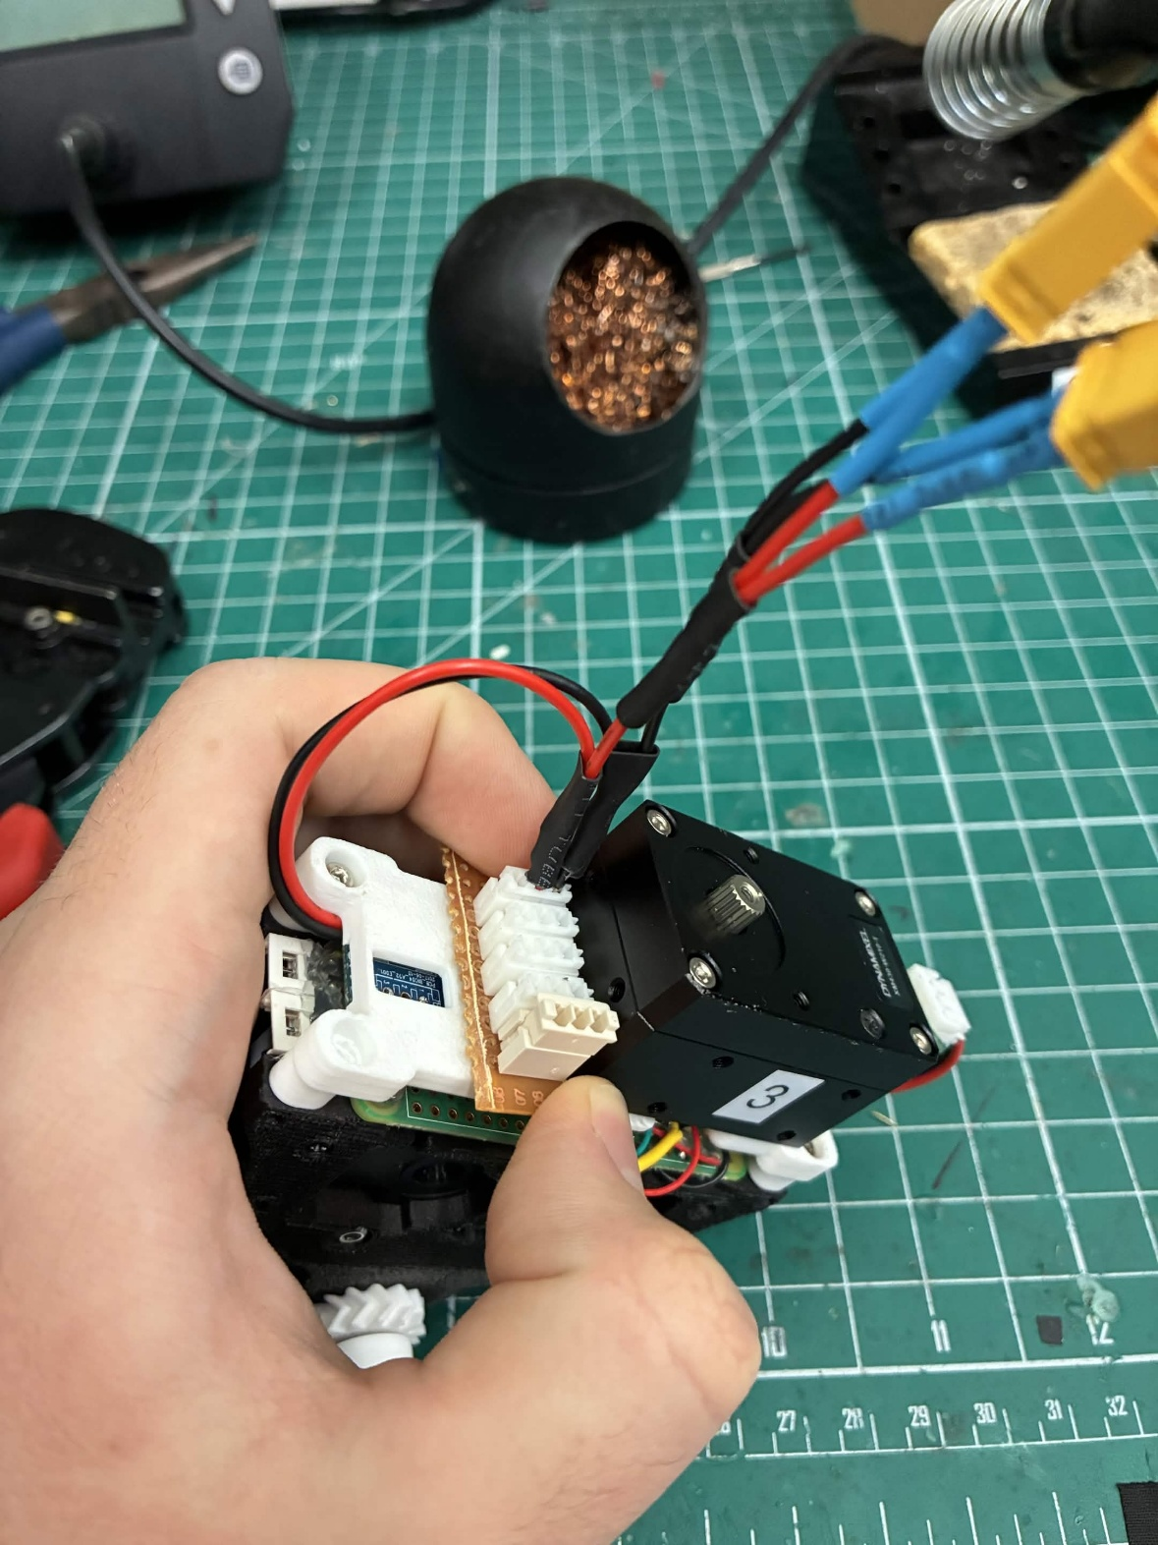
The above figure shows the battery connector, which was made by making two 3-way splices of wire. One splice had the red power line from each battery connector as the input and a red wire as the output, and the other splice had the same but black for ground. These outputs were then spliced into another set of two 3-way connections, with one end combining the battery connector wire output wire with the voltage regulator wire, and the other end having a crimped wire that attached to the perfboard connector. The end result connects two batteries and the voltage regulator to the perfboard, ensuring the voltage regulator wires route underneath the body cover and out to the other side of the drive module to attach to a connector on the voltage regulator.
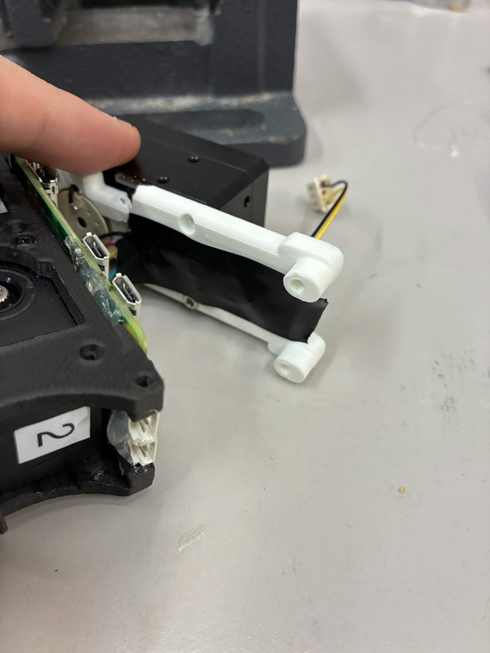
At this point, I also ensured to put a piece of tape over the U2D2 to prevent any interference between the U2D2 and the Raspberry Pi. This concluded the wiring that needed to be done for the primary drive module, and so I was ready to move on to the legs.

Wiring To-Do List (one module)
☒Connector that splices two battery recievers, one end has two female connectors for battery connections, the other end has power and ground wires to be soldered to perfboard
☒Crimp wires that go from voltage regulator under motor to perfboard
☒Perfboard needs solder line for all connections
☐Servo 3 to perfboard via stock connector wire
☐Servo 2 to perfboard via stock connector wire
☐Servo 1 to perfboard via stock connector wire
☒Black and yellow telephone wires crimped for connection to servo 1
☒Connector between U2D2 and perfboard, one side is connector, one side is direct solder
☒Redo perfboard

Leg
Assembly Checklist
- 2x XM430 Motors
  - Not including the base motor attached to the drive module
- 1x PLA Foot
- 1x PLA Leg Part 1
- 1x PLA Leg Part 2
- 1x PLA Leg Part 2 Cover
- 2x HN12 I101 servo horn
  - For wire organization
  - In big McMaster bag
- Leg battery
- M2.5x6mm Screws
  - For fastening to motor bodies
- M2x5mm Screws
  - For fastening to motor horns

The motors mounted on the legs utilize the HN12-I101 motor horn, which allows for wires to route through the motor and out of the back, directly opposite the active shaft. This prevents wire tangling and helps with wire harnessing.
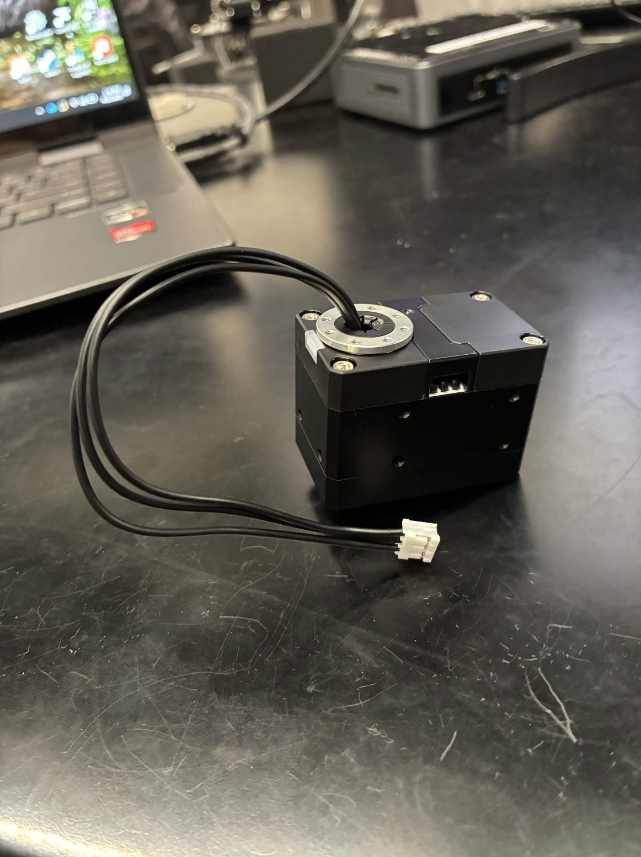
After attaching the new horns and routing the wires through the motor, I began assembling the leg using parts I had 3D printed with the P1S. I quickly ran into an issue with screw interference. The smallest screw size I could find for M2 screws in the lab, 5mm, was too long, and would poke through the standard servo horn and scratch the motor surface, as shown below. This caused heavy friction, so I decreased the depth of the counter bore on the white part pictured below by 0.5mm and reprinted the part. This fixed the issue.
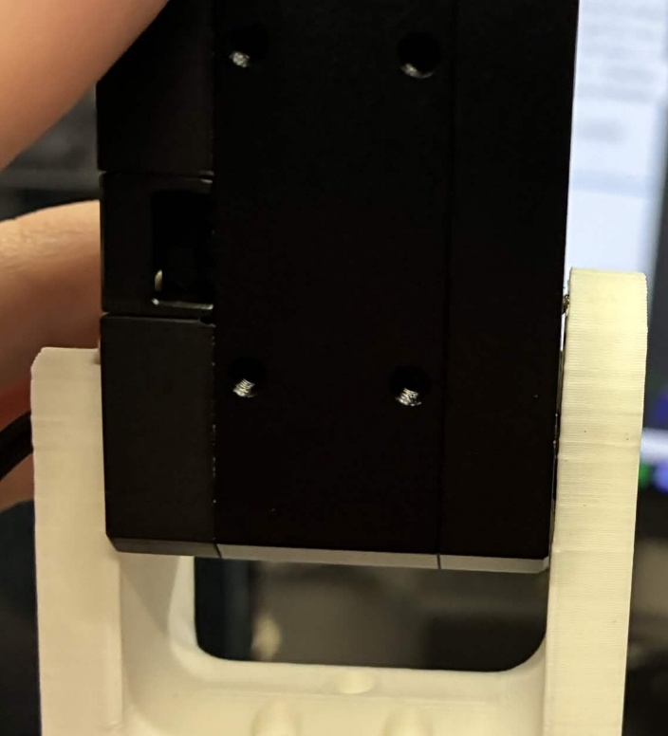
The rest of the assembly went quite smooth, yielding the following two Ringbot legs.
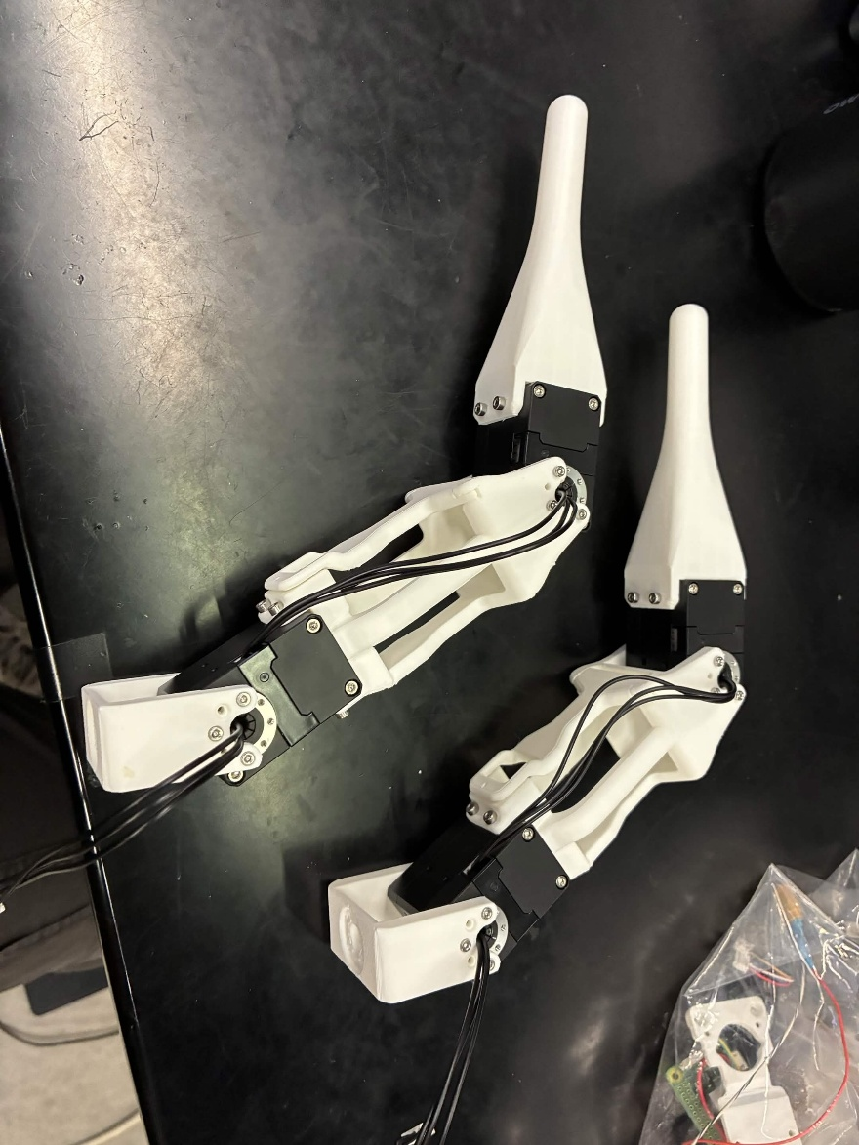
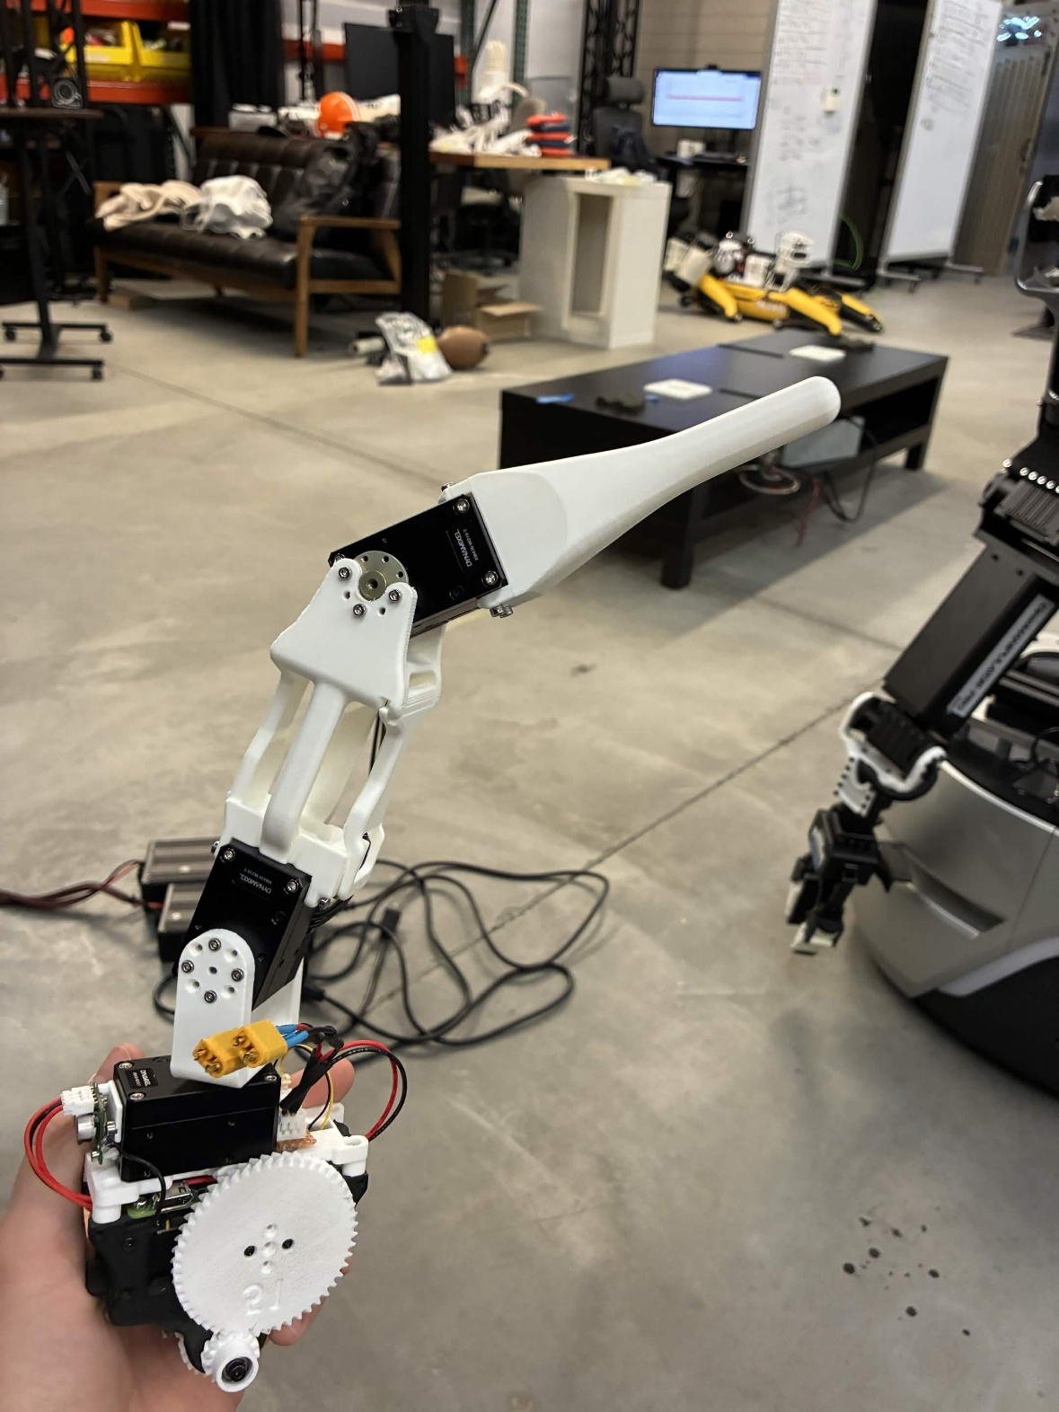
After attaching the leg to the primary module, one leg of the Ringbot was officially completed. This marks the final milestone I was able to complete this semester, I unfortunately ran out of time to finish the secondary drive module. That being said, the future work for this project consists of first finishing the secondary drive module, which is already partially completed. The IMU and telephone cable connections need to be attached, then the 3D printed Raspberry Pi stand-in can be attached. The U2D2 can then be attached the body cover. Another perfboard needs to be made and attached, and another battery connector needs to be made and attached as well. Finally, all data, power, and ground connections need to be connected to the perfboard, and the second module will be completed. At this point, the project will be ready to move on to testing.

Simulation

- Terminal 1:
roscore
- Terminal 2:
source ~/ringbot_ws/devel/setup.bash
rosrun mujoco_sim ringbot_sim
- Terminal 3:
source ~/ringbot_ws/devel/setup.bash
rosrun ring_robot_ros ringbot_control_node

To switch between sim and hardware files, swap out the files, then run
cd ~/ringbot_ws
catkin_make -Dmujoco_DIR=~/mujoco_install/lib/cmake/mujoco

