Stafford Scheduling
Current Setup & Path Forward
CTP Platform
June 21, 2026

Contents
1. The dataset at a glance
2. What the current Genius plan actually does
3. The real bottleneck is a handful of single machines
4. Data points we need Stafford to confirm
5. Why this matters to Stafford

Purpose: align on how Stafford’s work should be scheduled before we tune CTP further. This is a discussion document built from your own data, not a verdict.
Data analysed: the 3 June 2026 Genius snapshot (the full Stafford dataset — not the slim demo). All figures below come straight from that export.
A note on framing: Genius is doing what an ERP planner does — laying out the work at infinite capacity. CTP’s role is to add the finite-capacity reality on top (real shifts, one job per machine) so the dates reflect what the floor can actually deliver. The aim here is to align on inputs, not to second-guess Genius.

1. The dataset at a glance
 | Count
Total operations in snapshot | 2,563
Completed | 179
In progress (running) | 173
Locked / pinned | 4
To be scheduled | 2,207
Work-hours to be scheduled | ~8,234 h

Of the work to schedule, ~69% runs on single named machines/people (one job at a time) and ~31% on multi-capacity work-center pools.

2. What the current Genius plan actually does
When we line the snapshot up against a realistic working calendar, the Genius plan leans on two things the floor can’t physically do — because, as an infinite-capacity planner, it isn’t trying to model them:
(a) It runs single machines around the clock. 94% of named-machine operations are scheduled as continuous elapsed time — start, then run nights and weekends straight through. Across the near-term window it’s effectively all of them (685 tasks). Example, operation 28485-F (Fabrication, 144 h) on machine GRANT:
 | Span
Genius plan | Wed 20 May 10:33 → Tue 26 May 10:33 = 6 days straight (through the weekend)
Realistic (one 8 h shift, Mon–Fri) | ~4 weeks

None of the near-term named-machine tasks respect an 8 h/day shift.
(b) It puts many jobs on one machine at the same time. Named machines can only do one job at a time, yet the plan stacks several at once:
Machine | Jobs | Most running at once
MURRAY | 568 | 29
CONRAD | 95 | 8
ANDREW BARRY | 70 | 8
HAYDEN | 41 | 7
GRANT | 22 | 4

29 of 41 machines are over-booked this way. The clearest example is MURRAY, the QC/inspection function — 568 short checks (avg 16 min) all funnelled through a single station, peaking at 29 inspections booked at the same moment:
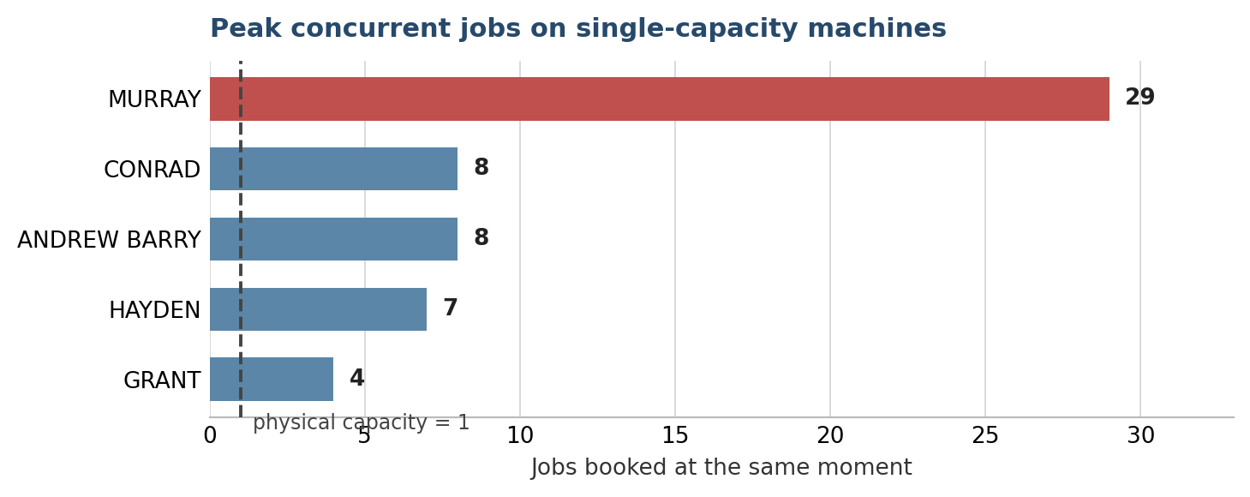
In short: this is an infinite-capacity plan — Genius lays out the work, but not against the hours and machines the floor actually has. That’s by design; an MRP-style planner plans, it doesn’t finite-schedule. CTP adds the finite-capacity layer — one job at a time, on real shifts — which is why the dates move out. It’s complementary to Genius, not a correction of it.

3. The real bottleneck is a handful of single machines
The pooled work centers are fine. The pressure is on specific named resources carrying months of work on a single shift:
Resource | Work-hours queued | At one 8 h shift
GRANT | 1,144 h | ~28.6 weeks
DYLAN | 653 h | ~16.3 weeks
HAYDEN | 377 h | ~9.4 weeks
JAMES | 320 h | ~8.0 weeks
WERNER | 273 h | ~6.8 weeks
CONRAD | 238 h | ~5.9 weeks
FABRICATION & WELDING (pool, cap 11) | 773 h | ~1.8 weeks
POLISHING (pool, cap 4) | 309 h | ~1.9 weeks
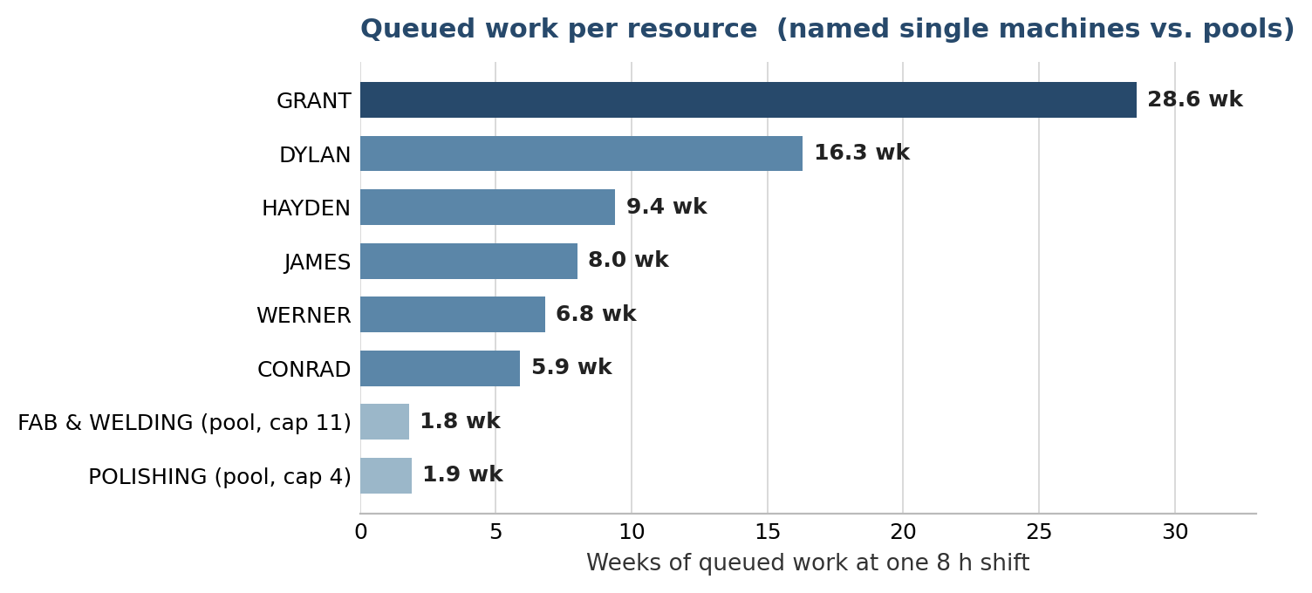
GRANT alone holds ~1,144 hours — over six months of single-shift work — and on the current model that single resource largely defines the schedule length.
One important caveat: that figure assumes the current Genius setup, where these big fabrication operations are pinned to GRANT specifically. If they can float across the qualified fabrication pool instead of staying bound to one name, the load redistributes across every capable resource and GRANT stops being the wall — the same way the cap-11 Fabrication & Welding pool already clears 773 hours in ~1.8 weeks rather than concentrating it on one person. How much it softens depends entirely on which resources are interchangeable, which is exactly what we ask you to confirm in §4, item 3. So read GRANT as the bottleneck under today’s pinning, and the pinning question as the single lever most likely to move it.

4. Data points we need Stafford to confirm
These are the levers that decide what “scheduled” means. Today the model is guessing on each:
1. Working calendars (shifts). What hours does each resource really run?
  - Is the standard one 8 h shift, Mon–Fri? Two shifts? Any 24/7 cells?
  - Do welders/machines like GRANT, DYLAN, HAYDEN run extra shifts? (If GRANT runs two shifts, its 28-week queue roughly halves.)
2. Parallel capacity. How many operators/machines can each resource run at once?
  - Genius field NumOfAvgResource says e.g. Fabrication & Welding = 11, Polishing = 4. We’ve now wired that into capacity (it was being ignored). Please confirm those counts.
  - MURRAY is the QC/inspection function — 568 short checks (548 QC ops, ~16 min each), but flagged capacity 0 so it’s treated as a single station. The plan routes up to 29 inspections through it at once (chart above). Is QC one inspector, or a function that runs many in parallel? This single setting changes a lot of promise dates.
3. Machine binding vs. pooling. Should an operation be locked to one named machine (e.g. GRANT), or float to whichever qualified machine/operator is free?
  - Today the big Fabrication operations are pinned to individual people, which is what creates the GRANT bottleneck (see §3). If they can float across the Fab pool, the picture changes dramatically.
4. Gaps between steps (LagHours). Genius shows a default 4 h lag on ~94% of links. Is that a real hand-off/cure time to enforce, or just a default we should ignore?
5. The existing backlog. The near-term load genuinely exceeds capacity. We should agree that CTP will show realistic promise dates and lateness rather than a plan that only “fits” by over-booking — so you can see true late-delivery exposure and decide where to add shifts, outsource, or re-sequence.

5. Why this matters to Stafford
Your priority is avoiding late-delivery penalties. Because Genius plans at infinite capacity — running machines around the clock and stacking jobs on one station — the backlog stays invisible until it lands as a late delivery. CTP scheduling against your real calendars and capacity does two things:
- Shows true promise dates per order, and exactly which late jobs are driven by which bottleneck (today: GRANT and a few single machines).
- Makes the capacity decision concrete — “GRANT has 28 weeks of work on one shift” is a number you can act on (second shift? more welders? float the work?), instead of a plan that quietly slips.
Once we’ve aligned on the five items in §4, we re-run the full dataset and show the realistic schedule, promise dates, and the specific bottlenecks — and from there it’s a straight conversation about where capacity is worth adding.
Prepared from the 3 June 2026 Genius snapshot. Figures are reproducible from the productionTaskWithAdvancedInfoViewEntity export + resource calendar/capacity records.

