Megan Wendell

Christine Harvey

Organ Transplant Data Redesign

The Organ Procurement and Transplantation Network (OPTN)[1] is a public-private partnership organization that links all parties involved in the donation and transplantation system. It records and manages all data on the transplant system in the United States. In their Annual Data Report for 2012[2], the section on Deceased Organ Donation includes a set of poorly designed graphs showing organs recovered and organs transplanted by state. By combining the data included in these maps with additional information regarding specific organ types, donor gender, and total population, a set of superior plots was created that provides additional context while maintaining a simple, elegant design.

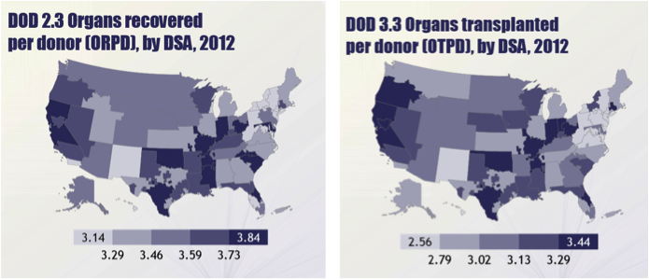

The first set of plots shows organs recovered per donor (ORPD) and organs transplanted per donor (OTPD) by state. Their main benefit is the ability to show geographical trends; however, they do not show information about specific organ types. Additionally, the geographical regions are defined by Donor Service Area (DSA) rather than state, which, to an average observer not intimately familiar with the transplant system, is less intuitive.

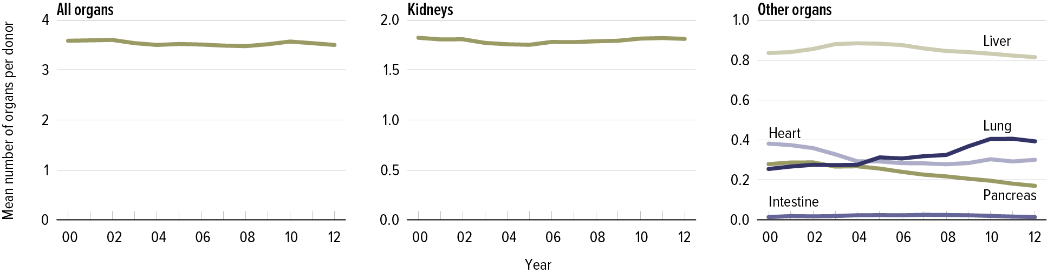

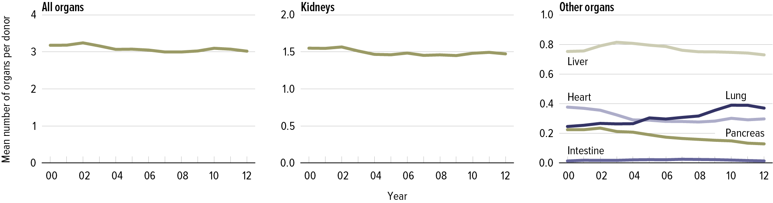

The other set of plots shows a time series trend for specific organ types. While it does a good job of comparing the trends between some organ types, it separates kidneys onto its own plot rather than including it with the other organs, and does not include any information about geography or gender. Additionally, the All Organs plot is on a significantly different scale than each individual organ, which makes these sets of plots a bit misleading. However, the biggest problem with these plots is the lack of resolution allowing for assessing the number of organs for a given year.

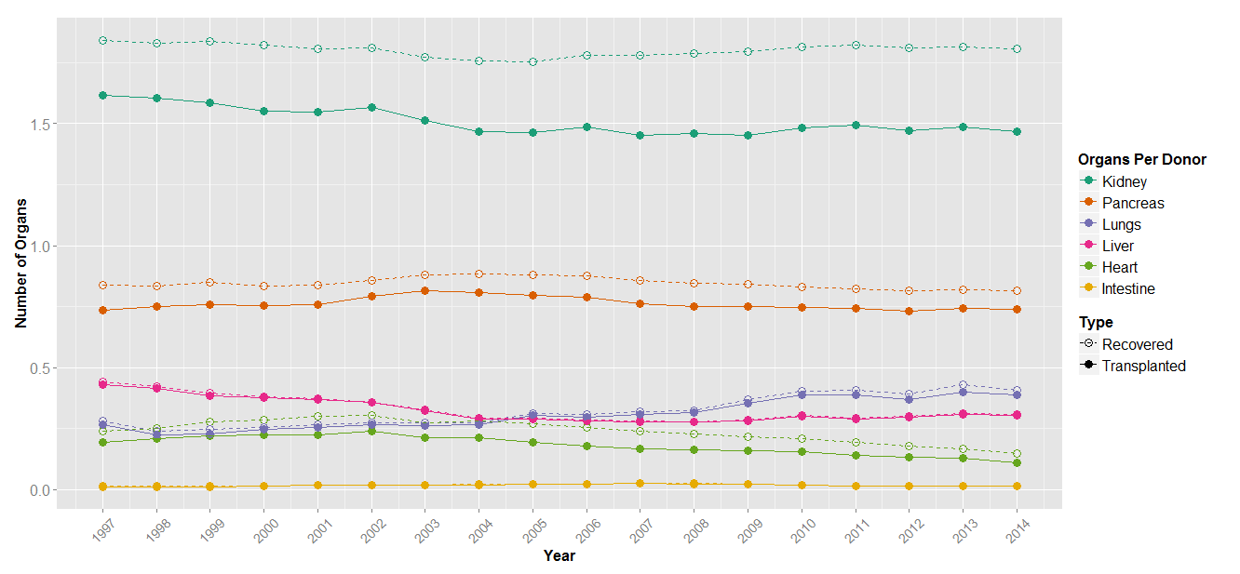

The information from both sets of plots will be brought together and combined with additional regarding gender and leading death mechanism in the following plots. The first redesigned plot, shown above, depicts ORPD and OTPD for each organ type by year, all on the same plot. Lines are color coded by organ type, with different point types for recovered versus transplanted. Including these points allows for better resolution of ORPD and OTPD for a given year, and visualizing ORPD and OTPD on the same plot allows for the two to be compared to qualitatively assess organ yield.

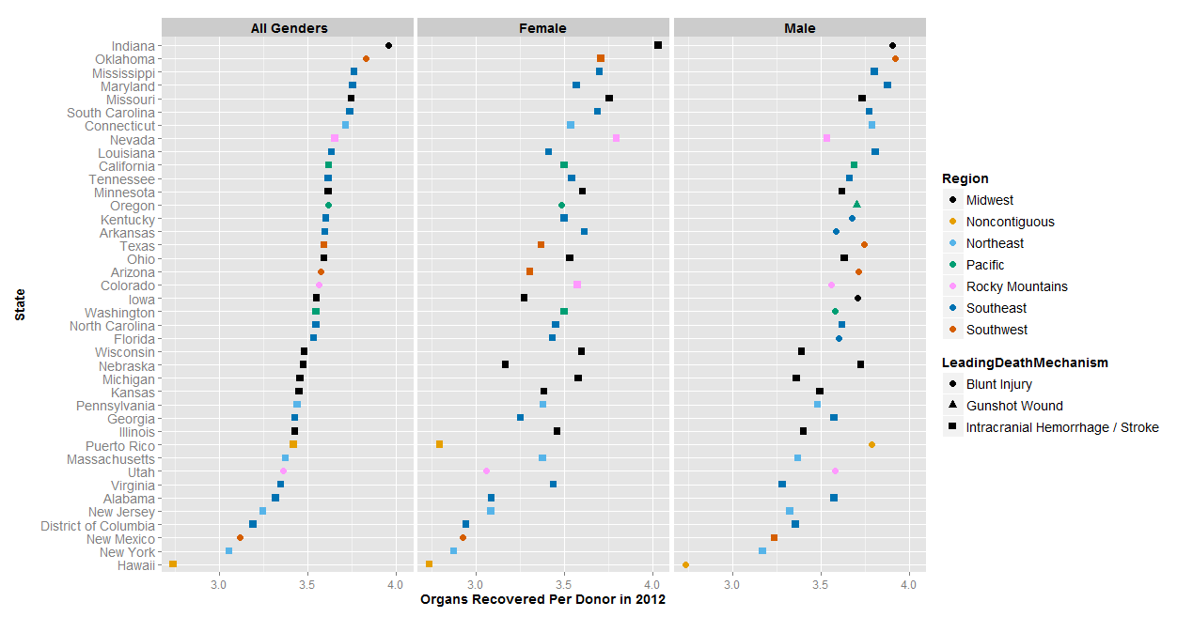

The next plot depicts ORPD for each state, sorted by the total for both genders. It also separates out the organs recovered per donor based on gender. The states are ordered by total organs recovered for all genders. By sorting in this way, we are able to see that the individual genders follow a similar pattern. The points are colored by geographical region; no specific trend by geographical region is found in the data. Additional information on leading death mechanism is included via point shape.

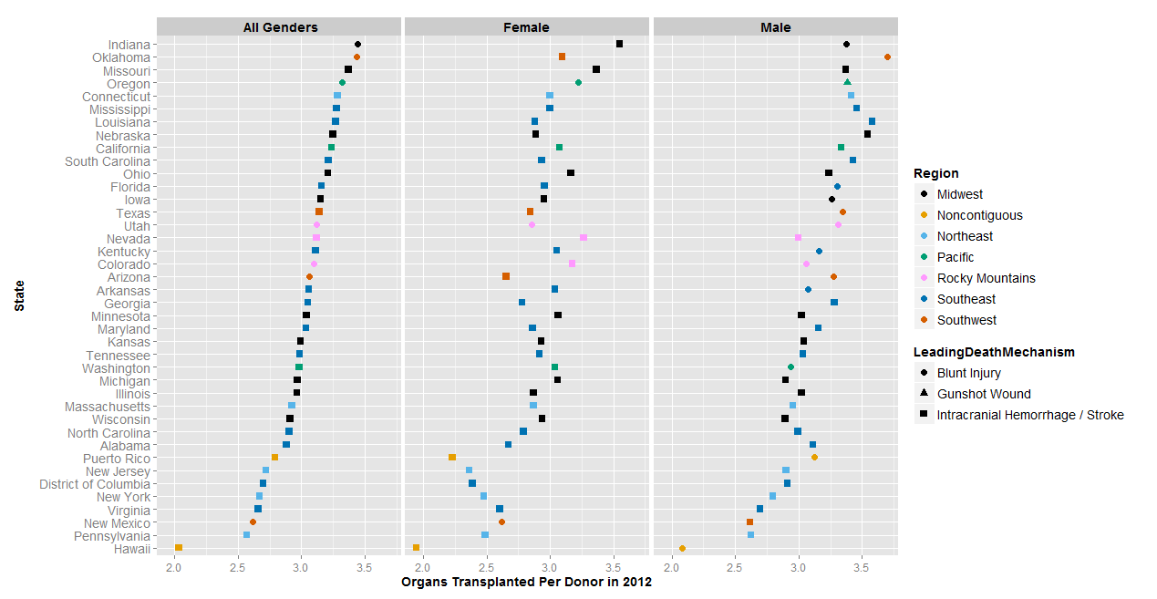

The next plot shows OTPD by state and by gender. As with the previous plot, the states are ordered by OTPD for all genders, and the points are colored by region. The overall trend is again similar for the individual genders as for all genders, and again we do not see a strong trend for the geographical regions. Additional information on leading death mechanism is included via point shape.

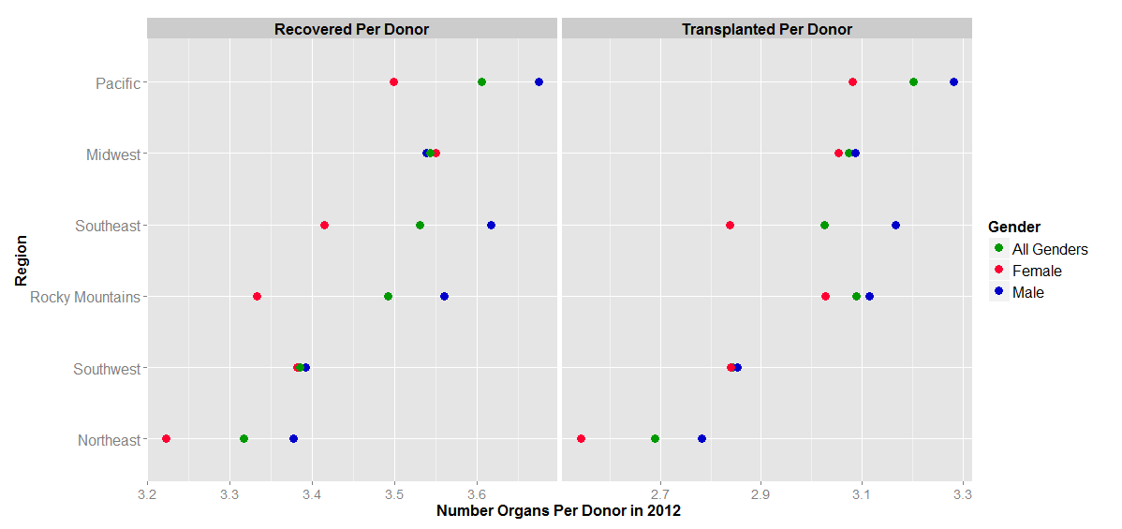

Next we plot the number of organs recovered and transplanted per donor by region. The points are colorized by gender: All Genders, Female, and Male. This view highlights the differences in ORPD and OTPD by geographic region better than colorizing the individual states. The geographical regions are ordered by ORPD for all genders. In this case, the trend for OTPD mirrors that of ORPD. This is not surprising, since you would expect that if more organs are recovered then more will be transplanted as well. As a result, we choose to compare organs recovered versus transplanted as a percent yield as opposed to an absolute comparison.

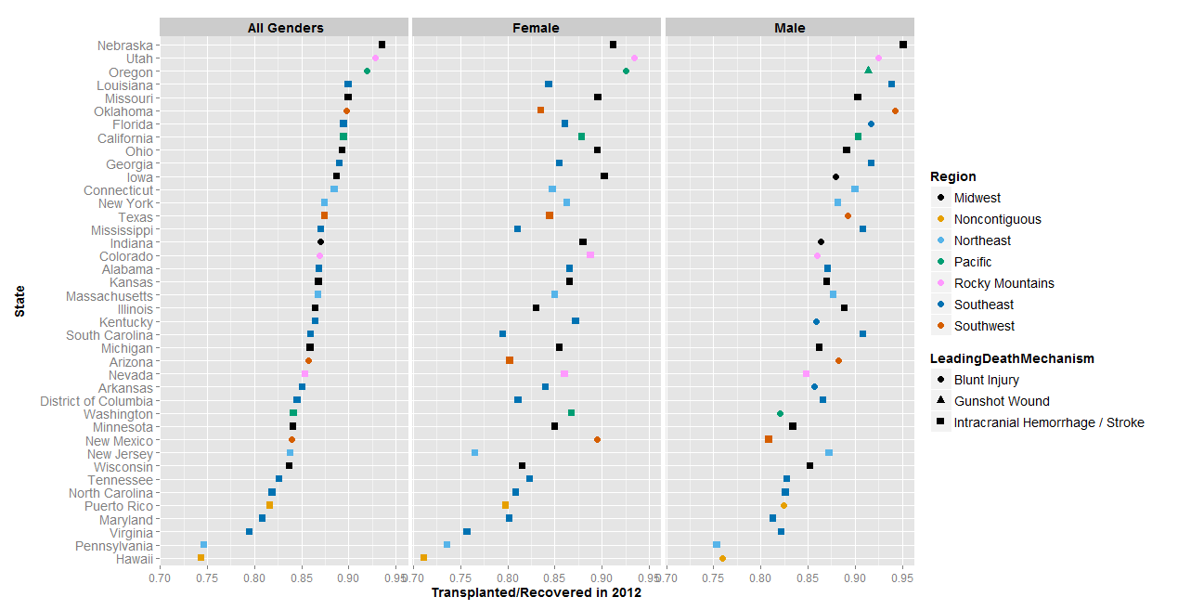

The final redesigned view of the data shows the organ yield (organs transplanted/organs recovered) for each gender by state. The states are ordered by the yield for all genders. When they are ordered in this way, a similar trend, though not exactly the same, can be seen in the yield for the individual genders. It is interesting to note that the order of states for OTPD/ORPD is not the same as for each metric on its own. Additional information on leading death mechanism is included via point shape.

By combining organ transplant data from different states, genders, organ types, and leading death mechanisms, additional trends can be seen in OTPD and ORPD. Plotting by geographic region rather than colorizing points for individual states does a better job of highlighting trends in OTPD and ORPD by geographic region. Each individual gender has a similar trend in OTPD and ORPD. Since OTPD and ORPD are positively correlated, plotting by organ yield (OTPD/ORPD) proves more interesting than separating the two.

Future work on visualizing ORPD and OTPD could include returning to a map view, but colorizing the map by state rather than DSA. This view may lead to a different assessment of geographical trends for ORPD and OTPD. Since the organ yield was determined to be of interest, the future mapped data may visualize yield instead of separate maps for ORPD and OTPD. Additionally, it would be interesting to look for trends in specific organ types relative to geography.

1. Organ Procurement and Transplantation Network, "Organ Procurement and Transplantation Network," 17 October 2014. [Online]. Available: http://optn.transplant.hrsa.gov/.
2. 2012 Annual Report of the U.S. Organ Procurement and Transplantation Network and the Scientific Registry of Transplant Recipients. Department of Health and Human Services, Health Resources and Services Administration, Healthcare Systems Bureau, Division of Transplantation, Rockville, MD; United Network for Organ Sharing, Richmond, VA; University Renal Research and Education Association, Ann Arbor, MI. (http://srtr.transplant.hrsa.gov/annual_reports/2012/Default.aspx)