University of Minnesota Evaluation of the Robert Noyce Teacher Scholarship Program, Final Report Section Five: Combined Analysis of the Robert Noyce Teacher Scholarship Program using ORC Macro and UMN Evaluation Data

Anica Bowe
Pey-Yan Liou
Frances Lawrenz, PI

Noyce Program Evaluation Team

Post Doctoral Members
Marjorie Bullitt Bequette
Michelle Fleming
Deena Wassenberg

Graduate Students
Jim Appleton
Maureen Braam

Chris Desjardins
Allison Kirchhoff
Kei Lee
Christina Madsen
Ann Ooms
Karen Parkhill
Mary Sande

May 2009




TABLE OF CONTENTS

 | Page Number
Introduction | 6
Part 1: Descriptive summary of demographic, academic and teacher-experience characteristics of the NETUM scholars | 7
Introduction | 7
Methodology | 7
Explanation of the variables | 8
Results | 9
Demographics | 9
Teaching experience | 13
NETUM scholar characteristics summary | 16
Part 2: Comparison of NETUM scholars to ORC-2 scholars | 18
Introduction | 18
Methodology | 18
Variables used for comparison | 18
Results | 18
Demographics | 18
Academic background | 20
Summary of the comparison of NETUM scholars to remainder of Noyce scholar population (ORC-2) | 24
Part 3: Comparison of NETUM factor scores by scholar groups | 25
Introduction | 25
Methodology | 25
Explanation of factors | 25
Results | 26
Sex differences for Factors 1 & 2 | 26
Sex differences for survey items 1 & 2 | 27
Minority status group differences for Factors 1 & 2 | 28
Minority status group differences for survey items 1 & 2 | 29
College major group differences for Factors 1 & 2 | 31
Group differences for remaining six factors | 33
Summary of group differences found amongst NETUM scholars on the 8 factors and the 2 survey items identified from the U of MN scholar survey | 38
Part 4: Results from cluster analysis | 39
Introduction | 39
Methodology | 39
Results | 40
Demographic characteristics and perceptions for the three groups | 43
Summary of cluster analysis | 44
Part 5: Conclusion | 45

APPENDICES |  | Page Number
Appendix A: Scholar survey |  | 48
Appendix B: Factor loadings and sample sizes for the items in each factor |  | 57
Appendix C: Squared multiple correlation for Two-Factor model |  | 61
Appendix D: Results for specific races for Factors 1 -8 and the two categorical survey items |  | 62
Appendix E: U of MN Noyce evaluation team comprehensive evaluation report sections |  | 65

List of Tables and Figures

Tables Page Number
Table 1 | Race/ethnicity of the NETUM scholars | 9
Table 2 | Type of Noyce support received over years 2004-2007 for NETUM scholars | 10
Table 3 | Years of teaching experience of the NETUM post-support scholars | 14
Table 4 | School district status on meeting criteria to be considered high need | 16
Table 5 | A comparison of the GPAs of ORC-2 and NETUM scholars upon applying for Noyce funding and after completing program | 20
Table 6 | Factor scores for the perceived influence of the Noyce funding on the scholars’ commitment to teach and commitment to teaching in a high need school, males vs. females | 27
Table 7 | Factor scores for the perceived influence of the Noyce funding on the scholars’ commitment to teach and commitment to teach in a high need school for Whites and Non-whites | 29
Table 8 | Factor scores for commitment to teach and commitment to teaching in a high need school amongst individuals with different majors | 31
Table 9 | Survey item 1. The effectiveness of the Noyce funding in influencing scholars of various majors to become teachers | 32
Table 10 | Survey item 2. The effectiveness of the Noyce funding in influencing scholars of various majors to teach in a high need school | 33
Table 11 | Sex differences for Factors 3-8 | 35
Table 12 | Differences between Whites and Non-whites for Factors 3-8 | 36
Table 13a | Differences between the college majors of Biology, Chemistry, Computer Science and Engineering for Factors 3-8 | 36
Table 13b | Differences between the college majors of Geology/Environmental Science, Math, Physics, and Physical Science for Factors 3-8 | 37
Figures
Figure 1 | Majors of NETUM scholars | 12
Figure 2 | K-12 level of certification of NETUM scholars | 12
Figure 3 | Subject areas NETUM scholars are certified to teach | 13
Figure 4 | Subject areas NETUM scholars intend to teach | 13
Figure 5 | Teaching status of NETUM post-support scholars for year 2007 | 15
Figure 6 | Sex demographics for ORC-2 database and NETUM scholars | 19
Figure 7 | The percent minority status of ORC-2 scholars and NETUM scholars | 19
Figure 8 | Reported race and ethnicity of ORC-2 scholars and NETUM scholars | 20
Figures 9a & 9b | K-12 level of certification of ORC-2 scholars and NETUM scholars | 21
Figure 10 | Reported majors of ORC-2 scholars and NETUM scholars | 22
Figure 11 | Subject areas ORC-2 scholars and NETUM scholars are certified to teach | 22
Figure 12 | Subject areas ORC-2 scholars and NETUM scholars intend to teach | 23
Figure 13 | Reported teaching status of ORC-2 scholars and NETUM scholars for 2007 | 23
Figure 14 | Survey Item 1 and 2. The influence of the Noyce funding on NETUM scholars’ commitment to teaching and commitment to teaching in a high need school, males vs. females | 28
Figure 15 | Survey Item 1: The influence of the Noyce funding on NETUM scholars’ commitment to teaching, Whites compared to Non-whites | 30
Figure 16 | Survey Item 2: The effectiveness of the Noyce funding on influencing NETUM scholars to teach in a high need school, Whites compared to Non-whites | 31
Figure 17 | The influence of the Noyce funding on currently teaching NETUM scholars (n = 304) commitment to teaching: Clusters 1, 2, and 3. | 40
Figure 18 | The influence of the Noyce funding on currently teaching NETUM scholars (n=304) commitment to teaching in a high need school: Clusters 1, 2, and 3. | 41
Figure 19 | Survey item 1. The influence of the Noyce funding on currently teaching NETUM scholars (n = 304) commitment to teaching: Clusters 1, 2, and 3. | 42
Figure 20 | Survey item 2. The influence of the Noyce funding on currently teaching NETUM scholars (n = 304) commitment to teaching in a high need school: Clusters 1, 2, and 3. | 43

Introduction

The National Science Foundation’s (NSF) Robert Noyce Teacher Scholarship Program was funded to increase the number of highly qualified teachers working in high need schools. This program has individual projects situated nationally at various university sites. The overall purpose of these projects is to recruit and support individuals with strong academic background in science, technology, engineering and mathematics (STEM) content areas into becoming teachers and working in high need schools. Research shows persistent correlations between student performance and teacher quality in science and mathematics (Goldhaber and Brewer, 1996; Jordan, Mendro, and Weerasinghe, 1997; National Research Council, 2000; Sanders and Rivers, 1996). Other studies (Ingersoll 1999, 2002) show that 56% of secondary students in physical science are being taught by teachers without a major or minor in physical science, and that students in high-poverty schools are 77% more likely to be taught by an out-of-field teacher.

To evaluate the effectiveness of the Robert Noyce Teacher Scholarship Program (hereafter referred to as the Noyce program) on various dimensions, the University of Minnesota Noyce Program evaluation project was funded in 2005.The evaluation team (hereafter referred to as U of MN Noyce evaluation team) has been composed of a number of graduate students and postdoctoral students with Frances Lawrenz as the principal investigator (PI). As suggested in the original evaluation project proposal, the University of Minnesota Noyce program evaluation project has four major components:

- preparation of an extensive literature review pertaining to effects of incentive programs in recruiting and retaining STEM K-12 teachers,
- thematic synthesis of the existing evaluation information through content analysis of project reports,
- statistical querying of the existing monitoring data to produce quantitative models of the program, and
- development and execution of an overall program evaluation plan through collaboration with existing projects.

The U of MN Noyce evaluation team presents its findings in a comprehensive evaluation report consisting of six sections. This report is the fifth of the six sections and it presents the results related to the third point above. Specifically, this report provides quantitative descriptions of the scholars using information from the existing monitoring data as well as data from an on-line scholar survey (Appendix A) that was developed by the U of MN Noyce evaluation team and issued in 2007. The existing monitoring data comes from the ORC Macro International Inc. Noyce Program monitoring system (hereafter referred to as the ORC database). This system collects annual data from the Noyce project PIs about the Noyce scholars including demographic and academic background information. The scholar survey contained various sections pertaining to the scholars’ teacher preparation experiences and various decisions they made along the way. A more in-depth explanation of the U of MN scholar survey and its results can be found in the University of Minnesota Evaluation of the Robert Noyce Teacher Scholarship Program, Final Report Section One: Planning and Survey Data. Some of the variables from the ORC database were not available from the scholar survey, therefore the information from the ORC database and the Noyce Evaluation Team University of Minnesota scholar survey database (NETUM database) (were combined to increase the number of variables available to examine the influence of the Noyce funding on the scholars’ various experiences and perceptions related to teaching.

This report contains five parts. The first part is a descriptive summary of the demographic, academic, and teaching experience characteristics of the scholars who took the scholar survey using data from the ORC data base. It should be noted that not all the Noyce scholars took the scholar survey; therefore it was important for the U of MN Noyce evaluation team to know the characteristics of the ones who did and determine whether or not they were different from the total population of Noyce scholars. Thus, the second part of this report is a descriptive comparison of the scholars who took the scholar survey (hereafter referred to as NETUM scholars) to the ones who did not (hereafter referred to as the ORC-2 scholars) to determine if the NETUM scholars were representative of the total population of Noyce scholars. The University of Minnesota Evaluation of the Robert Noyce Teacher Scholarship Program, Final Report Section Two: Factor Analysis of the Evaluation Questionnaire provides information on a factor analysis of the items in the scholar survey and the third part of this report presents comparisons of the factor scores for different demographic and academic groups of NETUM scholars. The fourth part of this report presents the results of a cluster analysis of the NETUM scholars based on their responses to the scholar survey. Finally, the fifth part of this report presents conclusions and implications.

Part 1: Descriptive summary of demographic, academic, and teacher-experience characteristics of the NETUM scholars

Introduction

A descriptive summary of the NETUM scholars is presented in this first part of the report. Information about the scholars on 17 variables regarding their demographics, academic backgrounds, and teaching experiences is summarized in paragraphs as well as in graphs and tables. The sample sizes are indicated in each figure with side notes providing any necessary additional information. The purpose of the descriptive summary is to provide information on how the data bases were merged and on the characteristics of the scholars who took the U of MN scholar survey.

Methodology

The ORC monitoring database contained 1504 Noyce scholars which is the entire population of Noyce scholars during the reporting period from 2003-2007. Data found in the ORC monitoring database were provided by the PIs and were entered during the 2003-2007 monitoring period. All Noyce PIs were required to enter information on each of the scholars in their programs every year. ORC maintained this data in a relational data base by year and scholar name. The scholar survey database contained 555 scholars’ responses to the scholar survey. To determine which ORC scholars completed the scholar survey, the U of MN Noyce evaluation team had to identify the scholars that were included in both databases. During the identification process, 507 of the 555 scholars responding to the scholar survey were identified on the ORC database using their first and last names. The names for the 48 ‘missing’ scholars were not available because their local Noyce program had e-mailed the scholar surveys to them instead of having them take it on-line. Therefore the only identifier on the scholar survey data base was their institution. Consequently these scholars were not identifiable in the ORC database. After matching the 507 scholars, a third database was formed which merged the ORC data and the U of MN scholar survey data of these 507 scholars. This third database was called the Noyce Evaluation Team University of Minnesota (NETUM) database. The third database allowed analyses using the combined set of variables.

Explanation of the variables:

The demographic, academic, and teaching experience characteristics describing the NETUM scholars included 17 variables that were found in the ORC database. The demographic variables were sex, minority status, race, and ethnicity. Sex was classified as males or females. Minority status was the label given to the category for which the PIs indicated whether their scholars were White or Non-white. For race, the PIs indicated whether their scholars were American Indian, Asian, Black, Native Hawaiian, or White. For ethnicity, the PIs indicated whether their scholars were Hispanic or Non-Hispanic.

The academic variables were type of Noyce funding recipient, anticipated year of teacher preparation program completion, anticipated year of obtaining teacher certification/licensure, cumulative GPA, major, grade level of certification, subject of certification, intended subject to teach, and whether or not the scholar transferred from a community college. For type of Noyce funding recipient, the PIs indicated whether their scholars were classified as scholarship recipients, stipend recipients, or post-support recipients. For anticipated year of teacher preparation program completion and anticipated year of obtaining teacher certification/licensure, the PIs reported the year they expected the scholars to complete the program as well as the year they expected them to obtain certification/licensure. Cumulative GPA indicated the scholars’ GPA at acceptance into the teacher preparation program and also their GPA when they had completed the program. For majors, the PIs indicated which of the 8 majors presented were those that their scholars were taking. For grade level of certification, the PIs indicated whether their scholars were being certified for the elementary, middle, junior high, or high school level. For subject of certification and intended subject to teach, only data for year 2007 was used because it was the most recent source of information.

The teaching experience variables were whether or not the scholar had taught in a high need environment, years of teaching experience in a high need school, the degree to which the scholars fulfilled certification and funding requirements, and the high need status of scholar’s current school environment. For whether or not the scholar had taught in a high need environment, the PIs simply indicated “yes” or “no.” For years of teaching experience, the PIs indicated how many complete academic years the scholars had taught in a high need environment. For the degree to which the scholars fulfilled certification and funding requirements, the PIs indicated their scholars’ status on the degree to which they had completed the teacher preparation course requirements and well as the Noyce program requirements. Finally, for high need status of scholar’s current school environment, the PIs indicated whether or not the school or district was classified as high need. It should be noted that throughout this report, all percents are reported within rounding, therefore their sum may not equal 100%.

Results

Demographics:

The demographic variables that describe the NETUM scholars were sex, minority status, race, and ethnicity. For sex, amongst the NETUM scholars there were 65% females and 35% males. For minority status, 67% of scholars were White and 33% were Non-white. For race, 67% were White, 10% Asian, 10% Black, 1% American Indian, and .2% Native Hawaiian. These percents do not sum to 100% because there were 13% of NETUM scholars who did not have their race reported. For ethnicity, 10% were reported to be Hispanic, 66% were non-Hispanic, and 24% did not have their ethnicity reported. It should be noted that the monitoring database allowed the PIs to indicate more than one race whenever it was necessary. Because of this, it is possible to have a sum of more than 100% for race even if all the scholars did not have their information reported because it was possible for an individual to be counted more than once. A summary of race/ethnicity is found in Table 1.

Table 1

Race/Ethnicity of the NETUM Scholars
Race | Percent
Whites | 67%
N = 341
Blacks | 10%
N = 52
Asians | 10%
N = 49
American Indian | 1%
N = 4
Native Hawaiian | 0%
N = 2
Missing
N= 64 | 13%
Ethnicity
Hispanic | 9%
N=46
Non-Hispanic
N = 337 | 66%
Missing | 24%
N = 124
Note. N = 507. Numbers may not sum to 100% due to rounding.

Academic

The academic variables that describe the scholars are type of Noyce funding recipient, anticipated year of teacher preparation program completion, anticipated year of obtaining teacher certification/licensure, cumulative GPA, major, grade level of certification, subject of certification, intended subject to teach, and whether or not the scholar transferred from a community college.

The variable, type of Noyce funding recipient, indicated the current funding status of the scholar for the 2003-2007 monitoring period. The scholars were classified as either a scholarship recipient, stipend recipient, or post-support recipient. A scholarship recipient was an individual who was accepted into the teacher preparation/certification program but had not obtained a baccalaureate degree as of yet. A stipend recipient was an individual who had already earned a baccalaureate, masters, or doctoral degree in a STEM discipline, and was enrolled in a teacher preparation/certification program. This category also included individuals who considered themselves to be career changers. A post-support recipient was an individual who had received a scholarship or stipend prior to the reporting period (that is, before 2007) and for whom the Noyce funding had ended. Table 2 provides a summary of the type of Noyce funding recipient for this monitoring period.

Table 2

Type of Noyce Support Received Over Years 2004-2007 for NETUM Scholars
 | 2004 | Year  2005 | 2006 | 2007
Type of Support
- Scholarship | 10% | 24% | 24% | 31%
- Stipend | 7% | 23% | 21% | 17%
- Post-support | 0% | 12% | 28% | 52%
- Missing responses | 83% | 42% | 27% | 0%
Note. N = 507. No data for Year 2003 was collected. There were many missing responses for years 2004 through 2006.

The percentages found in Table 2 demonstrate that the most common type of support from the Noyce program was a scholarship. Additionally, for this monitoring period, the total financial support for NETUM scholars ranged from $753 to $20,000, with an average of $8339.73 per student, and a standard deviation of $3,829.5. The ORC monitoring data, however, did not specify the allocation of which type of support (i.e. scholarship or stipend) or the years these funds represented, that is, how much was given in 2003, 2004, 2005, etc. The average number of semesters a NETUM scholar received support was 2.5, with a standard deviation of 1.2.

The PIs were asked to indicate which year they anticipated that the scholars would complete their teacher preparation program. The PIs reported this information for each year during this monitoring period (2003-2007). Only responses for year 2007 are presented in this report as it was the most recent information. There was also an opportunity for the PIs to report on scholars who had already completed their teacher preparation program. According to the PIs, 74% of NETUM scholars had already completed their teacher preparation program at the time the PIs responded to the monitoring data during year 2007. They anticipated that 4% would complete their programs by the end of 2007, 13% would complete it by 2008, and 4% would complete it by 2009. Over this monitoring period, 4% of NETUM scholars were reported to have left the program. Of the NETUM scholars who left their teaching program, less than 1% had returned the Noyce funding awarded to them. Although this may indicate more follow-up is necessary, scholars have six years to fulfill the requirements of the scholarship.

It should be noted that in the ORC database, teacher preparation program is differentiated from teacher certification/licensure. It can be inferred that teacher certification/licensure is the next step after completing the preparation program and it requires certain documents to be submitted to state departments in order to be classified as certified or licensed. The PIs were asked to report the year they anticipated that the scholars would receive certification/licensure. If the scholar had already done so, there was an opportunity for the PIs to report this as well. At the time when they responded to the monitoring data in 2007, the PIs reported that 72% of the NETUM scholars were already certified/licensed. They anticipated that by 2010, 95% of the NETUM scholars would be certified/licensed. These percentages are within approximation of what was reported for the completion of the teacher preparation program. (Recall that 4% of the NETUM scholars was reported to have left the program).

The average cumulative GPA of NETUM scholars, when selected to receive Noyce funding, was 3.48 with a standard deviation of .35, however GPA was reported for only 58% of scholars. At the end of the teacher preparation/certification program, their average GPA was 3.67, with a standard deviation of .3, which represented only 64% of the NETUM scholars. Most of NETUM scholars were biology and math majors (Figure 1), with the majority of them being certified to teach at the secondary level (Figures 2 & 3). Additional information for academic background included which subject scholars were certified to teach, as well as the subject in which the scholars actually intended to teach. By and large, the majors of the scholars corresponded with the subjects they were certified to teach, and also with the subjects they actually intended to teach (Figure 4), indicating that NETUM scholars tended to teach in their content area major. Note that in Figures 1-4, the percentages do not always sum to 100% because there were some scholars with more than one major or certification level. Finally, amongst the scholars, 11% were reported to have transferred from a community college, 47% had not, but there was a high non-response rate of 42% so the actual percentage of those who transferred might not be accurate.

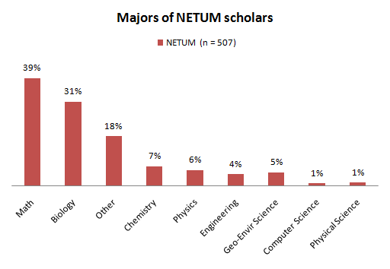

Figure 1. Majors of NETUM scholars
Note. Some scholars had more than one major therefore total percentage is greater than 100%.

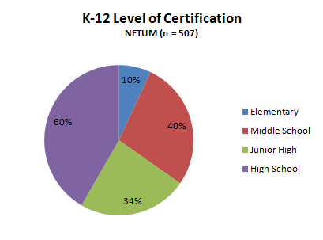

Figure 2. K-12 level of certification of NETUM scholars
Note. Many scholars were certified at more than one level therefore total percentage is greater than 100%.

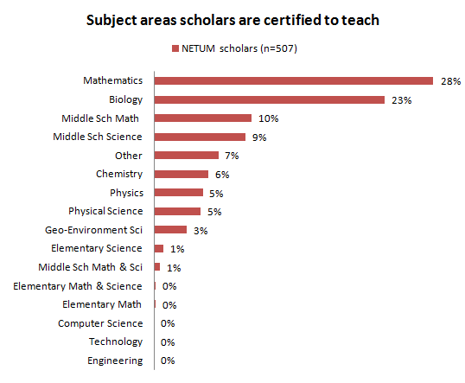

Figure 3. Subject areas NETUM scholars are certified to teach
Note. There is 2% data that was not reported.

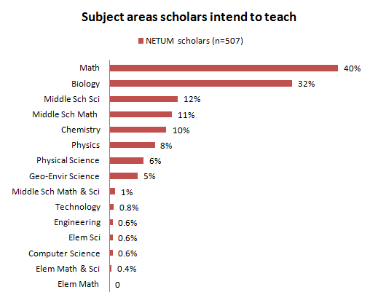

Figure 4. Subject areas NETUM scholars intend to teach
Note. Some scholars intended to teach more than one subject therefore total percentage is greater than 100%.

Teaching experience:

For each year of this monitoring period, the PIs were required to indicate whether or not post-support scholars had ever taught in a high need school and also the number of years of teaching experience in a high need school the post-support scholar had completed. For years of teaching experience, the PIs were only allowed to count complete academic years. For example, post-support scholars who had less than a year of teaching were considered as zero and scholars who had completed 1.5 years were reported as 1 yr, etc. (It should be noted that the number zero was not entered in the database for any scholar and perhaps this was because PIs interpreted this item to mean they should only indicate numbers 1 or greater). The PIs reported that 82% of the post-support scholars had taught in a high need school before and 18% had not. The range of teaching experience of NETUM post-support scholars was from 1 to 6 years. Since year 2007 represents the most up to date information for this variable, a summary of the number of years of teaching experience as of 2007 is found in Table 3. Thirty-two percent of the post-support scholars did not have a number reported for them on this variable. It is possible that these remaining 32% of scholars had completed less than a year of teaching therefore no number was entered for them. The monitoring database allowed the PIs to provide an explanation as to why the scholars had not taught in a high need school. The PIs provided over 40 reasons as to why the scholars had not taught in a high need school. The four most common reasons given were that the scholar was still completing coursework, the scholar had not completed the teacher preparation/certification program, the scholar had not graduated, and that the scholar had not returned teacher verification documents as of yet. Examples of other reasons given were that the scholar was not hired or was still in the process of applying; there were no jobs available in the cohort of schools partnering with teacher preparation/certification program; the scholar had a career change; and finally, the scholar had medical problems.

Table 3

Years of Teaching Experience of the NETUM Post-Support Scholars
No. of Years of Teaching Experience | Percent of post-support scholars
1 | 28%
2 | 25%
3 | 7%
4 | 1%
5 | 2%
6 | 3%
Other | 2%
Missing information | 32%
Note. N = 264 for post-support scholars. These percents are only for year 2007 because they are the most recent data. It is possible that post-support scholars who were missing information taught less than one year therefore they were considered as zero.

The PIs were also asked to choose which of the following four categories best described the current status of scholars who were post-support recipients. The choices were: the scholar has met teaching requirements; the scholar has not met teaching requirements and did not teach in a high need district; the scholar has not met teaching requirements but has taught in a high need district; and “other.” Recall that 264 of the scholars were considered post-support. Of these, 42% had met teaching requirements, 16% had not met teaching requirements and did not teach in a high need district, 34% had not met teaching requirements but taught in a high need district, and 7% were in the category labeled “other.” The two most common explanations for the category “other” were that the PI was still awaiting notice of the scholar’s teaching status and that the scholar had not completed coursework.

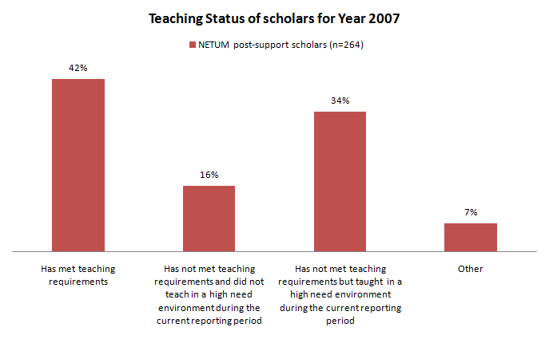

Figure 5. Teaching status of NETUM post-support scholars for year 2007

The final variable for teaching experience that was analyzed was the school’s district high need status. Seeing that the NETUM post-support scholars were (mostly) in high need environments, the PIs were asked to report which Title I criteria for high need status did the school’s district meet. To be considered high need, the district had to meet Title I criteria for teacher attrition rates, percentage of students eligible for free and reduced lunch, or percentage of teachers without a bachelor or graduate degree in the content area they did most of their teaching in. Title I criterion for teacher attrition was defined as the district having at least one school whose teacher attrition rate had been 15% or more over the last three years. The criterion for free and reduced lunch was defined as the district having at least one school in which 50% or more of the enrolled students were eligible for participation in the free and reduced price lunch program established by the Richard B. Russell National School Lunch Act (42 U.S.C. 1751 et seq.). Finally, the criterion regarding bachelor or graduate degrees was defined as the district having at least one school in which (i) more than 34% of the academic classroom teachers at the secondary level (across all academic subjects) did not have an undergraduate degree with a major/minor or graduate degree in the academic field in which they taught the largest percentage of their classes; or (ii) more than 34% of the teachers in two of the academic departments did not have an undergraduate degree with a major/minor or graduate degree in the academic field in which they taught the largest percentage of their classes. The results for schools’ district status are summarized in Table 4 below. Note that again these percentages only correspond to post-support students and the sample size is 264. The data suggest that there has been substantial growth in the percent of scholars teaching in districts that meet high need over the years 2004 to 2007 (no data for year 2003 was provided). The data also indicate that during year 2007, 79% of the post-support scholars were actually teaching in a high need environment and 4% were in a non-high need environment. It is possible that the remaining 16% were not teaching, but there was no variable in the ORC database that directly asked what percent of post-support scholars were currently teaching.

Table 4

School District Status on Meeting Criteria to be Considered High Need
Year | Scholars who taught in a school that did not meet requirements to be considered a high need school | Scholars who taught in a district that met high need requirement for teacher attrition | Scholars who taught in a district that did not require an undergraduate degree | Scholars who taught in a district that met criteria for free and reduced lunch
2004 |  |  |  | 0%
2005 | 2% | 2% | 4% | 8%
2006 | 10% | 8% | 8% | 27%
2007 | 4% | 13% | 8% | 58%
Note. n = 264. This numbers only correspond to NETUM scholars classified as post-support.

NETUM scholar characteristics summary:

This part of the report provided a summary of the NETUM scholars on various demographic, academic, and teacher experience characteristics. The data demonstrated that there is approximately a 2:1 female to male ratio for NETUM scholars. Likewise, there is approximately a 2:1 White to Non-white ratio, and that Asians and Blacks make up the majority of the NETUM minority population. For ethnicity, the ORC database only allowed the PIs to indicate whether the scholar was Hispanic or Non-Hispanic; no other ethnic group was provided as an option. For academics, 70% of NETUM scholars are math or biology majors, and 60% of them are certified to teach at the high school level. The percentage pattern for the majors (that is, which majors had the most scholars, least scholars, etc.) corresponded with the pattern for intended subject to teach, indicating that overall, NETUM scholars intended to teach in their content areas. By 2007, 74% had completed their teacher preparation program and 72% of them were already certified or licensed.

By 2007, the majority of NETUM scholars were classified as post-support, meaning that they had received a scholarship or stipend prior to this reporting period (that is, before 2007), but that their funding had ended. For the teaching experience characteristics, the PIs were only asked to report on the scholars who were considered post-support recipients. By 2007, 82% of the post-support scholars had experience teaching in a high need environment and 68% of them had completed at least one complete academic year of teaching. Also, during 2007, 79% of the post-support scholars were actually teaching in a high need district. Furthermore, by 2007, there were only 16% of the post-support scholars who had not met teaching requirements nor taught in a high need environment. Overall, for teaching experience, the data indicates that NETUM post-support scholars were being placed in teaching environments that satisfied the Noyce program requirements.

Part 2: Comparison of NETUM scholars to ORC-2 scholars

Introduction

In order to consider results for the NETUM scholars as indicative of Noyce scholars overall, it was important to know whether the scholars who took the U of MN scholar survey were representative of the population of Noyce scholars. Therefore, a descriptive comparison of NETUM scholars to the remainder of scholars found in the ORC database was conducted. This was to determine how similar the NETUM scholars were to the other scholars in the ORC database on demographic and academic characteristics. (Note: The NETUM scholars could have been compared to the full ORC database but then 507 of the scholars would be identical producing an inflated view of the similarity.)

Methodology

To perform this comparison, a fourth database was created, called ORC-2, which contained ORC monitoring data on the scholar population (n = 997) that did not respond to the U of MN scholar survey. That is, information regarding NETUM scholars was deleted from the ORC database so only the remainder of the population of scholars is found in ORC-2. This allowed NETUM scholars to be compared to ORC-2 scholars to determine whether or not they were similar.

Variables used for comparison:

The scholars in the two data bases were compared on nine demographic, academic, and teacher-experience characteristics that were thought to be useful for establishing representativeness. The first set of comparisons was made for the demographic variables of sex, minority status, race and ethnicity. The second set of comparisons was made for the academic characteristic variables of GPA, major, K-12 certification level, and certification subject. Finally, information about the scholars’ school/district high need environment was also examined.

Results

Demographics:

The sex demographics demonstrate that both groups are similar in their distribution of males and females (Figure 6). Similarly, the percent of Whites vs. Non-whites in Figure 7 show that again, both ORC-2 database and NETUM scholars are similar in regards to percent of minority status.

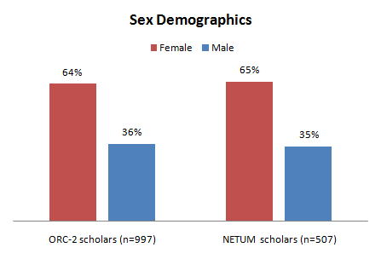

Figure 6. Sex demographics for ORC-2 database and NETUM scholars

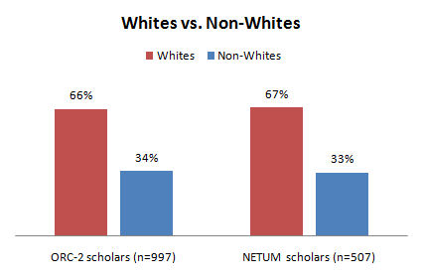

Figure 7. The percent minority status of ORC-2 scholars and NETUM scholars

For race, there was a small difference between ORC-2 and NETUM scholars with ORC-2 scholars having 3% less Asians (p = .034) compared to NETUM scholars. In contrast for ethnicity, there was a larger discrepancy with ORC-2 database containing 19% of Hispanics whereas NETUM contained only 9% (p <.001) (Figure 8). These results demonstrate that NETUM scholars are mostly representative of ORC scholars on racial characteristics, however, for ethnicity, Hispanic origin scholars may be underrepresented.

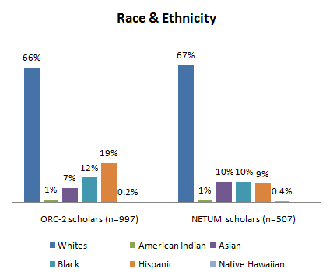

Figure 8. Reported race and ethnicity of ORC-2 scholars and NETUM scholars

Academic background:

ORC-2 scholars and NETUM scholars were compared in reference to their GPA, majors, certification level, certification subject, and their school environment. Table 5 shows that NETUM scholars had a significantly higher GPA when they applied for Noyce funding (t₈₅₇ =4.86, p <.001, d = .34) and upon completing (t_{743.9} = 3.25, p = .001, d = .23) the teacher preparation/certification program than ORC-2 scholars. As can be seen, however, these statistically significant differences were only around a difference of .1 GPA units which is of no practical significance. The effect sizes are relatively small using Cohen’s criteria, further supporting the notion that this difference is not important.

Table 5

A Comparison of the GPAs of ORC-2 and NETUM Scholars upon Applying for Noyce Funding and After Completing Program
 | GPA
 | ORC-2 scholars | NETUM scholars
At application for Noyce funding
Mean*** | 3.35 | 3.48
SD | 0.412 | 0.352
After completing teacher preparation/certification program
Mean** | 3.59 | 3.67
SD | 0.369 | 0.325
Note. ** p = .001 (d=.34), ***p < .001 (d=.23).

Figures 9a and 9b compare the ORC-2 and NETUM scholars on their distribution at the K-12 level of certification. These figures show that NETUM scholars had more scholars certified at every level compared to ORC-2 scholars, indicating that NETUM scholars had more individuals certified at more than one level (recall that it was possible for the scholars to gain certification at as many levels as they wished). All levels are significantly different except for elementary. For middle school, χ² = 9.17, p = .002; for junior high, χ² = 27.5, p <.001; and for high school, χ² = 39.5, p <.001. At each level, however, the pattern of certification is the same in both groups with the highest percent of scholars being certified at the high school level, followed by middle school, then junior high, and finally elementary.
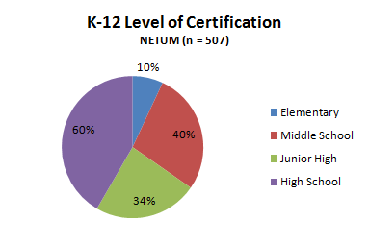
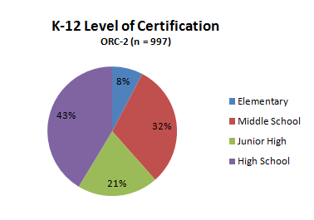

Figures 9a & 9b. K-12 level of certification of ORC-2 scholars and NETUM scholars

Figures 10, 11, and 12 are comparisons of ORC-2 scholars and NETUM scholars on their majors, subject area certified to teach and subject area intended to teach. In particular, it was important to know whether both groups had similar patterns. There were no differences found between the groups amongst the majors. For subject area certified to teach, differences were only found between math (χ² = 5.35, p = .021) and biology (χ² = 34.3, p <.001). It should be noted though that for subject area certified to teach, the ORC-2 database had a higher missing response rate (25% compared to 2% for NETUM) and perhaps the lack of responses can account for these discrepancies. For subject area intended to teach, the differences found here were between biology (χ² = 7.26, p = .007) and physics (χ² = 4.49, p = .034). The results indicate that overall, both groups have similar patterns confirming that NETUM scholars were representative of ORC-2 scholars on these three academic characteristics.

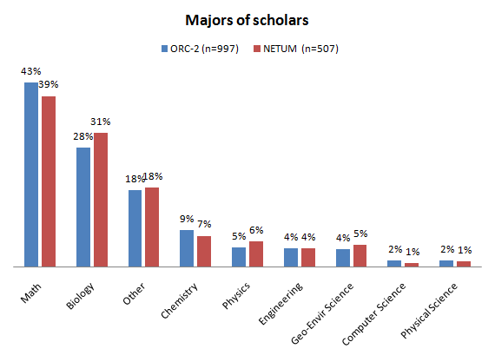

Figure10. Reported majors of ORC-2 scholars and NETUM scholars
Note. Some scholars indicated more than one major so percents sum to greater than 100%.

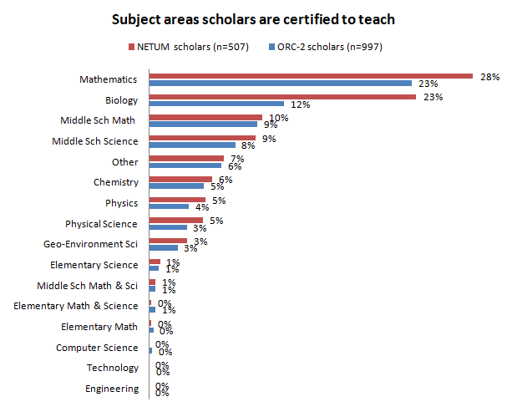

Figure 11. Subject areas ORC-2 scholars and NETUM scholars are certified to teach
Note. There was a 25% missing data for ORC-2 scholars and 2% missing data for NETUM scholars

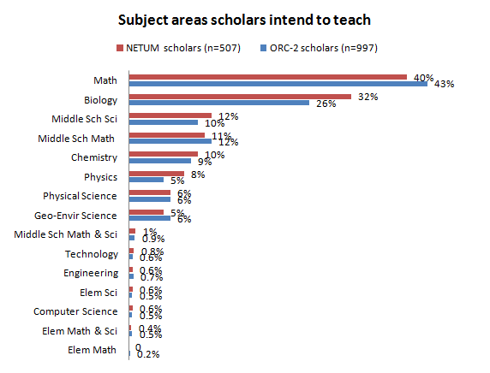
Figure 12. Subject areas ORC-2 scholars and NETUM scholars intend to teach
Note. Many scholars indicated more than one subject they intended to teach therefore percents sum to greater than 100%.

Finally, to determine comparability in the teaching status of NETUM and ORC-2 post-support scholars, a visual inspection of Figure 13 shows that there are slight differences between these groups in terms of the category in which they fall. There is a higher percentage of NETUM scholars who have met teaching requirements (category 1) and there is also a higher percentage of NETUM scholars who have taught in a high need school (category 3). Chi-square results show that at least one of these categories is significantly different (χ² = 17.6, p =.001).

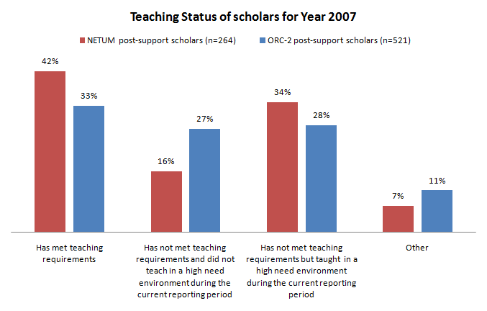

Figure 13. Reported teaching status of ORC-2 scholars and NETUM scholars for 2007.

Summary of the comparison of NETUM scholars to remainder of Noyce scholar population (ORC-2):

The NETUM scholars appear to be representative of Noyce scholars overall. Comparison of the NETUM scholars to the remainder of the scholar population demonstrated that the two groups were quite similar for many of the variables on which they were compared. Both groups were similar in their distributions of sex, minority status, major, certification areas, and intended subjects to teach. (There were a couple variations in percents amongst intended subject and certification areas, however by large, all other percents were comparable). There were, however, some differences found with race, ethnicity, GPA, reported certification levels, certification areas, intended subject to teach and current status. For race, the proportion of Asians were lower amongst the ORC-2 scholars and for ethnicity, the proportion of Hispanic scholars was lower amongst the NETUM scholars. For GPA, NETUM scholars had statistically significantly higher GPAs entering and completing the teacher preparation/certification program however this difference was of no practical importance. Pertaining to teaching status for year 2007, a slightly higher percentage of NETUM scholars compared to ORC-2 were reported to have met teaching requirements and also to have taught in a high need environment. These differences, however, do not appear critical; therefore results found for the NETUM population should be representative of the population of Noyce scholars.

Part 3: Comparison of NETUM factor scores by scholar groups

Introduction

This part of the report examines the scores obtained by different academic and demographic groups of scholars on the factors derived from the scholar survey items. Groups were formed according to sex, minority status, and majors of the NETUM scholars. Factors were those identified as discussed in the University of Minnesota Evaluation of the Robert Noyce Teacher Scholarship Program, Final Report Section Two: Factor Analysis of the Evaluation Questionnaire. Factors are described in more detail below and factor loadings, correlations, and items are in Appendix B: Factor loadings and sample sizes for the items in each factor and Appendix C: Squared multiple correlation for Two-Factor model.

Methodology

The data for this part of the report came from the University of Minnesota Noyce Evaluation Team (NETUM) database. Recall from part one of this report that the NETUM database is a combined database of ORC monitoring data and scholar survey data on only those scholars who took the scholar survey and were identifiable by name in the ORC monitoring database. The NETUM database included 507 scholars.

For differences amongst sex, males were compared to females. For minority status, Whites were compared to Non-whites. For majors, there were eight specified majors that the PIs could have chosen from to indicate the scholar’s content area: biology, chemistry, computer science, engineering, geology/environmental science, math, physics, or physical science. There was also an option of “other” reserved for the case where the major of the scholar was not listed. Each of the 8 majors was compared to all other majors as well as to the category labeled “other.” Note that the comparisons that included the category “other” are not presented in this report because the category “other” represented over 40 other majors. Consequently, the results for those comparisons involving “other” are less conclusive because they did not provide information about distinct majors. One-way Analysis of Variance and independent sample t tests using SPSS 17 were conducted to look for demographic differences amongst sex, minority status, and majors on the factors. A Bonferroni correction method was applied due to multiple testing of the eight different major groups (and “other”) and significance was set to an alpha level of .00625.

Explanation of factors:

The seven factors identified in the University of Minnesota Evaluation of the Robert Noyce Teacher Scholarship Program, Final Report Section Two: Factor Analysis of the Evaluation Questionnaire were as follows: (1) “Commitment to teaching in high need schools (Influence of Noyce); (2) “Preparation for high need schools”; (3) “Path to teaching” (4) “District/school high need environment”; (5) “Personal beliefs towards teaching”; (6) “School teaching environment”; and (7) “Mentoring experience.” Based on additional analyses presented in Perceived effects of scholarships on STEM majors’ commitment to teaching in high need schools (Liou, Kirchhoff, & Lawrenz, 2009), the first factor, “Influence of Noyce” was further broken down into two separate constructs: the perceived influence of the Noyce funding on scholars’ (a) “commitment to become a teacher” and (b) “commitment to teaching in a high need school”. Hence, in this report, the factors are reported as a group of eight instead of seven.

Group comparisons were made based on the scholars’ scores on the eight factors and their responses to two categorical survey items. Comparisons for the first two survey items are reported along with the comparisons for the first two factors “commitment to become a teacher” and “commitment to teaching in a high need school” because these items look at constructs similar to those dealt with in the first two factors. The first two factor scores and the two survey items are examined first and in more detail because they are most directly related to the impact of the Noyce funding.

The factor scores were standardized on a normal distribution with a mean of 0 and a standard deviation of 1. Interpretation of the average standardized scores for Factors 1 and 2 are given in light of what they represent on a 1 through 4 rating scale for perceived influence of the Noyce funding to convey meaning. The survey items were “Would you have become a teacher without the Noyce funding?” and “Would you have taught in a high need school without the Noyce funding?” The survey items were on a 3-point scale for which the scholars responded either “No,” “Possibly,” or “Yes” (refer to scholar survey, section IV “The decision to become a teacher”, items 6 and 7). There were no inferential statistical analyses performed for these categorical items; instead the scholars’ responses were summarized as percentages of “No,” “Possibly,” or “Yes” and results presented in graphical format. A visual inspection of these results can shed light on trends in the data. The remaining six factors were all reported as factor scores only. In the sections below, group differences for the first two factors and the two survey items are summarized first, followed by the results for the remaining six factors.

Results

Sex differences for Factors 1 & 2:

The NETUM scholars were first grouped by sex to determine whether there were any group differences. For the first factor, that is, the scholars’ perception of the influence of the Noyce funding on their commitment to becoming teachers, the factor scores for the sexes are found in Table 6 (this contains results for both Factors 1 and 2). A basic interpretation of these scores is that the higher the score, the more influential the funding was perceived to be on the scholar’s commitment to becoming a teacher. For the sexes, the mean score for the influence of the funding on the scholars becoming teachers was -.002. This score corresponds to an average of 1.74 on a rating scale of 1 through 4 for perceived influence of Noyce funding (1= not at all influential, 2 = not very influential, 3 = somewhat influential, 4 = very influential). A 1.74 indicates that on average, males and females perceived that the Noyce funding was not very influential on their decisions to become teachers. More specifically, for males it was -.066 (a 1.69 on the scale) and for females it was .033 (a 1.77 on the scale), though this difference was not significant (F_{1,505}, p = .251). For the second factor, that is, the perceived influence of the funding on the scholar’s commitment to teaching in a high need school, the factors scores for the sexes are also found in Table 6. Similarly, a basic interpretation of these scores is that the higher the score, the more influential the funding was perceived to be on the scholar’s commitment to teaching in a high need environment. The overall score for this factor was -.022. This score represents an average of 2.00 on the 1-4 rating scale indicating that again, on average, males and females perceived that the Noyce funding was not very influential on their decisions to teach in a high need school. For males the average score was -.111 (a 1.95 on the scale), and for females it was .026 (a 2.04 on the scale). Again females scored slightly higher than males, however this difference was not significant (F_{1,505}, p= .124).

Table 6

Factor Scores for the Perceived Influence of the Noyce Funding on the Scholars’ Commitment to Teach and Commitment to Teaching in a High Need School, Males vs. Females
 | Factor scores
Perceived influence of Noyce funding on scholars:
 | Commitment to teach  (M, SD) | Commitment to teach in high need schools  (M, SD)
Males | (-.066, .979) | (-.111, .974)
N (178)
Females | (.033, .907) | (.026,.945)
N(329)
Average | (-.002, .933) | (-.022,.956)

Sex differences for survey items 1 & 2:

For survey item 1, the question was asked “Would you have become a teacher if you had not received the Noyce funding?” NETUM scholars were asked to respond with “No”, “Possibly,” or “Yes.” Over 75% of both sexes reported they would have become teachers regardless of the Noyce funding, suggesting that the Noyce funding was not very influential on their commitment to teach. In contrast, for survey item 2 (Figure 14) which asked “Would you have taught in a high need school if you had not received the Noyce funding?,” the percentages of scholars responding “Yes” were much lower and conversely the percentages of scholars responding “No” were much higher, indicating that the funding might have been more influential in the scholars’ decision to teach in a high need school versus becoming teachers.
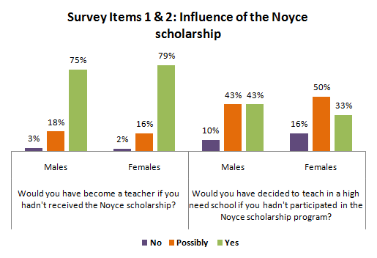

Figure 14. Survey Item 1 and 2. The influence of the Noyce funding on NETUM scholars’ commitment to teaching and commitment to teaching in a high need school, males vs. females.
Note: Percents do not sum to 100% due to missing responses

Minority status group differences for Factors 1 & 2:

Next, the NETUM scholars were grouped by minority status, Whites and Non-whites, to determine whether there were any group differences at this level. No further classification schema of the sub-groups of Non-whites (e.g. Blacks, Hispanics, Asians, etc) are reported here because some of these groups had very small sample sizes making attempts at further comparisons misleading. A summary of their factor scores and percentages, however, can be found in Appendix D: Results for racial/ethnic groups for factors 1 -8 and the two categorical survey items. Factor scores of Whites and Non-whites for the influence of the Noyce funding on the scholars’ commitment to becoming a teacher and commitment to teaching in a high need school are found in Table 7 and a summary of the percentages for the survey items are found in Figures 15 and 16.

For the first factor, the perceived influence of the Noyce funding on scholars’ commitment to teach, the overall score for both Whites and Non-whites was .022. This score corresponds to a 1.76 on the 1 through 4 rating scale for perceived influence of Noyce funding indicating that overall Whites and Non-whites perceived that the Noyce funding was not very influential on their decisions to become teachers. There was a group difference found between Whites and Non-whites with the mean score for Non-whites (.253, corresponding to a 1.93 on the rating scale) being significantly higher than Whites (-.086, corresponding to a 1.68 on the rating scale; F_{1,467}, p <.001). This indicates that Non-whites perceived the Noyce funding as being more influential in their decision to become teachers compared to Whites. For the second factor, the perceived influence of the Noyce funding on scholars’ commitment to teaching in a high need school, the overall score was -.035. This represented a 2.00 on the rating scale indicating that overall, Whites and Non-whites perceived that the Noyce funding was not very influential on their decisions to teach in a high need school. The mean score for Non-whites was slightly higher than Whites, however this time the difference was not significant (F_{1,467,} p = .823).

Table 7

Factor Scores for the Perceived Influence of the Noyce Funding on the Scholars’ Commitment to Teach and Commitment to Teach in a High Need School for Whites and Non-whites
Factor scores

Influence of the Noyce funding on the scholar’s:
 | Commitment to teach  (M, SD)*** |  | Commitment to teach in high need schools (M, SD)
Whites  (N=319) | (-.086, .914) | Whites | (-.042,.944)
Non-whites  (N=150) | (.253, .948) | Non-whites | (-.020, 1.03)
Note. *** p < .001 between Whites and Non-whites.

Minority status group differences for survey items 1 & 2:

For responses to the survey items, the results are found in Figures 15 and 16. For the first survey item, the influence of the Noyce scholarship on the scholars’ commitment to teaching, a visual inspection shows that both groups are similar in their percentages of “No”, “Possibly,” and “Yes.”

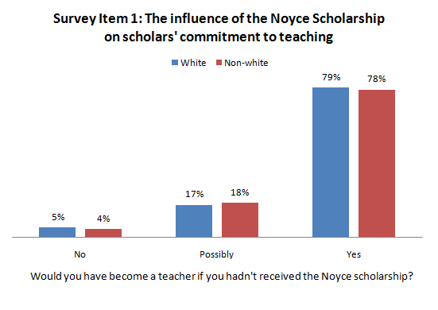

Figure 15. Survey Item 1: The influence of the Noyce funding on NETUM scholars’ commitment to teaching, Whites compared to Non-whites.

For the second survey item, the percentages of Whites and Non-whites responding “Yes” to the question of whether they would have worked in a high need environment regardless of the Noyce funding were not as high (Figure 16) as they were for the first survey item. This indicated that overall, these scholars perceived that the Noyce funding had more influence on their decisions to teach in a high need school than becoming teachers. The percentage of Whites responding “Yes” is lower than Non-whites responding “Yes” suggesting that more Whites reported that they felt more influenced by the Noyce funding to teach in a high need school, however it is difficult to draw a conclusion because the category of “Possibly” has the reverse percentage pattern. In contrast, for survey item 1, each category had similar patterns so those results were more easily interpretable.

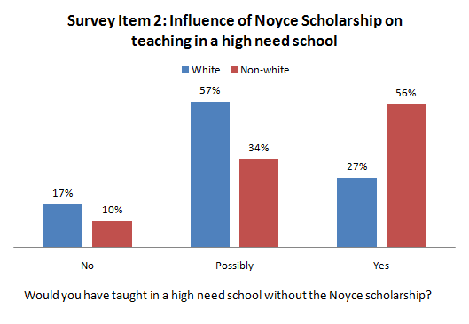

Figure 16. Survey Item 2: The effectiveness of the Noyce funding on influencing NETUM scholars to teach in a high need school, Whites compared to Non-whites.

College major group differences for Factors 1 & 2:

The final grouping of the NETUM scholars was according to the content area they majored in. It was of interest to know whether scholars majoring in different content areas scored differently on the factors. Comparisons by major content area for the first two factors are found in Table 8 and comparisons of the responses to the two survey items are found in Tables 9 and 10. Recall that there were eight specified majors that the PIs could have chosen from to indicate their scholars’ content area: biology, chemistry, computer science, engineering, geology/environmental science, math, physics, or physical science. There was also an option of “other” reserved for the case where the major of the scholar was not listed, however comparisons involving the “other” category are not presented here. Overall, 357 of the NETUM scholars had one major, 52 had two or more, and 97 had some other major that was not one of the eight listed. Independent sample t tests were run to see if any of the eight selected majors had a significantly different factor score from another major on any of the seven factors. Because these were independent sample t tests, the p-values correspond only to the scholars exclusive to one group. For example, individuals who were reported as being both biology and chemistry majors were not included in the analyses that compared biology and chemistry majors.

The average score for Factor 1, the perceived influence of the Noyce funding on the scholar’s commitment to teaching, was -.002 (Table 8). This score corresponds to an average of 1.74 on a rating scale of 1 through 4 for perceived influence of Noyce funding (1= not at all influential, 2 = not very influential, 3 = somewhat influential, 4 = very influential). A 1.74 indicates that on average, the scholars perceived that the Noyce funding was not very influential on their decisions to become teachers. The major with the highest factor score was physical science with a score of .211 (a 1.85 on the 1-4 scale) indicating that physical science majors tended to report feeling more influenced by the Noyce funding to become teachers compared to other majors. Conversely, the major with the lowest score was physics (-.183, representing a 1.60 on the 1- 4 scale), however, none of the eight majors were significantly different from another on this factor.

The factor scores for the majors regarding Factor 2, the perceived influence of the Noyce funding on the scholar’s commitment to teaching in a high need school, are found in Table 8. The average score amongst the majors was -.021 This score represents 2.01 on the 1-4 rating scale indicating that again, on average, the scholars perceived that the Noyce funding was not very influential on their decisions to teach in a high need school. In contrast to the results for Factor 1, physics majors scored the highest for perceived influence of the Noyce scholarship on their commitment to teaching in a high need school, whereas chemistry majors scored the lowest, though again, none of the eight majors were significantly different from another.

Table 8

Factor Scores for Commitment to Teach and Commitment to Teaching in a High Need School Amongst Individuals with Different Majors
Factor scores
 | Commitment to teach  (M, SD) |  | Commitment to teach in high need schools (M, SD)
Majors |  | Majors
Physical Science | (.211, 1.02) | Physics | (.115, .894)
Chemistry | (.156, .940) | Physical Science | (.113, 1.25)
Engineering | (.134, .758) | Geology_Envir Sci | (.041, .892)
Biology | (.078, .959) | Biology | (.025, .965)
Geology_Envir Sci | (.019, .897) | Math | (-.013, .960)
Computer_ Sci | (-.431, .839) | Computer_ Sci | (.042, .539)
Math | (-.024, .925) | Engineering | (-.098, .785)
Physics | (-.183, .972) | Chemistry | (-..042, .963)
Total | (-.002,.933) | Total | (-.021, .956)
Note. No groups were significantly different from another.

For the first survey item, the percentages demonstrate that at least 70% of all types of majors would have become teachers even if they had not participated in the Noyce program (Table 9). Again, this suggests that NETUM scholars had a high commitment to teaching regardless of the Noyce funding.

Table 9

Survey Item 1. The Effectiveness of the Noyce Funding in Influencing Scholars of Various Majors to Become Teachers
 |  | Would you have decided to become a teacher if you had not participated in the Noyce program?
Majors | (Group N) | No | Possibly | Yes
Biology | 154 | 6% | 20% | 74%
Chemistry | 37 | 3% | 27% | 70%
Computer_ Sci | 5 | 0% | 20% | 80%
Engineering | 21 | 0% | 14% | 86%
Geol_Envir Sci | 26 | 4% | 23% | 73%
Math | 200 | 2% | 15% | 84%
Physical Science | 8 | 13% | 0% | 87%
Physics | 30 | 10% | 7% | 83%

For the second survey item, the major that appeared to be most influenced by the Noyce program to teach in a high need school was physical science (Table 10). There were 38% of these individuals who said that they would not have decided to teach in a high need school if they had not participated in the program. The major that appeared to be least influenced by the Noyce program to teach in a high need school was geology/environmental science because only 4% reported that they would not have taught in a high need environment if they had not received the funding. However, again recall that the group sizes varied which makes interpretations of percentages at face value misleading.

Table 10

Survey Item 2. The Effectiveness of the Noyce Funding in Influencing Scholars of Various Majors to Teach in a High Need School
 |  | Would you have decided to teach in a high need school if you had not participated in the Noyce program? (%)
Majors | (Group N) | No | Possibly | Yes
Physical Science | 8 | 38% | 25% | 37%
Physics | 30 | 27% | 40% | 33%
Engineering | 21 | 20% | 35% | 45%
Computer_ Sci | 5 | 20% | 20% | 60%
Biology | 154 | 14% | 49% | 37%
Math | 200 | 14% | 46% | 40%
Chemistry | 37 | 7% | 44% | 50%
Geology_Envir Sci | 26 | 4% | 62% | 35%

Group differences for remaining six factors:

The rest of this section of the report presents the group comparisons of scores on the remaining six factors, which include scholars’ perceptions of their “preparation for high need schools”, “path to teaching”, “district/school high need environment”, “personal beliefs towards teaching”, “school teaching environment” and “mentoring experience”. Here again the scholars were grouped by sex, minority status, and majors and a summary of the results for these factor scores are found below. The results for group differences between the sexes are presented in Table 11. The results for group differences for minority status are in Table 12; and the results for group differences amongst the various majors are in Tables 13a and 13b. Overall mean scores are not presented for these remaining factors because the items that make up these factors use a combination of rating scales which makes interpretations difficult. For more information on the items and their rating scales, see University of Minnesota Evaluation of the Robert Noyce Teacher Scholarship Program, Final Report Section Two: Factor Analysis of the Evaluation Questionnaire.
The third factor, “preparation for high need schools”, included the scholars’ responses to 13 individual items. A basic interpretation of these scores is that the higher the score, the more the scholar felt prepared for teaching in a high need school. Mean scores for the sexes are found in Table 11, for Whites and Non-whites are found in Table 12, and for the different majors in Tables 13a and 13b. According to the mean scores, males tended to report feeling slightly more prepared for teaching in a high need school compared to females, however this difference was not significant (F_{1,463}, p = .540). In contrast there was a significant difference between Whites and Non-whites, (F_{1,467,} p = .001), with Non-whites scoring higher on this factor, indicating that Non-whites felt better prepared to teach in a high need school. For the majors, computer science scored significantly lower than biology (t(150) p = .003) and physics (t(23.1) p = .002) indicating that computer science majors are less likely to feel prepared compared to biology and physics majors for teaching in a high need school.

For the fourth factor, “path to teaching”, the scholars responded to seven items regarding various aspects of courses they took and decisions about becoming teachers, including previous career status. A basic interpretation of this score is that the higher the score, the more likely the scholar had another full-time career before becoming a teacher and considered themselves to have made a career change. In addition, they were ones who had taken more STEM classes. Mean scores for males and females are found in Table 11, for Whites and Non-whites are found in Table 12, and for the different majors are found in Tables 13a and 13b. Here again, males scored slightly higher than females on this factor but the difference was not significant (F_{1,257,} p = .269). Likewise, Non-whites scored slightly higher than Whites but again, the difference was not significant (F_{1,237}, p = .200). For the majors, there were significant differences found between engineering and four of the majors; engineering vs. biology (t(13.2), p <.001), engineering vs. chemistry (t(31), p =.001), engineering vs. math (t(12.6), p < .001) and engineering vs. physics (t(23.2),p = .002). These results indicate that engineering majors were more likely to have had a full-time career before becoming teachers, considered themselves to have made a career change more than other majors, and that they took more STEM classes compared to the other five majors. Additionally, there were significant differences found between geology/environmental science vs. biology (t(15.6),p < .001); geology/environmental science vs. chemistry (t(31.9), p <.001); and geology/environmental science vs. math (t(24.7), p <.001) with geology/environmental science majors scoring higher in all three cases. This indicates that geology/environmental science majors were more likely to have had a full-time career before becoming teachers, considered themselves to have made a career change more than other majors, and that they took more STEM classes compared to biology and chemistry majors.

The fifth factor, “districts/schools high need status”, included five items about the district/school status on the percentage of students receiving free or reduced lunch; the percentage of teachers lacking sufficient training in the academic area they do most of their teaching in; and the percentage of teacher attrition over the last three years. A basic interpretation of these scores is that higher scores correspond to districts/schools meeting Title I requirements for being considered high need. Mean scores for males and females are found in Table 11, for Whites and Non-whites are found in Table 12, and for the different majors are found in Tables 13a and 13b. The mean score for males was slightly higher than females though this difference was not significant (F_{1,287}, p = .740 ). In contrast, there was a difference between Whites and Non-whites with Non-whites scoring higher on this factor (F_{1,272}, p = .015) indicating that Non-whites tended more often to work in schools/districts that were categorized as high need. For the majors, there were no differences found between any of the content groups.

The sixth factor, “personal beliefs towards teaching”, included nine items to which the scholars responded on the scholar survey. Higher scores correspond to higher levels of job satisfaction, opportunities of professional growth, and higher self-efficacy towards teaching. Mean scores for males and females are found in Table 11, for Whites and Non-whites are found in Table 12, and for the different majors in Tables 13a and 13b. Although females scored slightly higher than males on this factor, the difference was not significant (F_{1,272}, p = .341). Likewise for ethnicity, Whites scored slightly higher than Non-whites, however this difference was also non-significant (F_{1,257}, p = .125). For the majors, there was only a significant difference found between math and physical science majors (t(9.8), p < .001) with physical science majors scoring higher on this factor.

The seventh factor, “school teaching environment”, included five items regarding collaboration, support, and the availability of materials at their schools. Higher scores on this factor indicate that the scholars perceived their environment as being more collaborative and supportive. Mean scores for males and females are found in Table 11, for Whites and Non-whites are found in Tables 12, and for the different majors in Tables 13a and 13b. Males tended to report more collaboration, support and availability of materials at their schools more often than females, though this difference was not significant (F_{1,303}, p = .497). Likewise, there was no difference between Whites and Non-whites for this factor (F_{1,288,} p = .996) with their mean scores being almost identical. There were no differences amongst the majors, making this the first factor for which there were no differences found between any of the groups.

Finally, for the eighth factor, “mentoring experiences”, the scholars were asked six questions regarding mentoring experiences they might have received during and after their teacher preparation/certification program. Higher scores for this final factor indicates that the scholars reported more mentoring experiences. Mean scores for males and females are found in Table 11, for Whites and Non-whites are found in Tables 12, and finally for the different majors are found in Tables 13a and 13b. There was a significant difference between the sexes for mentoring experiences (F_{1,462} = p = .017), with males reporting more experiences than females. Similarly, there was a significant difference between Whites and Non-whites (F_{1, 433}, p <.001), with Non-whites reporting substantially more mentoring experiences than Whites. For the majors, there were significant differences found between computer science and two other majors; computer science vs. chemistry (t(12.5), p = .001) and computer science vs. engineering (t(15.4) p < .001) with computer science majors receiving less mentoring experiences than the other two majors.

Table 11

Sex Differences for Factors 3-8
 | Factor Scores(M,SD)
 | Males |  |  | Females |  | Total
Preparation for high need school  N | (.048,.932) |  |  | (-.007, .913) |  | (.013, .924)
Preparation for high need school  N | 163 |  |  | 302 |  | 465
Personal path that lead into teaching  N | (-.021, .907) |  |  | (-.153, .904) |  | (-.109, .905)
Personal path that lead into teaching  N | 86 |  |  | 173 |  | 259
District/school high need environment  N | (.024, .842) |  |  | (-.012, .890) |  | (- .000, .873)
District/school high need environment  N | 97 |  |  | 192 |  | 289
Personal beliefs towards teaching  N | (-.092, .871) |  |  | (.010, .817) |  | (-.025,.836)
Personal beliefs towards teaching  N | 93 |  |  | 181 |  | 274
School teaching environment  N | (.041, .946) |  |  | (-.031, .852) |  | (-.006, .885)
School teaching environment  N | 106 |  |  | 199 |  | 305
Mentoring experience *  N | (.123, .940) |  |  | (-.081,.836) |  | (-.010, .878)
Mentoring experience *  N | 160 |  |  | 304 |  | 464
Note. Group sizes varies for each factor due to missing responses. The only factor that had significant sex differences was “mentoring experiences”, * F_{(1, 462)} = 5.77, p = .017.

Table 12

Differences Between Whites and Non-whites for Factors 3-8
 |  | Factor scores (M,SD)
 |  | Whites | Non-whites |  | Total
Preparation for high need school ** |  | (-.109,.956) | (.206,.853) |  | (-.011,.936)
N |  | 298 | 135 |  | 433
Personal path that lead into teaching |  | (-.161,.942) | (-.000,.806) |  | (-.110, .902)
N |  | 163 | 76 |  | 239
District/school high need environment |  | (-.101,.897) | (.179,.822) |  | (-.015,.883)
N * |  | 190 | 84 |  | 274
Personal beliefs towards teaching |  | (.013,.770) | (-.161, .986) |  | (-.041,.846)
N |  | 178 | 81 |  | 259
School teaching environment |  | (.005,.880) | (.004, .890) |  | (.005,.882)
N |  | 203 | 87 |  | 290
Mentoring experience *** |  | (-.142,.813) | (.342,.915) |  | (.011,.875)
N |  | 297 | 137 |  | 434
* = p <.05, ** = p <.01, *** = p<.001.

Table 13a

Differences between the College Majors of Biology, Chemistry, Computer Science and Engineering for Factors 3-8
 | Factor scores (M, SD)
 | Biology | Chemistry | Computer Science | Engineering
Preparation for high need school* | (.069,.900) | (.165,.1.07) | (-1.51,.860) | (-.105,.965)
N | 149 | 32 | 3 | 19
Personal path that lead into teaching* | (-.147,.803) | (-.067,.891) |  | (1.01,.572)
N | 92 | 25 | 0 | 10
District/school high need environment | (-.071,.898) | (.272,.840) | (-.731,.955) | (.005,.1.05)
N | 95 | 21 | 4 | 15
Personal beliefs towards teaching* | (.057,.777) | (.060,.908) | (-.459,.637) | (.003,.901)
N | 94 | 18 | 5 | 14
School teaching environment | (-.074,.926) | (-.152,.906) | (-.309,.701) | (-.044,.876)
N | 102 | 22 | 5 | 17
Mentoring experience* | (.022,.821) | (-.011,.882) | (-.892,.281) | (.239,.820)
N | 149 | 34 | 4 | 17
Note. Significance level was set at .00625. * indicates that there was a difference amongst the eight majors for this factor.

Table 13b

Differences between the College Majors of Geology/Environmental Science, Math, Physics, and Physical Science for Factors 3-8
 | Factor scores (M,SD)
 | Geol/Env Science | Math | Physics | Physical Science | Total
Preparation for high need school* | (.098,.900) | (-.002,.869) | (.118,1.09) | (.311,.960) | (.0125,.924)
N | 22 | 180 | 28 | 8 | 465
Personal path that lead into teaching* | (.717,.535) | (-.329,.918) | (.054,.937) | (.581,.935) | (-.109,.905)
N | 13 | 84 | 20 | 6 | 259
District/school high need environment | (.244,.957) | (-.021,.844) | (-.364,.990) | (.629,.524) | (-.000,.873)
N | 17 | 101 | 15 | 3 | 289
Personal beliefs towards teaching* | (.083,.686) | (-.141,.937) | (-.488,.939) | (.643,.150) | (-.025,.836)
N | 18 | 93 | 13 | 3 | 274
School teaching environment | (-.033,.850) | (.113,.834) | (-.323,1.04) | (-.043,1.20) | (-.006,.885)
N | 18 | 103 | 14 | 4 | 305
Mentoring experience* | (-.146,.876) | (-.036,.931) | (-.144,1.02) | (.072,.867) | (-.010,.878)
N | 23 | 179 | 28 | 8 | 464
Note. Significance level was set at .00625. * indicates that there was a difference amongst the eight majors for this factor.

Summary of group differences found amongst NETUM scholars on the 8 factors and the 2 survey items identified from the scholar survey:

There were a few significant group differences found between the sexes, minority status, and majors for the eight factors and two categorical survey items of the scholar survey. There were no significant differences for the sexes on any of the factors except mentoring experiences in which males reported more mentoring experiences compared to females.

Regarding minority status, there were significant differences between the groups on four of the factors. These differences were that Non-whites perceived that the Noyce funding was more influential on their decisions to becoming teachers; Non-whites felt more prepared for teaching in a high need school; Non-whites reported teaching in high need environments at a higher rate; and finally, Non-whites reported more mentoring experiences.

For the majors, there were differences amongst the groups on four of the factors. The first difference was that computer science majors felt less prepared for teaching in a high need school compared to biology and physics majors. The second difference was that engineering majors were more likely to have been full time workers before becoming teachers and considered themselves to have made more of a career change compared to biology, chemistry, math, and physics majors. Likewise, geology/environmental science majors were also more likely to have been full time workers before becoming teachers and considered themselves to have made more of a career change compared to biology and chemistry majors. The third difference was that computer science majors reported having received less mentoring experiences compared to chemistry and engineering majors. Finally, the fourth difference was that physical science majors reported higher levels of job satisfaction, opportunities of professional growth, and higher self-efficacy towards teaching than math majors.

Part 4: Results from cluster analysis

Introduction

Cluster analysis is a statistical procedure that sorts through raw data and groups them into clusters. It is used when the researcher does not know the number of groups in advance but wishes to establish groups and then analyze group membership. Cluster analysis implements this by seeking to identify a set of groups which both minimize within-group variation and maximize between-group variation; therefore members of the same group are similar to each other, but different from any other group. Once the groups are identified, other characteristics can be examined. A cluster analysis of the NETUM scholars was performed to determine whether the scholars could be assigned to groups based on the patterns of their responses to the scholar survey. An in-depth report of the cluster analysis can be found in Liou, Desjardin & Lawrenz (in press).

Methodology

A two-stage hierarchical cluster analysis (TSHCA, performed with SPSS) was used to categorize the Noyce scholars’ perceptions of the Noyce scholarship (Liou, Desjardin & Lawrenz, in press). The data used came from the scholar survey database (NETUM scholars) which contained information on the scholars who took the survey. Recall from Final Report Section 1: Planning and Survey Data, there were seven variations of the survey; these variations corresponded to the current status of the scholar. One variation of the survey was tailored towards scholars who were currently teaching full time or part time. Of the 507 NETUM scholars, only 304 of them were current STEM teachers during that time. It was data from this group “current STEM teachers” (n=304) that the TSHCA was performed. TSHCA is a technique which statistically groups similar participants together. Scholars included in the same cluster are considered more closely related to each other than scholars in other clusters. In other words, TSHCA analysis seeks to identify a set of groups which both minimizes within-group variation and maximizes between-group variation (Johnson, 1998).

After formation of the clusters, analysis of variance (ANOVA) and two-way contingency table analysis were used to examine whether there were differences among the clusters for the Noyce scholars’ sex and minority status and perceptions related to teaching and teaching in high need schools.

Four variables were included in TSHCA. The variables were used because they were most directly related to the impact of the Noyce funding. These variables were the same as in the “NETUM factor score results from the scholar survey” section on page 25 of this report. Recall that two of the four variables were the factor scores for “commitment to become a teacher” and “commitment to teaching in a high need school” factors. The other two variables were the categorical survey items noted above for which the scholar responded “Yes”, “No” and “Possibly.” The items were, “Would you have become a teacher if you had not received the Noyce scholarship?” and “Would you have decided to teach in a high need school if you had not participated in the Noyce scholarship program?”

Results

TSHCA divided the 304 NETUM scholars into three clusters. Seventy-one recipients were in the first cluster, 119 were in the second cluster, 104 were in the third cluster, and 10 cases were excluded from the analysis because of missing values.

The three clusters showed clear distinctions for the four variables (Figures 17-20). Figure 17 shows that the Noyce funding was perceived as having relatively high impact on scholars in cluster one’s decision to become a teacher.

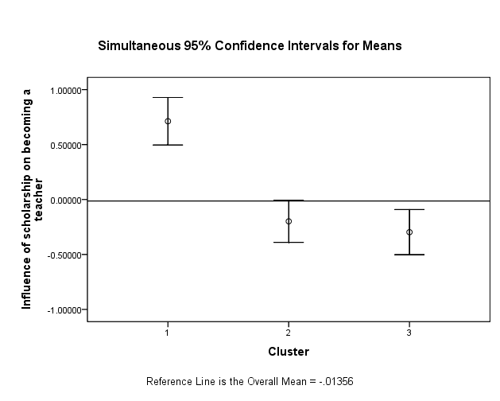

Figure 17. The influence of the Noyce funding on currently teaching NETUM scholars (n = 304) commitment to teaching: Clusters 1, 2, and 3.

Figure 18 shows that the scholarship was perceived as having a large impact on scholars in both clusters one and two on their decision to become a high need school teacher.

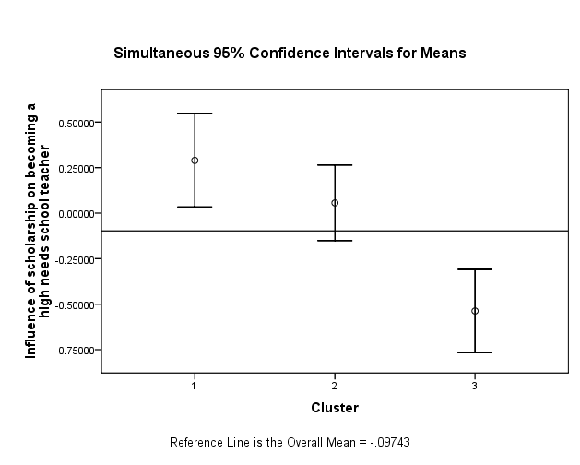

Figure 18. The influence of the Noyce funding on currently teaching NETUM scholars (n=304) commitment to teaching in a high need school: Clusters 1, 2, and 3.

Figure 19 shows that scholars in clusters two and three all indicated that they would have become teachers if they had not received the Noyce funding, but all scholars in cluster one selected “no” or “possibly”.

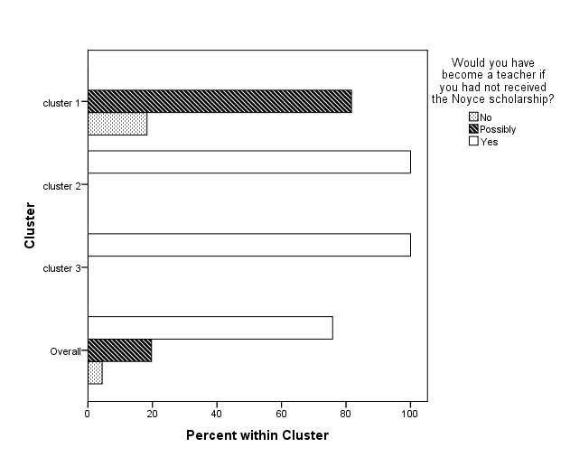

Figure 19. Survey item 1. The influence of the Noyce funding on currently teaching NETUM scholars (n = 304) commitment to teaching: Clusters 1, 2, and 3.

Figure 20 shows that scholars in cluster three all indicated they would have decided to teach in a high need school if they had not participated in the Noyce program, but scholars in clusters one and two indicated that “no/I have not taught in a high need school” or “possibly” when asked whether they would teach in a high need school.
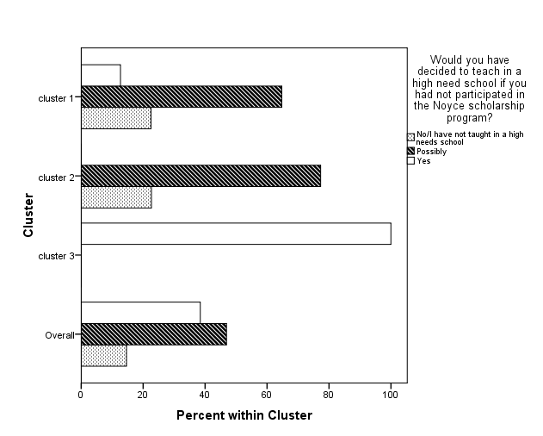

Figure 20. Survey item 2. The influence of the Noyce funding on currently teaching NETUM scholars (n = 304) commitment to teaching in a high need school: Clusters 1, 2, and 3.

There were significant main effects of cluster on each continuous variable included in the clustering algorithm for “commitment to become a teacher” (F_{2,293}, p < 0.01), and for “commitment to becoming a high need school teacher” (F_{2,293}, p < 0.01). These statistical tests showed that the three clusters had different means for these two variables. There is no statistical test for the two categorical variables, so a visual examination of Figures 19 and 20 was performed to further explain the clustering. Cluster one contained 71 NETUM scholars who selected the highest ratings for the two continuous variables and only “no” and “possibly” ratings for the two categorical variables. This cluster was named “less committed to becoming a teacher and teaching in a high need school.” Cluster two contained 119 NETUM scholars whose responses for the two continuous variables were lower than cluster one, and their responses for the categorical variable “Would you have become a teacher if you had not received the Noyce Scholarship?” were all “yes”, but their responses for the categorical variable “Would you have decided to teach in a high need school if you had not participated in the Noyce scholarship program?” were “possibly” or “no.” This cluster was named “highly committed to becoming a teacher but not to teaching in a high need school.” Cluster three contained 104 NETUM scholars, and exhibited the lowest scores on the two continuous variables, and answered “yes” for the two categorical variables. This cluster was named “highly committed to becoming a teacher and teaching in a high need school.”

Demographic characteristics and perceptions for the three groups:

Two-way contingency table analyses were conducted to evaluate the relationship between the three groups based on minority status (non-White vs. White) and sex (female vs. male). Forty-seven percent of the White NETUM scholars were in the “highly committed to becoming a teacher but not to teaching in a high need school” cluster, while 47% of the non-White NETUM scholars were in the “highly committed to becoming a teacher and teaching in a high need school.” This result showed that more White NETUM scholars have higher commitments to become teachers than to become teachers in high need schools and that non-White NETUM scholars have high commitments to not only become teachers but also to teach in high need schools. There was no statistical evidence to suggest there was a difference among the three clusters according to sex (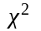(2, n=294) = 1.65; p = 0.44).

Summary of cluster analysis:

The three clusters that were identified in this section of the report were: Less committed to becoming a teacher and teaching in a high need school, highly committed to becoming a teacher but not to teaching in a high need school, and highly committed to becoming a teacher and teaching in a high need school. The scholars in the less committed cluster were the most influenced by the Noyce funding and they perceived the funding to affect their decision to enter teaching and to teach at high need schools. The scholars in the highly committed to teaching but not high need cluster had a perceived effect of the Noyce funding on their decision to teach in high need schools but not on their decision to enter teaching. Finally, the scholars that were in the highly committed to teaching and high need cluster were the least influenced by the Noyce funding and they did not perceive an effect of the funding on their decision to enter teaching or to teach in a high need schools. The three clusters differed in their proportion of White and non-White scholars. White scholars were more likely to be in the highly committed to teach but not high need cluster indicating that White scholars were the most profoundly affected by the Noyce funding to teach STEM in high need settings. Non-White scholars were more likely to be in the highly committed to teaching and high need cluster indicating they perceived a lower effect of the Noyce funding on their decision to teach or to teach in high need schools. These results suggest that the Noyce funding may be important in recruiting White scholars to teach in high need schools.

Part 5: Conclusion

The purpose of this report was to use the data from the ORC Macro International Inc. Noyce Program monitoring system and the scholar survey to provide more insight into the effect of the Noyce program. To accomplish this, the ORC scholar data was combined with the scholar data from the scholar survey. Combining the data bases was useful because many of the variables in the ORC data base were not available in the UMN survey data, e.g., sex, minority status, major field, etc. This new combined data base, NETUM, served as the basis for several analyses using the different variables.

The first part of this report presented a descriptive summary of the Noyce scholars who took the scholar survey (NETUM scholars) on 17 demographic, academic, and teaching experience characteristics. Highlights from this descriptive summary are that there is approximately a 2:1 female to male ratio, a 2:1 White to Non-white ratio, and that Asians and Blacks make up the majority of the NETUM minority population. For academics, 70% of NETUM scholars are math or biology majors, and 60% of them are certified to teach at the high school level. By 2007, 74% had completed their teacher preparation program and 72% of them were already certified or licensed. Also, by 2007, 82% of the post-support scholars had experience teaching in a high need environment and 79% of the post-support scholars were actually teaching in a high need district.

Since it was proposed to use the results of the scholar survey as indicative of all the Noyce scholars, representativeness of the NETUM scholars had to be established. Thus, the second part of the report was a comparison of the NETUM scholars to the rest of the Noyce scholars (ORC-2 scholars) on nine demographic, academic, and teacher-experience characteristics to determine if the scholars who took the scholar survey were similar to the ones who did not. Results from the comparisons showed that both groups were similar in their proportions of males and females, Whites and Non-whites, and content areas the scholars majored in and intended on teaching. They were also comparable on their proportions of various racial groups except that NETUM scholars had a slightly higher proportion of Asians and a lower proportion of Hispanics than the ORC-2 scholars. There were also some differences in the percents of scholars teaching at various K-12 levels, however, for both groups, the majority of the scholars were certified at the high school level. Therefore, it was decided that the NETUM scholars were representative of Noyce scholars generally.

The third part of this report examined group differences amongst the scholars on the factors identified in the scholar survey. The groups were sex (male and females), minority status (Whites and Non-Whites), and content major areas (biology, chemistry, computer science, engineering, environmental science/geology, math, physics, and physical science). The analyses demonstrated that there were some group differences in perceptions as reported on the scholar survey factor scores. A major finding from part three was that here were no significant differences for the sexes on any of the factors except mentoring experiences in which males reported more mentoring experiences compared to females. A second major finding was that there were significant differences between Whites and Non-whites on four of the factors. These differences were that Non-whites perceived that the Noyce funding was more influential on their decisions to becoming teachers; Non-whites felt more prepared for teaching in a high need school; Non-whites reported teaching in high need environments at a higher rate; and Non-whites reported more mentoring experiences. Finally, for the majors, there were differences amongst the groups on four of the factors. One of the differences was that computer science majors felt less prepared for teaching in a high need school compared to biology and physics majors. A second difference was that engineering majors were more likely to have been full time workers before becoming teachers and considered themselves to have made more of a career change compared to biology, chemistry, math, and physics majors. A third difference was that computer science majors reported having received less mentoring experiences compared to chemistry and engineering majors. Finally, the fourth difference was that physical science majors reported higher levels of job satisfaction, opportunities of professional growth, and higher self-efficacy towards teaching than math majors.

The fourth part of this report presented the results of a cluster analysis of NETUM scholars who were current STEM teachers which demonstrated that the Noyce program supports three types of scholars: (a) those who are “less committed to becoming a teacher and teaching in a high need school”; (b) those who are “committed to becoming a teacher but not teaching in a high need school”; and (c) those who are “committed to becoming a teacher and teaching in a high need school”. The cluster analysis demonstrated that there was a higher percentage of Non-whites (47%) in cluster three (highly committed to becoming a teacher and teaching in a high need school) than Whites (30%). From the cluster analysis then, it was inferred that a higher proportion of Non-whites reported less influence of the Noyce funding on their decisions to become teachers and teach in high need schools. This inference conflicts with the one from the factor scores analysis which demonstrated that on average, non-whites perceived themselves to be more influenced by the Noyce funding to become teachers. The differences between the factor scores results and the cluster analyses results might be explained by the fact that factor analyses attempts to categorize items whereas cluster analyses attempts to categorize people. Also, a factor scores analysis allows the researcher to look for group differences amongst already intact groups, whereas in contrast, a cluster analysis allows the researcher to use the data and create groups based on their latent characteristics. It is important to keep in mind as well that the cluster analysis only examined the NETUM scholars who were currently teaching, whereas the factor analysis included all of the NETUM scholars. Thus, the results from the factor score analyses do not necessarily negate the premise that there are three distinct groups of Non-whites. These findings suggest then that the Noyce program is effective in recruiting minority STEM majors into the teaching profession who otherwise may not have considered this field.

An important limitation of this report was the substantial proportion of missing data in the ORC data base. There were 177 variables, but many of them were not useful to analyze due to the missing data; if these data are missing for some systematic reason (i.e., not missing at random), the results of the analyses could be biased. Also, it is possible that a variable that could have been important for the purposes of this report was not able to be analyzed due to the missing data. Additionally, the ORC database was not user friendly. Often variables had to be recoded before analyses could be conducted. For example, in order to conduct the independent sample t tests for part three of this report, the variables for “type of major” had to be recoded so comparisons were possible. One suggestion to the Noyce program is to re-organize the database with future statistical inquiries in mind so as to better facilitate its end use.

Finally, it was difficult to determine the actual percent of scholars who met the high need teaching requirements for the Noyce program because scholars are given up to six years to fulfill their 2-year obligation for teaching in a high need environment. Moreover, the ORC monitoring database did not indicate the numbers of years the scholars had remaining to satisfy the requirements. A more effective system of scholar follow-up is needed to ensure that the scholars are meeting the requirements of the Noyce program.

Appendix A: Scholar survey

Scholar Survey
Robert Noyce Scholarship Program Evaluation

These questions pertain to your experience in the Noyce scholarship program at UofM
Groups:
A: In a teacher certification program, not yet a full-time teacher
B: Completed a teacher certification program, but never taught
C: Did not complete a teacher certification program and will not return
D: In a teacher certification program and teaching full-time as part of that program
E: Teaching full-time or part-time
F: Taught after being certified, and now working in education but not as a teacher
G: Taught after being certified, and now not working in education
*The groups are based on the scholar’s current education status. A few questions within the surveys differed based on the groups. The questions are labeled with the groups corresponding letter.
Section I: Project Overview
 | 1. | Which of the following describe your teacher certification program? (Mark one.)
A,D,E,F,G |  | Undergraduate program leading to a bachelor’s degree  Teaching credential (no degree)  Post-baccalaureate or graduate program (no master’s degree awarded)  Graduate program (master’s degree awarded)  Other
 | 2. | At what point in your training did you become the “official” teacher in charge of a classroom (sometimes known as the “teacher of record”)? (Mark one.)
At the beginning of the program
After a brief introduction (e.g., a summer session)
During the program – first half
During the program – second half
Upon completion of the program
Other
 | 3. | For how many terms of your teacher training did you receive Noyce scholarship funds? (Enter the number of terms and choose the appropriate term length)
Semesters 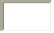 number of semesters
Quarters number of quarters
I don’t know
 | 4. | How much money were you awarded for each term of funding? (Enter the dollar amount and choose the appropriate term length.)
Semester $ amount per semester
Quarter $ amount per quarter
I don’t know
 | 5. | What proportion of your tuition was covered by your scholarship or stipend?
0% (money not used for tuition)
1-24%
25-49%
50-74%
75-99%
100%
I don’t know
Section II: Program characteristics and organization
 | 1. | Which of these were part of your experience in your teacher certification program? (Mark yes or no for each item.)
no
yes
Opportunities to interact with adults from different cultures
Opportunities to interact with children from different cultures
Education about different cultures
Class(es) in teaching methods specific to your subject area (e.g., science or math)
Education about how to work in high needs schools specifically
Opportunities to observe/work at high needs schools (not student teaching)
Student teaching experience
Student teaching experience in a high needs school
A guaranteed job (assuming successful completion of program) at a participating school district
Mentoring experiences provided by your certification program during your first year of teaching
Mentoring experiences provided by your district during your first year of teaching
Mentoring experiences provided by your certification program during your second year of teaching
Mentoring experiences provided by your district during your second year of teaching
Continuing contact with participants in your teacher education program

 | 2. | Five types of field experience are listed below. Please indicate whether each of the experiences below was a requirement of your teacher certification program. Indicate the length of any required experience.
121 hours or more
81-120
41-80
1-40
Yes | No | Education field experience working in schools (e.g. tutoring, teacher aide) with young people like those who attend high needs schools | if yes, please answer:
Yes | No | Education field experience working outside of schools (e.g. summer camp) with young people like those who attend high needs schools in the area | if yes, please answer:
Yes | No | Research field experience (e.g., participation in a science, technology, engineering, or math (STEM) research project) in your subject area | if yes, please answer:
Yes | No | Supervised actual classroom teaching in high needs schools (this may be called student teaching, internship, etc. in your state) | if yes, please answer:
Yes | No | Supervised actual classroom teaching in NON high needs schools (this may be called student teaching, internship, etc. in your state) | if yes, please answer:

 | 3. | Some teacher certification programs require other types of field experience. Did your program require additional field experience?
 |  | Yes | No
 |  | If yes, please explain the nature of that experience briefly:
 |  | 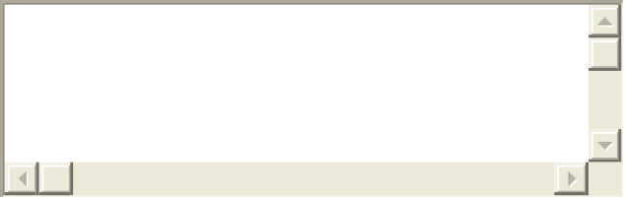
 |  | If yes, please mark the length of this field experience below
1-40 hours
41-80 hours
81-120 hours
121 hours or more

 | 4. | In your teacher certification program, how much opportunity did you have to do the following? (Mark one in each row.)
None
Touched on it briefly
Spent time discussing or doing
Explored in some depth
Extensive opportunity
Develop specific strategies for teaching English language learners (those with limited English proficiency)
Develop specific strategies for teaching students identified with learning disabilities
Develop specific strategies for teaching students from diverse racial and ethnic backgrounds
Consider the relationship between education and social justice and/or democracy

Section III: Teaching environment and experience
D, E | 1. | Which of the following describes your current teaching status? (Please mark only one.)
Teaching in a high needs school
Teaching in another type of school
D, E, F, G | 2. | How much do you agree or disagree with each of the following statements about teaching? (Mark one in each column.)
D, E, F, G  D, E
  Strongly disagree
  Disagree
  Neither agree nor disagree
  Agree
  Strongly agree
  I am satisfied with my current teaching job.
  I really dislike STEM teaching.
  If I had to do it all over again, in view of my present knowledge, I would become a teacher.
  If I had it to do all over again, I would choose the same teacher preparation program and/or route into teaching.
  In the next three years, I am likely to assume a leadership position (e.g., lead teacher, department chair, official or unofficial mentor).
  D, E
D, E, F, G | 3. | Which of the following characterize your school? For each option, indicate whether the description applies or not, or whether you are not sure.
D, E, F, G
  applies
  does not apply
  I am not sure
  Over 50% of students receive free or reduced lunch
  Over 33% of teachers lack sufficient training in their academic area
  There has been over 15% teacher attrition over the last three years
 | 4. | Which of the following characterize your district? For each option, indicate whether the description applies or not, or whether you are not sure.
D, E  F,G
  applies
  does not apply
  I am not sure
  Over 50% of students receive free or reduced lunch
  Over 33% of teachers lack sufficient training in their academic area
  There has been over 15% teacher attrition over the last three years
 | 5. | Within the last three years have you held any professional educational leadership positions, e.g., lead mathematics teacher, science committee chair, etc.
 |  | Yes | No
 |  | If yes, please give examples
D, E, F, G | 6. | Please rate your school environment as high, medium, or low on the following features:
D, E, F, G
  High
  Medium
  Low
  Collegial relationships (e.g., teachers consult on the quality of student work and make joint decisions based on assessment, collaborate to solve classroom challenges, observe and discuss each others’ instruction)
  Strong collaborative leadership (e.g., principals and other leaders provide teachers with opportunities to do well; principals and other leaders can be trusted; principals and other leaders share your vision of successful classroom practice)
  Availability of supplies or material (e.g., textbooks, print resources, instructional materials such as lab supplies or math manipulatives, and classroom supplies such as paper, pencils, or tape)
  Mentoring and/or induction support (e.g., organized, supported contact with a more experienced teacher, help with issues particular to early career teaching)
 | 7. | For how many years have you lived in the community in which you currently teach?
D, E, F, G |  | 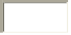 years
 | 8. | For how many years have you lived in the state in which you currently teach?
 |  | years
Section IV: The decision to become a teacher
 | 1. | At what point in your life did you decide to become a STEM teacher?
Childhood/adolescence (age 18 or before)
Early adulthood (age 19-22)
Adulthood (age 23 or older)
 | 2. | What age were you when you began the teacher certification program?
 |  | years
 | 3. | Did any of the following help you decide to become a STEM teacher? (Mark all that apply.)
no
yes
I like sharing my subject with others
I like working with young people
I like having summers off
I like the flexibility and/or autonomy of STEM teaching
I feel that a teaching career is/will be conducive to my family life
I feel that I have a talent for teaching STEM
I feel this career allows me to ‘make a difference’ in the world
Other

 |  | If other, please describe
 | 4. | Did you first learn about the Noyce scholarship before or after you decided to become a teacher?
Before
After
 | 5. | Did any of the following help you learn about the Noyce scholarship? (check all that apply)
Web site
Advisor
Career center
Other Please describe
 | 6. | Would you have become a teacher if you hadn’t received the Noyce scholarship?
Yes
Possibly
No
 | 7. | Would you have decided to teach in a high need school if you hadn’t participated in the Noyce scholarship program?
Yes
Possibly
No
I have not taught in a high needs school
 | 8. | How influential was the Noyce Scholarship money in your commitment to:
Not at all influential
Not very influential
Somewhat influential
Very influential
become a teacher
complete the certification program
take a teaching job
teach in a high needs school
remain teaching in a high needs school for the full term of your commitment
remain teaching in a high needs school beyond the full term of your commitment

Section V: Background and experience
 | 1. | How many upper level (junior/senior) or graduate level classes have you taken in:
 |  | Math: classes
 |  | Physical Science: classes
 |  | Life Science: classes
 |  | Earth Science: classes
 |  | Engineering: classes
 |  | Teaching Methods: classes
 | 2. | In what year did you last take a formal course for college credit in:
 |  | Mathematics: yyyy
 |  | Science: yyyy
 | 3. | Did you work full time before entering the teacher certification program?
 |  | Yes | No
 |  | If yes, in what field was the majority of your work? (Please mark one.)
Social services
K-12 education
Informal/non-K-12 education
Science
Engineering
Mathematics
Technology
Business
Other (Please describe):

 |  | Please briefly describe your work responsibilities in that job:
 | 4. | In entering the teacher certification program, do you consider yourself to have made a “career change”?
 |  | Yes | No
Section VI: Overall experience
 | 1. | What requirements were you expected to meet to fulfill your obligation to the Noyce program after you finished your schooling?
 | 2. | Did you have any special opportunities or responsibilities during your certification program because you were a Noyce Scholar (e.g., special seminars available or required)?
 |  | Yes | No
 |  | If yes, please describe those opportunities or responsibilities
 | 3. | Did the scholarship allow you to do anything you wouldn’t have been able to do otherwise outside of your schooling (e.g., not have to take a part-time job, teach in an area with a higher cost of living, travel to conferences, etc)?
 |  | Yes | No
 |  | If yes, please describe what Noyce allowed you to do:
B, C, F, G
  4. What reasons led you to stop pursuing a career in teaching?
 | 4. | Finally, do you have any suggestions for improving your experience in the Noyce program and/or better preparing you to teach successfully in high needs settings?

Appendix B: Factor loadings and sample sizes for the items in each factor

Table 1

Items, Loading and Sample Size for “Commitment to Teaching in High Need Schools (Influence of Noyce)” Factor (6 items)
Item | Factor loading | Sample size
IV.8.c Take a teaching job | 0.82 | 270
IV.8.d Teach in a high needs school | 0.80 | 270
IV.8.e Remain teaching in a high needs school for the full term of your commitment | 0.78 | 269
IV.8.a Become a teacher | 0.77 | 270
IV.8.f Remain teaching in a high needs school beyond the full term of your commitment | 0.75 | 269
IV.8.b Complete the certification program | 0.68 | 270
Note. All items from scholar survey question IV.8: “How influential is the Noyce Scholarship money in your commitment to: _____?”

Table 2

Items, Factor Loadings and Sample Sizes for “Preparation for High Need Schools” Factor (13 items)
Item | Factor loading | Sample size
II.4.c Develop specific strategies for teaching students from diverse racial and ethnic backgroundsª | 0.66 | 273
II.4.d Consider the relationship between education and social justice and/or democracyª | 0.63 | 273
II.1.e Education about how to work in high needs schools specifically^{b} | 0.52 | 274
II.4.a Develop specific strategies for teaching English language learners (those with limited English proficiency)ª | 0.50 | 273
II.4.b Develop specific strategies for teaching students identified with learning disabilitiesª | 0.49 | 273
II.1.h Student teaching experience in a high needs school^{b} | 0.48 | 272
II.2.d Supervised actual classroom teaching in high needs schools (this may be called student teaching, internship, etc. in your state)^{c} | 0.45 | 263
II.1.f Opportunities to observe/work at high needs schools (not student teaching)^{b} | 0.35 | 274
II.1.c Education about different cultures^{b} | 0.35 | 274
II.1.g Student teaching experience^{b} | 0.34 | 274
II.1.b Opportunities to interact with children from different cultures^{b} | 0.32 | 274
II.2.a Education field experience working in schools (e.g. tutoring, teacher aide) with young people like those who attend high needs schools^{c} | 0.32 | 267
II.1.a Opportunities to interact with adults from different cultures^{b} | 0.28 | 274
ª Items from scholar survey question II.4: “Five types of experiences are listed below. Please indicate whether each of the experiences below is a requirement of your teacher certification program. Indicate the length of any required experiences”
^{b}Items from scholar survey question II.1: “Which of these are part of your experience in your teacher certification program?”
^{c}Items from scholar survey question II.2: “In your teacher certification program, how much opportunity do you have to do the following:_____?”

Table 3

Items, Factor Loadings and Sample Sizes for “Path to Teaching” Factor (7 items)
Item | Factor loading | Sample size
IV.2 What age were you when you began the teacher certification program?__years | 0.81 | 270
V.3 Did you work full time before the teacher certification program? If yes, in what field was the majority of your work? | 0.69 | 231
IV.1 At what point in your life did you decide to become a STEM teacher? | 0.68 | 270
V.4 In entering the teacher certification program, do you consider yourself to have made a “career change”? | 0.68 | 267
V.1.a How many upper level (junior/senior) or graduate level classes have you taken in: STEM? | 0.30 | 171
V.2.a In what year did you last take a formal course for college credit in: Mathematics | -0.25 | 258
V.2.b In what year did you last take a formal course for college credit in: Science | -0.25 | 239

Table 4

Items, Factor Loadings and Sample Sizes for “District/school high need environment” Factor (5 items)
Item | Factor loading | Sample size
III.4.b Over 33% of teachers lack sufficient training in their academic area.(district)ª | 0.79 | 161
III.3.b Over 33% of teachers lack sufficient training in their academic area.(school)^{b} | 0.67 | 161
III.3.a Over 50% of students receive free or reduced lunch.(school) ^{b} | 0.44 | 163
III.4.a Over 50% of students receive free or reduced lunch.(district) ª | 0.44 | 162
III.1 Which of the following describes your current teaching status? | 0.36 | 158
ªItems from scholar survey question III.4: “Which of the following characterize your school? For each option, indicate whether the description applies or not, or whether you are not sure”
^{b}Items from scholar survey question III.3: “Which of the following characterize your district? For each option, indicate whether the description applies or not, or whether you are not sure”

Table 5

Items, Factor Loadings and Sample Sizes for “Personal beliefs towards teaching” Factor (9 items)
Item | Factor loading | Sample size
III.2.a I am satisfied with my current teaching jobª | 0.67 | 157
III.2.c If I had to do it all over again, in view of my present knowledge, I would become a teacherª | 0.65 | 164
III.2.d If I had it to do all over again, I would choose the same teacher preparation program and/or route into teachingª | 0.58 | 164
III.2.e In the next three years, I am likely to assume a leadership position (e.g., lead teacher, department chair, official or unofficial mentor)ª | 0.35 | 158
IV.3.f I feel that I have a talent for teaching STEM^{b} | 0.32 | 263
III.2.b I really dislike STEM teachingª | -0.32 | 160
III.5 Within the last three years have you held any professional educational leadership positions, e.g., lead mathematics teacher, science committee chair, etc. | 0.28 | 157
IV.3.d I like the flexibility and/or autonomy of STEM teaching^{b} | 0.26 | 259
IV.3.b I like working with young people^{b} | 0.23 | 268
ªItems from scholar survey question III.2: “How much do you agree or disagree with each of the following statements about teaching?”
^{b}Items from scholar survey question IV.3: “Did any of the following help you decide to become a STEM teacher?”

Table 6

Items, Factor Loadings and Sample Sizes for “School teaching environment" (4 items)
Item | Factor loading | Sample size
III.6.b Strong collaborative leadership (e.g., principals and other leaders provide teachers with opportunities to do well; principals and other leaders can be trusted; principals and other leaders share your vision of successful classroom practice) | 0.77 | 116
III.6.a Collegial relationships (e.g., teachers consult on the quality of student work and make joint decisions based on assessment, collaborate to solve classroom challenges, observe and discuss each others’ instruction) | 0.71 | 115
III.6.d Mentoring and/or induction support (e.g., organized, supported contact with a more experienced teacher, help with issues particular to early career teaching) | 0.66 | 116
III.6.c Availability of supplies or material (e.g., textbooks, print resources, instructional materials such as lab supplies or math manipulatives, and classroom supplies such as paper, pencils, or tape) | 0.48 | 115
Note. All items from scholar survey question III.6: “Please rate your school environment as high, medium, or low on the following features”

Table 7

Items, Factor Loadings and Sample Sizes for “Mentoring Experience” Factor (6 items)
Item | Factor loading | Sample size
II.1.l Mentoring experiences provided by your certification program during your second year of teaching | 0.58 | 164
II.1.m Mentoring experiences provided by your district during your second year of teaching | 0.55 | 264
II.1.j Mentoring experiences provided by your certification program during your first year of teaching | 0.51 | 272
II.1.k Mentoring experiences provided by your district during your first year of teaching | 0.49 | 271
II.1.i A guaranteed job (assuming successful completion of program) at a participating school district | 0.37 | 271
II.1.n Continuing contact with participants in your teacher education program | 0.30 | 270
Note. All items from scholar survey question II.1: “Which of these are part of your experience in your teacher certification program?”

Appendix C: Squared multiple correlation for Two-Factor model

Table 1

Squared Multiple Correlation for Two-Factor Model
Item | Squared Multiple Correlation
Factor 1 Influence of scholarship on STEM majors becoming teachers
Become a teacher | 0.763
Complete certification | 0.654
Take teaching job | 0.749
Factor 2: Influence of scholarship on STEM majors becoming high needs teachers
Full commitment | 0.815
Teach in high needs | 0.791
Beyond commitment | 0.589

Appendix D: Results for racial/ethnic groups for factors 1 -8 and the two categorical survey items

Table 1
Factor Scores for the Perceived Influence of the Noyce Funding on the Scholars’ Commitment to Teach and Commitment to Teaching in a High Need School, Races & Ethnicities
Factor scores

Influence of the Noyce funding on the scholar’s:
 | Commitment to teach  (M, SD)*** |  | Commitment to teach in high need schools (M, SD)
Whites  (N=319) | (-.086, .914) | Whites | (-.042,.944)
Non-whites  (N=150) | (.253, .948) | Non-whites | (-.020, 1.03)
Native Hawaiian | (1.16,.491) | Native Hawaiian | (1.07,.106)
Hispanic | (.451,.986) | Biracial | (.427,.524)
Black | (.333,.874) | Hispanic | (.351,.872)
American Indian | (.258,1.29) | American Indian | (.327,1.02)
Hispanic/White | (.236, .939) | Hispanic/White | (-.093, 1.15)
Asian | (.054,.994) | Black | (-.146,1.08)
Biracial | (-.063,.982) | Asian | (-.213,1.01)
Total | (.022, .938) | Total | (-.035,.970)
Note. For race and ethnicity, PIs were allowed to select as many categories that describe the scholars. Some scholars were described as Hispanic & White (Hispanic/White), and others as a combination of two or more racial groups (Biracial).

Table 2

Race and Ethnic Differences for Factors 3-8
 |  | Factor Scores (M, SD)
 | American Indian | Asian | Black | Hispanic | Pacific Islander | Hispanic/White | Whites
Preparation for high needs school | (-.490,1.38) | (.335,.820) | (.013,.839) | (.197,.925) | (.853,.390) | (.406,.689) | (-.089,.938)
Personal path that lead into teaching |  | (-.158,.924) | (.205,.857) | (-.166,.502) | (-.312,.250) | (.080,.839) | (-.161,.942)
District/school high needs environment | (.769, ) | (.089,.1.01) | (.208,.643) | (.165,.922) | (.629, ) | (.551,.374) | (-.101,.897)
Personal beliefs towards teaching |  | (-.454,1.20) | (-.062,.773) | (-.049, 871) | (.795, ) | (.454,.442) | (.013,.770)
School teaching environment | (-.418, ) | (-.220,.882) | (.009,.993) | (.044,.684) | (-.536, ) | (.651,.574) | (.005,.880)
Mentoring experience | (.217,1.09) | (.167,.820) | (.303,.971) | (.678,.985) | (.349,1.12) | (.444,.934) | (-.142,.813)
Note. Differences among the racial and ethnic groups on factors 2-8. Empty cells resulted from no one from that group responding to items for that factor. For race and ethnicity, PIs were allowed to select as many categories that describe the scholars. Some scholars were described as Hispanic & White (Hispanic/White), and others as a combination of two or more racial groups (Biracial).

Table 3

Survey Item 1. The Effectiveness of the Noyce Funding in Influencing Scholars of Various Races and Ethnicities to Become Teachers
 |  | Would you have become a teacher if you had not participated in the Noyce scholarship program?
Ethnic Group | (Group N) |  | No | Possibly | Yes
White  (N=311) | 311 |  | 5% | 17% | 79%
Non-white
(N =143)
Pacific Islander/Native Hawaiian | 2 |  | 50% | 0% | 50%
American Indian/Alaska native | 3 |  | 0% | 33% | 67%
Hispanic | 26 |  | 4% | 27% | 69%
Black | 51 |  | 2% | 20% | 78%
Asian | 43 |  | 7% | 12% | 81%
Hispanic/White | 18 |  | 0% | 17% | 83%
Note. There were 54 missing responses

Table 4
Survey Item 2. The Effectiveness of the Noyce Funding in Influencing Scholars of Various Races and Ethnicities to Teach in a High Need School
 |  | Would you have decided to teach in a high need school if you had not participated in the Noyce scholarship program?
Ethnic Group | (Group N) | No | Possibly | Yes
White | 309 | 17% | 57% | 27%
Non-white | 143
Pacific Islander/Native Hawaiian | 2% | 50% | 50% | 0%
Hispanic | 26 | 15% | 54% | 31%
Asian | 43 | 14% | 33% | 54%
Black | 50 | 4% | 28% | 68%
American Indian/Alaska native | 3 | 0% | 33% | 67%
Hispanic/White | 18 | 0% | 17% | 83%
Note. There were 55 missing responses

Appendix E: U of MN Noyce evaluation team comprehensive evaluation report sections

Appleton, J., Bullitt Bequette, M., Desjardins, C., Liou, P.-Y., Madsen, C, Ooms, A, & Lawrenz, F. (2008). University of Minnesota Evaluation of the Robert Noyce Teacher Scholarship Program, Final Report Section One: Planning and survey data.

Liou, P.-Y. and Lawrenz, F. (2008). University of Minnesota Evaluation of the Robert Noyce Teacher Scholarship Program, Final Report Section Two: Factor analysis of the evaluation questionnaire.
Kirchhoff, A. and Lawrenz, F. (2008). University of Minnesota Evaluation of the Robert Noyce Teacher Scholarship Program, Final Report Section Three: District representative perceptions of and experiences with the Robert Noyce Teacher Scholarship Program.
Liou, P.-Y., Braam, M. and Lawrenz, F. (2009). University of Minnesota Evaluation of the Robert Noyce Teacher Scholarship Program, Final Report Section Four: The influence of scholar and program level variables on scholar perceptions of the effect of the Noyce funding.
Bowe, A. and Lawrenz, F. (2009). University of Minnesota Evaluation of the Robert Noyce Teacher Scholarship Program, Final Report Section Five: Combined analysis of the Robert Noyce Teacher Scholarship Program using ORC Macro and UMN evaluation data.

Kirchhoff, A. Lawrenz, F. and Braam, M. (2009).University of Minnesota Evaluation of the Robert Noyce Teacher Scholarship Program, Final Report Section Six: A model of the pathway to retention in high need settings: Analysis of Noyce scholar interviews.

