Statistical Crib Notes

Finding the numbers in the middle

Mean— A mathematical average of a group of numbers.

Sum of all the scores 15+13+12+18+15+17+16+13
= = 14.75
Number of scores 8

To average or not to average, that is the question. Here are some examples.

OK to average Not OK to average

Raw scores Categorical information
Standard scores Male/Female
Free and reduced lunch
Percentile Ranks
Grade Equivalents
Likert Scale Results

- The calculation of the mean can be done with a formula in Microsoft Excel.

Median— The actual middle of a group of numbers when the numbers are in numerical order.

14,18,18,18,19,21,23

The middle number is 18.

If there is an even number of items, find the average of the two middle numbers.

11,11,13,15,18,19,22.25

15+18
= 16.5 Median
2

- The calculation of the median can be done with a formula in Microsoft Excel.

Mode – The number that occurs the most often. A group of numbers can have more than one mode or there can be no mode at all.

12,12,12,15,16,16,17,17,17,19

This group of numbers has two modes, 12 and 17.

Middle Quartile Range – The range that contains the middle two quartiles, starting at the 25th percentile and ending at the 75th percentile.

12, 14, 15, 15, 15, 18, 21, 21, 22, 23, 23, 23, 24, 24, 25, 25, 27

1st quartile 2nd and 3rd quartiles 4th quartile

In this group of numbers the items that are in the box fall in the second and third quartiles.

Elements of Dispersion

Frequency Counts – Shows how many times a certain piece of data occurs. This is useful when data are divided into categories such as male/female, number ranges, percent of students meeting a cut score.

Test Scores | Tally | Frequency
0-5 | ||| | 3
6-10 | | | 1
11-15 | |||| || | 7
16-20 | |||| | 5
21-25 | ||| | 3
26-30 | || | 2

Some other things you may want to tally:
Students that have met a cut score
Likert scale results
Male/Female
Free and reduced lunch

- Frequency counts can be done with a formula in Microsoft Excel.

Range – The difference between the largest and smallest numbers in a group of data.

12,15,15,15,16,18,18,19,21 21-12= 9 Range

Hi Lo

Standard deviation –

Standard deviation is a measure of the dispersion of data. In essence, it represents the average distance from the average, which means that the score from one standard deviation below the mean to one standard above the mean represents the “average range”. Statistical packages and spreadsheets like Excel compute these scores. Because standard deviation is a more complex statistic, we won’t address it any further in this document.
Mean
1 standard deviation
above and below the mean

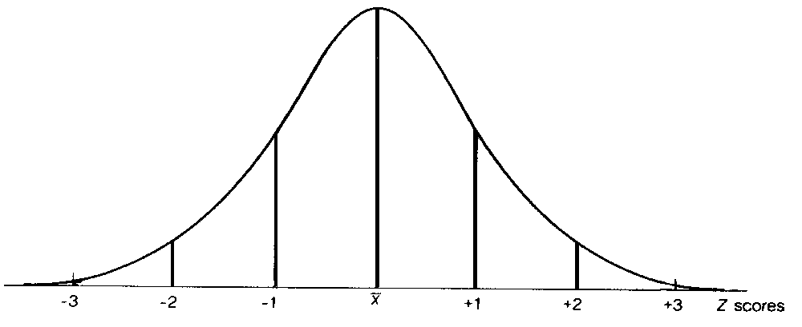

- Standard deviation can be calculated with a formula in Microsoft Excel.

You say “percent” I say “percentile…” Let’s call the whole thing off.

“So you’ve got these two words, percent and percentile, that sound sort of alike, and sort of talk about the same thing, but aren’t. How are you supposed to know which is which?”

Percent refers to the proportion of the whole thing, as in “I got 25% right on the test,” or “90% of the kids passed the test.” Essentially, it answers the question “how much?” or “what part of 100.” A percent is absolute, referring to the exact part of the whole.

Percentile is short for percentile rank. In the world of assessment, a percentile describes how a score fits in to the distribution or spread of scores in the comparison group. So, if a student scored at the 40th percentile, he scored better than 40 percent of those in the comparison group. It answers the question “how well compared to…?” A percentile is a score relative to the comparison group, and is totally dependent on how everyone in that group performs.

How do they relate to each other? A student may know six letters of the upper case alphabet, which is about 23 percent of the letters. If her score was the highest of all those in the comparison group, she would score at the 99th percentile relative to that group. If, however, the typical or middle performance on the alphabet test for the group was six letters (23 percent correct), her score would be at the 50th percentile relative to that group. On the other hand, if everyone else scored higher than 23 percent correct (more than six letters), her score would be at the 1st percentile.

Using Grade Equivalent Scores

Statements like “Bill has a 5.4 reading level” or “Susan performed at the 2nd grade 3rd month level on the Woodcock-Johnson” are heard often in meetings with educators and parents. While such statements seem simple enough for anyone to understand there is great potential for misunderstanding. Usually, such statements are unaccompanied by any further explanation, such as what the student actually did to earn a particular grade equivalent score, or to whom the student’s performance was compared. Stating that Bill reads at the 5th grade level appears to mean just that: Bill reads like a 5th grader reads. While using a grade equivalent seems like a simple way to describe a students skills, understanding and explaining what a grade equivalent really means is much more difficult.

What are the common mistakes that people make using Grade Equivalents (GE)?
- People often think that if a 5th grade student obtains a GE score of 8.2 on a test then they are ready to do the 8th grade curriculum. This is not what GE means.
- People often think that you can determine how much a student learned by adding/subtracting GE scores. Example: Susie had a GE in math of 3.4 last year and this year she obtained a GE score of 5.2, so her math learning grew 1.8 years in a year. This is not how to use a GE score.
- People often think that if 2 3rd graders (Tommy and Billy) both get a GE score of 3.2 then they have the same skills or can do the tasks equally well. Again, this is not what grade equivalent means.

Where do grade equivalents (GE) come from?
A grade equivalent for an individual student's raw score is computed by matching his/her raw score with students in the norm group (others who took the SAME TEST) whose average for their grade level is equivalent the raw score.

- Students in the 4th grade, 6th month are in a norm group taking level 7 of the “LMNOP Test”
- The average raw score for this group of students is 42.
- Later, Jamie takes the very same test (level 7 of the LMNOP Test”) and has a raw score of 42.
- Jamie's GE Score on this (now norm referenced) test is 4.6.

But in reality: In reality, not every test has a norm group made up of enough students at each year and month in school to have an exact average for each level. Moreover, many raw scores fall between the averages at the various "grade/month" levels. Therefore, many grade level scores are extrapolated from the scores of the norm group.

More problems: But wait, it gets even more complicated than that. As most any educator or parent knows, learning doesn't take place on a straight-line trajectory. To the extent that a test measures changes in learning, the progression of scores also is not a straight line.

Based on the norm group from the scenario above, five students in a classroom, at the same grade might have "raw" test scores and GE scores that look like this:

Student | "Raw" Test Score | Grade Equivalent
Jamie | 24 | 1.8
Sasha | 25 | 2.0
Tali | 34 | 5.4
Falon | 30 | 3.6
Kris | 28 | 3.0

So, Sasha's grade equivalent score is two months above Jamie's and has a raw score that is 1 point higher, while Tali's grade equivalent score is three years and six months above Jamie's, but has a raw score that is 10 points higher. The difference between what Sasha got correct and what Jamie got correct, is only be one test item, while Tali got ten more items correct. The number of questions a person needs to get correct to move up the grade equivalent scale are not the same across the scale, the GE scores are not an “Equal interval” score. Moreover, it doesn't matter which actual items the students got right or wrong, only how many right or wrong. It's easy to see why grade equivalent scores tell us very little about what skills a student knows and what they can do.

And, remember the test materials. Many tests, such as the Iowa Tests of Basic Skills, have multiple levels of tests, with a certain level recommended to be given a specific grade. To at least some extent, the test level meant for the grade better reflects the curriculum for that grade. However, GE scores, based on the averages from the norm group, essentially had many students taking "out-of-level" tests that were not commensurate with the curricula being taught at their grades. For example, students in the third month of the sixth grade taking a third grade test would have an average score that would generate a GE score of 6.3. These sixth-graders from the norm group might have gotten virtually every item correct on the "third-grade level" test. Conversely, if later, a 3rd grade student took the test and had a raw score that "matched" the average score of the norm-group students in the third month of sixth grade, this does NOT mean that student could do well with sixth material.

False sense of Criterion-Referenced utility: As discussed above, grade equivalent scores do not describe what a student actually did to earn a particular score. Thus, by definition, GE scores cannot be used to make criterion-referenced decisions. For example, on a math test, a 3rd grader may earn a GE of 5.0 by getting all of the 3rd grade items correct. A 7th grader may earn a GE score of 5.0, but by getting a small percentage of the cumulative items up to those expected by 7th grade students correct. These students’ GE scores appear to be equivalent; their performances however, are not. Nothing can be said about these student’s instructional needs based on the GE scores alone. It is very likely that neither of these students should be placed instructionally in 3rd grade material. Unfortunately, the statement that the 7th grader “is functioning at the 5th grade level” appears to suggest just that.

The Myth of the “Average” Child: In a seductive way, GE scores encourage misunderstandings on the part of test interpreters. For example, a 3rd grade student from who earned a score a few raw-score points below the average score for 3rd graders on the test would earn a GE that is below 3.0, suggesting that this student is performing “below grade level”. Nothing could be farther from the truth! “Average” performance is best described as a range, not as a score. Using a GE of 3.0 as a standard of performance is to suggest that all students beginning their third grade year should perform at exactly the 3.0 level. Thus, marginally low GE scores give the impression that students are performing behind expectations when in fact they may be in the average range. Similar problems arise for marginally high GE scores.

So what do GE scores tell us? Grade equivalent scores are on a continuum. A GE score of 5.4 does reflect that a student got more items correct than a student with a GE score of 5.3 (we just don't know how many or what items). Also, if a student has a GE score considerably higher than his/her grade level, reflects that a student is doing very well on the test material considered typical for his/her grade level. A student, who has a GE score considerably below his/her grade level, is not doing so well. Composite grade equivalent scores can give a general picture of how a group of students is performing on the test compared to the norm group. This can be helpful in determining the immediacy of a need or the general strength of a skill area. Grade equivalent scores can provide one piece of information that can support a decision but would be difficult to use by themselves when making a high stakes decision.

