HW 4

No names needed - indicate group members in gradescope

Due February 17, 2025

# HW 4 Instructions:

* In groups of 2 to 4 (your choice of group members, but you must be in a group to complete the submission), complete the following questions. If you are having trouble identifying group members, post in the Water Cooler channel in MS Teams.

Read Fabusova et al. (2024) and use the provided data set (“moths.xlsx”) to answer the following questions.

* Fabusova M, Gaston KJ, Troscianko J. 2024 Pulsed artificial light at night alters moth flight behaviour. Biol. Lett. 20: 20240403. <https://doi.org/10.1098/rsbl.2024.0403>

## Part I: More modeling of latency time

The Latency (seconds) is the time to the moth starting to move after the treatment is applied or 10 seconds of dark for the control group. The treatment information is coded in three variables, Treatment with 5 levels (numbered unhelpfully as 1 to 5, shown with better labels once we figure out their meaning on the x-axis in Figure 2a) and also in Colour (cold or warm) and Spectra (LED or RGB - note that the LED level in this variable is the “Phosphor LED” and RGB level is the “RGB LED” in their Figure 2).

library(readxl)  
moth <- read_excel("moths.xlsx",   
 sheet = "complete_dataset_MAIN FAMILIES.",   
 na = "NA")  
  
library(lubridate)  
moth <- moth %>% mutate(Date = factor(ymd(Date))) %>% dplyr::select(-Sunset_time)  
  
moth2 <- moth %>% drop_na(Date, ID, Location, Treatment, Treatment_y_n, Colour, Spectra, Moon_Phase, Temp, Wind_speed_ms, Humidity, Common_name, Latin_name, Family, Sub_family, Latency, Erratic_behaviour)  
  
moth2 <- moth2 %>% mutate(Treatment = fct_recode(factor(Treatment),  
 "Cold Phosphor" = "1",  
 "Warm Phosphor" = "2",  
 "Cold RGB" = "3",  
 "Warm RGB" = "4"), #5 recoding not needed - controls dropped  
 logLatency = log(Latency))

## Use the cleaned data set for all remaining questions on the HW:

lm1 <- lm(logLatency ~ Humidity * Treatment, data = moth2)  
summary(lm1)

##   
## Call:  
## lm(formula = logLatency ~ Humidity * Treatment, data = moth2)  
##   
## Residuals:  
## Min 1Q Median 3Q Max   
## -2.8249 -0.9578 -0.1323 0.9886 3.3480   
##   
## Coefficients:  
## Estimate Std. Error t value Pr(>|t|)  
## (Intercept) -5.59197 3.85451 -1.451 0.1479  
## Humidity 0.16394 0.08596 1.907 0.0575  
## TreatmentWarm Phosphor 5.03695 5.45739 0.923 0.3568  
## TreatmentCold RGB 11.49687 5.38314 2.136 0.0335  
## TreatmentWarm RGB 1.53140 5.19801 0.295 0.7685  
## Humidity:TreatmentWarm Phosphor -0.09833 0.12135 -0.810 0.4184  
## Humidity:TreatmentCold RGB -0.24237 0.12016 -2.017 0.0446  
## Humidity:TreatmentWarm RGB -0.01491 0.11628 -0.128 0.8981  
##   
## Residual standard error: 1.255 on 294 degrees of freedom  
## Multiple R-squared: 0.09027, Adjusted R-squared: 0.06861   
## F-statistic: 4.168 on 7 and 294 DF, p-value: 0.0002154

lm1 %>% tbl_regression(intercept = T)

| **Characteristic** | **Beta** | **95% CI***1* | **p-value** |
| --- | --- | --- | --- |
| (Intercept) | -5.6 | -13, 2.0 | 0.15 |
| Humidity | 0.16 | -0.01, 0.33 | 0.057 |
| Treatment |  |  |  |
| Cold Phosphor | — | — |  |
| Warm Phosphor | 5.0 | -5.7, 16 | 0.4 |
| Cold RGB | 11 | 0.90, 22 | 0.034 |
| Warm RGB | 1.5 | -8.7, 12 | 0.8 |
| Humidity * Treatment |  |  |  |
| Humidity * Warm Phosphor | -0.10 | -0.34, 0.14 | 0.4 |
| Humidity * Cold RGB | -0.24 | -0.48, -0.01 | 0.045 |
| Humidity * Warm RGB | -0.01 | -0.24, 0.21 | 0.9 |
| *1*CI = Confidence Interval | | | |

lm2 <- lm(logLatency ~ Humidity + Treatment, data = moth2)  
summary(lm2)

##   
## Call:  
## lm(formula = logLatency ~ Humidity + Treatment, data = moth2)  
##   
## Residuals:  
## Min 1Q Median 3Q Max   
## -2.70176 -0.99937 -0.08427 0.98319 3.05061   
##   
## Coefficients:  
## Estimate Std. Error t value Pr(>|t|)  
## (Intercept) -1.68919 1.87851 -0.899 0.36926  
## Humidity 0.07686 0.04181 1.838 0.06702  
## TreatmentWarm Phosphor 0.62741 0.20128 3.117 0.00200  
## TreatmentCold RGB 0.65030 0.20184 3.222 0.00142  
## TreatmentWarm RGB 0.84016 0.19992 4.202 3.5e-05  
##   
## Residual standard error: 1.26 on 297 degrees of freedom  
## Multiple R-squared: 0.07383, Adjusted R-squared: 0.06136   
## F-statistic: 5.919 on 4 and 297 DF, p-value: 0.0001353

lm2 %>% tbl_regression(intercept = T)

| **Characteristic** | **Beta** | **95% CI***1* | **p-value** |
| --- | --- | --- | --- |
| (Intercept) | -1.7 | -5.4, 2.0 | 0.4 |
| Humidity | 0.08 | -0.01, 0.16 | 0.067 |
| Treatment |  |  |  |
| Cold Phosphor | — | — |  |
| Warm Phosphor | 0.63 | 0.23, 1.0 | 0.002 |
| Cold RGB | 0.65 | 0.25, 1.0 | 0.001 |
| Warm RGB | 0.84 | 0.45, 1.2 | <0.001 |
| *1*CI = Confidence Interval | | | |

plot(allEffects(lm2), grid = T)

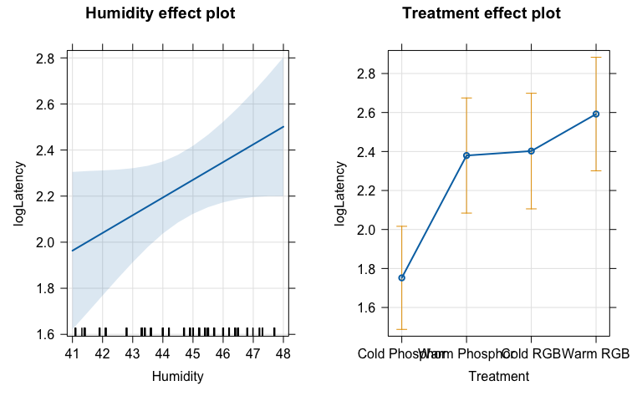

* Interaction model from HW 3: $\hat{μ}\{logLatency|Humidity*Treatment\}=-5.6+0.16Humidity+5.0I_{Treatment=WarmPhosphor}+11I_{Treatment=ColdRGB}+1.5I_{Treatment=WarmRGB}-0.10HumidityI_{Treatment=WarmPhosphor}-0.24HumidityI_{Treatment=ColdRGB}-0.01HumidityI_{Treatment=WarmRGB}$
* where $I_{Treatment=WarmPhosphor}$ is 1 for a warm phoshor observation and 0 otherwise, $I_{Treatment=ColdRGB}$ is 1 for a cold RGB observation and 0 otherwise, and $I_{Treatment=WarmRGB}$ is 1 for a warm rgb observation and 0 otherwise.

For lm1, the theoretical linear model being fit is:

$$μ\{logLatency|Humidity*Treatment\}=β_{0}+β_{1}Humidity+β_{2}I_{Treatment=WarmPhosphor}+β_{3}I_{Treatment=ColdRGB}+β_{4}I_{Treatment=WarmRGB}+β_{5}HumidityI_{Treatment=WarmPhosphor}+β_{6}HumidityI_{Treatment=ColdRGB}+β_{7}HumidityI_{Treatment=WarmRGB}$$

1. The following code compares the two provided models. In ESS F-tests, we set coefficients to 0 under the null hypothesis, Write out the null and alternative hypotheses in terms of the numbered true slope coefficients (the $β$ s) from lm1 as written out above for the following result:

anova(lm2, lm1)

## Analysis of Variance Table  
##   
## Model 1: logLatency ~ Humidity + Treatment  
## Model 2: logLatency ~ Humidity * Treatment  
## Res.Df RSS Df Sum of Sq F Pr(>F)  
## 1 297 471.53   
## 2 294 463.16 3 8.3703 1.7711 0.1528

$H_{0}:$ $β_{5}=β_{6}=β_{7}=0$

* $H_{A}:$ at one of $β_{5},β_{6},β_{7}$ does not equal 0

1. Run Anova on the interaction model and use that result to write out an evidence sentence for the interaction test. Make sure you include details on the test statistic, its distribution under the null, and whether you think there really is an interaction here and whether you would keep/remove the interaction based on this result.

**There is weak evidence against the null hypothesis of no interaction between humidity and treatment on the log-latency (F(3,294) = 1.77, p-value = 0.153), so we would conclude that there is not an interaction between them and drop it from the model.**

##Don’t need to mention controlling for other variables for an interaction

Anova(lm1)

## Anova Table (Type II tests)  
##   
## Response: logLatency  
## Sum Sq Df F value Pr(>F)  
## Humidity 5.36 1 3.4055 0.0659852  
## Treatment 33.13 3 7.0103 0.0001438  
## Humidity:Treatment 8.37 3 1.7711 0.1527528  
## Residuals 463.16 294

Regardless of your previous answer, use the additive model for the following questions.

1. Report an evidence sentence using the t-test for Humidity in the additive model. Again, remember to include details on the test statistic, its distribution under the null, and whether you think there is a relationship and whether you would keep/remove the term based on this result.

**There is some evidence against the the null hypothesis of no relationship between Humidity and log latency time ( $t_{297}$ = 1.838, p-value = 0.067), after controlling for Treatment. We conclude that there is some evidence of a relationship between humidity and log latency time and would keep the term in the model.**

summary(lm2)

##   
## Call:  
## lm(formula = logLatency ~ Humidity + Treatment, data = moth2)  
##   
## Residuals:  
## Min 1Q Median 3Q Max   
## -2.70176 -0.99937 -0.08427 0.98319 3.05061   
##   
## Coefficients:  
## Estimate Std. Error t value Pr(>|t|)  
## (Intercept) -1.68919 1.87851 -0.899 0.36926  
## Humidity 0.07686 0.04181 1.838 0.06702  
## TreatmentWarm Phosphor 0.62741 0.20128 3.117 0.00200  
## TreatmentCold RGB 0.65030 0.20184 3.222 0.00142  
## TreatmentWarm RGB 0.84016 0.19992 4.202 3.5e-05  
##   
## Residual standard error: 1.26 on 297 degrees of freedom  
## Multiple R-squared: 0.07383, Adjusted R-squared: 0.06136   
## F-statistic: 5.919 on 4 and 297 DF, p-value: 0.0001353

1. Report the test statistic, distribution under the null, and p-value for humidity (no evidence sentence needed) based on the following code. Then explain why the p-value for humidity here is different from your previous result.

$F_{1,297}$**=2.807, p-value = 0.09489.** The first problem uses a t-test, while the second problem uses a Type 1 test. For a t-test, the t-statistic and p-value are conducted while holding all other components constant. The results of the Type 1 Test are conditional on anything higher up in the model, so Humidity is not conditioned on any other component. If, instead, you were to use a Type 2 test (Anova(lm2)), the p-value would match the 0.067 p-value found with the t-test, as the Anova() function refits the model with each component last so that it conditions on all other variables.

anova(lm2)

## Analysis of Variance Table  
##   
## Response: logLatency  
## Df Sum Sq Mean Sq F value Pr(>F)  
## Humidity 1 4.46 4.4571 2.8073 0.0948857  
## Treatment 3 33.13 11.0438 6.9561 0.0001542  
## Residuals 297 471.53 1.5876

1. Write a scope of inference for lm2 in this situation. Note that you need to explain your reasoning clearly for why you are making both your causality and generalization assessments and that each aspect should be done in separate sentences (sentence(s) for causality and sentence(s) for generalization). Also, with two predictors, you need to address both in the causality assessment. And finally, you have information on when and where the moths were sampled and should incorporate that information in your SOI.

* Because the light treatments were randomly assigned, we can make causal inferences for that predictor, but humidity is not randomly assigned, so is not causal. If there were an interaction here, the SOI would change to something like the treatment causing differences in log-latency that are modified/changed based on the humidity.
* There is a discussion of random orders of sampling of transects on a given night, so the transect could be causal (but it currently isn't in the model). The moths are not randomly selected, they are just the moths that they happened upon and could catch. At best you could consider this haphazard selection, but the moths caught might systematically differ from those they couldn't catch. Because the moths were not randomly sampled, the results only apply to the moths caught in these 5 locations in Cornwall from June to September 2023.
* It is important to note that there were "exclusions": Some moths failed to do anything, so inferences do not apply to the moths that did move due to missing observations recorded for the ones that failed to do anything.
* Note: For a future assignment, note that Location is the transect number and corresponds to the map in the supplemental materials for where the moths were caught and that they revisited the same transects over multiple days in the study.

**Treatment of light exposure was randomly assigned to moths in this study, so we can infer causal relationships between treatment and logLatency. Since humidity was not randomly assigned, we cannot infer a causal relationship between humidity and logLatency. The data was collected from wild-caught moths at Tremough Campus, Penryn, Cornwall, UK, over the months of June to September 2023. Generalization is limited to wild months in similar environmental conditions. We cannot generalize to all wild-caught moths since only moths from specific study locations were used.**

1. We took the authors’ assessment at face value to produce the previous results. Let’s explore the need for the log-transformation of the Latency time. Fit the interaction model with Humidity and Treatment to the original Latency time responses and generate the standard “R” diagnostic plot array from ggResidpanel. Discuss the normality of residuals assumption, citing pertinent plot(s).

**There is a clear violation of the normality assumption based on the QQ-plot of the residuals. The residuals appear to have a severe right-skew.**

lm_orig <- lm(Latency ~ Humidity*Treatment, data = moth2)  
ggResidpanel::resid_panel(lm_orig, "R")

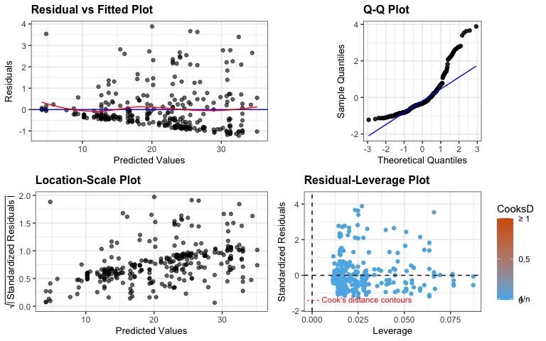

1. Now consider the log-Latency response additive (no interaction) model (lm2 above). Use resid_calibrate to make four QQ-plots (one real and three simulated when the normality assumption is actually true). Use the array of plots to discuss the normality of residuals assumption for the additive model for the log-latency response and implications for using this model based on this result.

**Based on the QQ-plots simulated assuming a normal distribution, we have strong evidence of a violation of Normality since the simulated residuals (that are Normal) look different from our observed residuals. There is a light-tailed distribution present in the observed residuals, which is not present in any of the three simulations. Since the short-tailed violation will only make our model more conservative, we will proceed with the model.**

set.seed(406)   
resid_calibrate(lm2, plots = c("qq"), nsim = 3, identify = TRUE)

## [1] "Real residuals are in column 4"

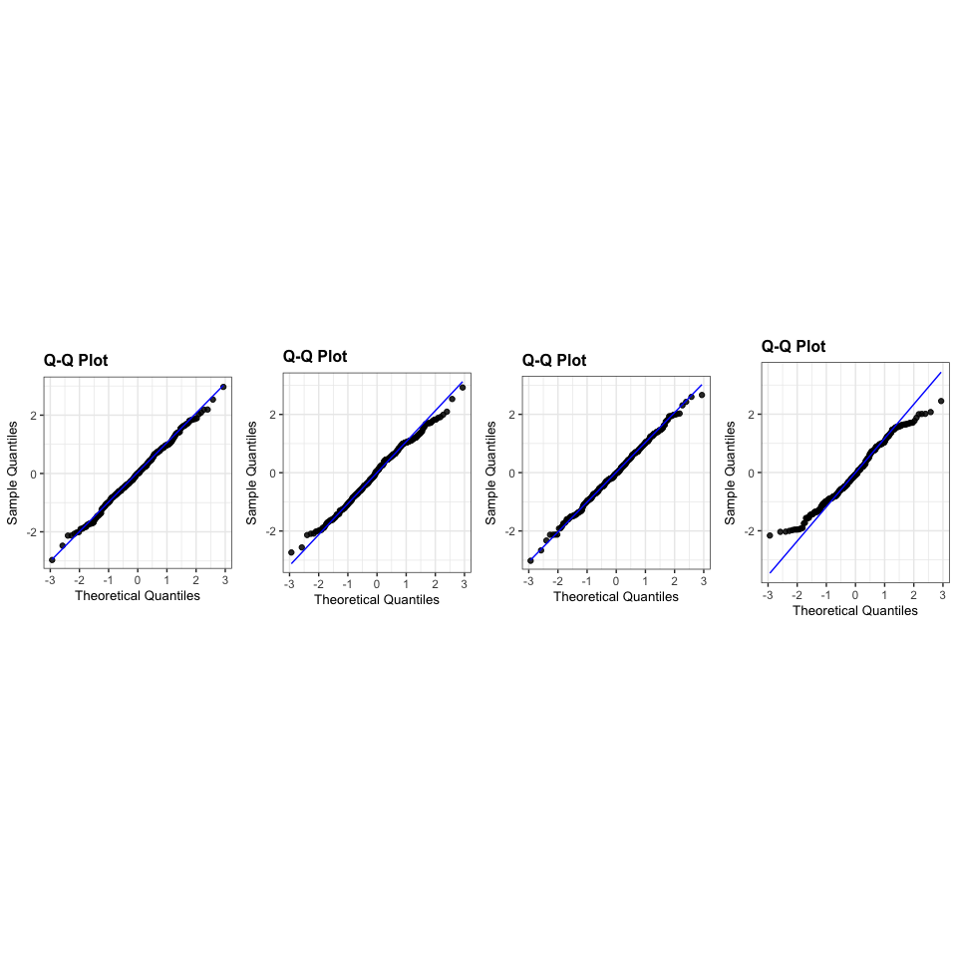

## Part II: Flight type analysis

1. Another outcome of interest to the researchers was the type of flight that the moths took after the various treatments were applied. This information is stored in variables such as Fly_Into_Light, which was coded as a 1 for when the moth flew toward the light and 0 otherwise, converted to a factor variable with those levels for you with any missing values on the outcome removed in moth3. Make an appropriate display of that flight-into-light response versus the Treatment. This should resemble a part of their Figure 2a, although it will contain less information.

Based on your plot, which treatments had the highest and lowest proportions of moths that flew into the light?

**Treatments with the highest proportion of moths flying into the light were the cold phosphor and cold rgb, cold phosphor being the greatest. The warm treatments had the lowest proportions, with cold phosphor seeming the lowest.**

moth3 <- moth2 %>% drop_na(Fly_Into_Light) %>%   
 mutate(Fly_Into_Light = factor(Fly_Into_Light))  
  
ggplot(moth3) +  
 geom_mosaic(aes(x = product(Treatment), fill = Fly_Into_Light)) +  
 labs(title = "Proportion of Moths Flying into Light by Treatment",  
 x = "Treatment",  
 y = "Proportion of Moths Flying into Light") +  
 scale_fill_manual(values = c("steelblue", "orange3"),   
 name = "Fly Into Light",  
 labels = c("otherwise", "flew toward light")) +  
 theme_minimal()

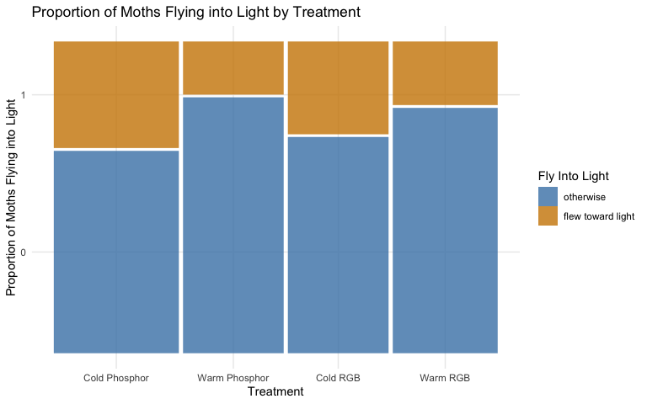

1. Fit an appropriate generalized linear model for the response of flight-into-light based on the Treatment. Make effects plots on the link and response scale (don’t change the y-axis text labels). No discussion.

lm_light <- glm(Fly_Into_Light ~ Treatment, data = moth3, family = "binomial")  
  
plot(allEffects(lm_light, residuals = T), type = "link")

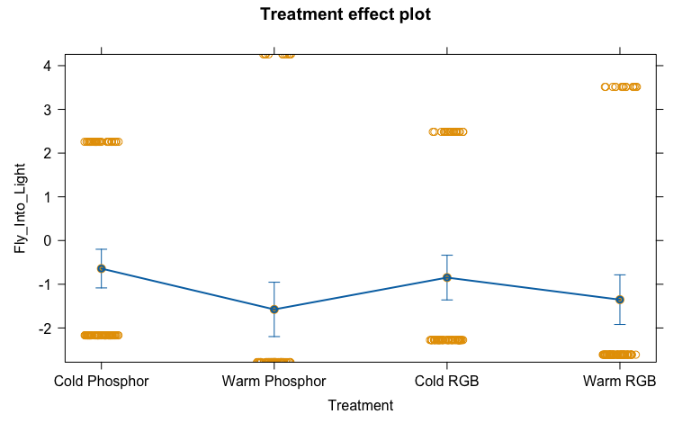

plot(allEffects(lm_light, residuals = T), type = "response")

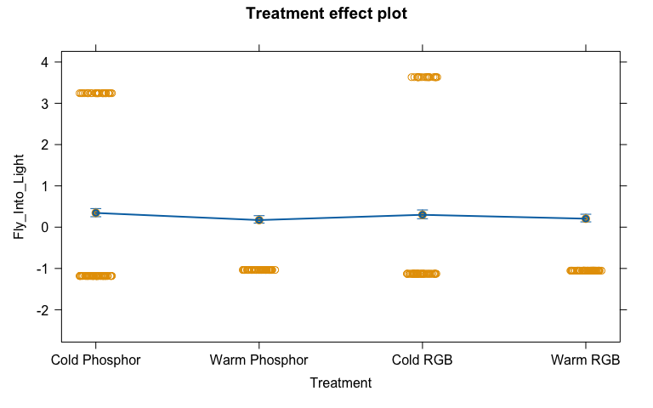

1. The effects plot result on the response scale should match the previous plot in terms of the estimated probabilities. Based on this comparison, was the “1” (yes, the moth flew into the light) or “0” (no, the moth did not fly into the light) the “success” in the GLM? How did you determine this?

**In the effects plot, a probability of about 0.35 is seen in the Cold Phosphor treatment group. When looking at the mosaic plot, we see the “1” (yes, moth flew into light) chunk of the bar looks to be about 0.35 as well. Therefore, a “success” in this GLM would be a “1” (yes, the moth flew into the light).**

1. Document any collaborations or pertinent discussions with other students or resources outside of your group and the resources that I am providing and the *Sleuth* that you used to complete this assignment *or report that you did not have any*. If you used generative AI (chatGPT, Bard, etc.), report which question(s) and how/what you asked for.

* NONE