Lab 12

4/14/25

# Rules

In groups of 2 to 4, mostly as assigned in class, complete the following questions.

# Previous data wrangling:

GripStrengthMeasurements <- read_excel("GripStrengthMeasurementsS25.xlsx")  
GS <- GripStrengthMeasurements %>% drop_na(GripStrength) #Mostly cleans out empty rows  
  
GS2 <- GS %>% drop_na(Arm)  
GS2 <- GS2 %>% mutate(Arm = forcats::fct_collapse(Arm,  
 Up = c("Up", "up"),  
 Down = c("Down", "down"),  
 "90" = c("90", "90 degree")),  
 SubjectID = forcats::fct_collapse(SubjectID,  
 MDEarl = c("MDEarl","MDEar")),  
 Arm = factor(Arm),  
 Hand = factor(Hand),  
 OrderF = factor(Order)  
)  
  
GS2 <- GS2 %>% mutate(Hand.Arm = factor(str_c(Hand, Arm)))  
  
GS2 <- GS %>% drop_na(Arm)  
GS2 <- GS2 %>% mutate(Arm = forcats::fct_collapse(Arm,  
 Up = c("Up", "up"),  
 Down = c("Down", "down"),  
 "90" = c("90", "90 degree")),  
 SubjectID = forcats::fct_collapse(SubjectID,  
 MDEarl = c("MDEarl","MDEar")),  
 Arm = factor(Arm),  
 Hand = factor(Hand),  
 OrderF = factor(Order)  
)

## Part II from Lab 11 with new numbers: Merging (left_join-ing) the demographics data

The following code will read in and (eventually) join the demographics data.

dim(GS2)

## [1] 263 6

Demographics <- read_excel("DemographicsS25.xlsx")  
Demographics <- Demographics %>% dplyr::select(-c(12:13)) #Because of a "note" left in column 13...  
dim(Demographics)

## [1] 44 11

**1) The following code highlights a potential issue with one of the subject IDs. Fix the problem in the Demographics data.frame using R code.**

data.frame(sort(unique(GS2$SubjectID)), sort(unique(Demographics$SubjectID)))

## sort.unique.GS2.SubjectID.. sort.unique.Demographics.SubjectID..  
## 1 ABH1997 ABH1997  
## 2 AFEDU2020 AFEDU2020  
## 3 AustinLions AustinLions  
## 4 AZBlackhawks AZBlackhawks  
## 5 AZRams AZRams  
## 6 BelknapBull BelknapBull  
## 7 BostonLakers BostonLakers  
## 8 BostonWolverines BostonWolverines  
## 9 CAJustinBieber CAJustinBieber  
## 10 CenntenialWarriors CentennialWarriors  
## 11 COMichealFranti COMichealFranti  
## 12 DCSNAP DCSNAP  
## 13 DenverCoyotes DenverCoyotes  
## 14 DenverGalaxy DenverGalaxy  
## 15 FLTaller FLTaller  
## 16 GASNAP GASNAP  
## 17 HYENA HYENA  
## 18 IAGarthBrooks IAGarthBrooks  
## 19 IDAJR IDAJR  
## 20 IDPAD IDPAD  
## 21 LACROIX LACROIX  
## 22 LADeathGrips LADeath  
## 23 MDEarl MDEarl  
## 24 NDLawrence NDLawrence  
## 25 NewYorkLaeeb NewYorkLaeeb  
## 26 NMSnuggies NMSnuggies  
## 27 NVKP NVKP  
## 28 OrlandoChamp OrlandoChamp  
## 29 ORMichelangelo ORMichelangelo  
## 30 PATaller PATaller  
## 31 SanDiegoBobcat SanDiegoBobcat  
## 32 UTSNAP UTSNAP  
## 33 VancouverMcLaren VancouverMcLaren  
## 34 VTPink VTPink  
## 35 WATaller WATaller  
## 36 WinonaBadgers WinonaBadgers  
## 37 WIWiggles WIWiggles  
## 38 WYBeavers WYBeavers  
## 39 WYIW WYIW  
## 40 WYJourney WYJourney  
## 41 WYSlipKnot WYSlipKnot  
## 42 WYSNAP WYSNAP  
## 43 WYTaller WYTaller  
## 44 ZOO ZOO

which(sort(unique(GS2$SubjectID)) != sort(unique(Demographics$SubjectID)))

## [1] 10 22

# Fix the problem in Demographics to match GS2:  
Demographics <- Demographics %>% mutate(SubjectID =   
 forcats::fct_recode(SubjectID, LADeathGrips = "LADeath"),   
 SubjectID =   
 forcats::fct_recode(SubjectID, CenntenialWarriors =   
 "CentennialWarriors"))  
  
#Check that problem was fixed:  
data.frame(sort(unique(GS2$SubjectID)), sort(unique(Demographics$SubjectID)))

## sort.unique.GS2.SubjectID.. sort.unique.Demographics.SubjectID..  
## 1 ABH1997 ABH1997  
## 2 AFEDU2020 AFEDU2020  
## 3 AustinLions AustinLions  
## 4 AZBlackhawks AZBlackhawks  
## 5 AZRams AZRams  
## 6 BelknapBull BelknapBull  
## 7 BostonLakers BostonLakers  
## 8 BostonWolverines BostonWolverines  
## 9 CAJustinBieber CAJustinBieber  
## 10 CenntenialWarriors CenntenialWarriors  
## 11 COMichealFranti COMichealFranti  
## 12 DCSNAP DCSNAP  
## 13 DenverCoyotes DenverCoyotes  
## 14 DenverGalaxy DenverGalaxy  
## 15 FLTaller FLTaller  
## 16 GASNAP GASNAP  
## 17 HYENA HYENA  
## 18 IAGarthBrooks IAGarthBrooks  
## 19 IDAJR IDAJR  
## 20 IDPAD IDPAD  
## 21 LACROIX LACROIX  
## 22 LADeathGrips LADeathGrips  
## 23 MDEarl MDEarl  
## 24 NDLawrence NDLawrence  
## 25 NewYorkLaeeb NewYorkLaeeb  
## 26 NMSnuggies NMSnuggies  
## 27 NVKP NVKP  
## 28 OrlandoChamp OrlandoChamp  
## 29 ORMichelangelo ORMichelangelo  
## 30 PATaller PATaller  
## 31 SanDiegoBobcat SanDiegoBobcat  
## 32 UTSNAP UTSNAP  
## 33 VancouverMcLaren VancouverMcLaren  
## 34 VTPink VTPink  
## 35 WATaller WATaller  
## 36 WinonaBadgers WinonaBadgers  
## 37 WIWiggles WIWiggles  
## 38 WYBeavers WYBeavers  
## 39 WYIW WYIW  
## 40 WYJourney WYJourney  
## 41 WYSlipKnot WYSlipKnot  
## 42 WYSNAP WYSNAP  
## 43 WYTaller WYTaller  
## 44 ZOO ZOO

Demographics <- Demographics %>% mutate(Weights = factor(Weights),  
 GripTesterID = factor(GripTesterID))  
  
Demographics <- Demographics %>% mutate(Weights = fct_collapse(Weights, no = c("no", "No"),  
 yes = c("yes", "Yes")))  
  
#Join Demographics to the GS2 repeated measures data  
combined <- left_join(x = GS2, y = Demographics, by = "SubjectID")  
  
combinedR <- combined %>% drop_na()  
  
combinedR <- combinedR %>% mutate(forearm_bins =   
 factor(cut_number(ForearmLength, n = 3)),  
 epworth_bins =   
 factor(cut_number(Epworth, n = 3)),  
 balance_bins =   
 factor(cut_number(BalanceTime, n = 3))  
 )  
dim(combinedR)

## [1] 257 19

dim(combined)

## [1] 263 16

dim(GS2)

## [1] 263 6

tally(~SubjectID, data = combinedR)

## SubjectID  
## ABH1997 AFEDU2020 AustinLions AZBlackhawks   
## 6 6 6 6   
## AZRams BelknapBull BostonLakers BostonWolverines   
## 6 6 6 6   
## CAJustinBieber CenntenialWarriors COMichealFranti DCSNAP   
## 6 6 5 6   
## DenverCoyotes DenverGalaxy FLTaller GASNAP   
## 6 6 6 6   
## HYENA IAGarthBrooks IDAJR IDPAD   
## 6 6 6 6   
## LACROIX LADeathGrips MDEarl NDLawrence   
## 6 6 0 6   
## NewYorkLaeeb NMSnuggies NVKP OrlandoChamp   
## 6 6 6 6   
## ORMichelangelo PATaller SanDiegoBobcat UTSNAP   
## 6 6 6 6   
## VancouverMcLaren VTPink WATaller WinonaBadgers   
## 6 6 6 6   
## WIWiggles WYBeavers WYIW WYJourney   
## 6 6 6 6   
## WYSlipKnot WYSNAP WYTaller ZOO   
## 6 6 6 6

**2) What is the sample size before and after the left_join? How many subjects are in the data set as analyzed in combinedR?**

Sample size was 263 before left_join and 263 after. The combinedR group had the NAs removed after join which lowered the sample size to 257. There are 44 unique subjects in the dataset in CombinedR.

unique(combinedR$SubjectID)

## [1] GASNAP WYSNAP UTSNAP DCSNAP   
## [5] COMichealFranti LADeathGrips NMSnuggies CAJustinBieber   
## [9] ORMichelangelo VTPink WYSlipKnot IAGarthBrooks   
## [13] WYJourney WIWiggles NDLawrence WATaller   
## [17] FLTaller PATaller WYTaller NVKP   
## [21] IDAJR WYIW IDPAD LACROIX   
## [25] VancouverMcLaren ZOO HYENA AFEDU2020   
## [29] ABH1997 BelknapBull DenverGalaxy CenntenialWarriors  
## [33] OrlandoChamp AustinLions BostonWolverines WinonaBadgers   
## [37] NewYorkLaeeb DenverCoyotes SanDiegoBobcat AZRams   
## [41] BostonLakers AZBlackhawks WYBeavers   
## 44 Levels: ABH1997 AFEDU2020 AustinLions AZBlackhawks AZRams ... ZOO

dim(combinedR)

## [1] 257 19

dim(combined)

## [1] 263 16

dim(GS2)

## [1] 263 6

**3) Now we can incorporate forearm binned variables into the model using the forearm_bins, which we will treat as a fixed effect. Make a model_diagram from the provided model (I like to add the option of heightVal = 800) and explain/discuss the location of the fixed effects in it.**

Hand, Arm, and Hand:Arm are located at the top of the right column of the model diagram. This is because these are indicated at the observation level, not the subject level. The 6 observations per individual are a combination of hand and arm. The forearm bins are located in the left column as they are splitting the individuals into groups based on their forearm size, as a proxy for height. These groups were then split down into the 6 hand and arm observations per individual.

combinedR <- combinedR %>% mutate(  
 forearm_bins = fct_recode(forearm_bins,  
 low = "[9.25,10]",  
 medium = "(10,11]",  
 high = "(11,13.1]")  
 )  
lmer2 <- lmer(GripStrength ~ Hand*Arm + forearm_bins + (1|SubjectID), data = combinedR)  
  
model_diagram(lmer2, heightVal = 800)

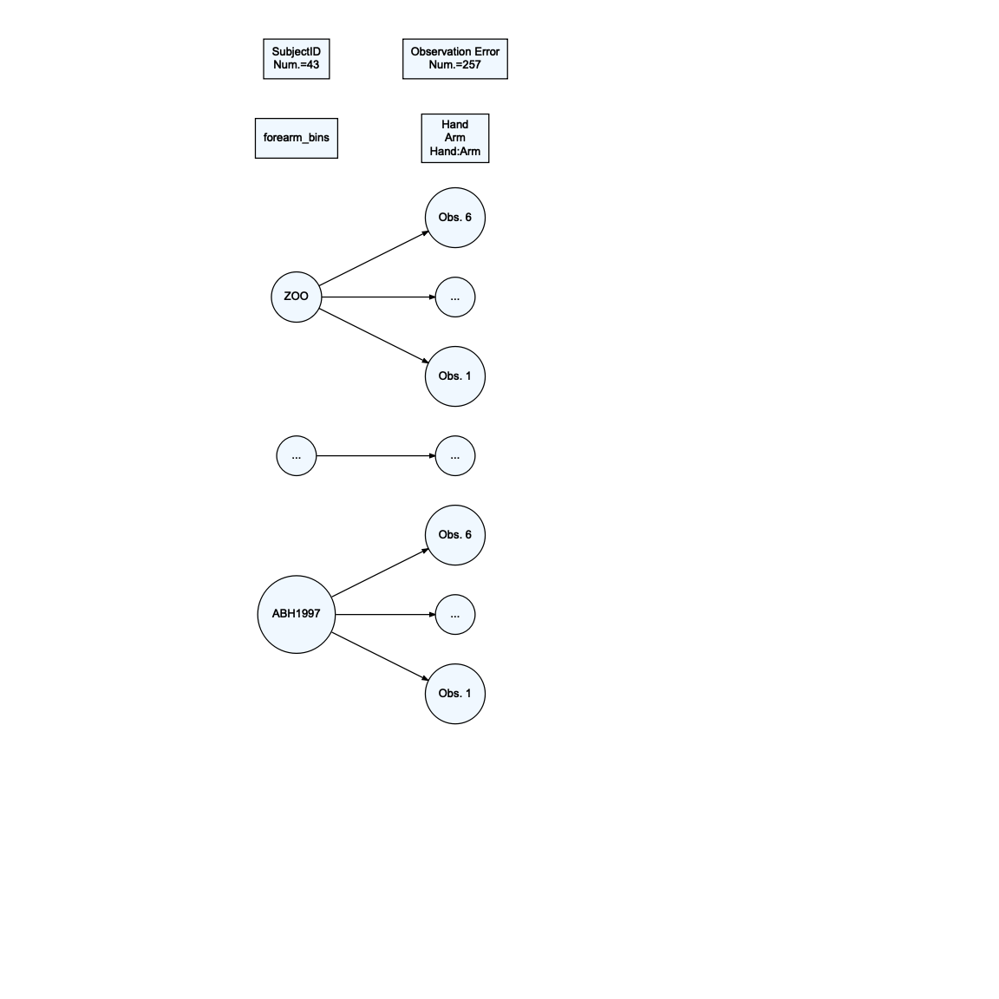

**4) The following provides the theoretical and estimated fixed effect part of the model, except does not add the subscripts for the fixed effects or define the distributions of the random effects (see all locations with ?). Add the definition of the random effects and subscripts in the appropriate places based on the previous model diagram.**

lmer2 %>% tbl_regression(intercept = T)

| **Characteristic** | **Beta** | **95% CI***1* | **p-value** |
| --- | --- | --- | --- |
| (Intercept) | 47 | 38, 56 | <0.001 |
| Hand |  |  |  |
| D | — | — |  |
| ND | -3.7 | -5.9, -1.6 | <0.001 |
| Arm |  |  |  |
| 90 | — | — |  |
| Down | 0.25 | -1.9, 2.4 | 0.8 |
| Up | 2.0 | -0.14, 4.2 | 0.067 |
| forearm_bins |  |  |  |
| low | — | — |  |
| medium | 12 | -1.7, 25 | 0.085 |
| high | 35 | 21, 48 | <0.001 |
| Hand * Arm |  |  |  |
| ND * Down | 1.4 | -1.7, 4.4 | 0.4 |
| ND * Up | 1.5 | -1.6, 4.5 | 0.3 |
| *1*CI = Confidence Interval | | | |

* Theoretical model: $GripStrength_{ij}=μ_{ij}+Subject_{i}+ϵ_{ij}$
  + where $Subject_{i}∼N\left(0,σ_{subject}^{2}\right)$ and $ϵ_{ij}∼N\left(0,σ_{ϵ}^{2}\right)$ and $i=1,...,I$ subjects and $j=1,...,n_{i}$ for the $j^{th}$ observation on the $i^{th}$ subject.
* Estimated model for $μ_{ij}$:
  + Result: ${\hat{μ}}_{ij}=47−3.7I_{Hand=ND,ij}+0.25I_{Arm=Down,ij}+2.0I_{Arm=Up,ij}+12I_{forearmbins=medium,i}+35I_{forearm_{b}ins=high,i}+1.4I_{Hand=ND,ij}I_{Arm=Down,ij}+1.5I_{Hand=ND,ij}I_{Arm=Up,ij}$

## Part 2 (all new questions): Summarizing/exploring mixed models

In mixed models, the random effect variances create some extra opportunities and challenges when trying to summarize the model. The following models will also incorporate the GripTesterID so we can control for differences in the different machines used.

First, the random effects can be used to calculate the intra-class correlation (ICC) as discussed on page 16 of the Mixed Models Part A notes.

**5) For the model lmer3 below, report the estimated subject variance and estimated residual variance.**

lmer3 <- lmer(GripStrength ~ Hand*Arm + forearm_bins + GripTesterID + (1|SubjectID), data = combinedR)  
  
summary(lmer3)

## Linear mixed model fit by REML. t-tests use Satterthwaite's method [  
## lmerModLmerTest]  
## Formula: GripStrength ~ Hand * Arm + forearm_bins + GripTesterID + (1 |   
## SubjectID)  
## Data: combinedR  
##   
## REML criterion at convergence: 1681.5  
##   
## Scaled residuals:   
## Min 1Q Median 3Q Max   
## -2.76250 -0.56395 0.04184 0.55084 2.99852   
##   
## Random effects:  
## Groups Name Variance Std.Dev.  
## SubjectID (Intercept) 258.08 16.065   
## Residual 25.53 5.052   
## Number of obs: 257, groups: SubjectID, 43  
##   
## Fixed effects:  
## Estimate Std. Error df t value Pr(>|t|)  
## (Intercept) 49.7050 6.5861 36.8617 7.547 5.49e-09  
## HandND -3.7474 1.0974 209.0198 -3.415 0.000766  
## ArmDown 0.2535 1.0896 209.0036 0.233 0.816271  
## ArmUp 2.0070 1.0896 209.0036 1.842 0.066908  
## forearm_binsmedium 14.9673 6.1736 36.0023 2.424 0.020481  
## forearm_binshigh 35.8431 6.2432 36.0007 5.741 1.54e-06  
## GripTesterIDD2 -20.3543 8.4488 36.0137 -2.409 0.021229  
## GripTesterIDD3 2.8831 7.8507 36.0172 0.367 0.715588  
## GripTesterIDD4 3.4540 8.4488 36.0137 0.409 0.685095  
## GripTesterIDD5 -10.6640 8.7142 36.0103 -1.224 0.228996  
## HandND:ArmDown 1.3893 1.5464 209.0118 0.898 0.370014  
## HandND:ArmUp 1.4870 1.5464 209.0118 0.962 0.337389  
##   
## Correlation of Fixed Effects:  
## (Intr) HandND ArmDwn ArmUp frrm_bnsm frrm_bnsh GTIDD2 GTIDD3  
## HandND -0.080   
## ArmDown -0.083 0.496   
## ArmUp -0.083 0.496 0.500   
## frrm_bnsmdm -0.332 -0.001 0.000 0.000   
## frrm_bnshgh -0.262 -0.001 0.000 0.000 0.471   
## GrpTstrIDD2 -0.631 -0.002 0.000 0.000 -0.102 -0.110   
## GrpTstrIDD3 -0.699 -0.002 0.000 0.000 -0.009 -0.174 0.580   
## GrpTstrIDD4 -0.631 -0.002 0.000 0.000 -0.102 -0.110 0.541 0.580  
## GrpTstrIDD5 -0.559 -0.002 0.000 0.000 -0.230 -0.238 0.543 0.578  
## HndND:ArmDw 0.057 -0.710 -0.705 -0.352 0.001 0.001 0.001 0.001  
## HndND:ArmUp 0.057 -0.710 -0.352 -0.705 0.001 0.001 0.001 0.001  
## GTIDD4 GTIDD5 HND:AD  
## HandND   
## ArmDown   
## ArmUp   
## frrm_bnsmdm   
## frrm_bnshgh   
## GrpTstrIDD2   
## GrpTstrIDD3   
## GrpTstrIDD4   
## GrpTstrIDD5 0.543   
## HndND:ArmDw 0.001 0.001   
## HndND:ArmUp 0.001 0.001 0.504

${\hat{σ}}_{subject}^{2}=258.08$

${\hat{σ}}_{ϵ}^{2}=25.53$

**6) Use the two variances to calculate the estimated ICC. Show your work.**

* Estimated ICC = 258.08 / (258.08 + 25.53) = 0.91

**7) Interpret the ICC result in a sentence as you would in a report and then write a sentence to discuss what this suggests about repeated measures on grip strength (something about what the ICC suggests).**

Once we account for grip tester, arm position, hand dominance, and forearm length, the estimated correlation of the two grip strength measurements is 0.91. This indicates high correlation between two observations once we account for systematic changes across subjects.

**8) We can also explore the estimates for each subject on the random subject effect. These are not to be used to do inferences for differences, but we can qualitatively explore the variability. You can print out the subject random effect estimates using ranef(modelname) or you can plot the results with estimates of the uncertainty using dotplot(ranef(modelname, postVar = T)) or you can make a QQ-plot to use for assessing normality of a single random effect using the provided code. *Fix the title on the QQ-plot*, then find a subject of interest to you in the caterpillar plot, note their ID, and discuss their random effect estimate relative to other subjects.**

LACROIX’s grip strength is roughly 35 pounds lower than average from the other subjects. Their respective grip strength is roughly 5 pounds lower than the next subject, AustinLion’s, strength measurement.

ranef(lmer3)

## $SubjectID  
## (Intercept)  
## ABH1997 -18.9222476  
## AFEDU2020 -27.3589088  
## AustinLions -32.0617553  
## AZBlackhawks 5.5772627  
## AZRams -3.1790597  
## BelknapBull 2.2202531  
## BostonLakers 15.3495004  
## BostonWolverines 4.2726050  
## CAJustinBieber -10.9992280  
## CenntenialWarriors -4.5357118  
## COMichealFranti 8.7024014  
## DCSNAP -1.3220229  
## DenverCoyotes -1.3213632  
## DenverGalaxy 0.6550206  
## FLTaller 4.6429109  
## GASNAP 5.2603926  
## HYENA 27.4618081  
## IAGarthBrooks 22.5844403  
## IDAJR -10.3482257  
## IDPAD 6.5734899  
## LACROIX -36.7553106  
## LADeathGrips -17.5020184  
## NDLawrence 9.2377935  
## NewYorkLaeeb -18.0361838  
## NMSnuggies -0.3916764  
## NVKP -8.1839046  
## OrlandoChamp 5.2235946  
## ORMichelangelo -3.3913114  
## PATaller 30.6379712  
## SanDiegoBobcat -6.9617152  
## UTSNAP -10.1432711  
## VancouverMcLaren 16.6408623  
## VTPink -12.2453523  
## WATaller -0.7685516  
## WinonaBadgers -2.1622432  
## WIWiggles 24.4953455  
## WYBeavers -8.5564100  
## WYIW 2.3760186  
## WYJourney 7.3447403  
## WYSlipKnot -0.5711354  
## WYSNAP 16.8034385  
## WYTaller 17.4224954  
## ZOO 2.2352620  
##   
## with conditional variances for "SubjectID"

library(lattice)  
dotplot(ranef(lmer3, postVar = T))

## $SubjectID

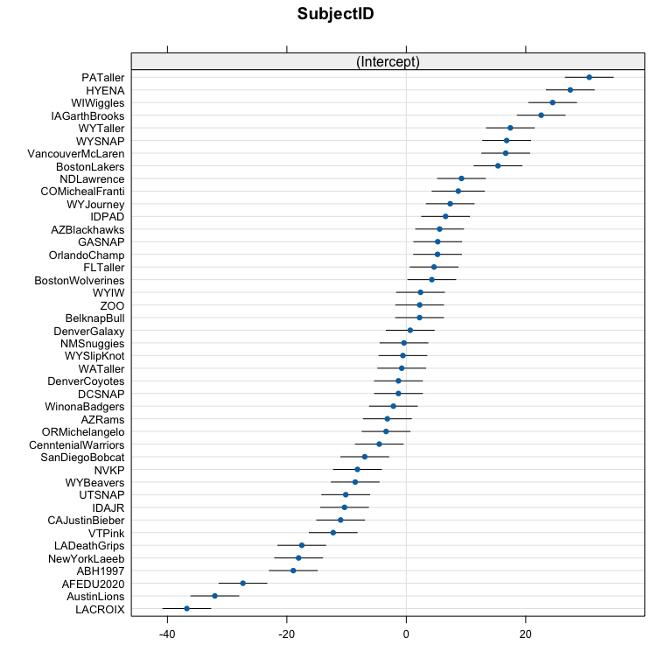

as.data.frame(ranef(lmer3)) %>% ggplot(aes(sample = condval)) +  
 stat_qq_point(alpha = 0.6) +  
 stat_qq_line() + theme(aspect.ratio = 1) +  
 labs(x = "Theoretical Quantiles",  
 y = "Sample Quantiles",  
 title = "QQ-plot of random intercept of subject") +  
 coord_fixed()

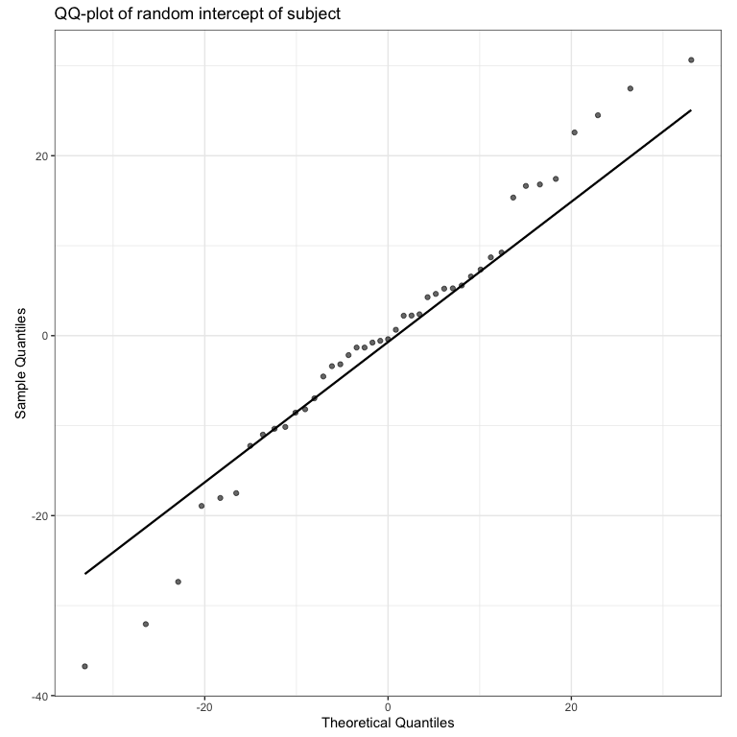

**9) Calculate and write two sentences to report the two R-squared results for lmer3. Be specific about the contents of the model in reporting the results.**

The fixed effects of forearm length, hand, arm, and grip tester explain 50.7% of the variation in the grip strengths. The fixed effects with the random effect of subject together explain 95.57% of the variation in grip strength.

library(MuMIn)  
r.squaredGLMM(lmer3)

## R2m R2c  
## [1,] 0.5078611 0.9557038

## Part 3: Three-level model

**10) The previous model failed to account for groups and that you were nested into groups for taking measurements that might also be systematically different on grip strength. Modify lmer3 to fit a new model account for group and then make a new model_diagram and generate an Anova set of F-tests for the model. No discussion.**

lmer4 <- lmer(GripStrength ~ Hand*Arm + forearm_bins + GripTesterID + (1|GroupName/SubjectID), data = combinedR)  
  
Anova(lmer4, test.statistic = "F")

## Analysis of Deviance Table (Type II Wald F tests with Kenward-Roger df)  
##   
## Response: GripStrength  
## F Df Df.res Pr(>F)  
## Hand 19.5002 1 209.006 1.613e-05  
## Arm 6.5154 2 209.006 0.0017994  
## forearm_bins 10.1805 2 33.920 0.0003443  
## GripTesterID 1.3293 4 5.739 0.3625960  
## Hand:Arm 0.5782 2 209.006 0.5618222

model_diagram(lmer4, heightVal = 800)

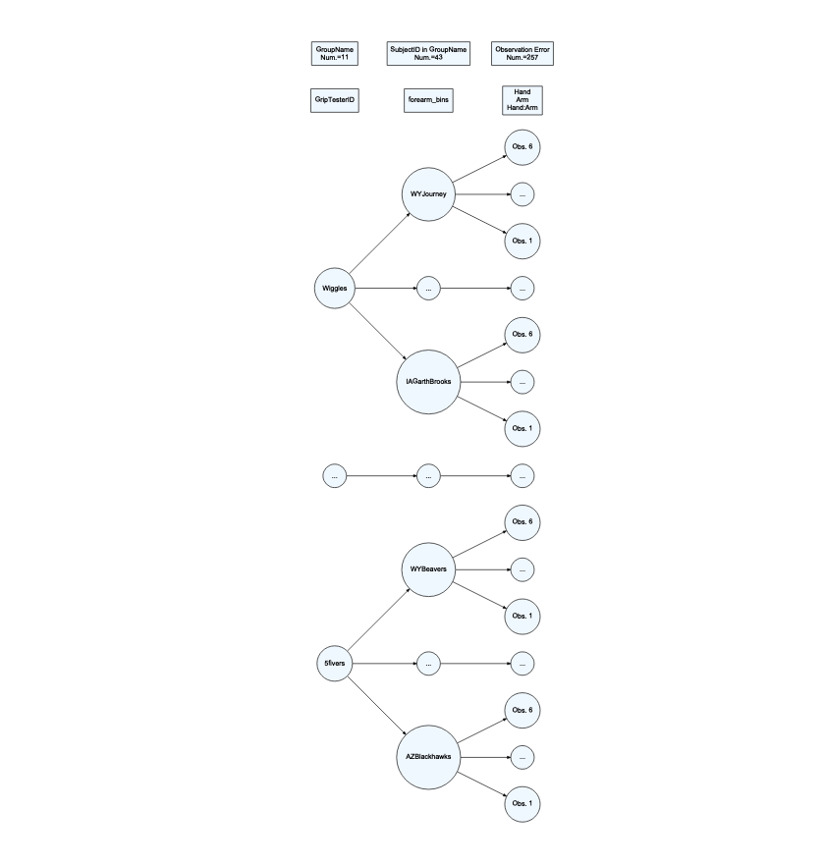

**11) Discuss how the denominator DF from the F-tests loosely/qualitatively relate to the model_diagram results for the Grip Tester, forearm, and Hand fixed effects. Report how many unique values were present at each level (provided in the model diagram) and the denominator DF in the discussion. Note that this is not about a formula but about relative size and number of unique observations at each level.**

The model diagram shows 11 groups, 43 subjects, and 257 observations. The denominator DF generally make sense because the griptester DF is 5.739, forearm_bins is 33.920, and hand, arm, hand:arm all have denominator DF of 209.006. These relative sizes line up with the unique values in our model diagram for the levels where these groups were applied.

**12) Generate an caterpillar plot from your new model. Find your group or a group of interest to you. Discuss the relative location of that group and, if you know something about the group, discuss whether this result is something you expected given how we formed the groups based on height of the students.**

At the group level, the TallerThanYou group had relatively higher estimated mean grip strength than the rest of the groups, and the average. This makes sense as these individuals were the tallest in their class last semester, and included PATaller who had the highest grip strength of all.

ranef(lmer4)

## $`SubjectID:GroupName`  
## (Intercept)  
## ABH1997:BANAVIG -7.5761812  
## AFEDU2020:BANAVIG -14.0182654  
## AustinLions:GentleGiants -26.4846160  
## AZBlackhawks:5fivers 2.9398201  
## AZRams:5fivers -2.5804367  
## BelknapBull:Shawties 2.7620350  
## BostonLakers:5fivers 12.6558283  
## BostonWolverines:GentleGiants 9.6406761  
## CAJustinBieber:Boxplots -6.9782713  
## CenntenialWarriors:Shawties -0.7693745  
## COMichealFranti:Snuggies 8.2861776  
## DCSNAP:SNAPCREW -3.6384098  
## DenverCoyotes:Shawties -0.7592028  
## DenverGalaxy:BANAVIG 11.8884391  
## FLTaller:TallerThanYou -7.6098964  
## GASNAP:SNAPCREW 4.8521628  
## HYENA:BESTBY 25.7167890  
## IAGarthBrooks:Wiggles 12.5002301  
## IDAJR:GrapeJuice -7.2854334  
## IDPAD:GrapeJuice 6.3532329  
## LACROIX:BESTBY -36.1847913  
## LADeathGrips:Snuggies -12.6273592  
## NDLawrence:Wiggles -0.7696199  
## NewYorkLaeeb:BANAVIG -9.8808974  
## NMSnuggies:Snuggies 2.4384973  
## NVKP:GrapeJuice -5.1335659  
## OrlandoChamp:GentleGiants 10.5861936  
## ORMichelangelo:Boxplots 0.5858693  
## PATaller:TallerThanYou 23.3673020  
## SanDiegoBobcat:Shawties -6.3671002  
## UTSNAP:SNAPCREW -12.4089004  
## VancouverMcLaren:BESTBY 11.7724255  
## VTPink:Boxplots -8.2172253  
## WATaller:TallerThanYou -9.8045397  
## WinonaBadgers:GentleGiants 1.2968216  
## WIWiggles:Wiggles 12.4541075  
## WYBeavers:5fivers -11.1125272  
## WYIW:GrapeJuice 2.1799140  
## WYJourney:Wiggles -4.5978128  
## WYSlipKnot:Boxplots 3.3898180  
## WYSNAP:SNAPCREW 16.3287899  
## WYTaller:TallerThanYou 10.2278681  
## ZOO:BESTBY 2.5814291  
##   
## $GroupName  
## (Intercept)  
## 5fivers 1.148931  
## BANAVIG -11.827506  
## BESTBY 2.346463  
## Boxplots -6.775055  
## GentleGiants -2.995643  
## GrapeJuice -2.346463  
## Shawties -3.099938  
## SNAPCREW 3.099938  
## Snuggies -1.148931  
## TallerThanYou 9.770698  
## Wiggles 11.827506  
##   
## with conditional variances for "SubjectID:GroupName" "GroupName"

dotplot(ranef(lmer4, postVar = T))

## $`SubjectID:GroupName`

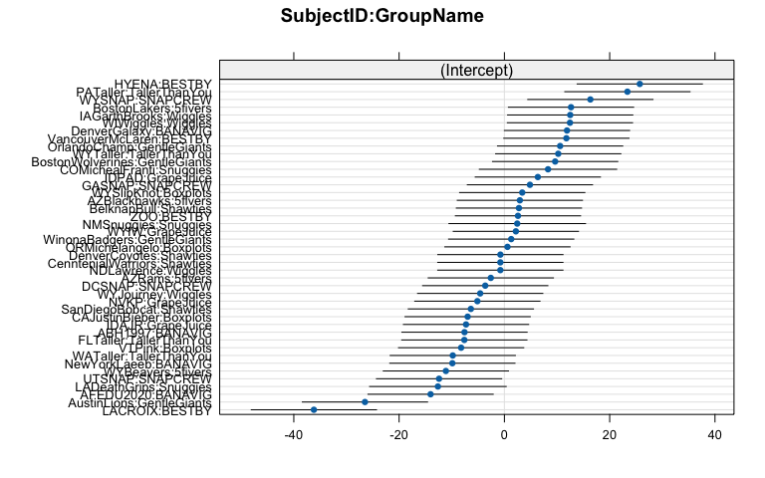

##   
## $GroupName

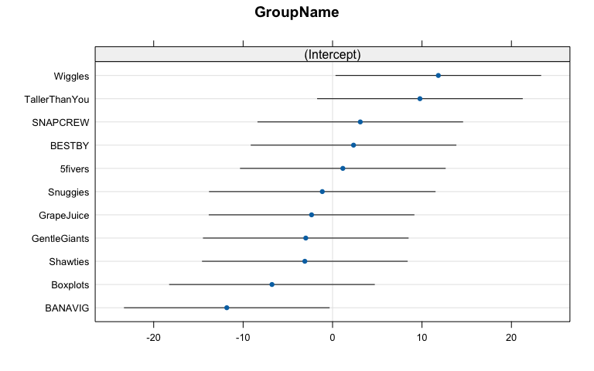

**13) Note any additional resources used to complete this lab or NONE.**

NONE