**Centre for Excellence in Information Technology (CEIT)**

**University of Papua New Guinea**

**Networking Fundamentals Practical test – Feb- Batch 2021**

**Routing using Cisco Packet Tracer**

**Test Duration: Not more than 2hrs**

**Q. 1. Configure static routing in the following topology**

**Basic networking- 5 marks**

**Static routing- 10 marks**

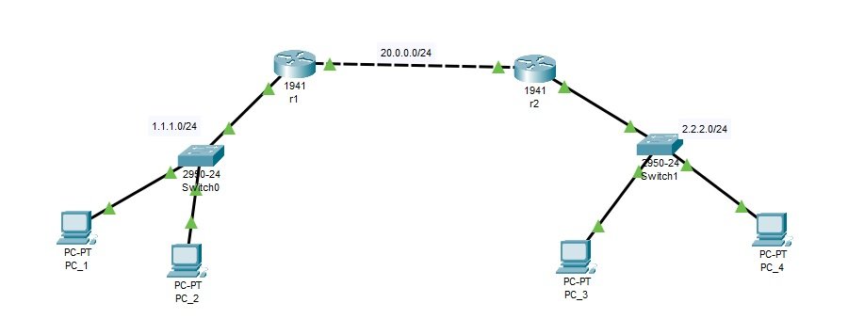

**Q. 2. Configure dynamic routing in the following topology. Also, configure the server in network 192.168.10.0/24 so that it becomes a DHCP server to dynamically assign ip addresses to the clients in the same network.**

**Basic networking- 5 marks**

**Static routing- 15 marks**

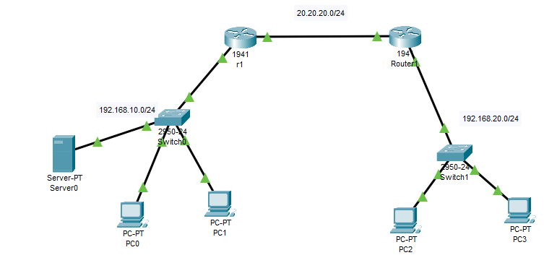

All the best!